|  |
| --- |
| TS017 - TC111_Validation of Concern Email Notification |

|  |
| --- |
| TC004_Validation of CAN field_Account has Multiple CAN with Multiple Service |

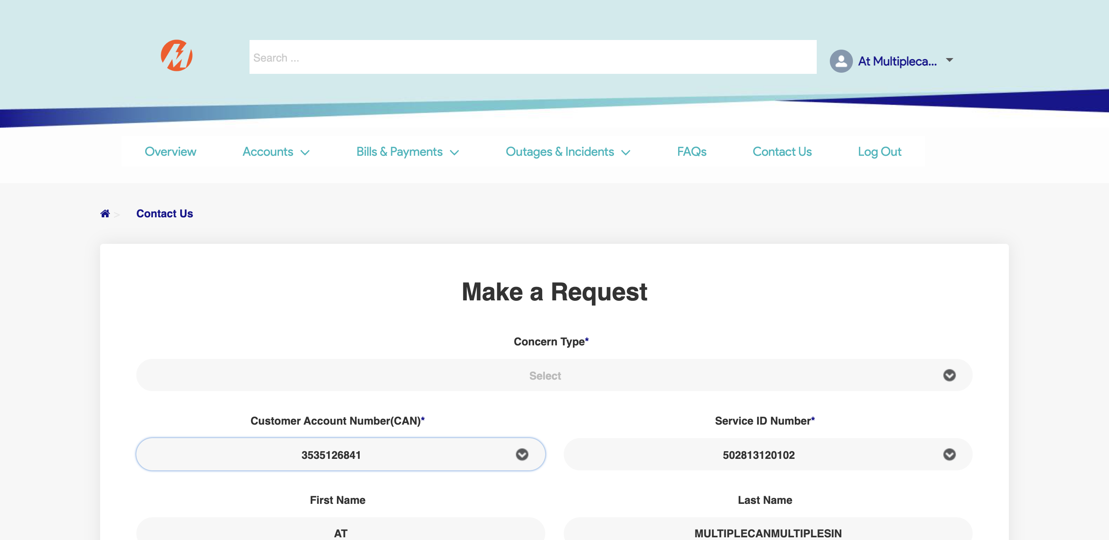

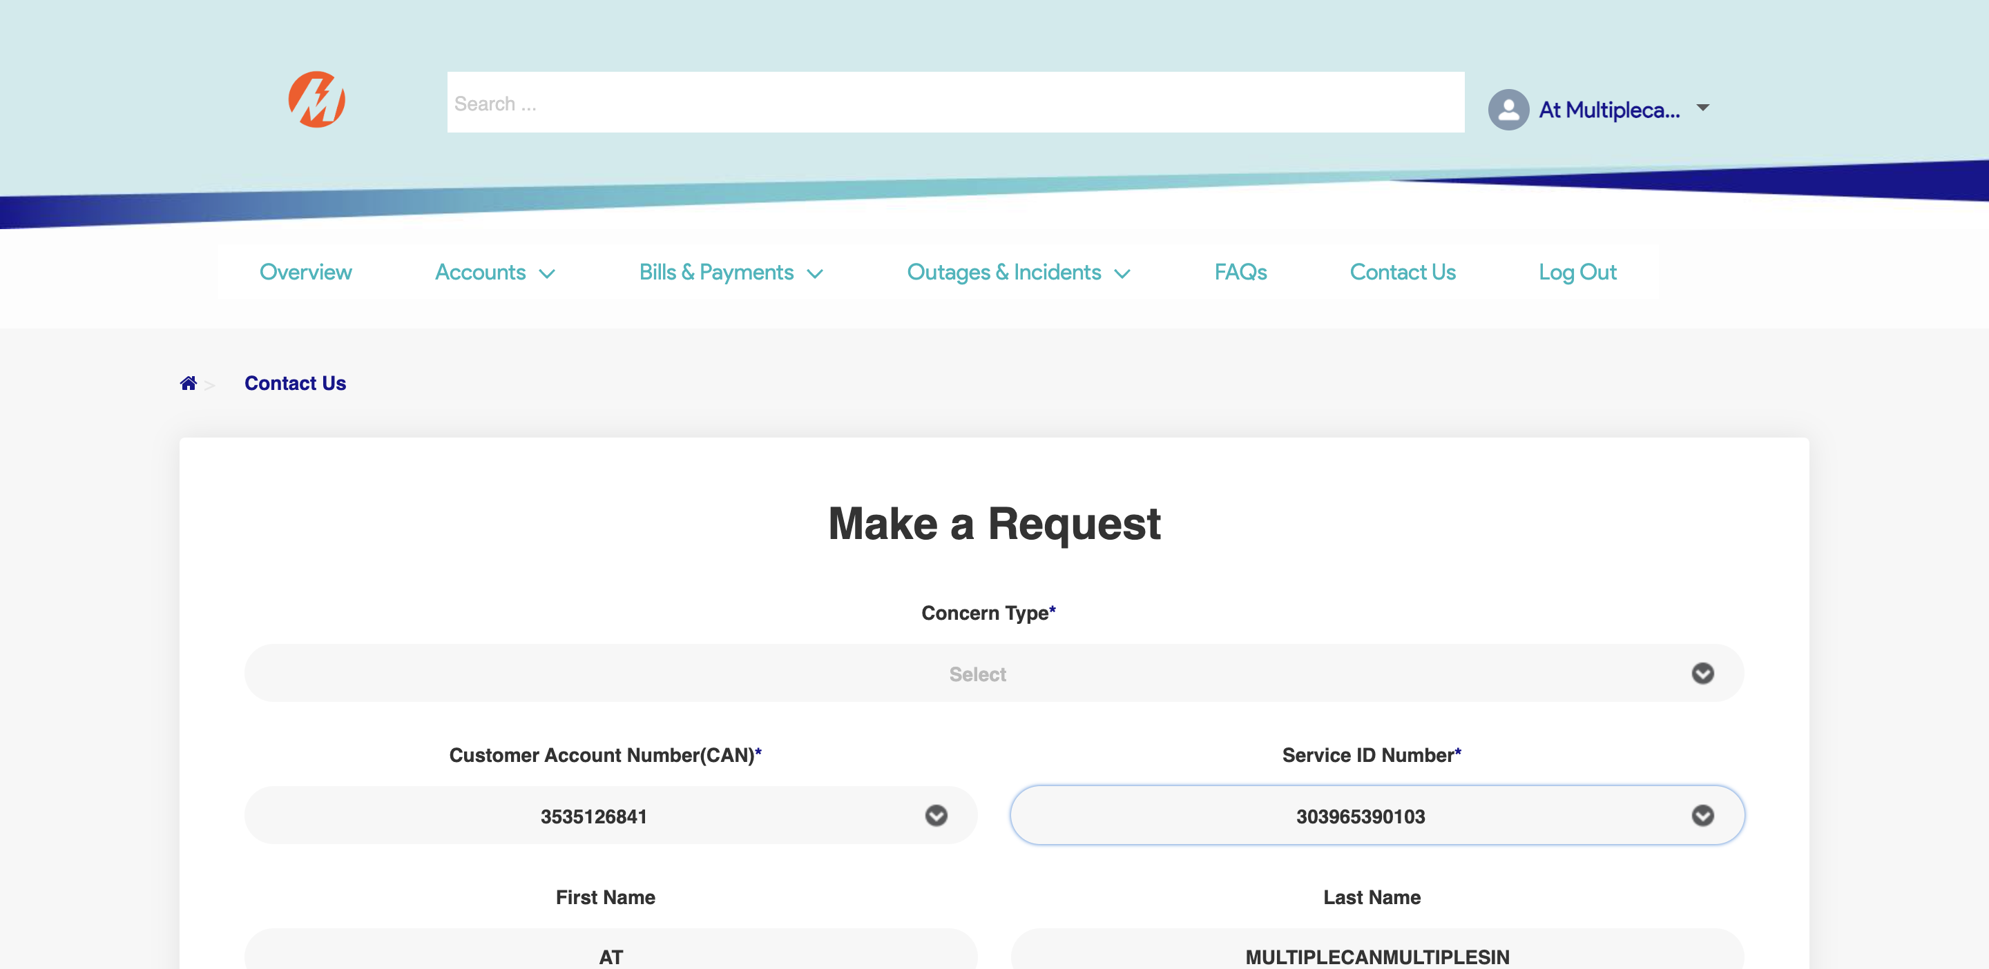

|  |
| --- |
| TC005_Create Concern |

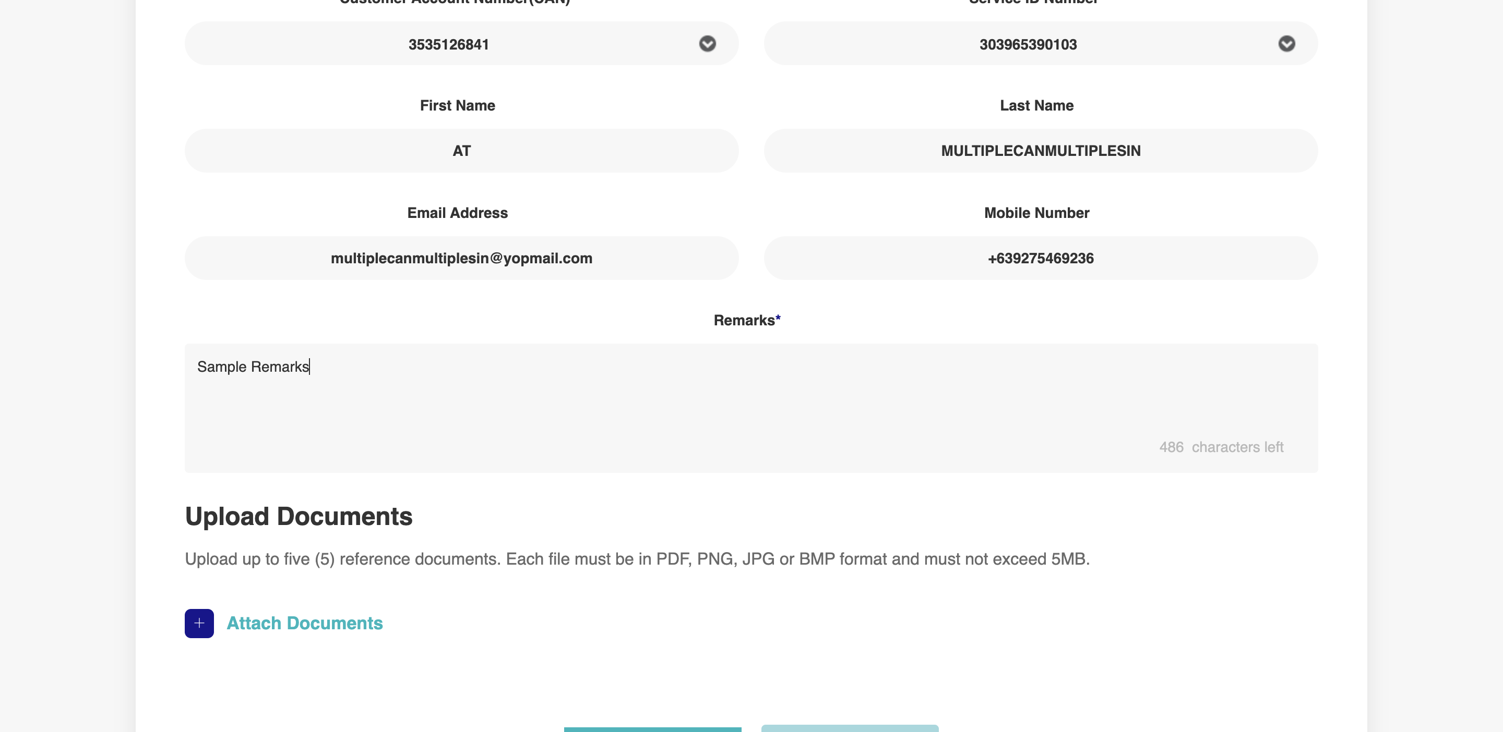

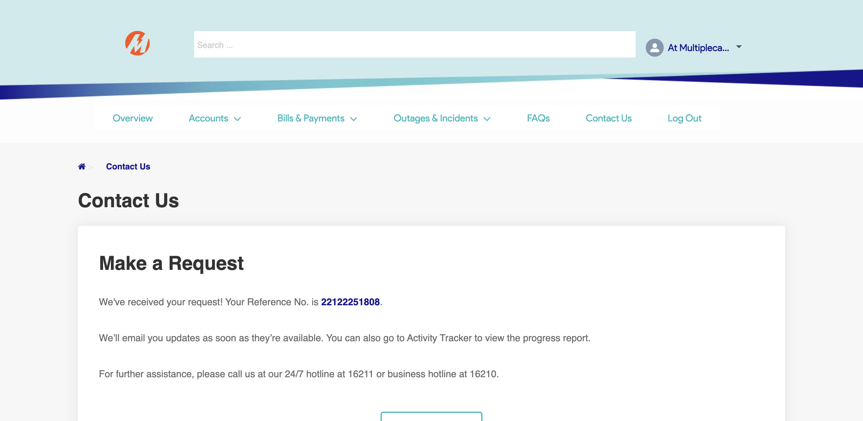

|  |
| --- |
|  |

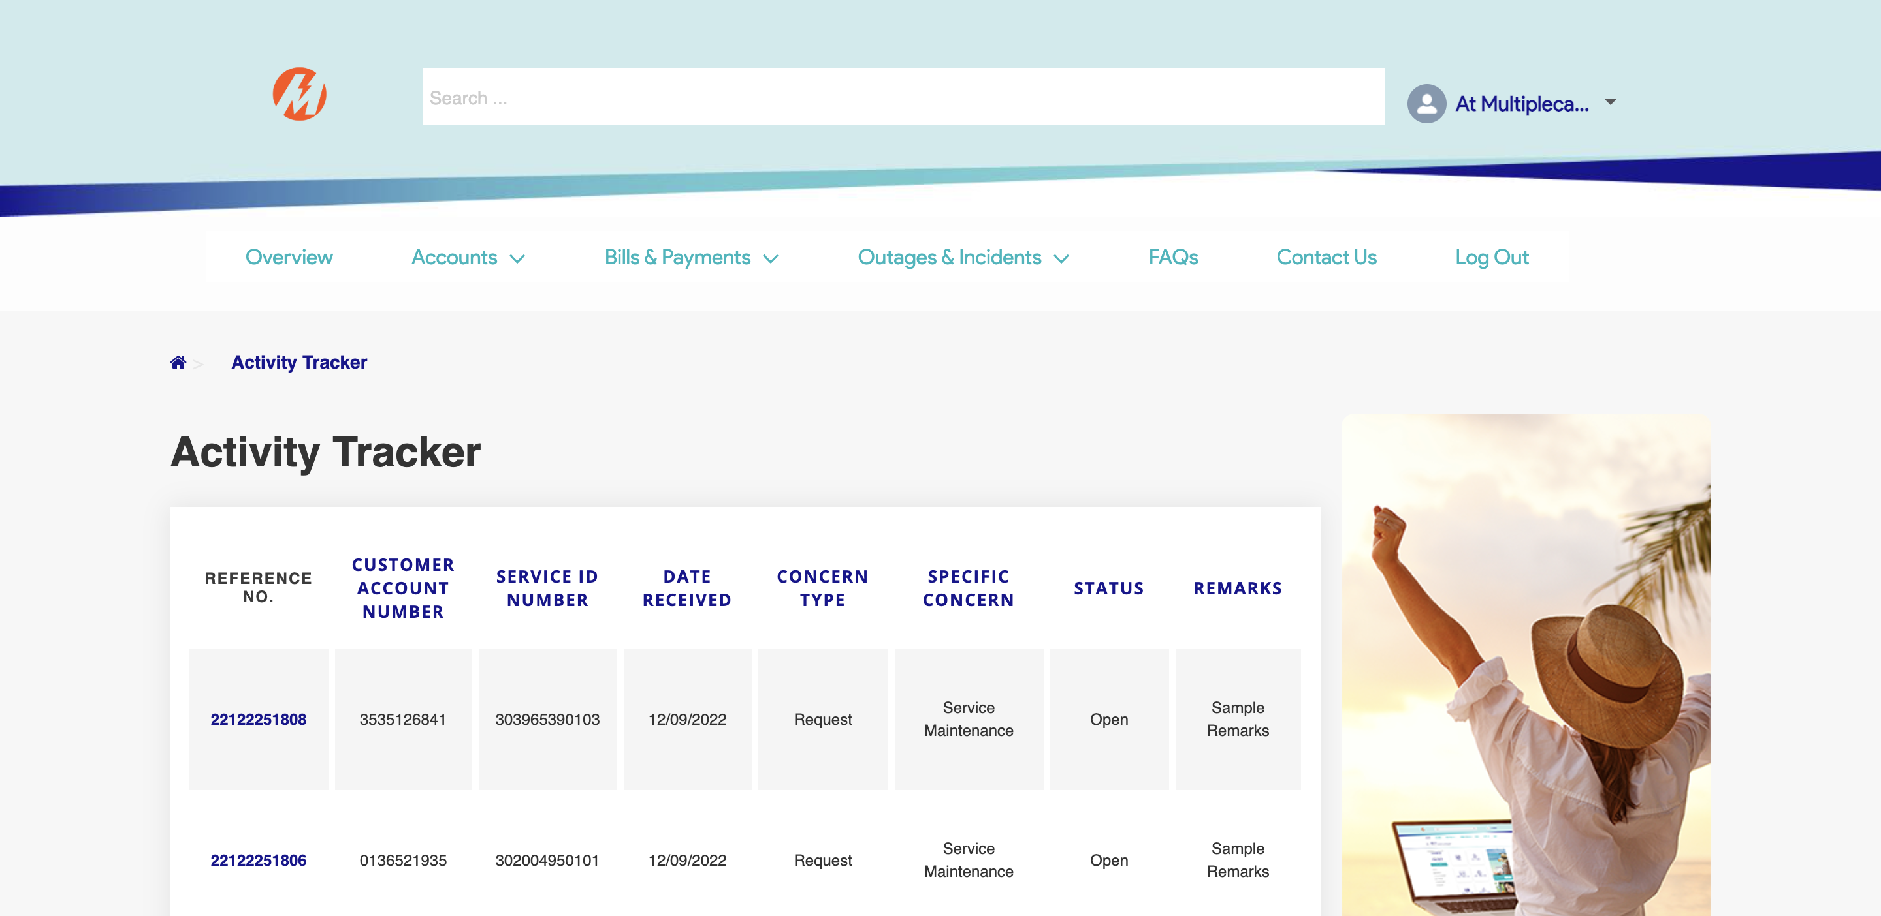



|  |
| --- |
|  |

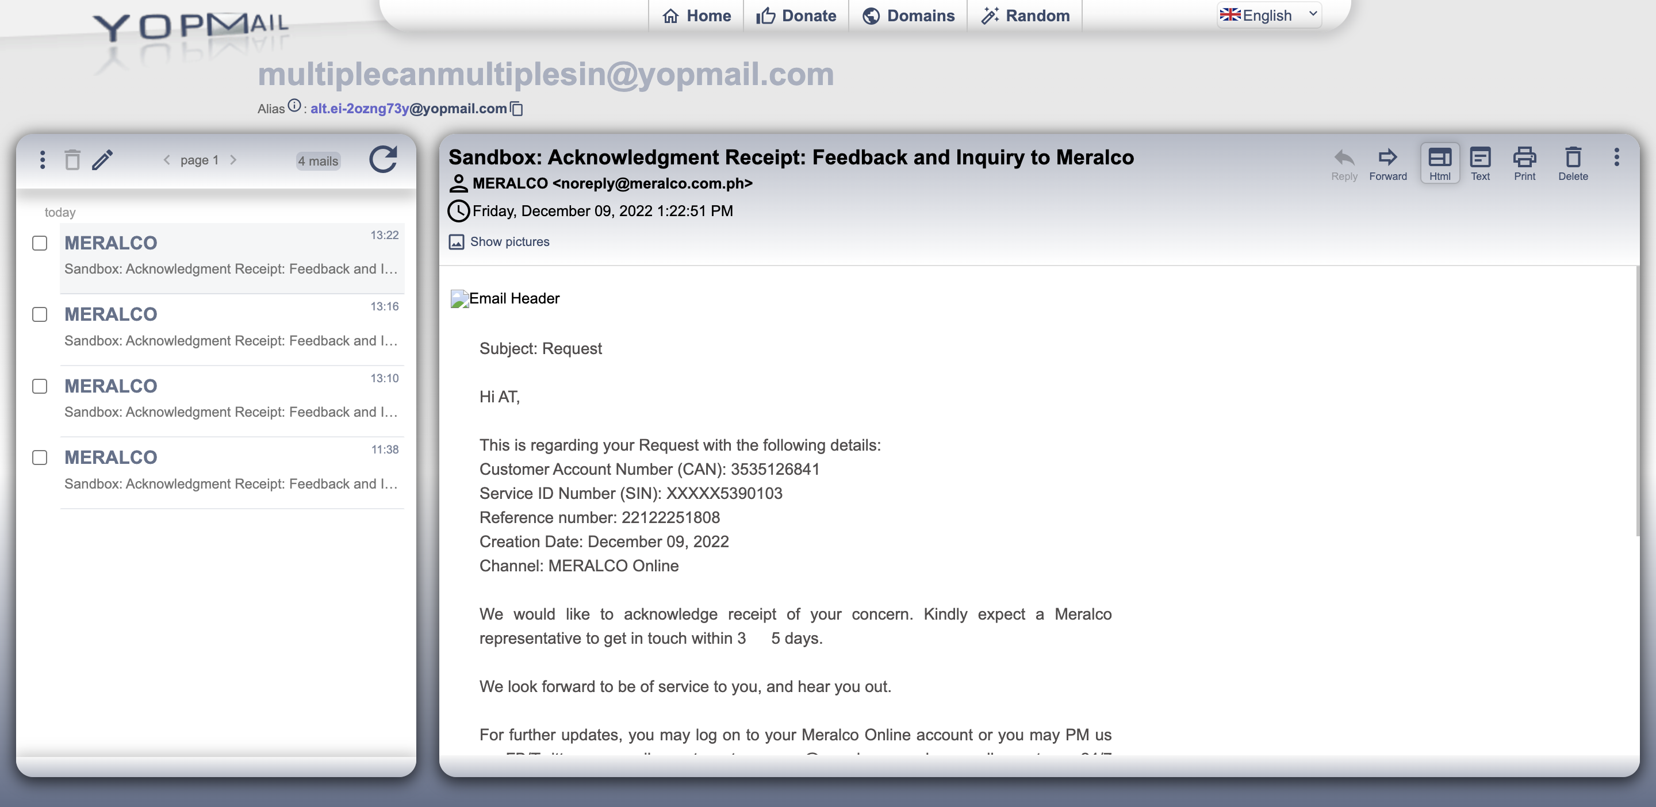

Passed