|  |
| --- |
| TS019 - TC111_Validation of Concern Email Notification |

|  |
| --- |
|  |

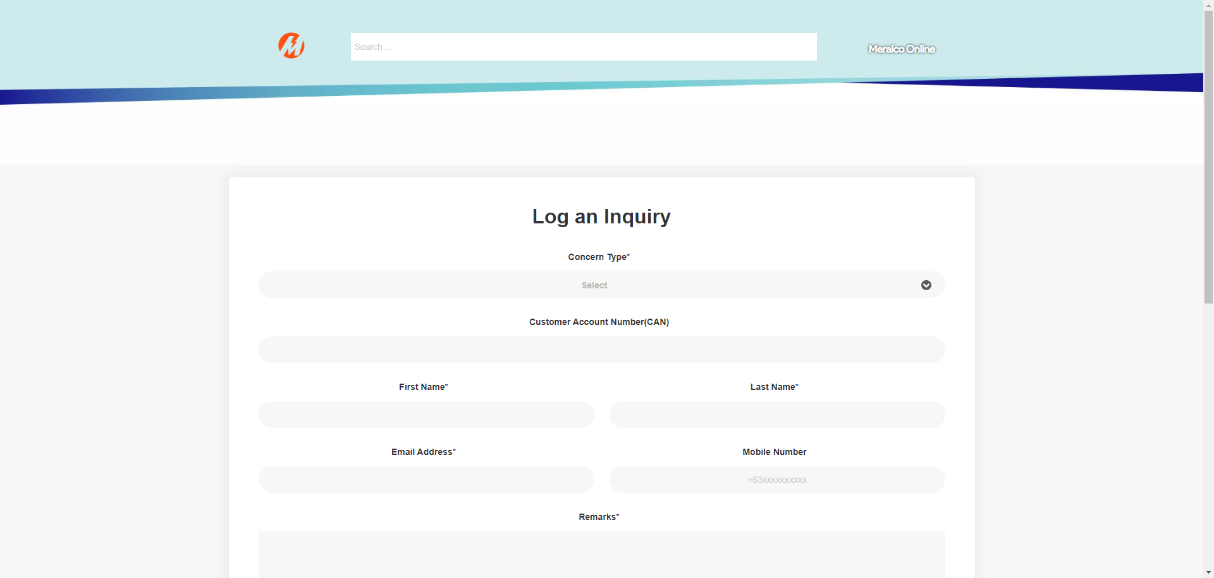

|  |
| --- |
| TC003_Validation of CAN field_Account has 1 CAN with Multiple Service |

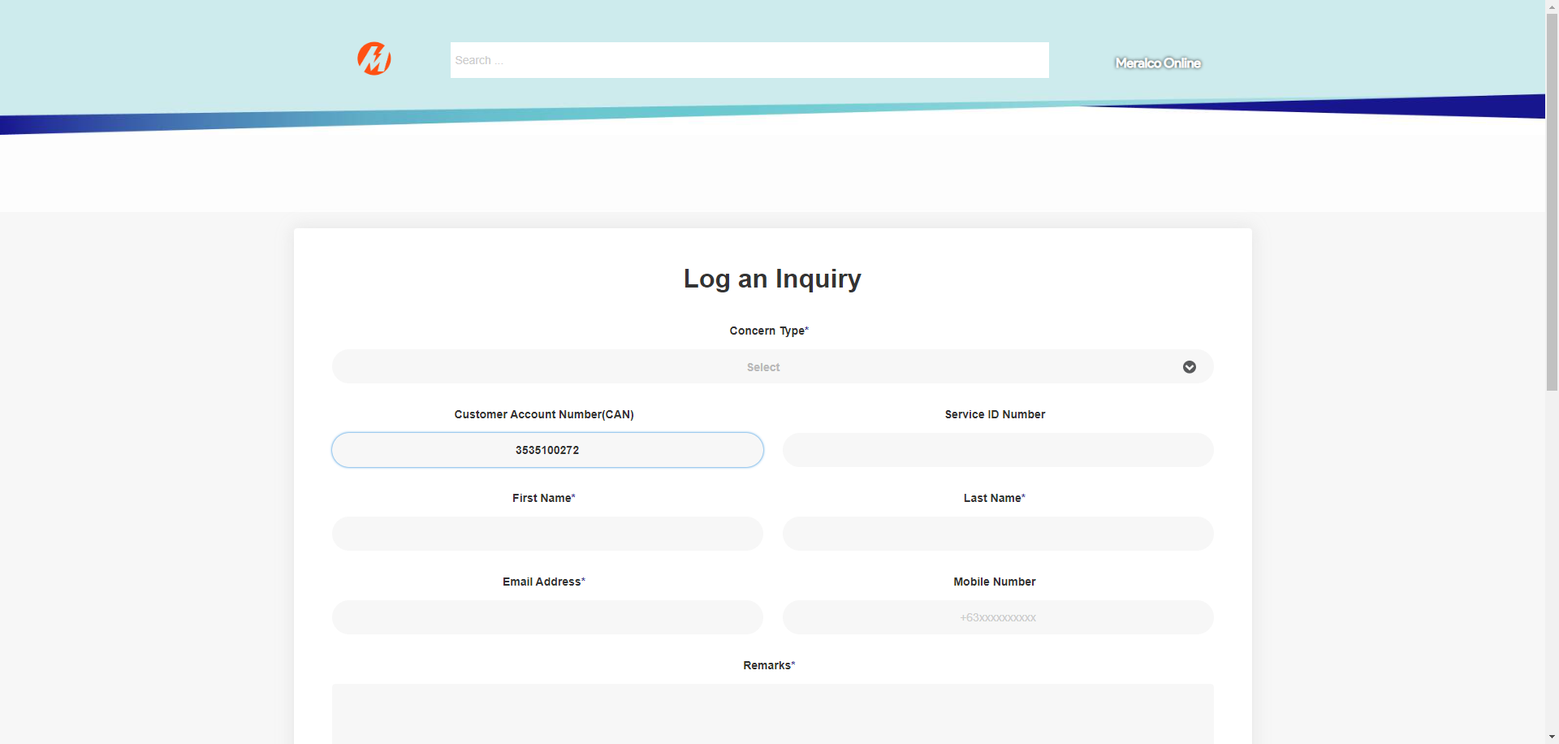

|  |
| --- |
| TC005_Create Concern |

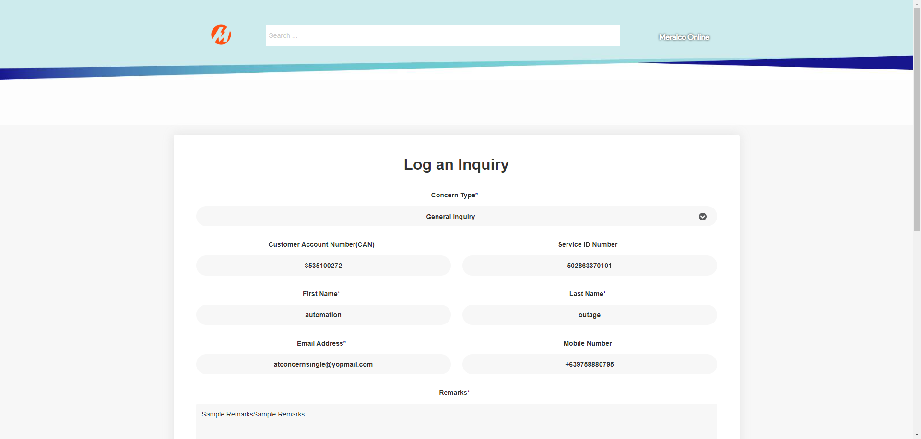

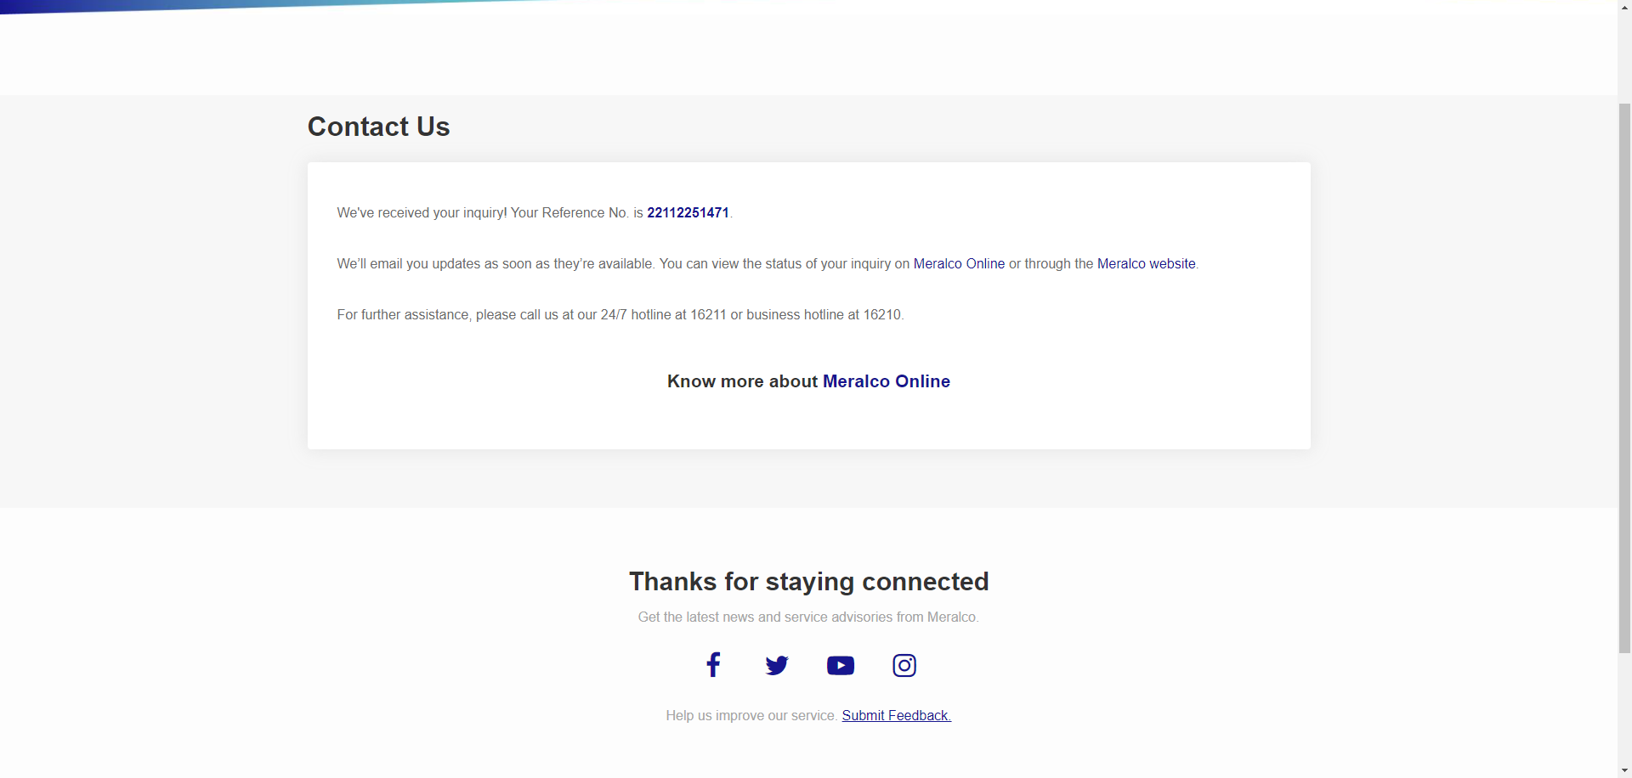

|  |
| --- |
|  |

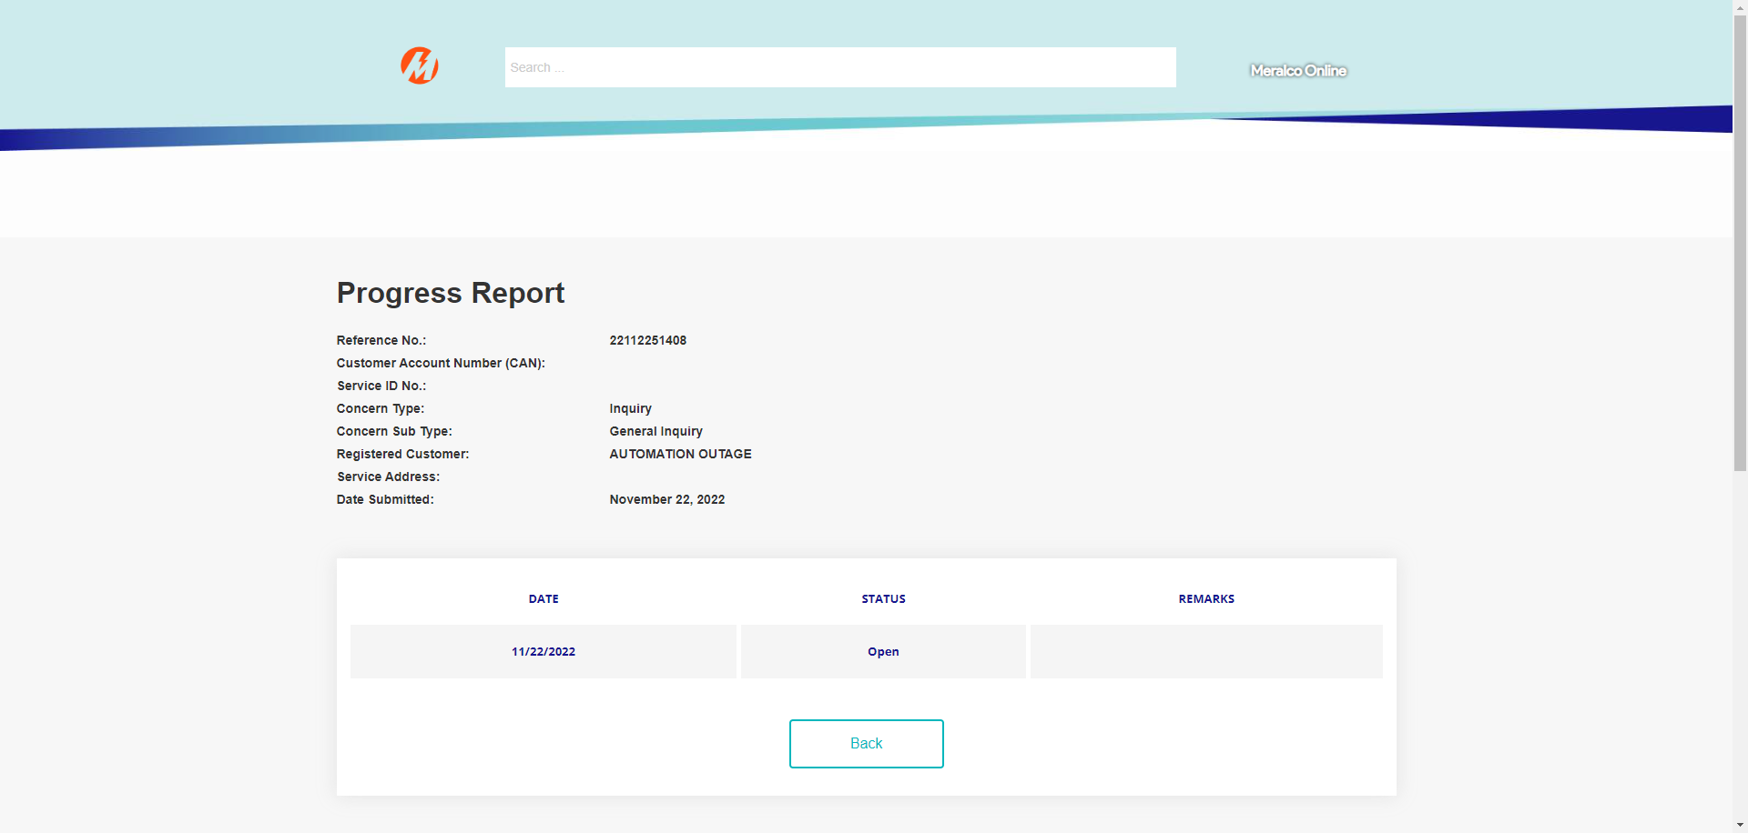

|  |
| --- |
|  |

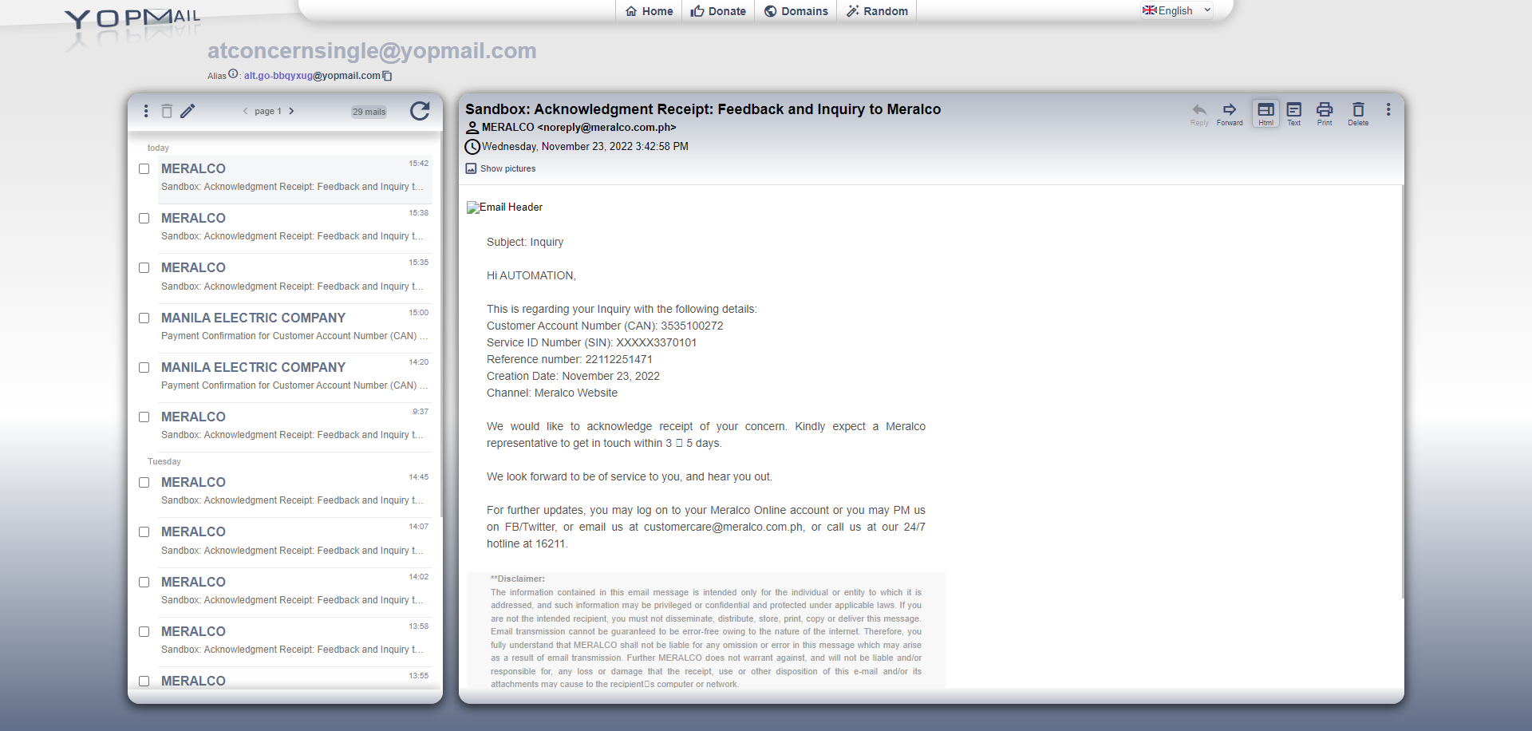

Passed