|  |
| --- |
| TS020 - Create No Power Case for Service with No Pending No Power Case but with Pending Incident in ADMS |

|  |
| --- |
| TC057_Create No Power Case for Service with No Pending No Power Case but with Pending Incident in ADMS |

|  |
| --- |
| Step 1 - Access outage reporting form for Guest users. |
| User should be able to access outage reporting form for Guest users. |

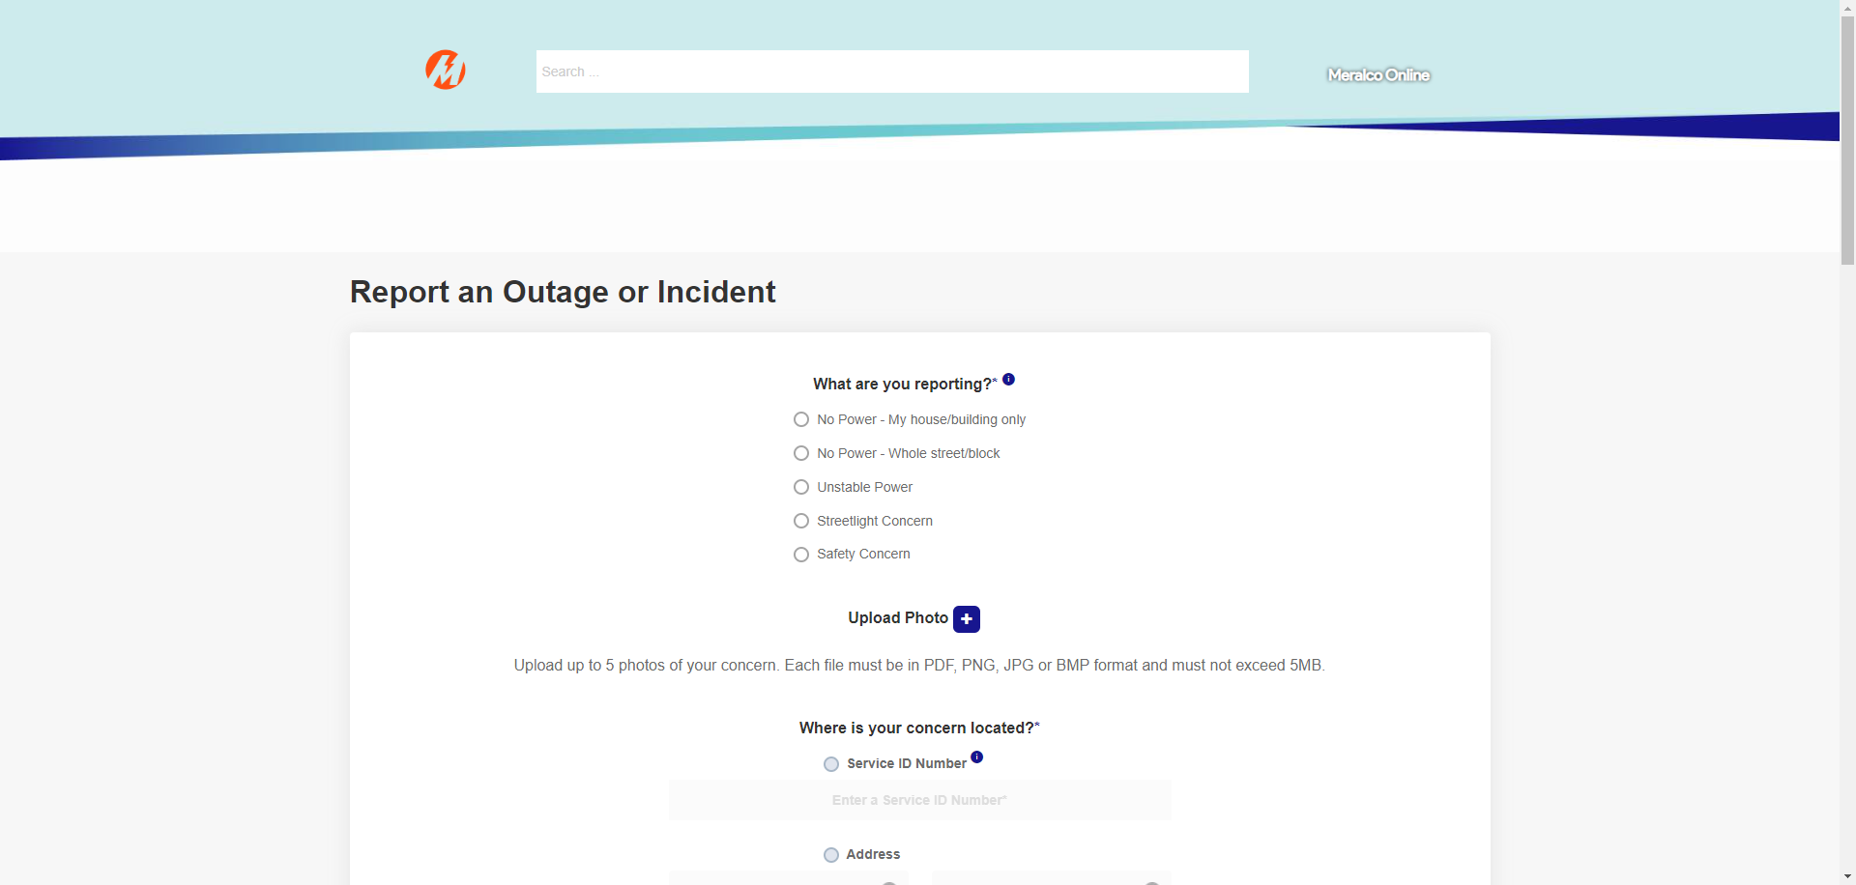

|  |
| --- |
| Step 2 - Choose 'No Power - My house/building ' from the 'What are you reporting?' option. |
| The following questions should appear: Q1: What specific damage do you see or hear? |

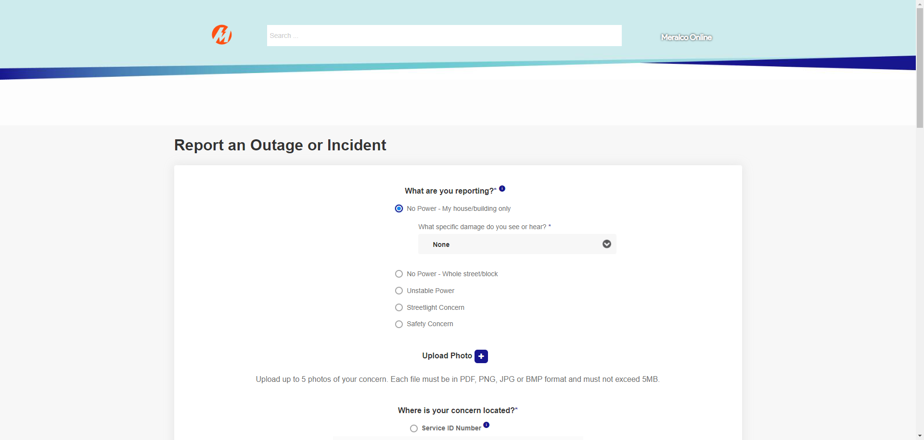

|  |
| --- |
| Step 3 - Click the dropdown field for Q1. |
| The following options should appear: a. None b. Pole is broken or has fallen c. Wire is detached or has fallen from the pole d. Something blew up |

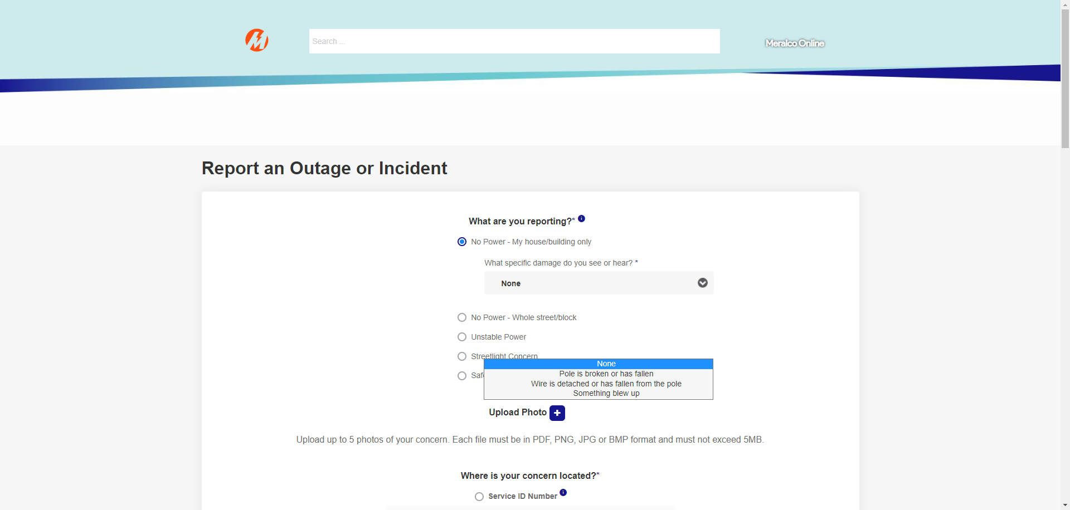

|  |
| --- |
| Step 4 - Choose 'None' from the option. |
| The dropdown field for Q1 should be populated. |



|  |
| --- |
| Step 5 - Input the SIN with no pending No Power case but with pending incident in ADMS under the 'Where is your concern located?' section. |
| A message prompt should be displayed.  Meralco is aware of the outage you are reporting and is working to resolve it. Do you still want to proceed with your report?  AND  User is allowed to choose to proceed or not with the submission of report. |

|  |
| --- |
| Step 6 - Select No. |
| User is redirected to Meralco website. |

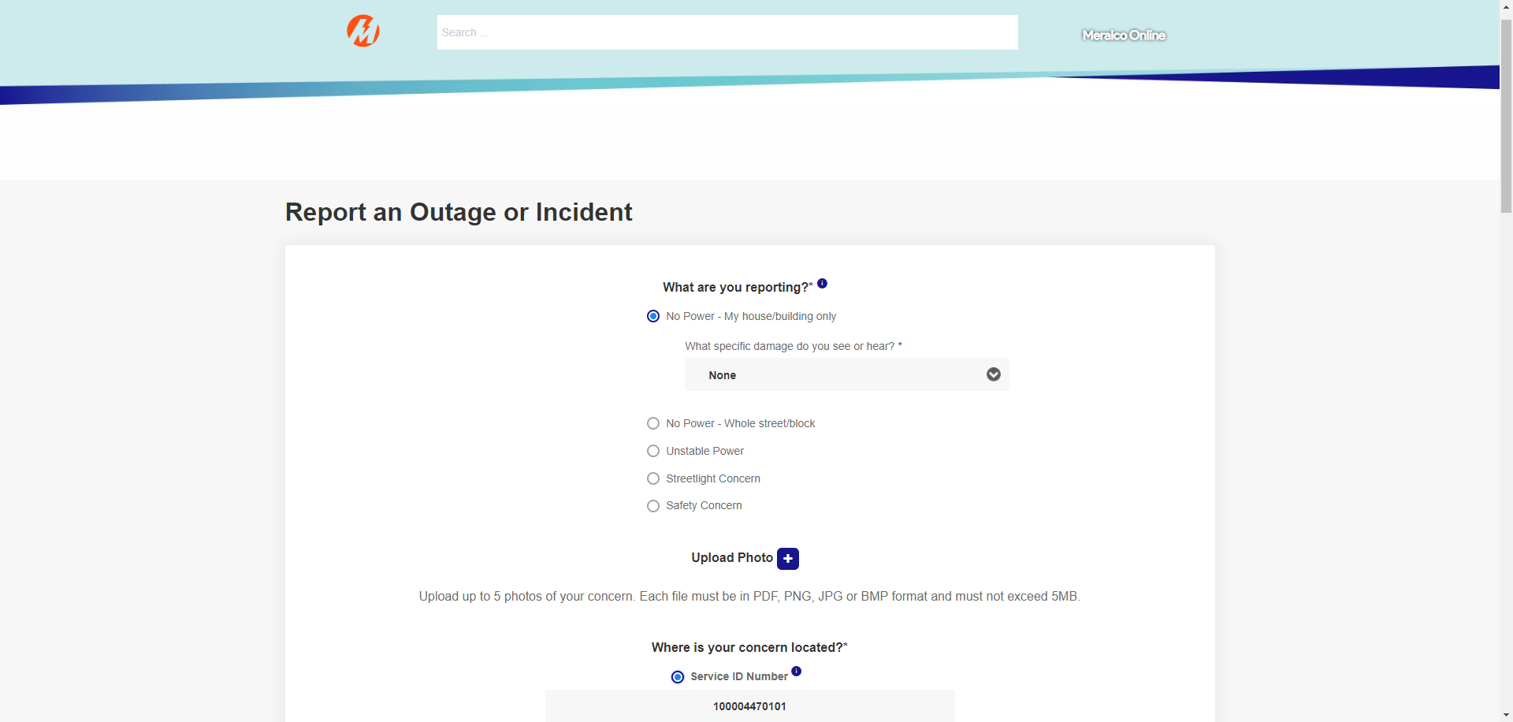

|  |
| --- |
| Step 7 - Access outage reporting form for Guest users. |
| User should be able to access outage reporting form for Guest users. |



|  |
| --- |
| Step 8 - Choose 'No Power - My house/building ' from the 'What are you reporting?' option. |
| The following questions should appear: Q1: What specific damage do you see or hear? |



|  |
| --- |
| Step 9 - Click the dropdown field for Q1. |
| The following options should appear: a. None b. Pole is broken or has fallen c. Wire is detached or has fallen from the pole d. Something blew up |



|  |
| --- |
| Step 10 - Choose 'None' from the option. |
| The dropdown field for Q1 should be populated. |



|  |
| --- |
| Step 11 - Input the SIN with no pending No Power case but with pending incident in ADMS under the 'Where is your concern located?' section. |
| A message prompt should be displayed.  Meralco is aware of the outage you are reporting and is working to resolve it. Do you still want to proceed with your report?  AND  User is allowed to choose to proceed or not with the submission of report. |

|  |
| --- |
| Step 12 - Select Yes. |
| User is allowed to continue with the outage reporting. |



|  |
| --- |
| Step 13 - Select the 'Landmarks/Directions' option and input values in the text box. |
| Landmarks/Directions' field should be populated. AND Character count should not overlap with inputted values.  Note: A maximum of 1,000 characters should be accepted. |

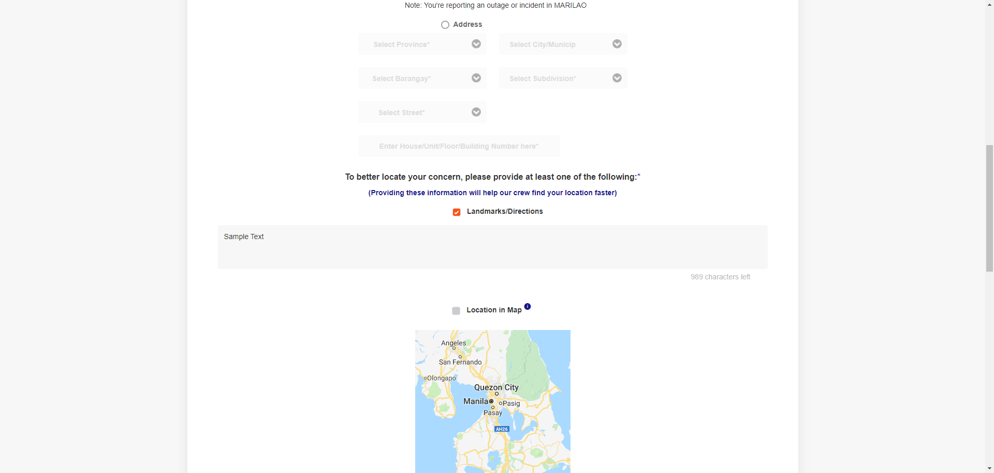

|  |
| --- |
| Step 14 - Populate the following fields: a) First Name b) Middle Name c) Last Name d) Mobile Number e) Landline f) Email |
| Fields should be populated. |

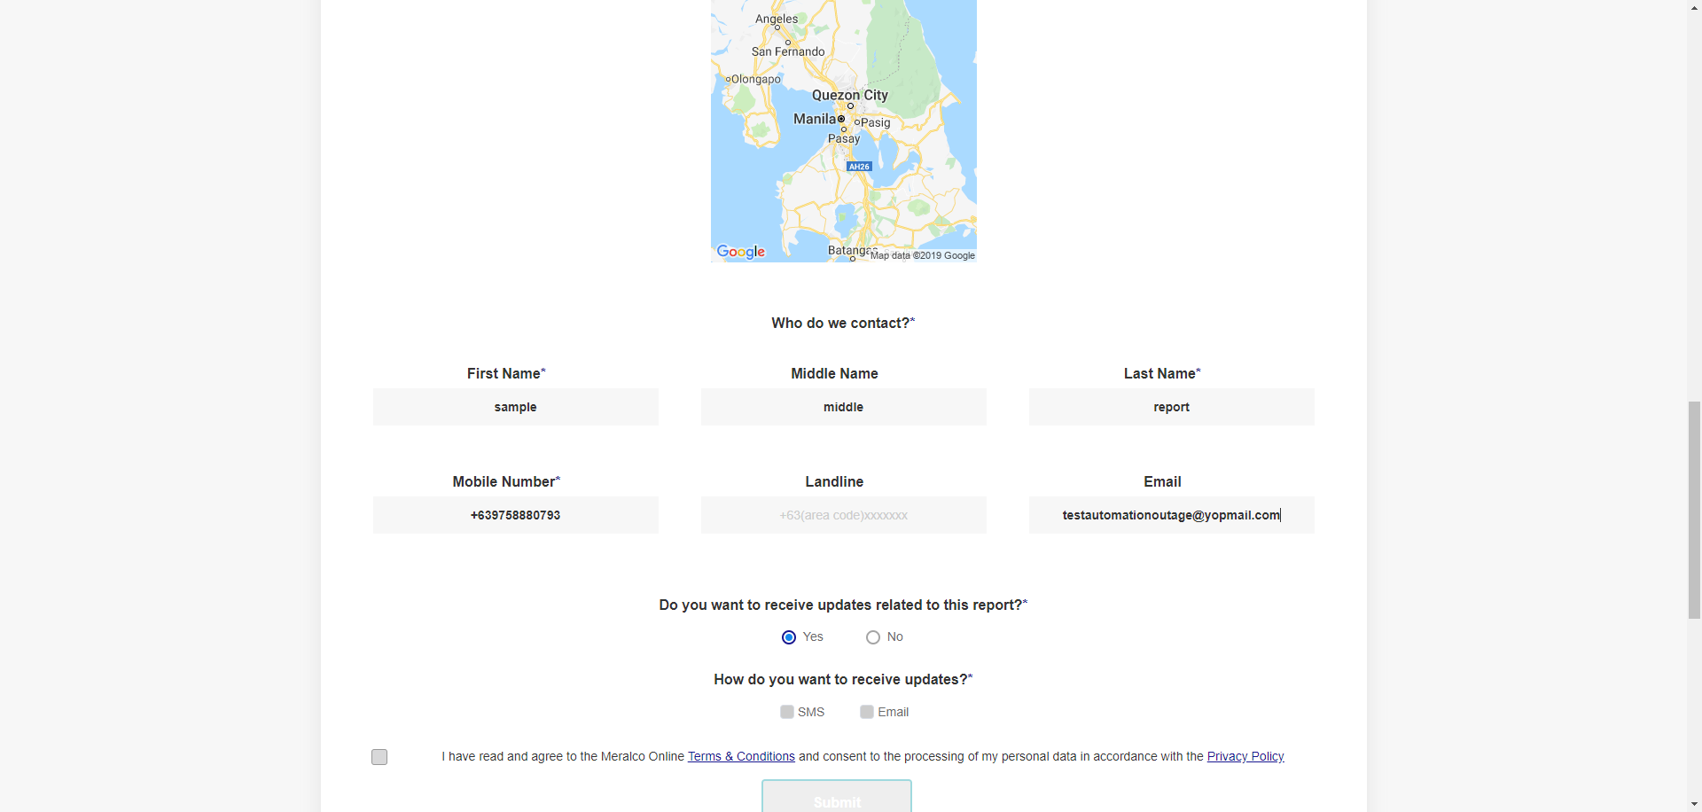

|  |
| --- |
| Step 15 - Verify if 'Yes' is selected from the options under 'Do you want to receive updates related to this report?' |
| Yes' is selected by default from the options under 'Do you want to receive updates related to this report?' |



|  |
| --- |
| Step 16 - Select SMS and Email as preferred Case Notification Channel. Note: Ensure that 'Email' field has valid value if Email has been selected as preferred Case Notification Channel. |
| Preferred Case Notification Channel has been selected. |

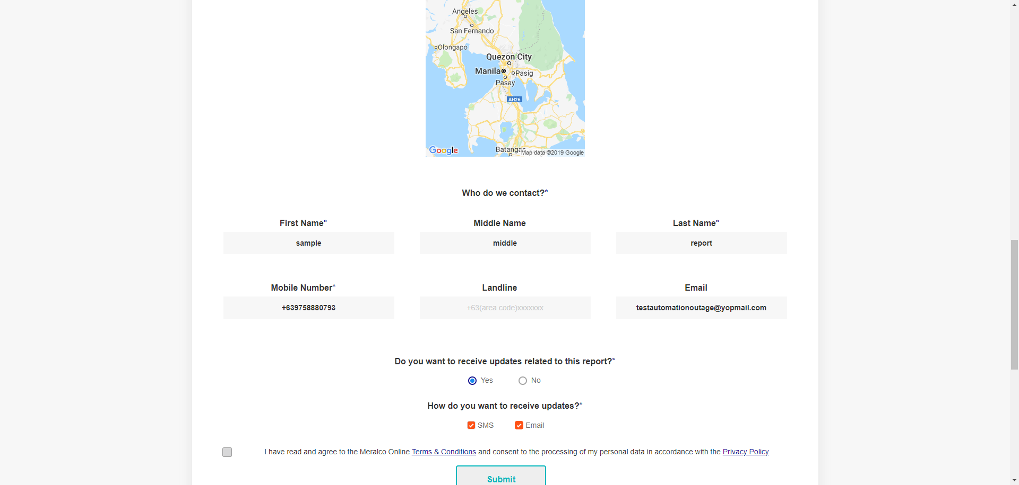

|  |
| --- |
| Step 17 - Select the checkbox for: I have read and agree to the Meralco Online Terms & Conditions and consent to the processing of my personal data in accordance with the Privacy Policy. |
| User has agreed to the Meralco Online Terms & Conditions. |

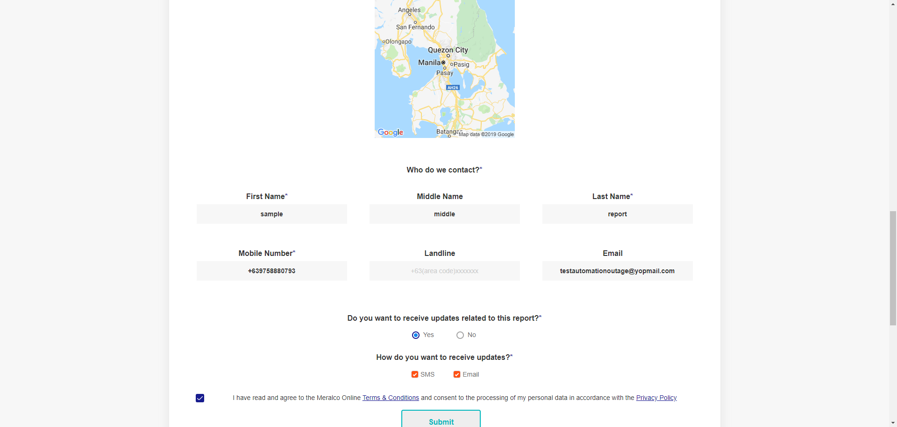

|  |
| --- |
| Step 18 - Click ‘Submit’ button. |
| The following message should be displayed:  We've received your report! Your Reference No. is [Case Number].  We'll also send you updates as soon as they're available. |

|  |
| --- |
| Step 19 - Verify received SMS notification. |
| User was able to receive one SMS notification, with template below.  We’ve received your report with Ref.# [Case Number]. We’ll send you updates as soon as they become available. Thanks. |

|  |
| --- |
| Step 20 - Verify received Email notification. |
| User was able to receive one Email notification, with template below.  Subject: Acknowledgement Receipt of Report   Hi [First Name],   We’ve received your report with Reference No. [Case Number]. We’ll send you updates as soon as they become available.   To conveniently check the status of your report, register or log in to Meralco Online. |

|  |
| --- |
| Step 21 - Verify received Push notification. |
| No notification was received. |

Passed