|  |
| --- |
| TS022 - Create Report: Concern Type = Streetlight Concern; Q1 Answer = No. |

|  |
| --- |
| TC059_Create Report: Concern Type = Streetlight Concern; Q1 Answer = No. |

|  |
| --- |
| Step 1 - Access outage reporting form for Guest users. |
| User should be able to access outage reporting form for Guest users. |

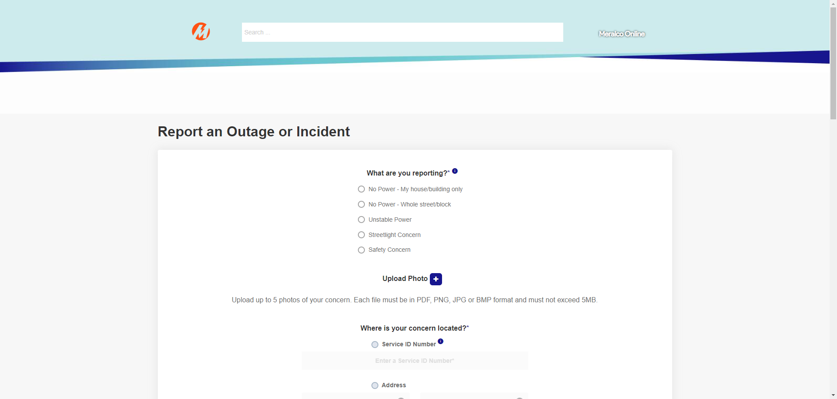

|  |
| --- |
| Step 2 - Choose 'Streetlight Concern' from the 'What are you reporting?' option. |
| The following questions should appear: Q1: Is this streetlight connected to a Meralco Pole? |

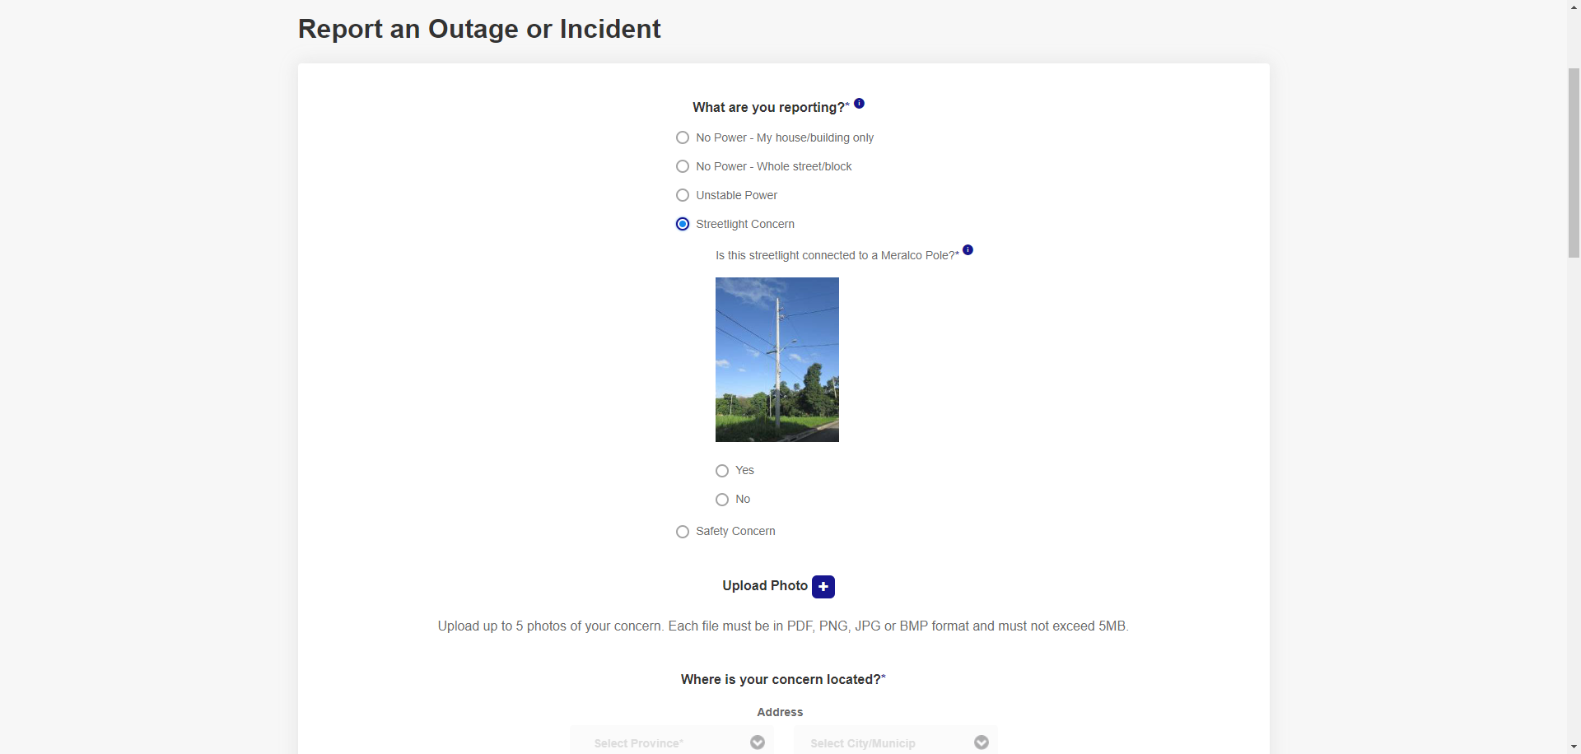

|  |
| --- |
| Step 3 - Choose 'No' from the options. |
| A message should appear: 'This type of streetlight is not covered by Meralco. Please contact your Homeowners' Association or Local Government Unit. Thank you.' |

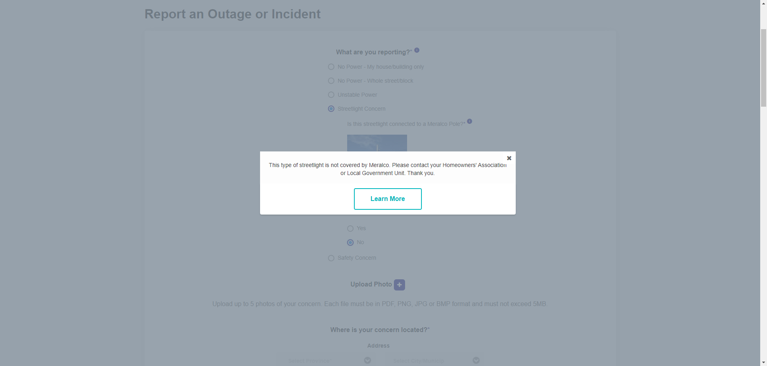

|  |
| --- |
| Step 4 - Click 'Learn More'. |
| User should be redirected to FAQs screen. |

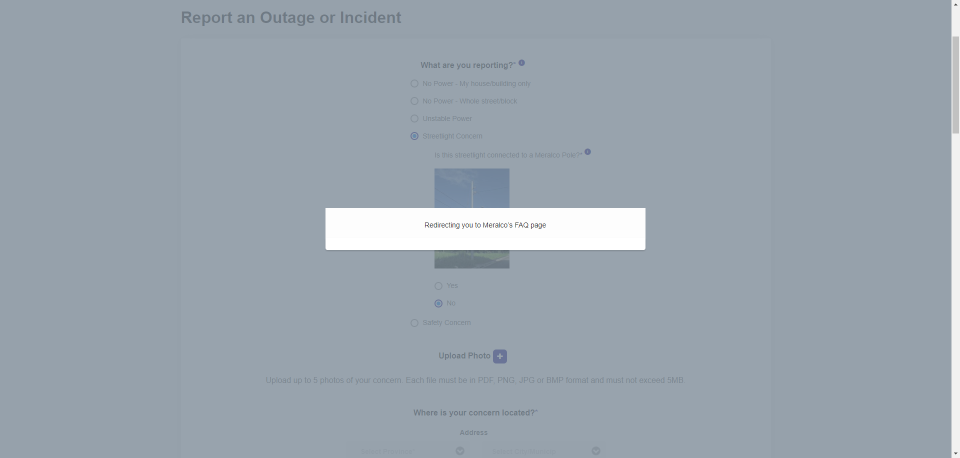

Passed