|  |
| --- |
| TS023 - Weather icon; Temperature; Zoom level 8 - Internal Map |

|  |
| --- |
| TC060_Validation of weather icons using Zoom Level - Internal Map |

|  |
| --- |
| Step 1 - Go to Internal Map |
| User should be redirected to Internal Map |

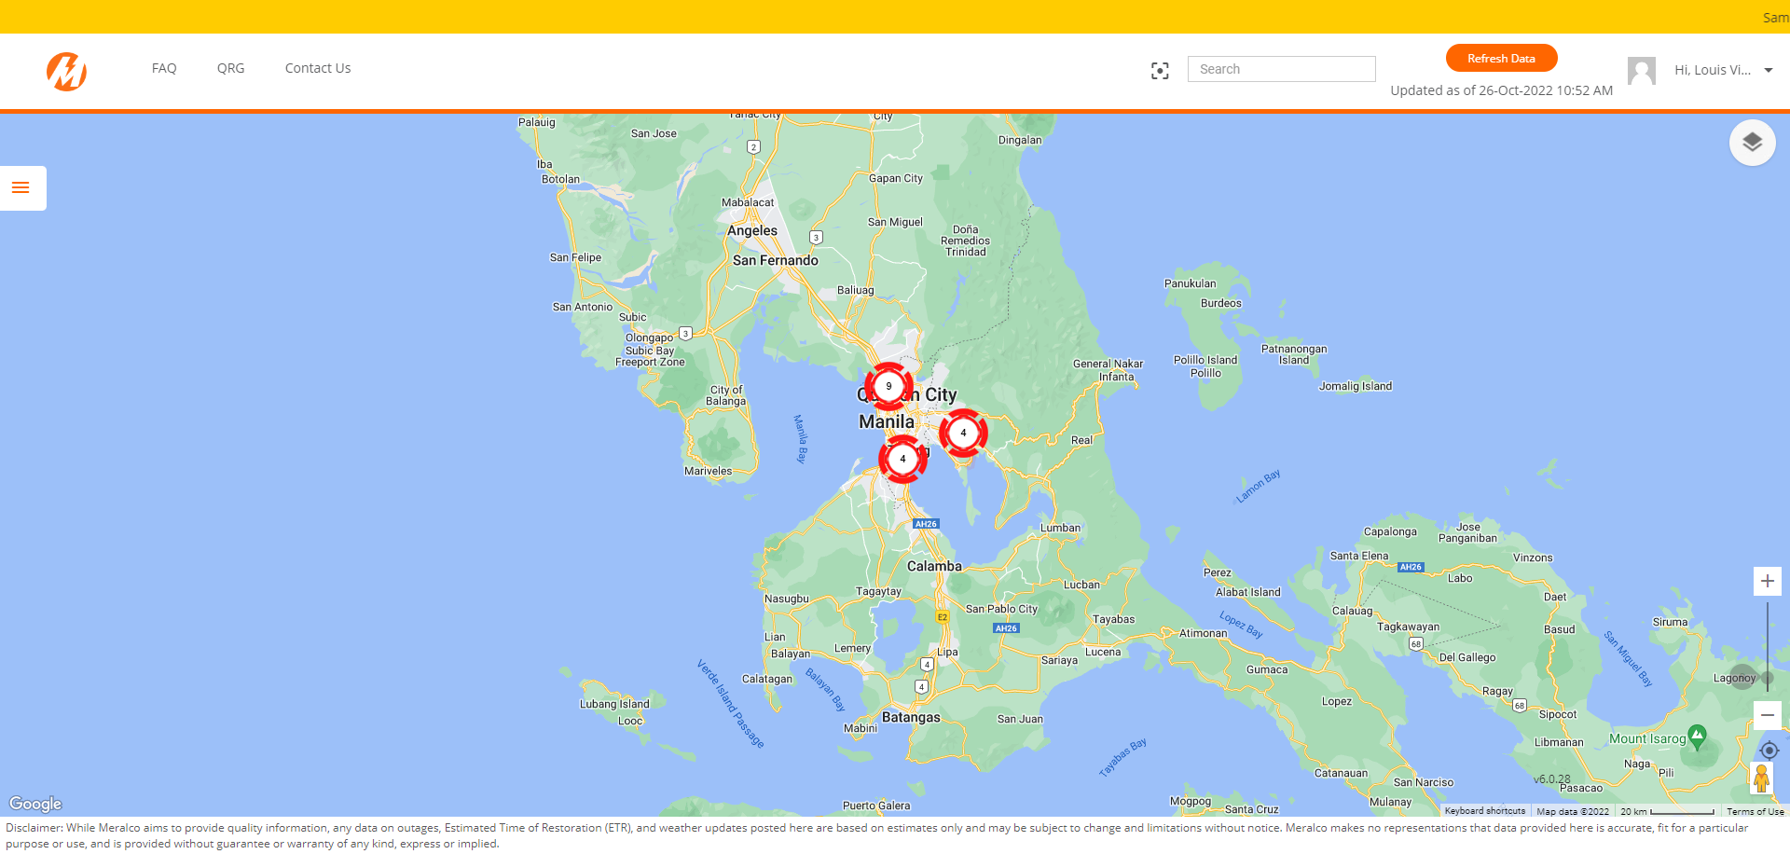

|  |
| --- |
| Step 2 - Open Menu -> Map Displays -> tick weather |
| Weather information should be displayed |

|  |
| --- |
| Step 3 - tick weather icon to be displayed according to the scenario |
| Weather icon should be ticked |

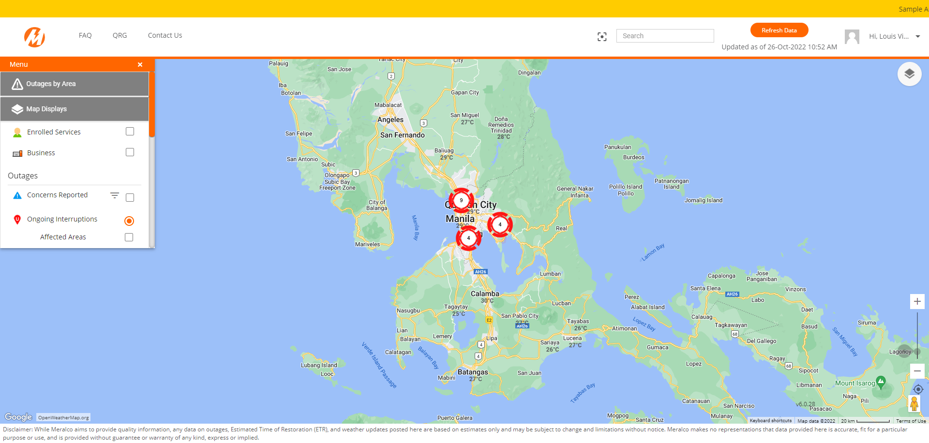

|  |
| --- |
| Step 4 - Adjust zoom level according to scenario |
| zoom level should be adjusted |

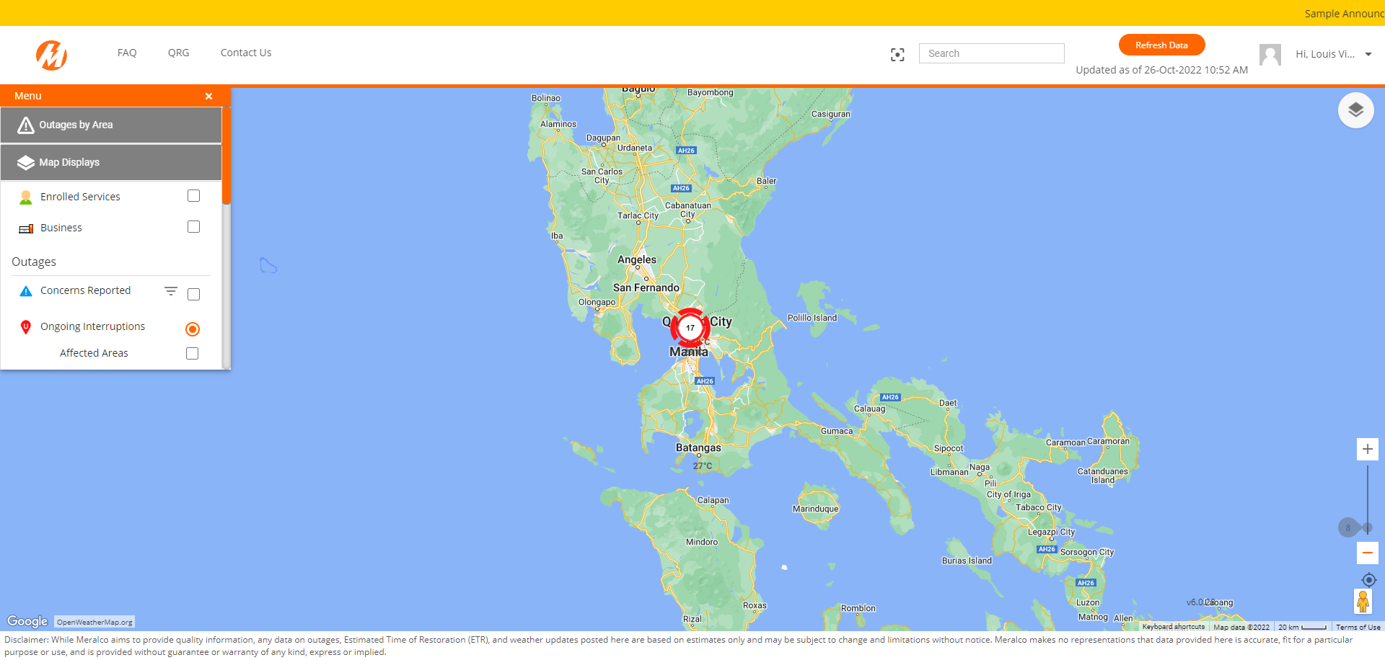

|  |
| --- |
| Step 5 - Validate weather icons in Internal Map |
| Weather icons should be displayed  Note: Due to technical limitations, weather values/icons may be distant from the City/Municipality name or overlaps with one another in higher zoom levels. This is due to Google Maps constantly updating |

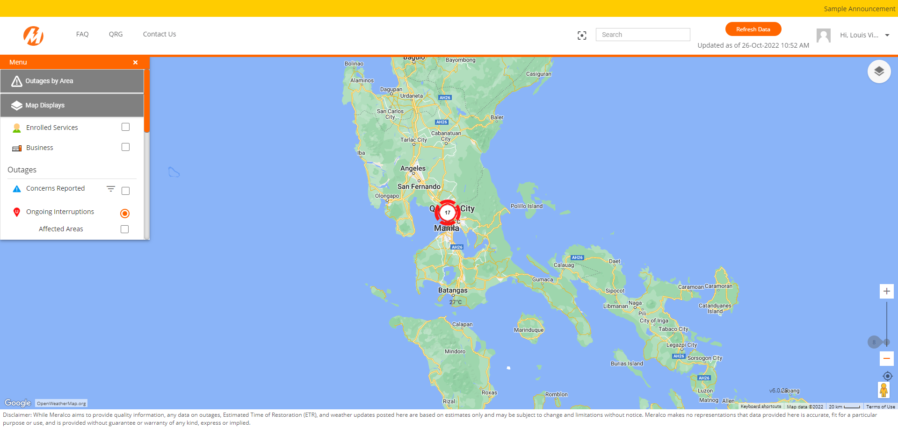

Passed