|  |
| --- |
| TS027 - Weather icon; Temperature; Zoom level 8 - External Map as Authenticated User |

|  |
| --- |
| TC061_Validation of weather icons using Zoom Level - External Map |

|  |
| --- |
| Step 1 - Go to External Map |
| User should be redirected to External Map |

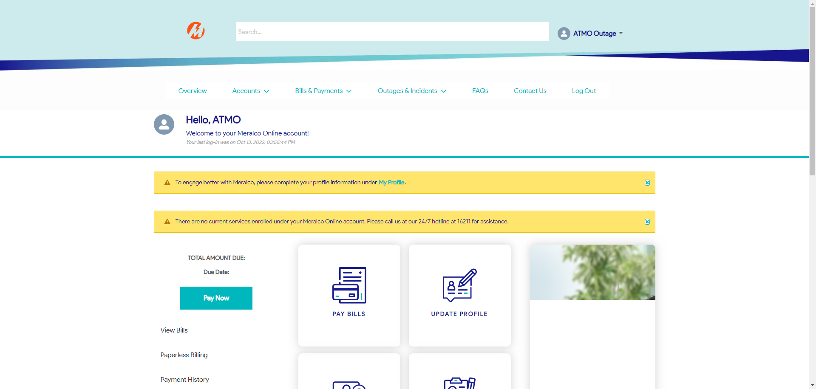

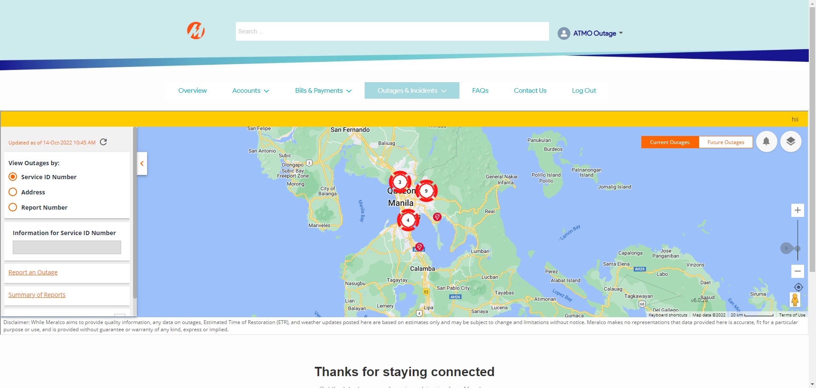

|  |
| --- |
| Step 2 - Select weather information to be displayed |
| Weather information should be displayed |

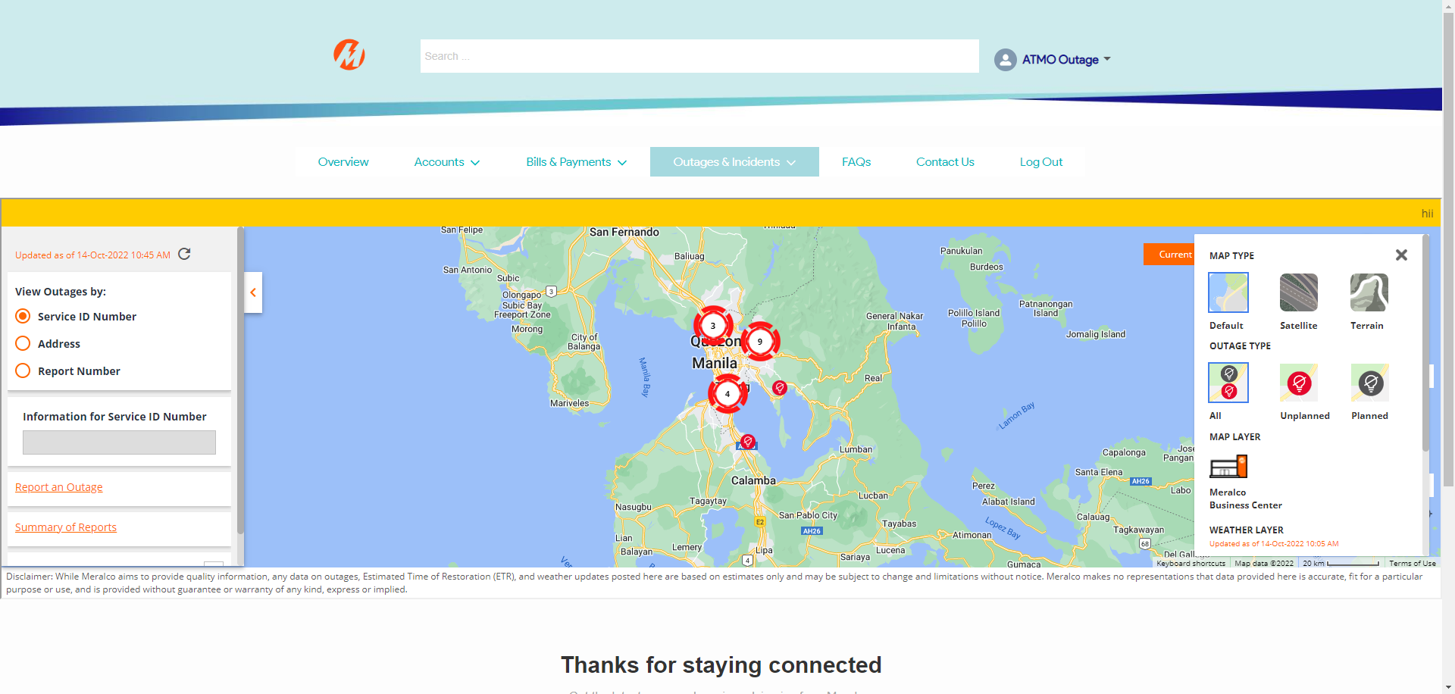

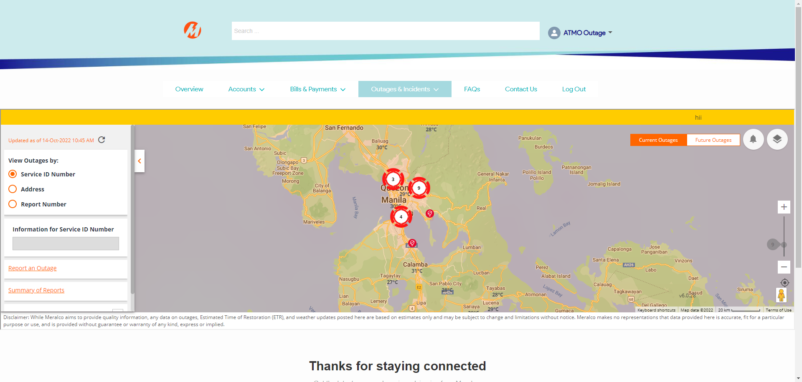

|  |
| --- |
| Step 3 - Adjust outage map zoom level to greater than 8 |
| zoom level should be adjusted |

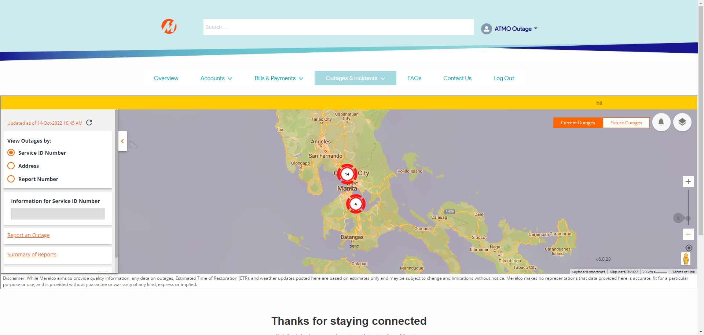

|  |
| --- |
| Step 4 - Validate weather icons in Internal Map |
| Weather icons should be displayed  Note: Due to technical limitations, weather values/icons may be distant from the City/Municipality name or overlaps with one another in higher zoom levels. This is due to Google Maps constantly updating |

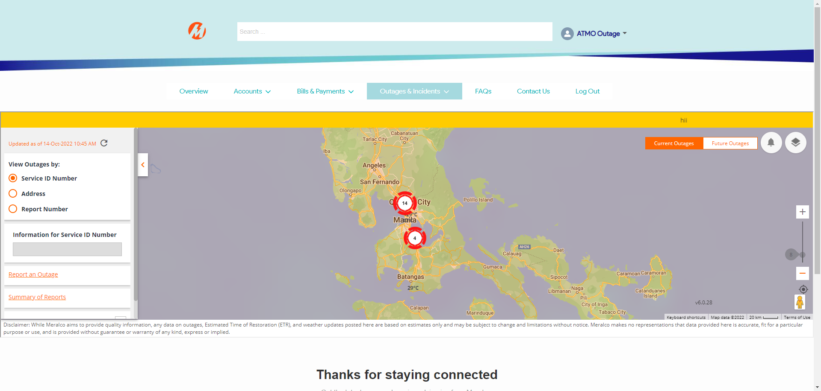

Passed