|  |
| --- |
| TS028 - Weather icon; Rainfall; Zoom level 15 - External Map as Authenticated User |

|  |
| --- |
| TC061_Validation of weather icons using Zoom Level - External Map |

|  |
| --- |
| Step 1 - Go to External Map |
| User should be redirected to External Map |

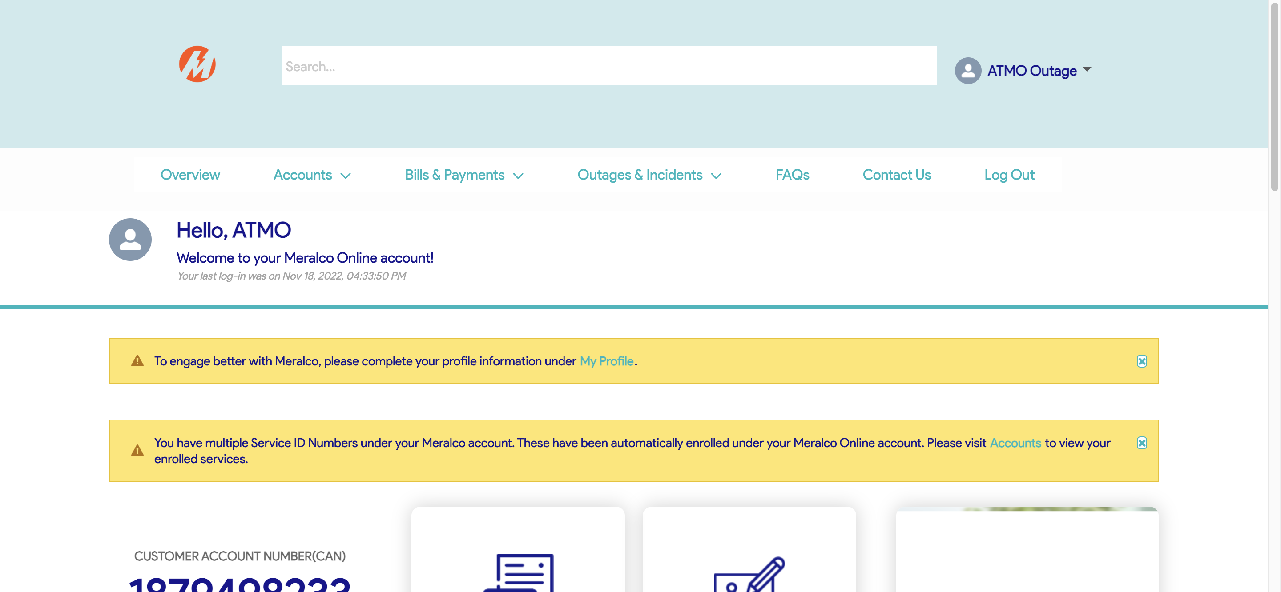

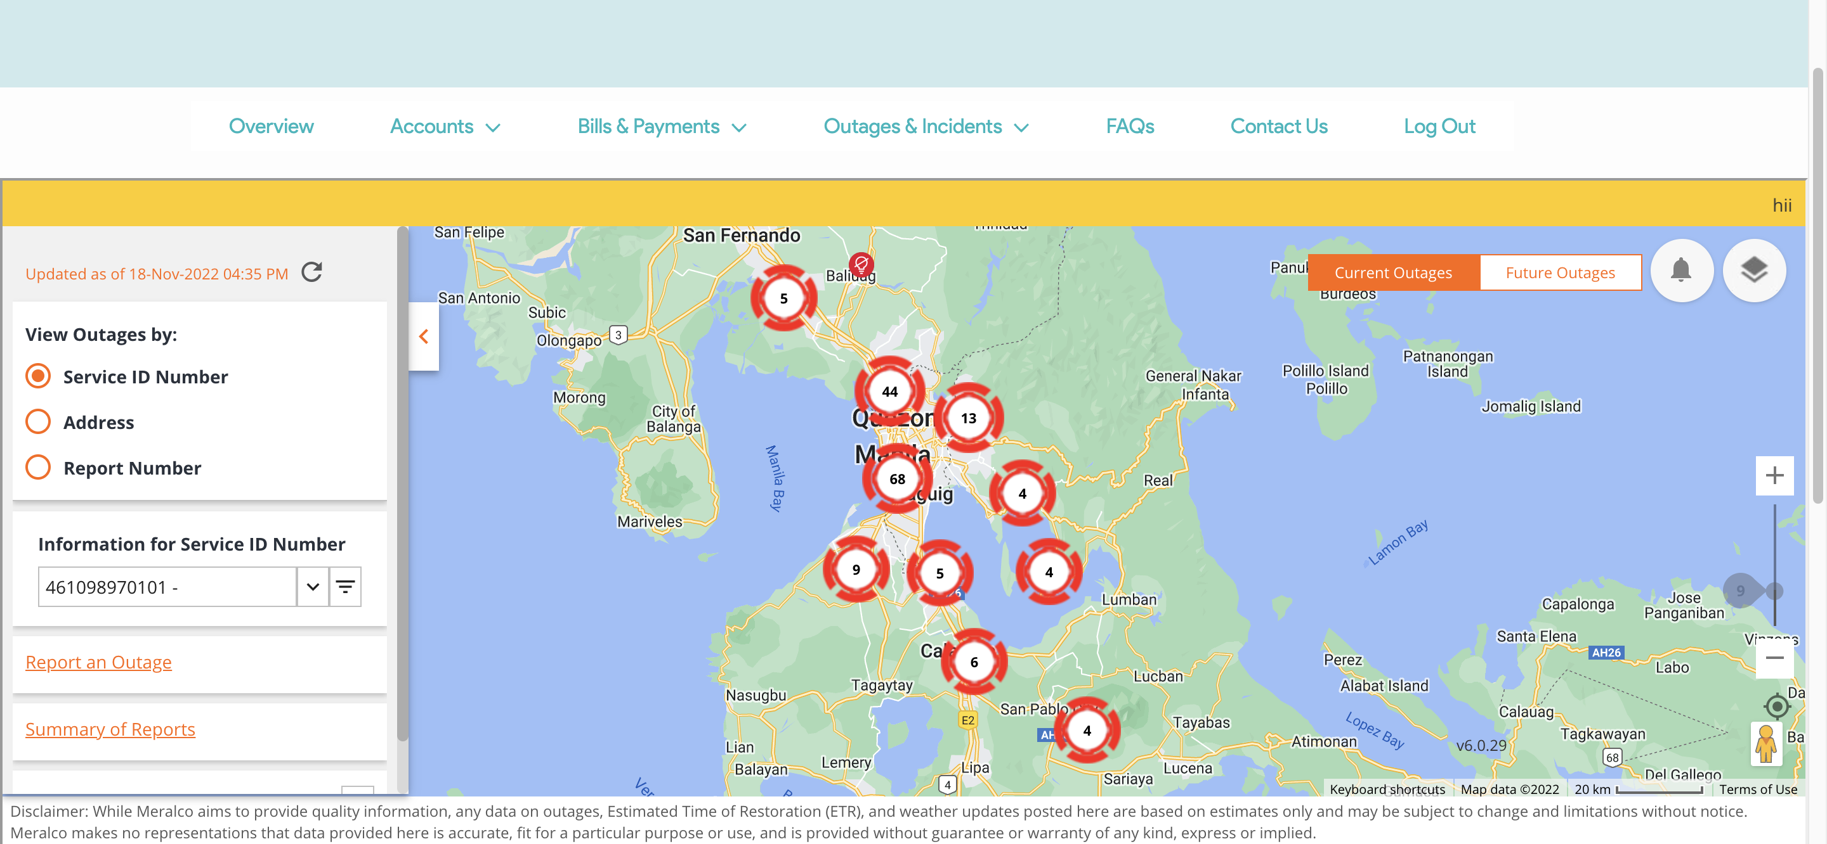

|  |
| --- |
| Step 2 - Select weather information to be displayed |
| Weather information should be displayed |

