|  |
| --- |
| TS033 - Weather icon; Wind Speed; Zoom level 11 - External Map as Guest User |

|  |
| --- |
| TC061_Validation of weather icons using Zoom Level - External Map |

|  |
| --- |
| Step 1 - Go to External Map |
| User should be redirected to External Map |

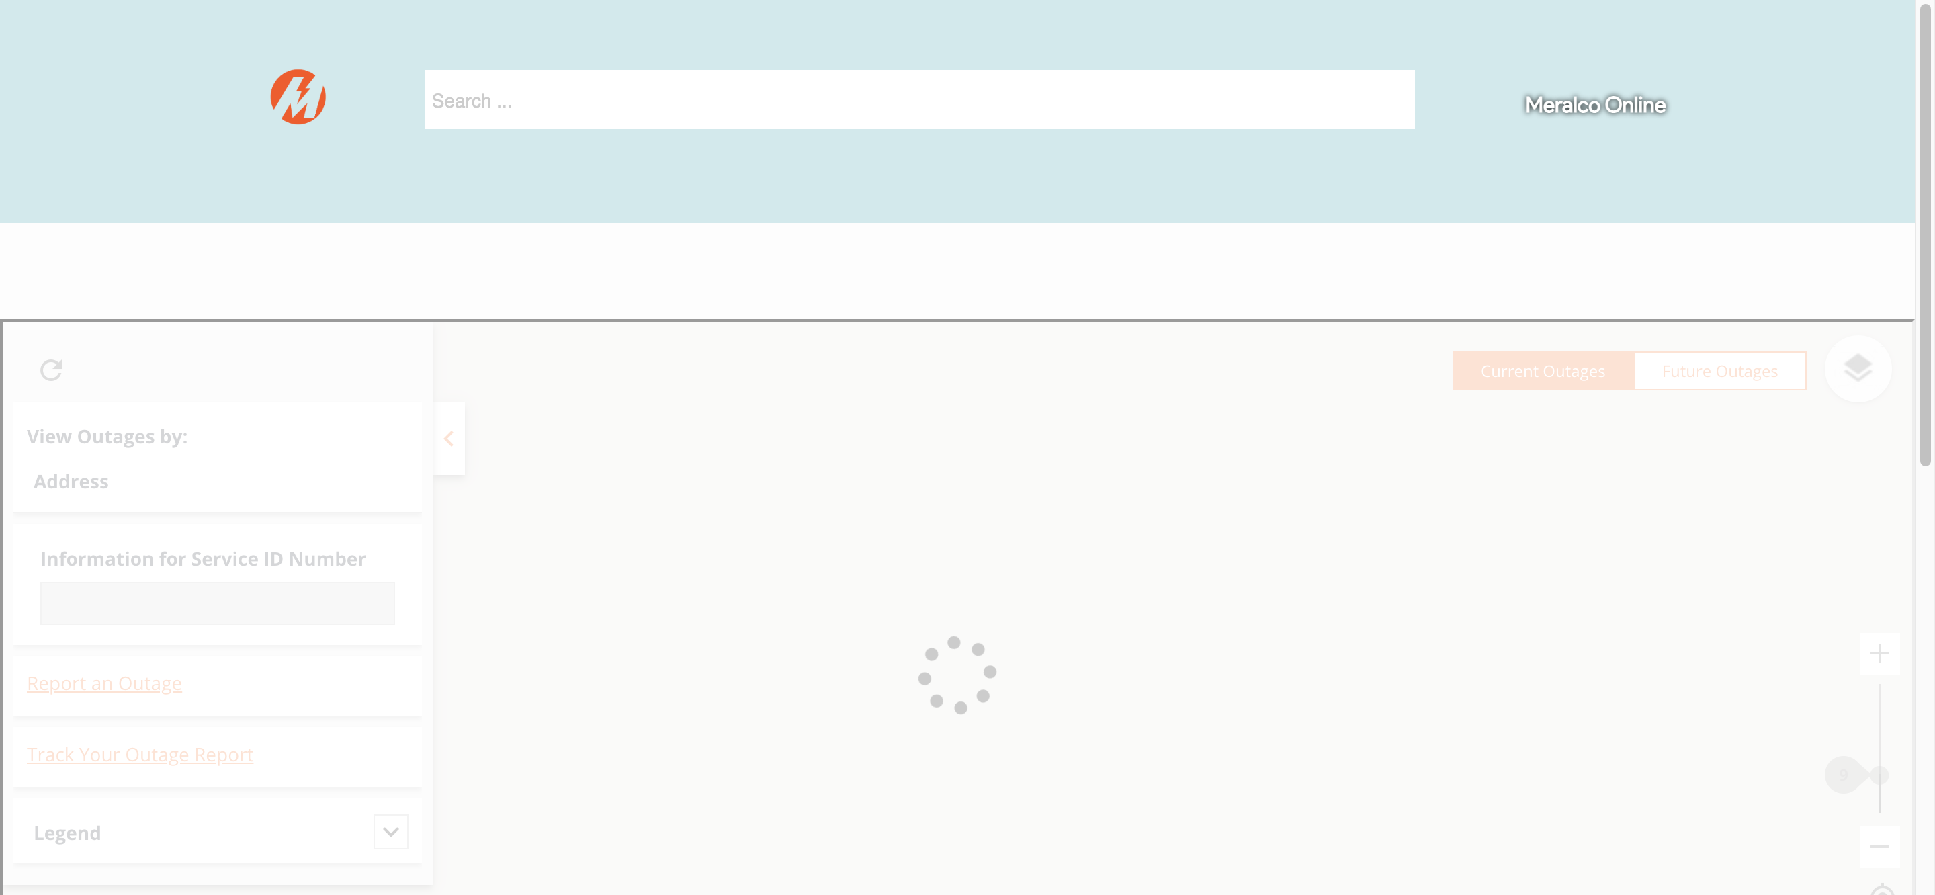

|  |
| --- |
| Step 2 - Select weather information to be displayed |
| Weather information should be displayed |

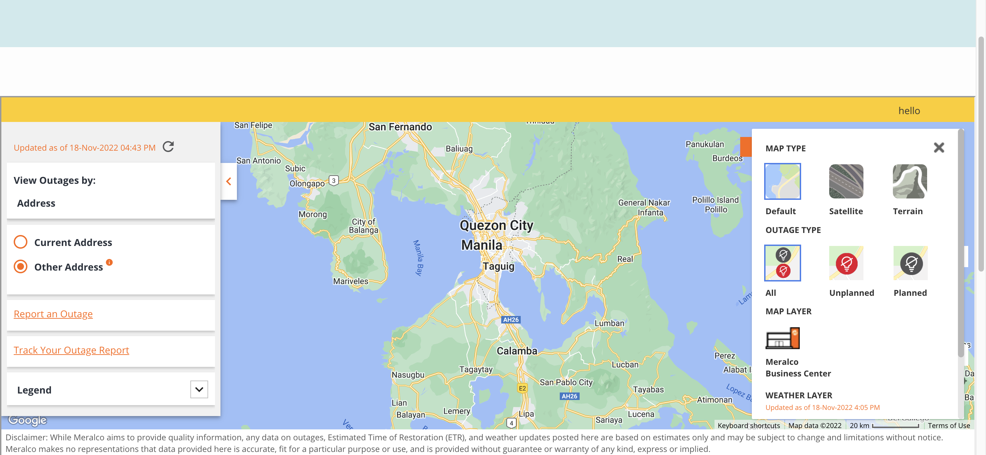

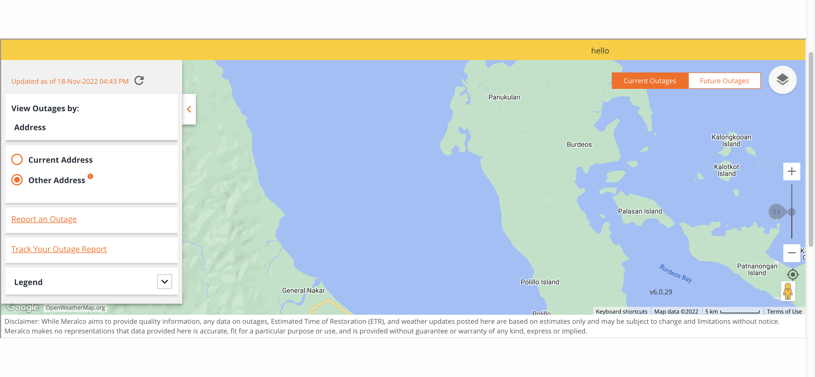

|  |
| --- |
| Step 3 - Adjust outage map zoom level to greater than 8 |
| zoom level should be adjusted |