|  |
| --- |
| TS034 - Weather icon; Clouds; Zoom level 16 - External Map as Guest User |

|  |
| --- |
| TC124_External: Viewing as Guest User - GPS Enabled |

|  |
| --- |
| Step 1 - Go to https://fuat-meralco.cs73.force.com/customers/s/outagemap |
| User should be irected to outage map. Message prompt should be displayed: Meralco would like to access your location to identify if your area is affected by an outage. Buttons: Disagree Agree |

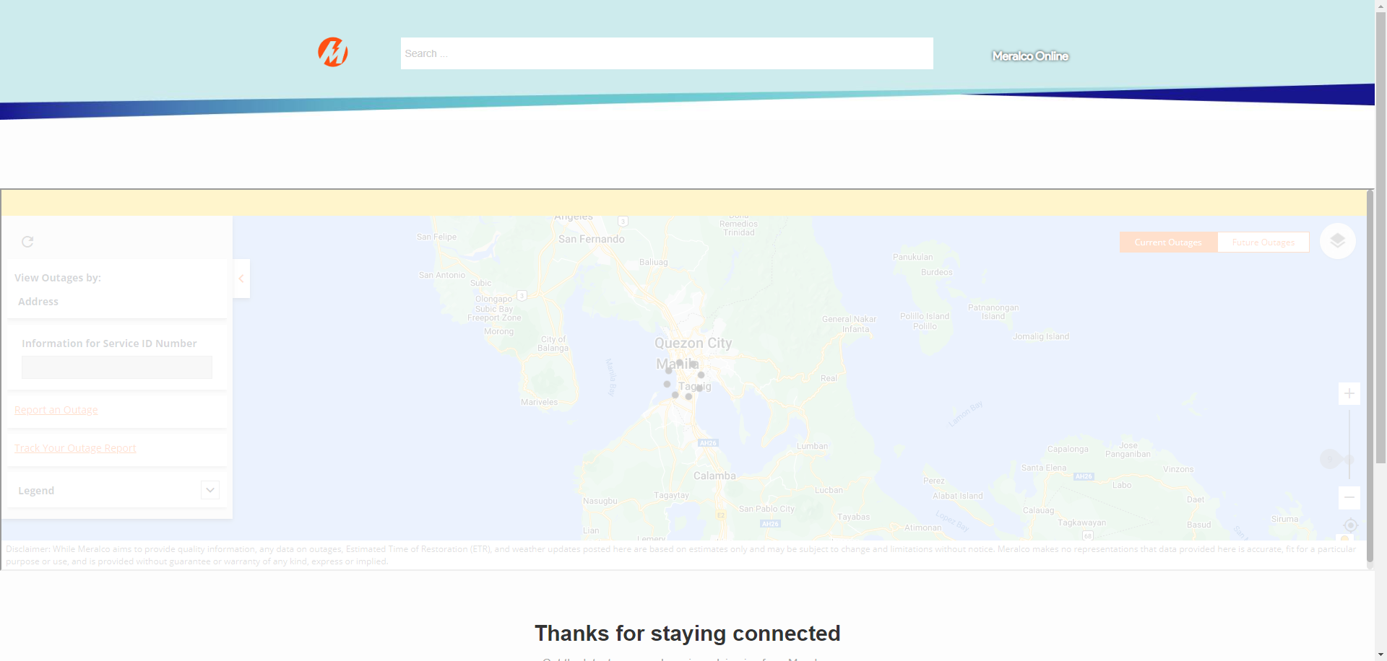

|  |
| --- |
| Step 2 - Click Agree |
| User should be redirected to Outage map with GPS enabled |

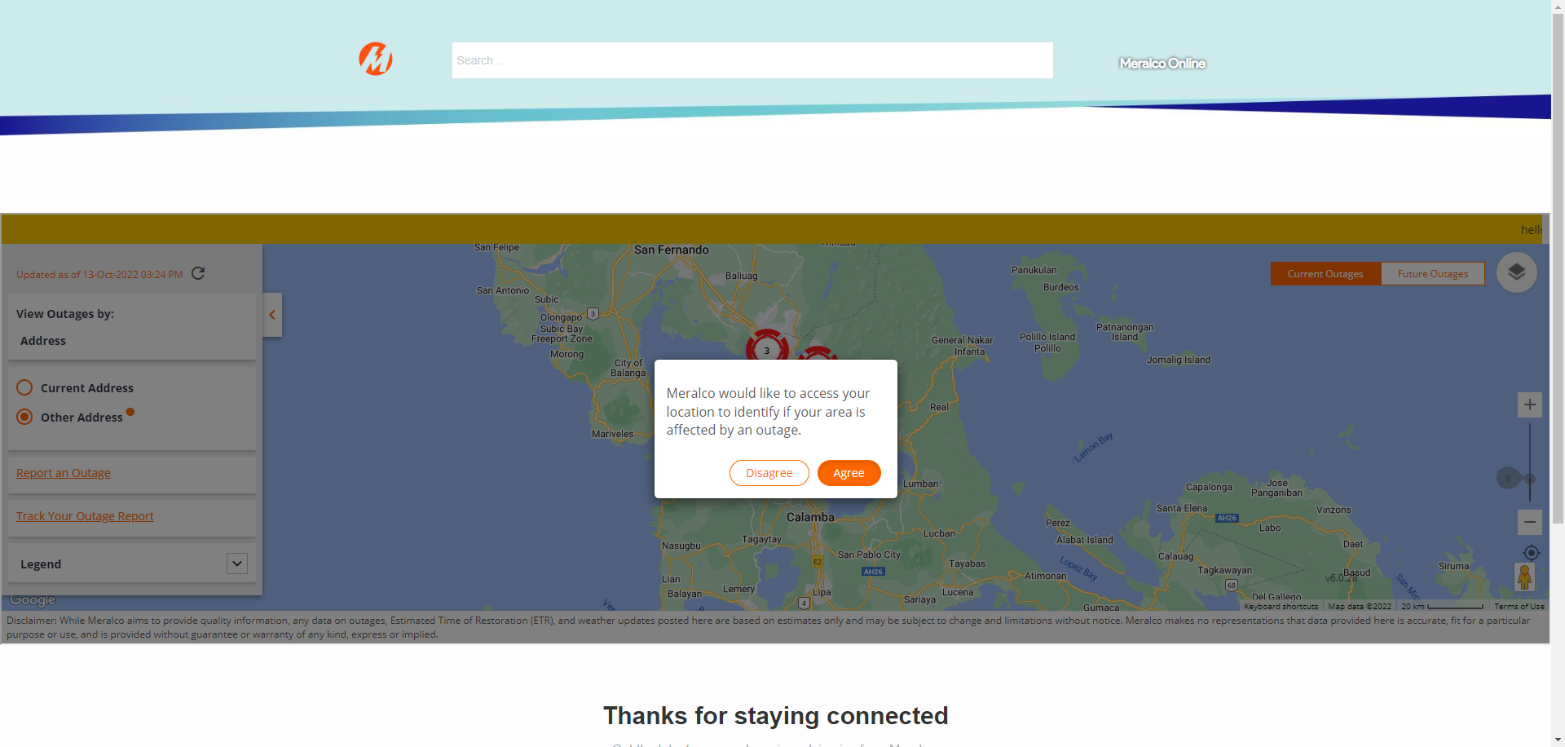

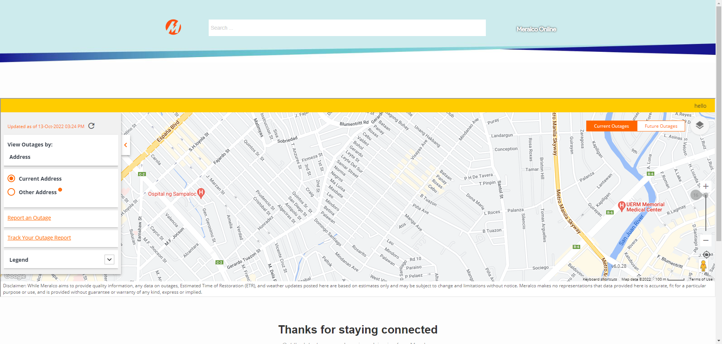

|  |
| --- |
| TC125_External: Viewing as Guest User - GPS Disabled |

|  |
| --- |
| Step 1 - Go to https://fuat-meralco.cs73.force.com/customers/s/outagemap |
| User should be irected to outage map. Message prompt should be displayed: Meralco would like to access your location to identify if your area is affected by an outage. Buttons: Disagree Agree |

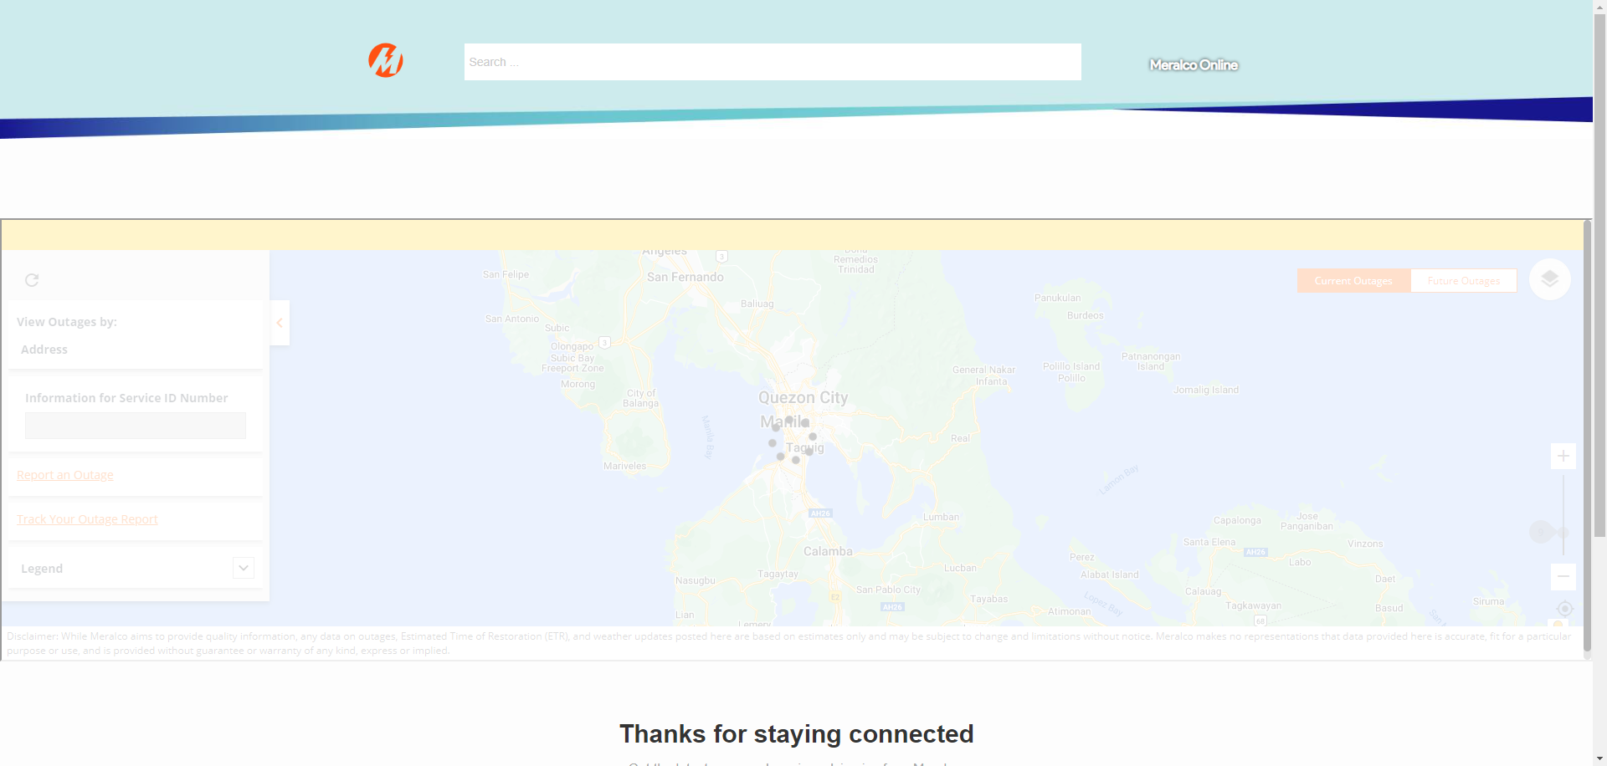

|  |
| --- |
| Step 2 - Click Disagree |
| User should be redirected to Outage map with GPS disabled |

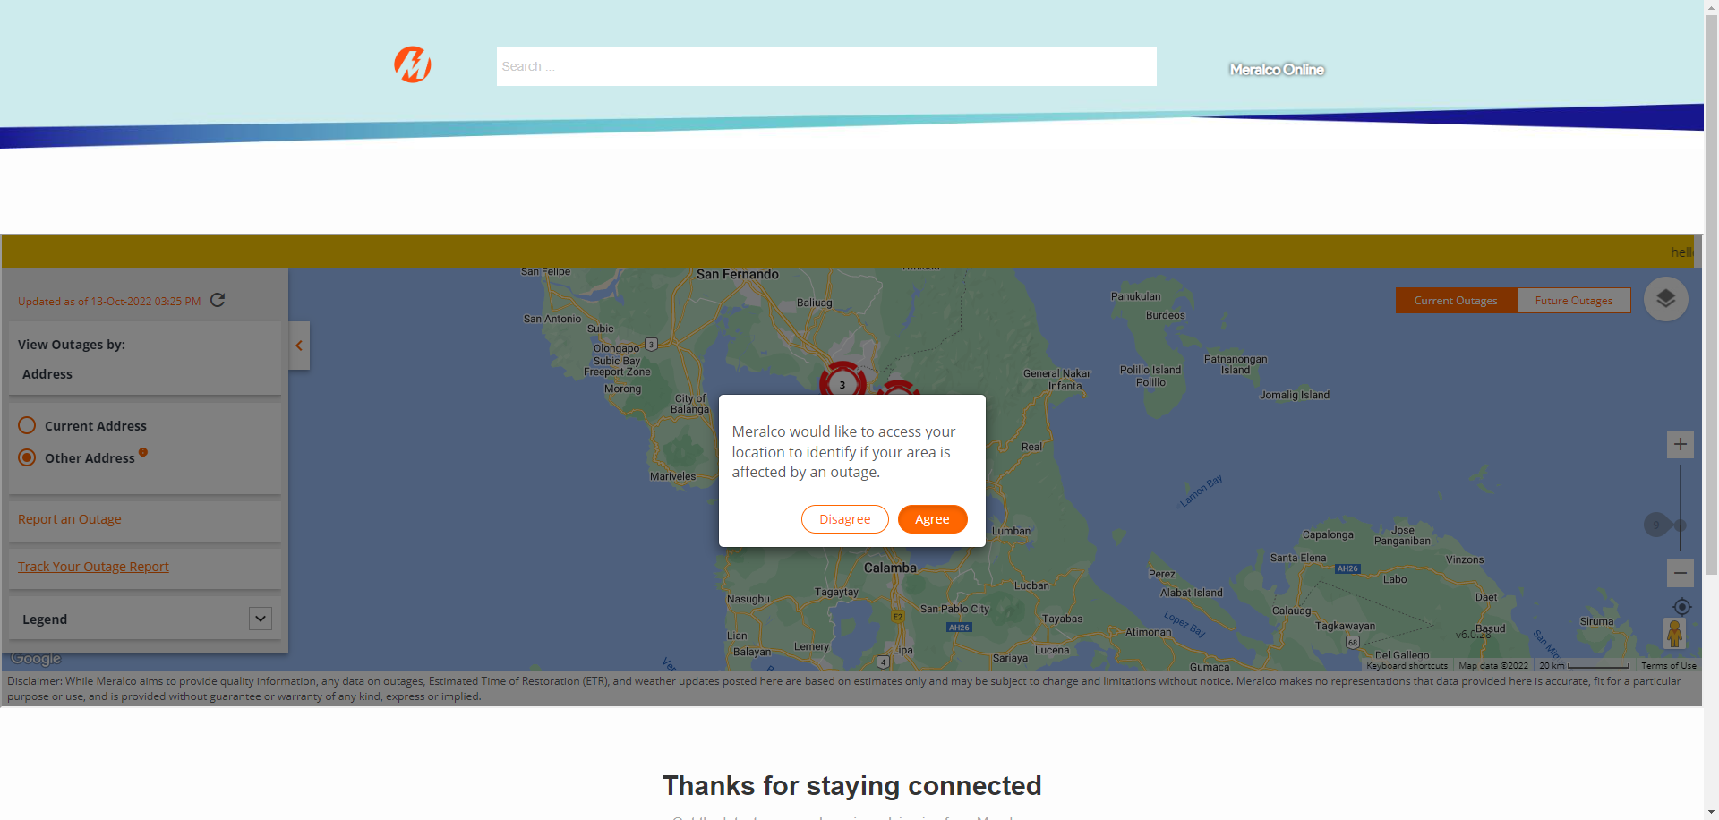

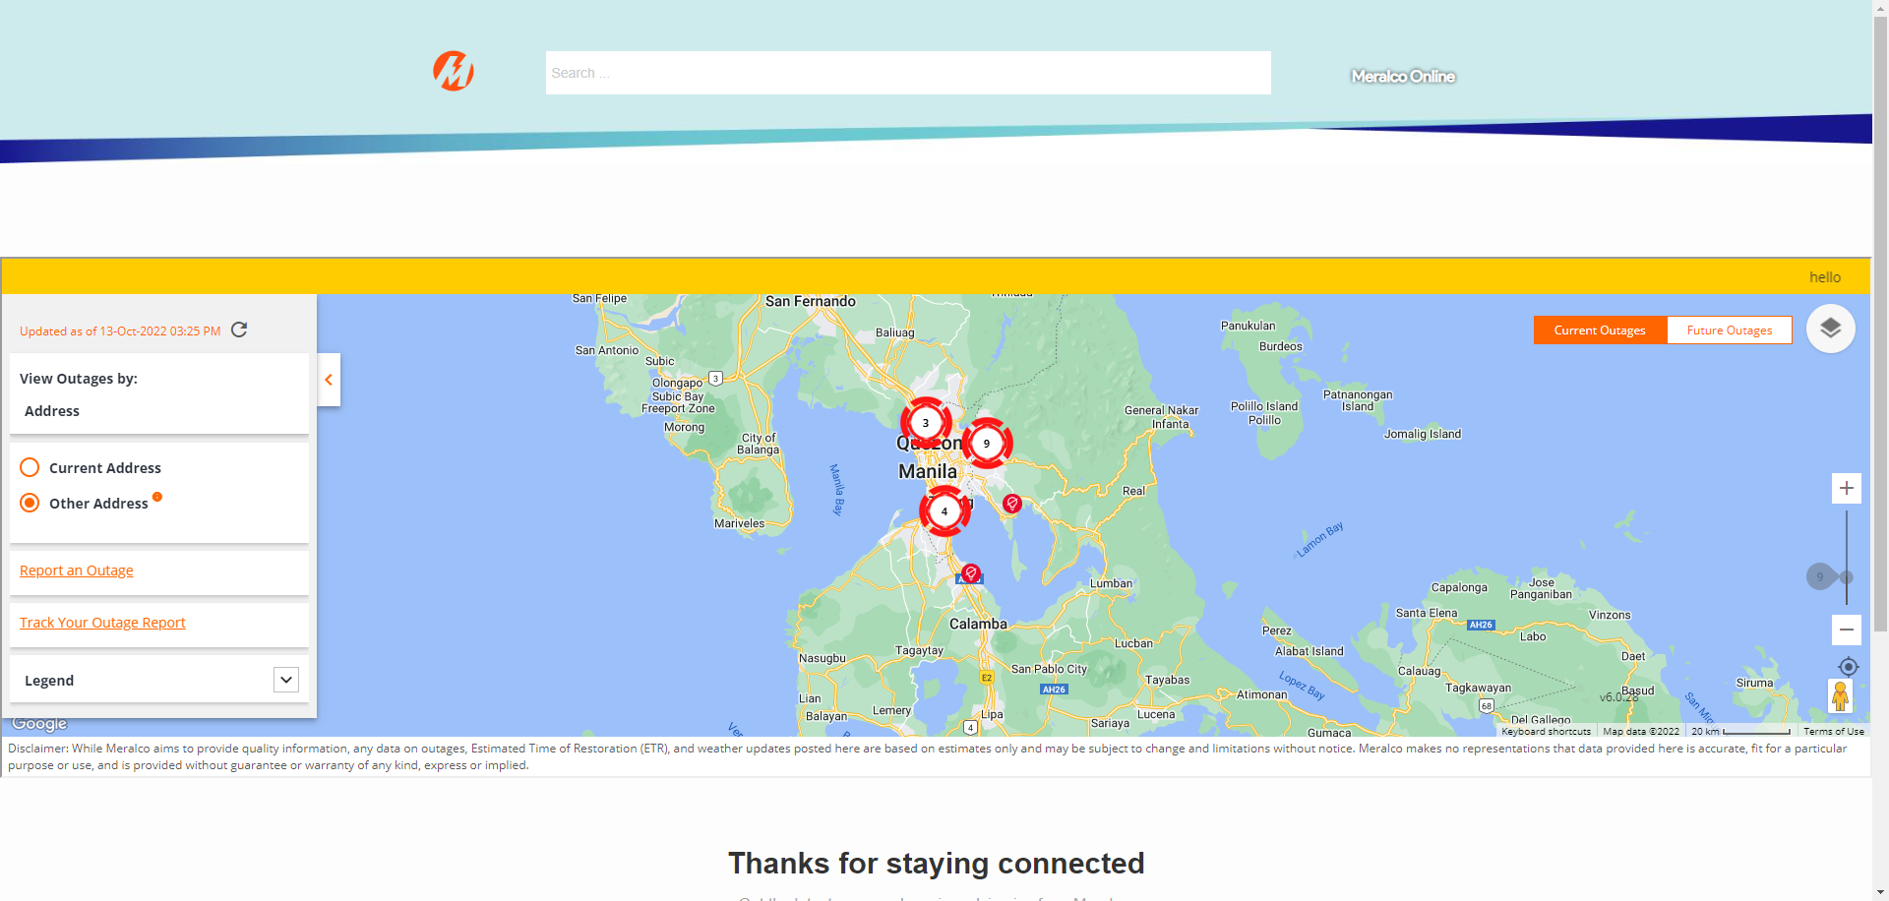

Passed