|  |
| --- |
| TS035 - Internal Map Multiple Profile validation |

|  |
| --- |
| TC062_Multiple Profile: Login |

|  |
| --- |
| Step 1 - Log in to Internal Map using this link: https://outage-api.meralco.com.ph/ |
| User should be logged in to Internal Outage Map |

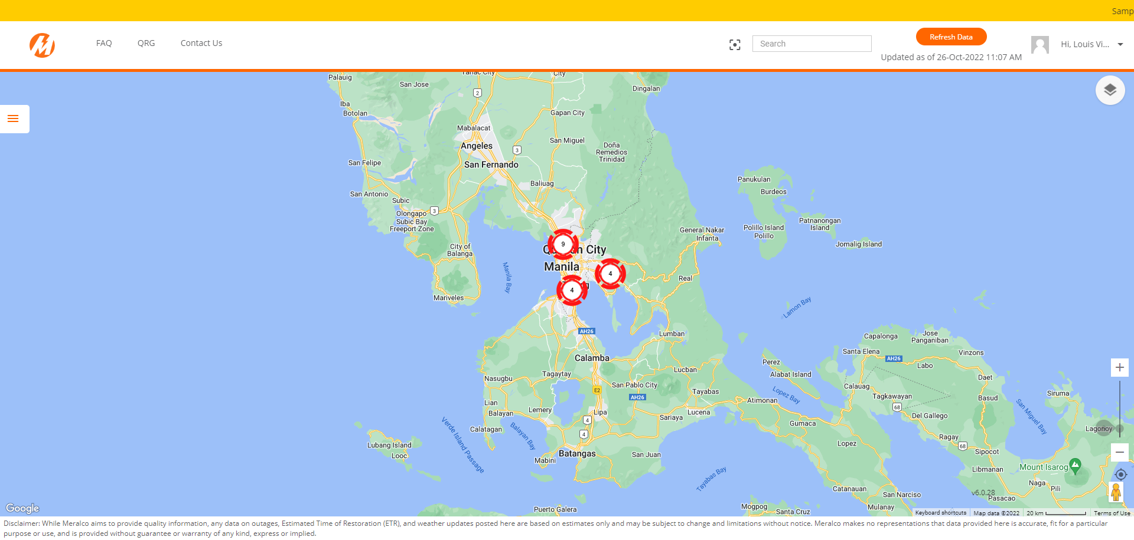

Passed