|  |
| --- |
| TS036 - Internal Map Header Section |

|  |
| --- |
| TC073_Admin Button |

|  |
| --- |
| Step 1 - In Outage Map for Internal users, click on Admin option in the menu |
| User should be redirected to the Admin portal |

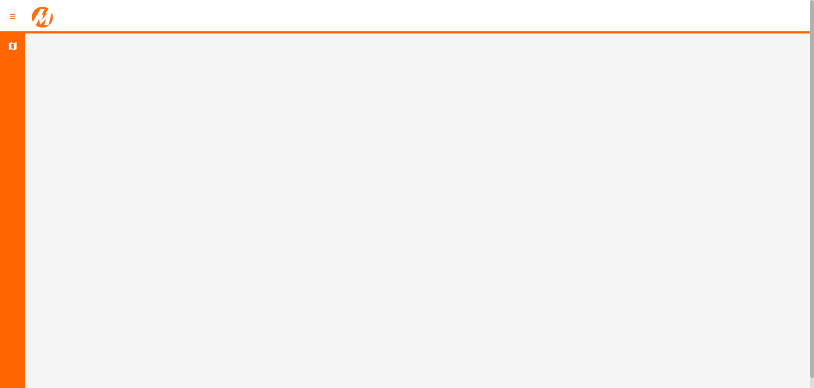

Passed