|  |
| --- |
| TS038 - Internal Map - Map Type |

|  |
| --- |
| TC077_Map Type button: Satellite |

|  |
| --- |
| Step 1 - Click Map Views icon in Internal Map -> Select Satellite |
| May Display should be updated to Satellite view |

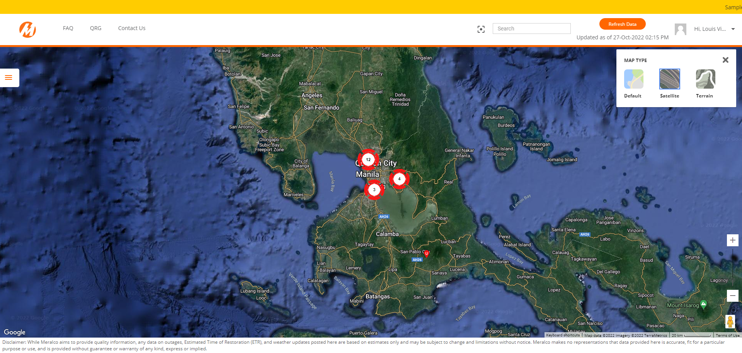

Passed