|  |
| --- |
| TS040 - Internal Map - Outages by Area Menu |

|  |
| --- |
| TC085_Outages by Area: Sector function |

|  |
| --- |
| Step 1 - Click on burger menu > Outages by Area |
| The following should be displayed under Outages by Area: - Sector - Area Level |

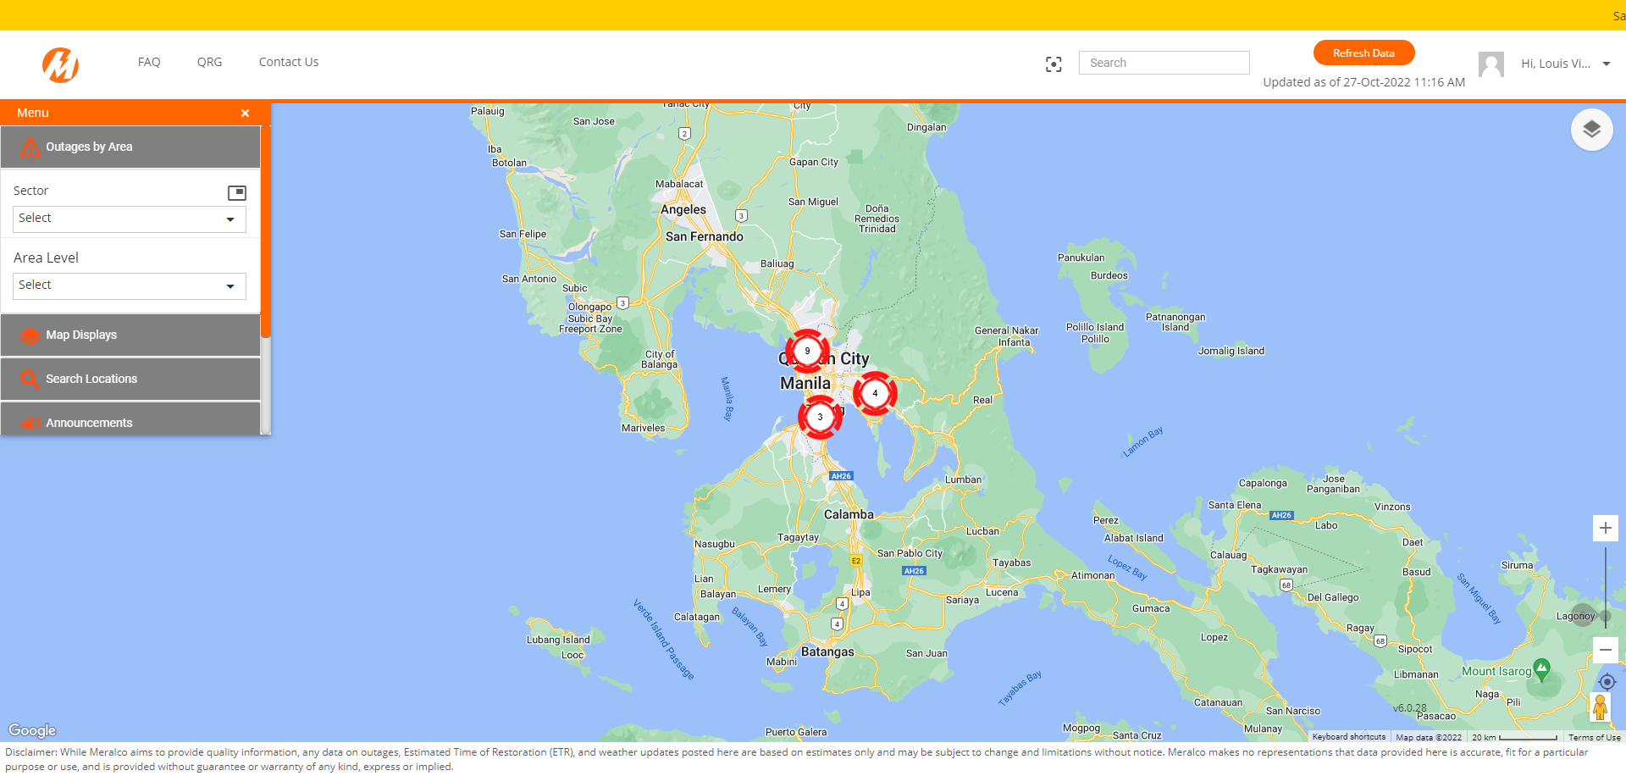

|  |
| --- |
| Step 2 - Select Sector |
| Selected sector should be displayed in map |

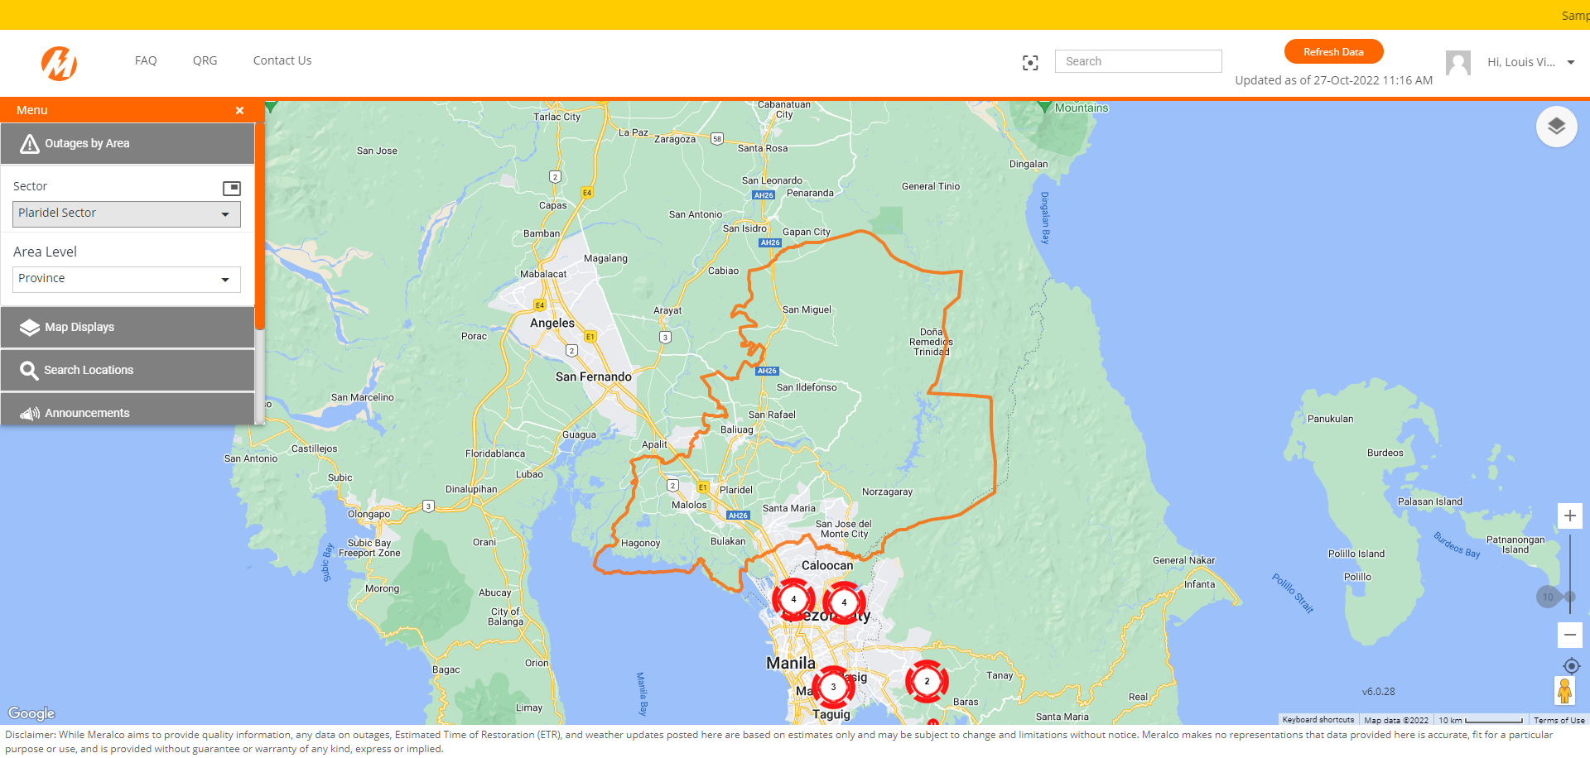

|  |
| --- |
| TC086_Outages by Area: Area Level function |

|  |
| --- |
| Step 1 - Click on burger menu > Outages by Area |
| The following should be displayed under Outages by Area: - Sector - Area Level |

|  |
| --- |
| Step 2 - Select Area Level |
| Selected area level should be displayed in map |

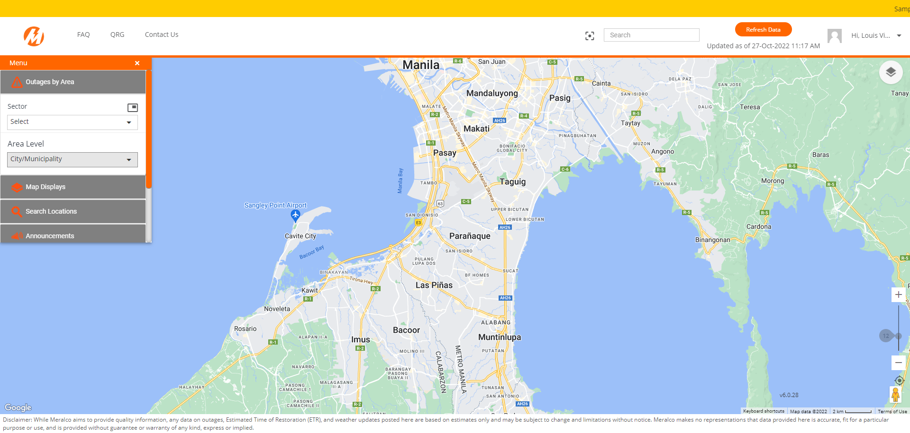

|  |
| --- |
| TC087_Outages by Area: Political Boundaries function. |

|  |
| --- |
| Step 1 - Click on burger menu > Outages by Area |
| The following should be displayed under Outages by Area: - Sector - Area Level |

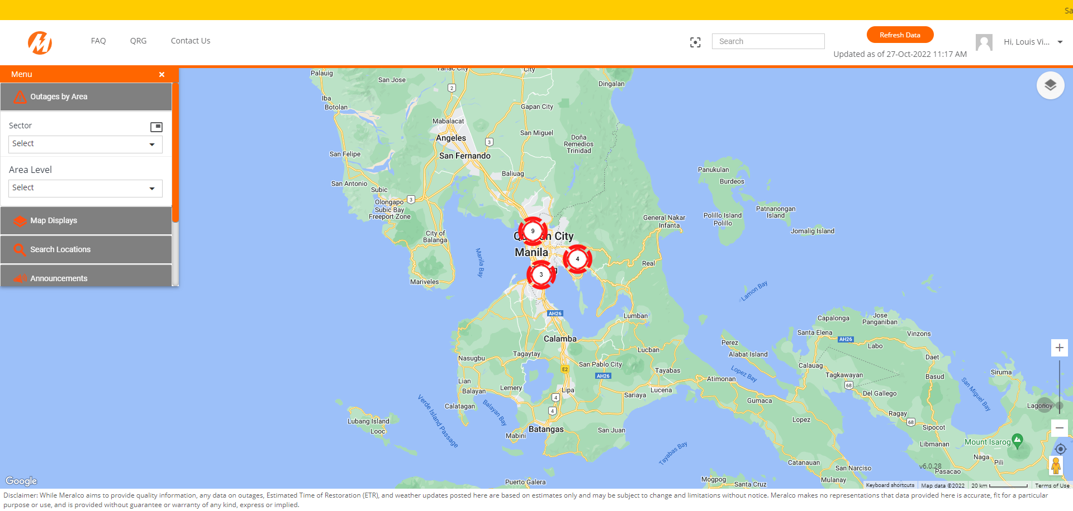

|  |
| --- |
| Step 2 - Select Sector |
| Selected sector should be displayed in map |

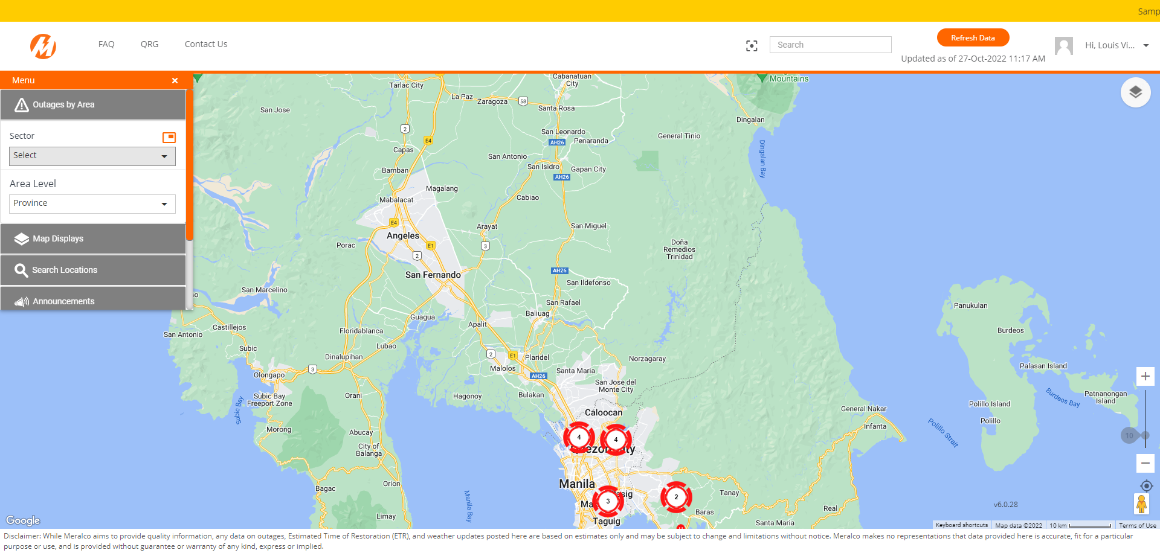

|  |
| --- |
| Step 3 - Click on Toggle Political Boundaries icon |
| Sector value on dropdown field should return to default value (Select) |

Passed