|  |
| --- |
| TS044 - Internal Map - Map Displays Menu; Establishments |

|  |
| --- |
| TC112_Map Displays: Establishments: Sector Offices |

|  |
| --- |
| Step 1 - Go to Map Displays -> Establishment -> Tick Sector Offices |
| Sector Offices Pins and Clusters should be displayed in map |

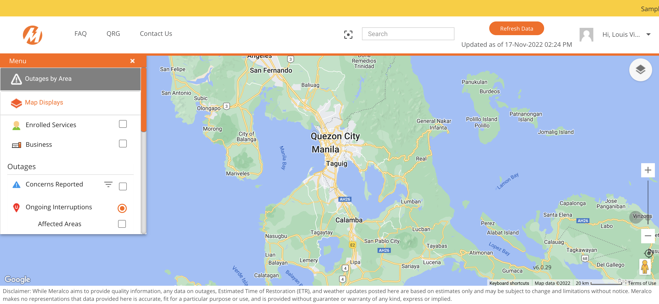

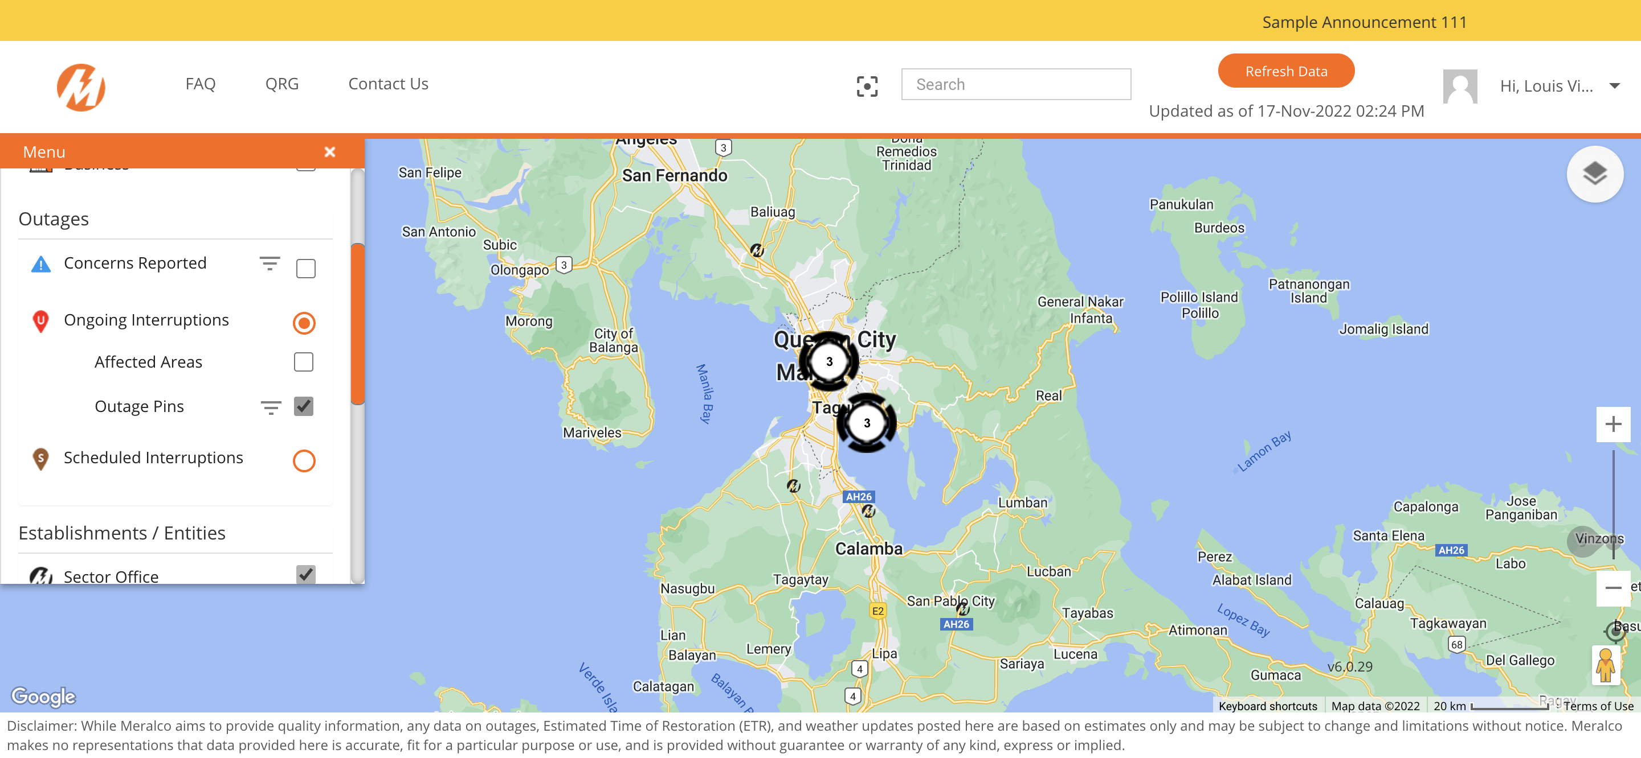

|  |
| --- |
| Step 2 - Click on any Sector Office pin |
| Sector office details should be displayed |