|  |
| --- |
| TS045 - Search Services |

|  |
| --- |
| TC117_Search Services: Service ID No. |

|  |
| --- |
| Step 1 - Click on burger menu > Search Locations |
| The following should be displayed under Search Locations: - Dropdown field (Default value: Service ID No.) - Search Field (default label: Enter Service ID No.) |

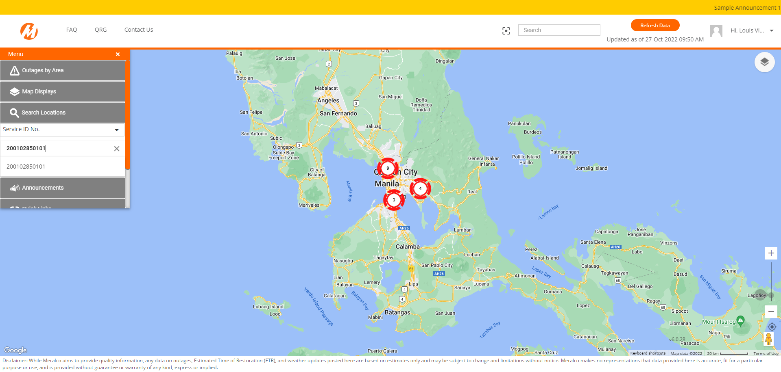

Passed