|  |
| --- |
| TS047 - Legend: Ongoing Outage Pins |

|  |
| --- |
| TC122_Legend: Ongoing Outage Pins |

|  |
| --- |
| Step 1 - Click on burger menu > Legends |
| Legends should be displayed |

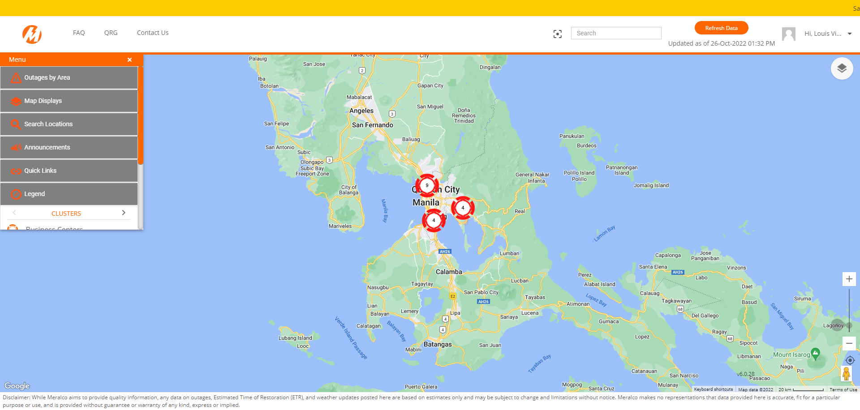

|  |
| --- |
| Step 2 - Validate Legend for Ongoing Outage Pins |
| Ongoing Outage Pins legend should be validated |

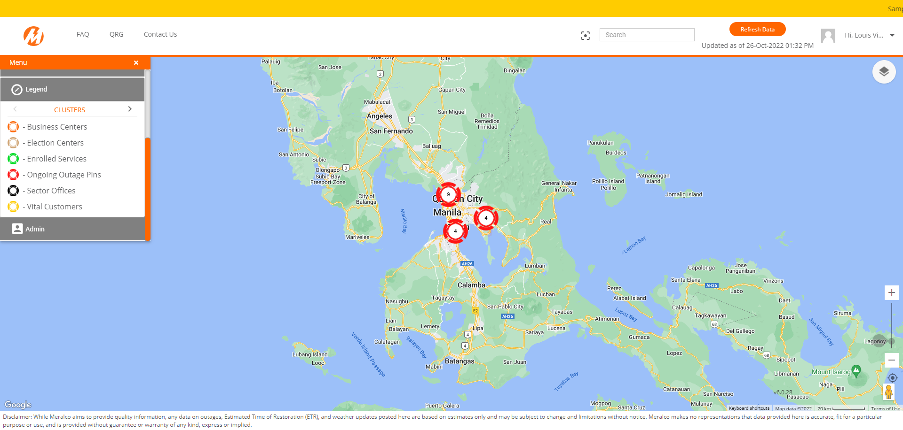

Passed