|  |
| --- |
| TS049 - Admin button. |

|  |
| --- |
| TC123_Legend: Scheduled Outage Pins |

|  |
| --- |
| Step 1 - Click on burger menu > Legends |
| Legends should be displayed |

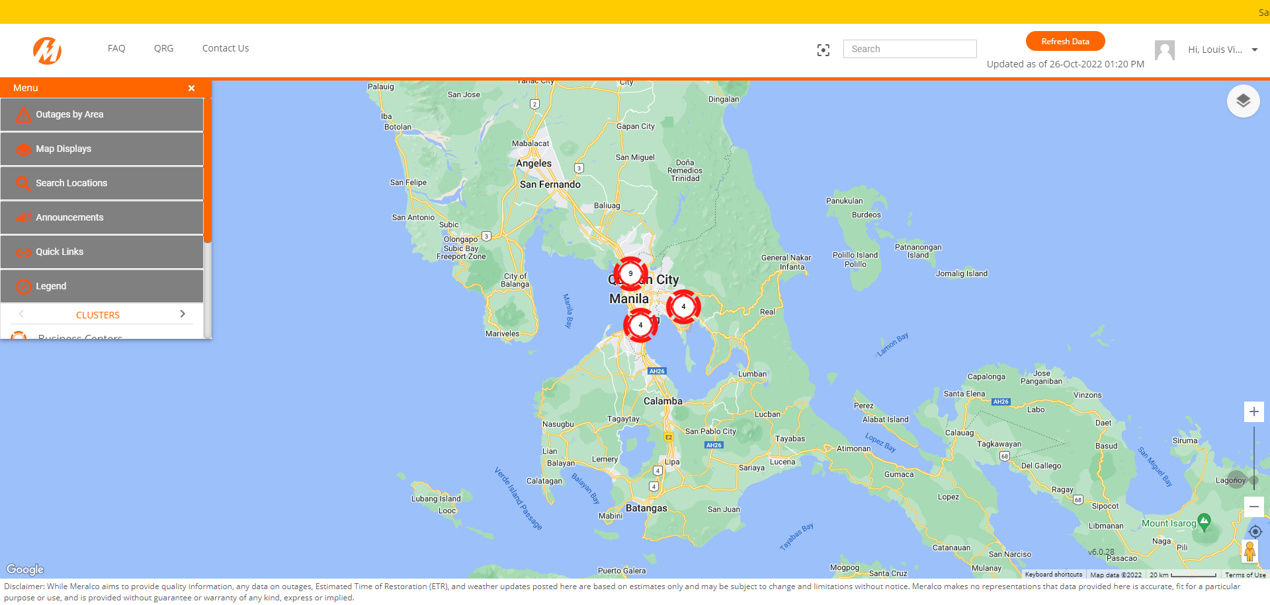

|  |
| --- |
| Step 2 - Validate Legend for Scheduled Outage Pins |
| Scheduled Outage Pins legend should be validated |

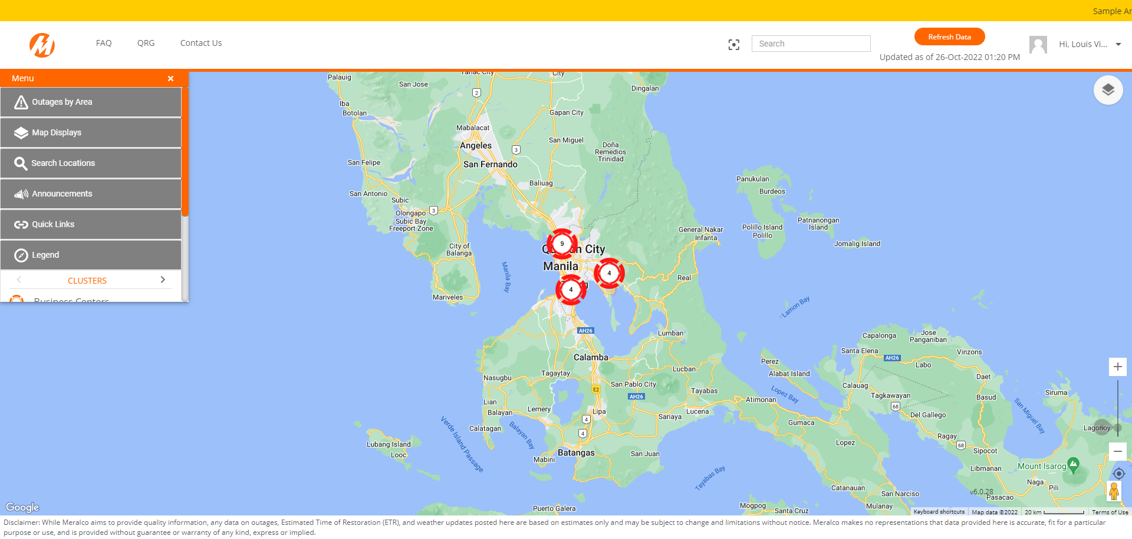

Passed