|  |
| --- |
| TS051 - Validation in External Map: Viewing as Authenticated User |

|  |
| --- |
| TC126_External: Viewing as Authenticated User - GPS Enabled |

|  |
| --- |
| Step 1 - Login to Meralco Online |
| User should be logged in |

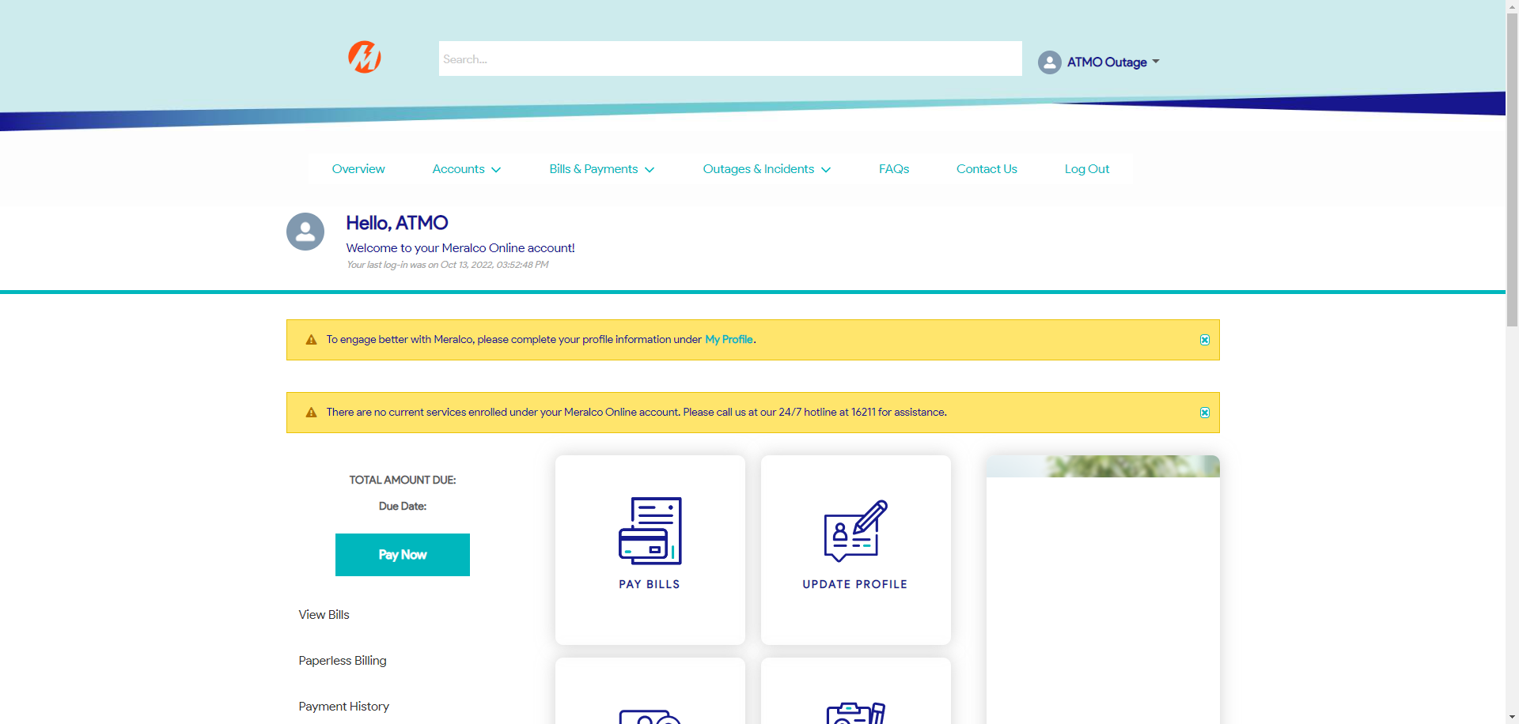

|  |
| --- |
| Step 2 - Go to Outages & Incidents > View/Report Outages > Tick Address on View Outages by > tick Current Address |
| User should be irected to outage map. Message prompt should be displayed: Meralco would like to access your location to identify if your area is affected by an outage. Buttons: Disagree Agree |

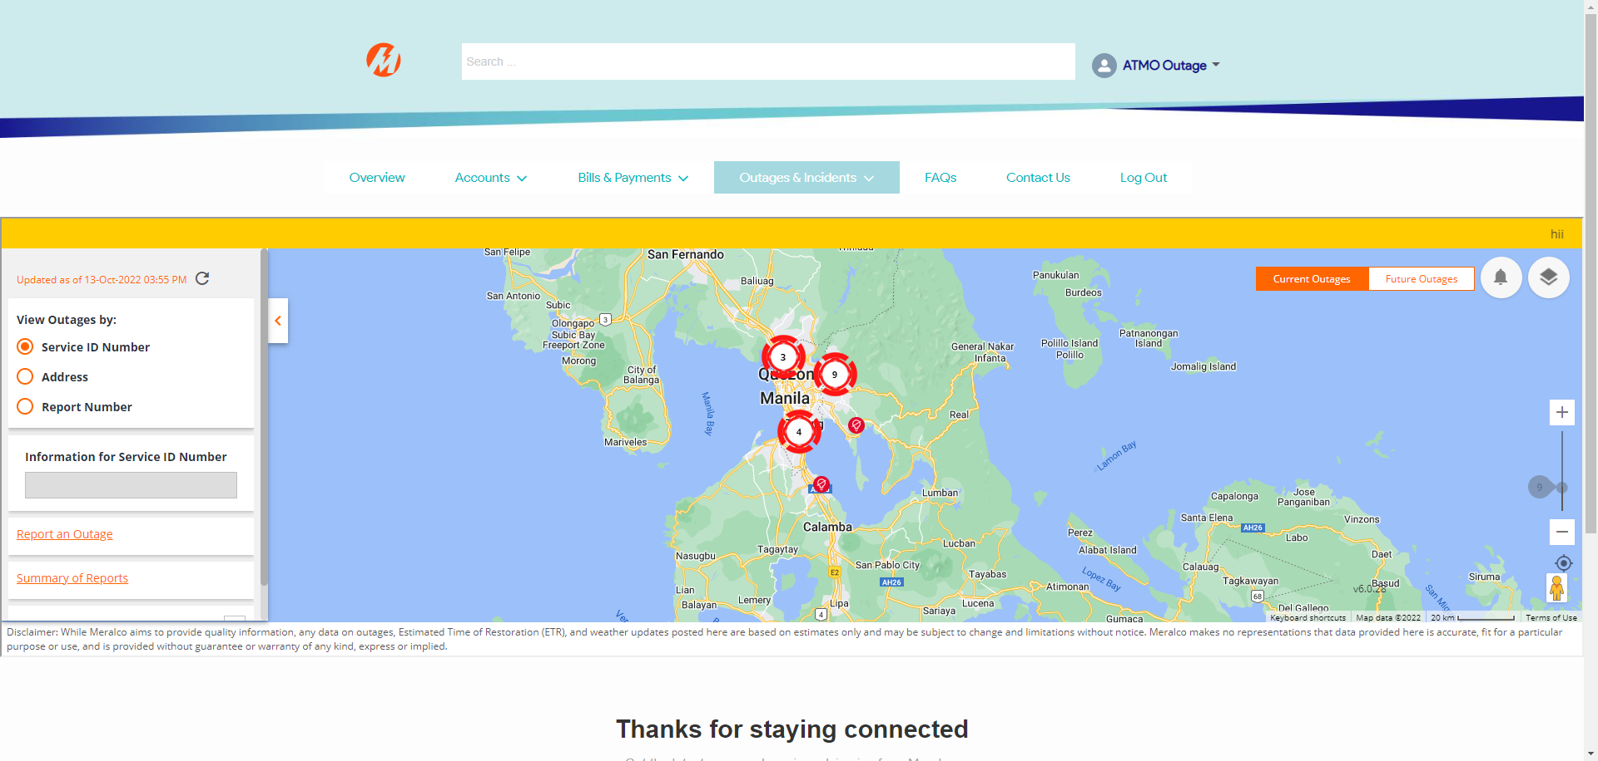

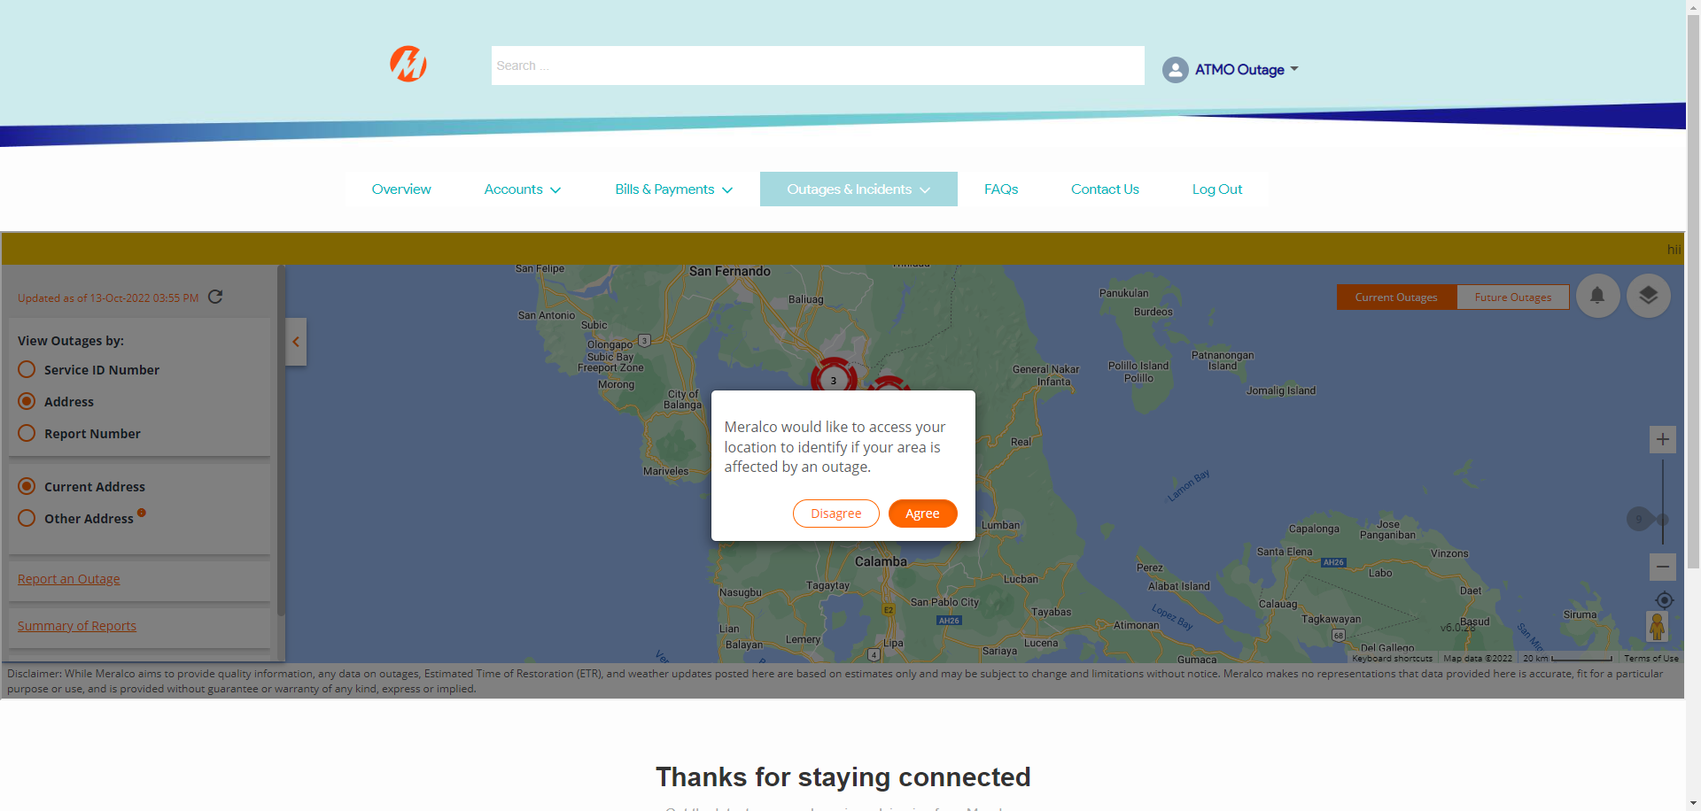

|  |
| --- |
| Step 3 - Click Agree |
| User should be redirected to Outage map with GPS enabled |

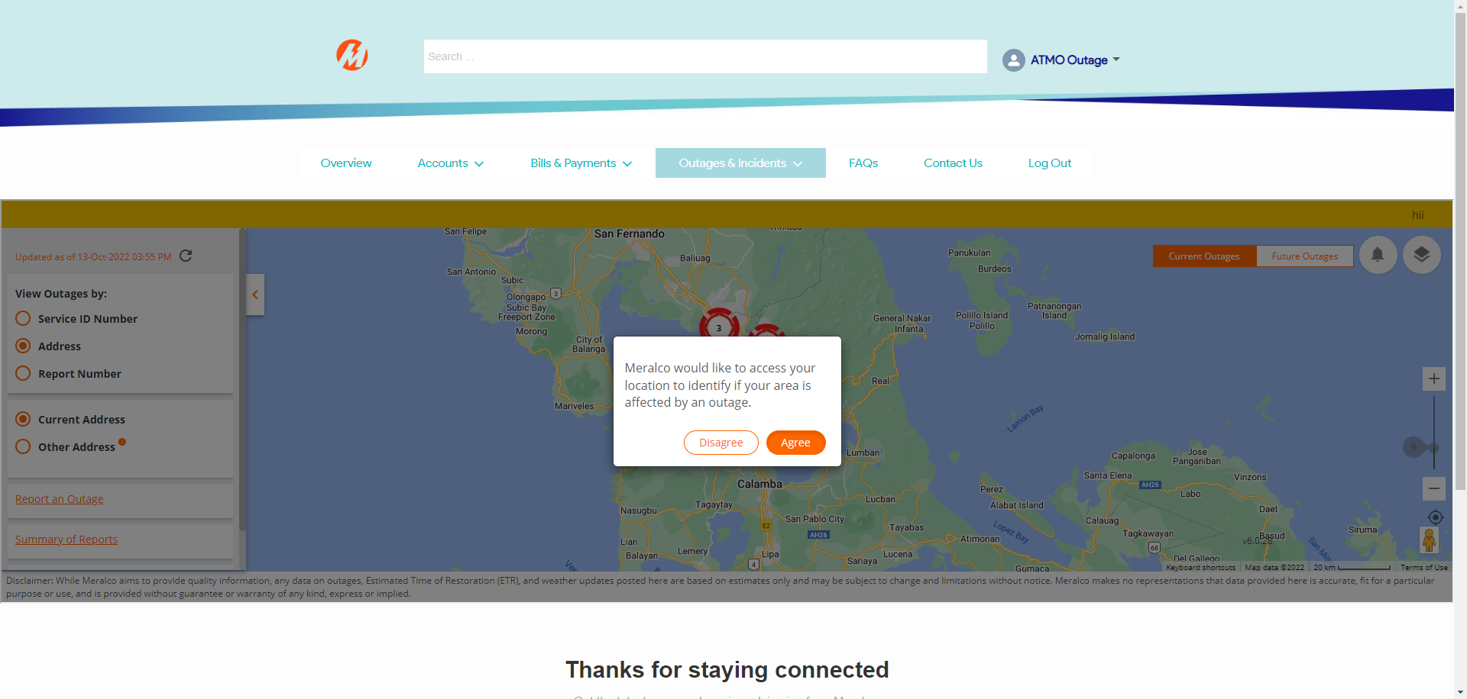

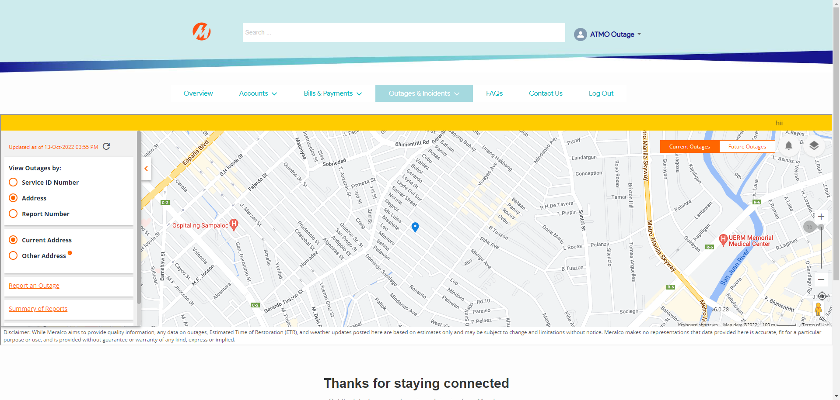

|  |
| --- |
| TC127_External: Viewing as Authenticated User - GPS Disabled |

|  |
| --- |
| Step 1 - Login to Meralco Online |
| User should be logged in |

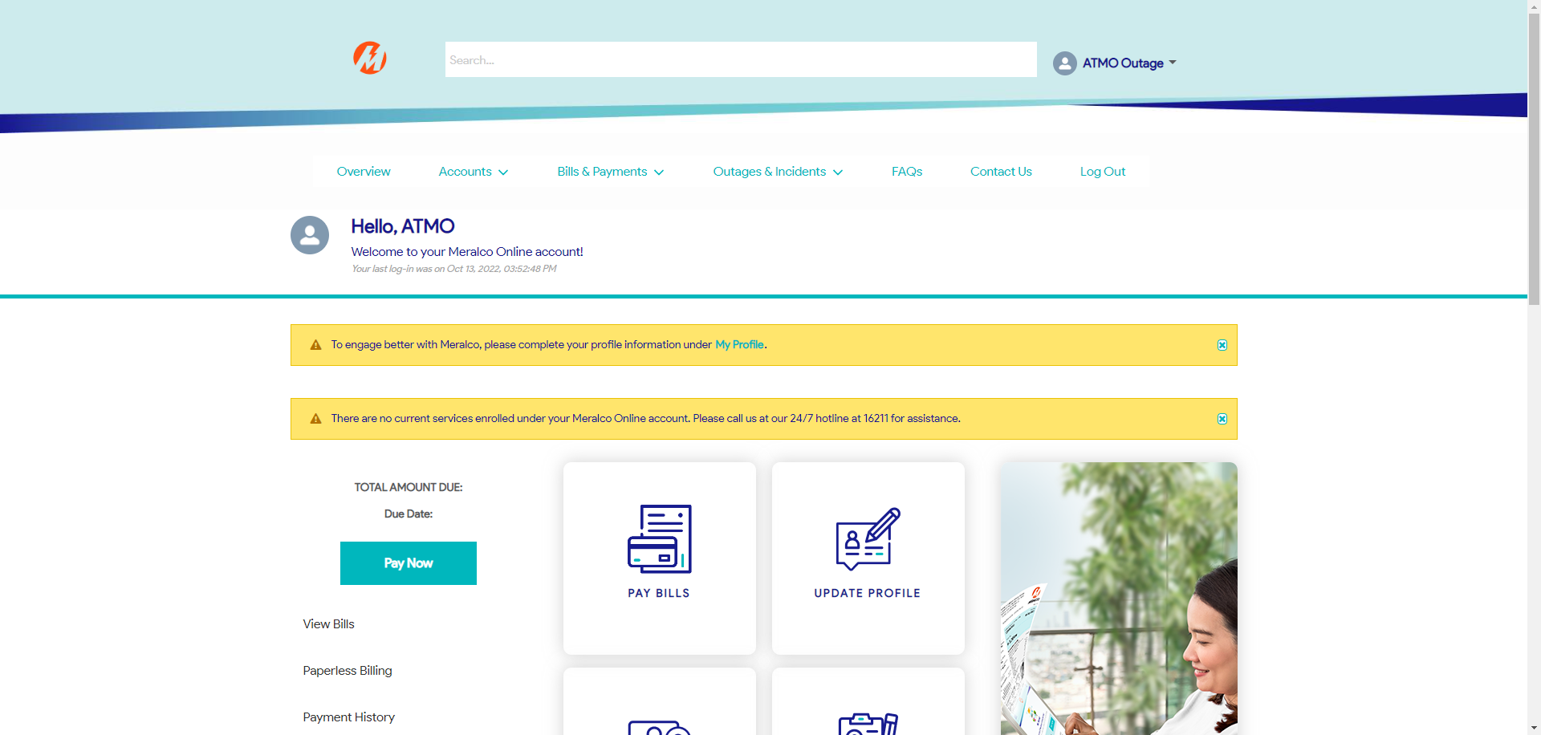

|  |
| --- |
| Step 2 - Go to Outages & Incidents > View/Report Outages |
| User should be irected to outage map. Message prompt should be displayed: Meralco would like to access your location to identify if your area is affected by an outage. Buttons: Disagree Agree |

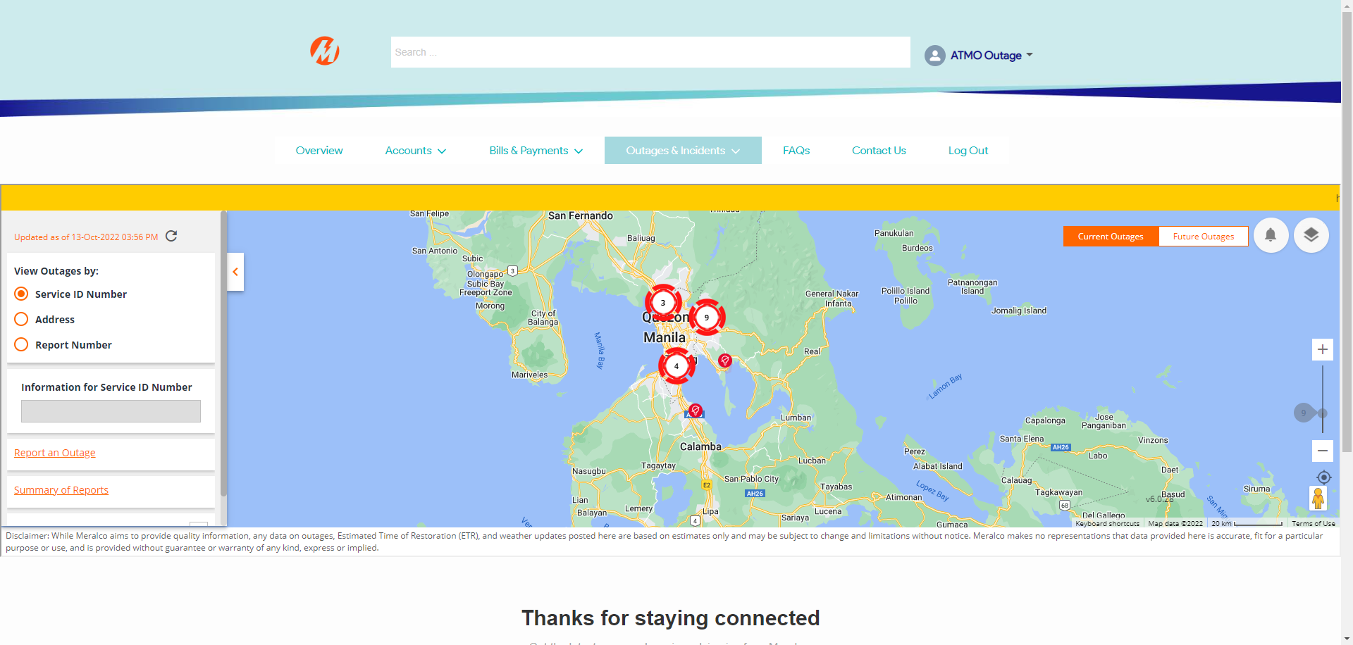

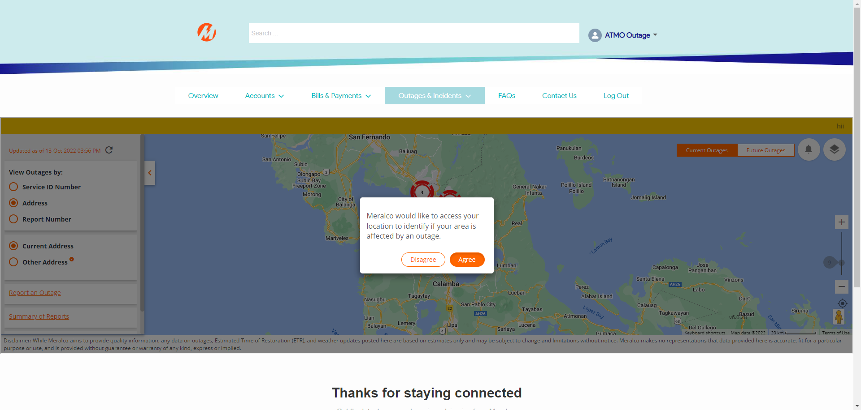

|  |
| --- |
| Step 3 - Click Disagree |
| User should be redirected to Outage map with GPS disabled |

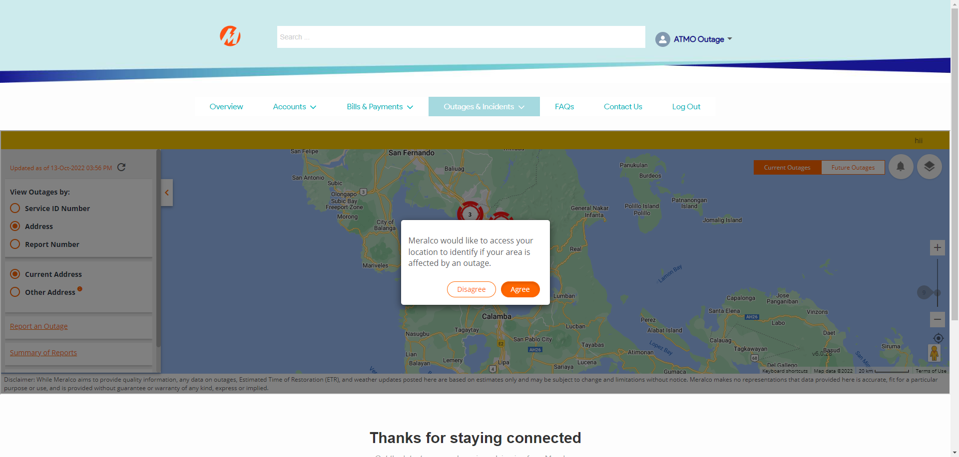

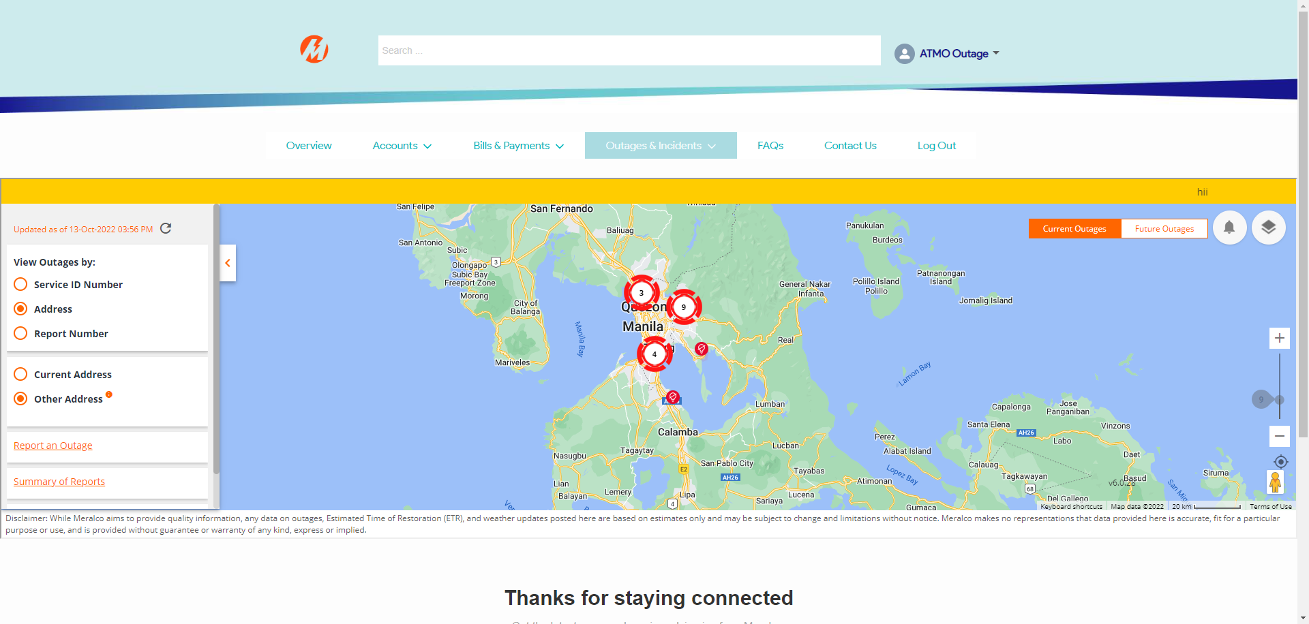

Passed