|  |
| --- |
| TS053 - Validation in External Map: Mini-map in Outage Reporting form |

|  |
| --- |
| TC129_External Viewing as Guest User - Mini-map in Outage Reporting form |

|  |
| --- |
| Step 1 - Go to https://fuat-meralco.cs73.force.com/customers/s/outagemap |
| Map should be displayed |

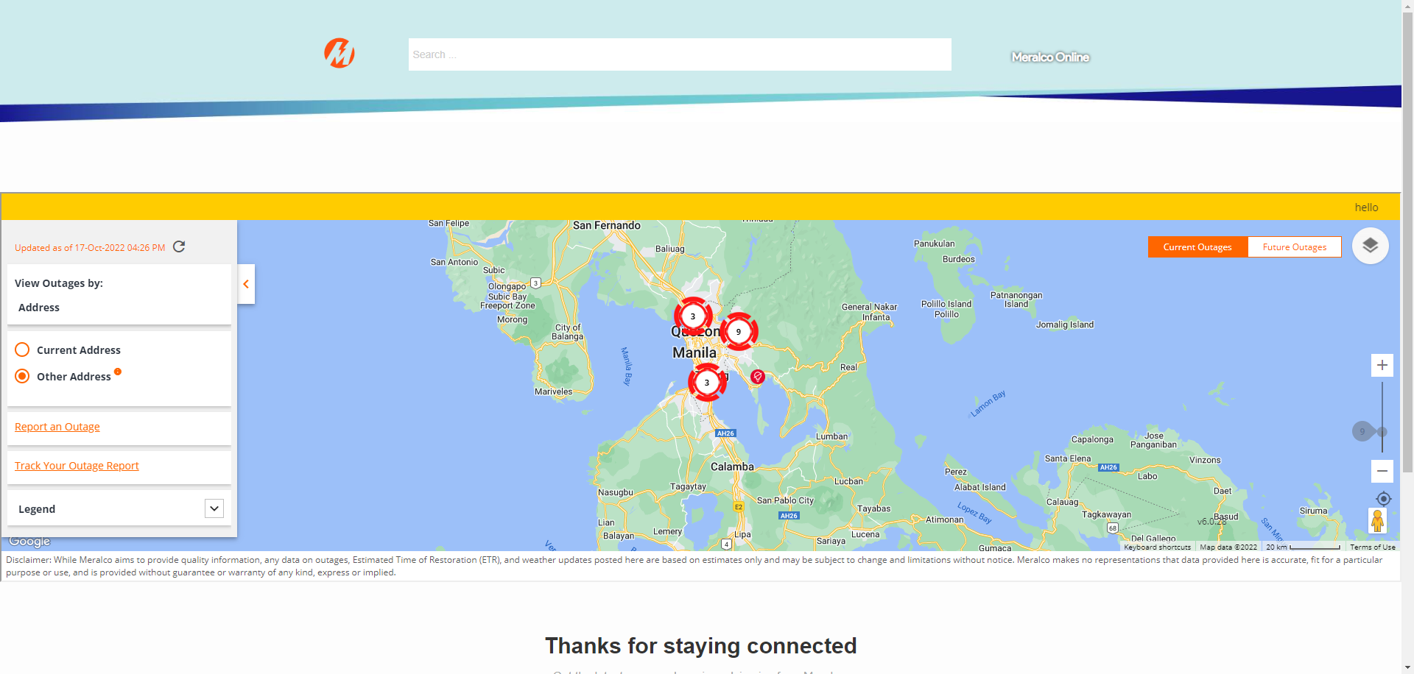

|  |
| --- |
| Step 2 - Click Report an Outage |
| User should be directed to Report an Outage or Incident page |

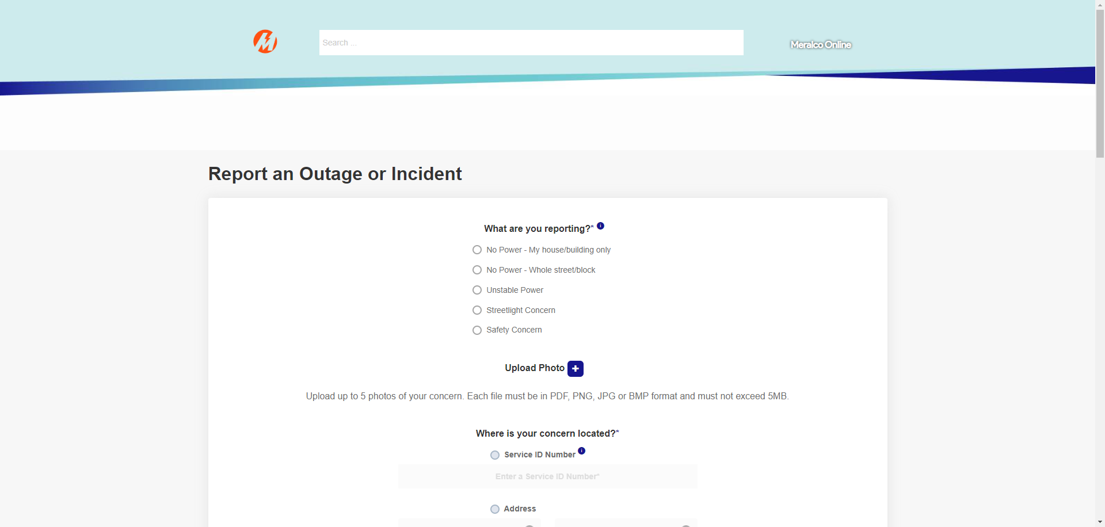

|  |
| --- |
| Step 3 - Populate required fields then tick Location in Map |
| Mini-map should be displayed under Location in Map |

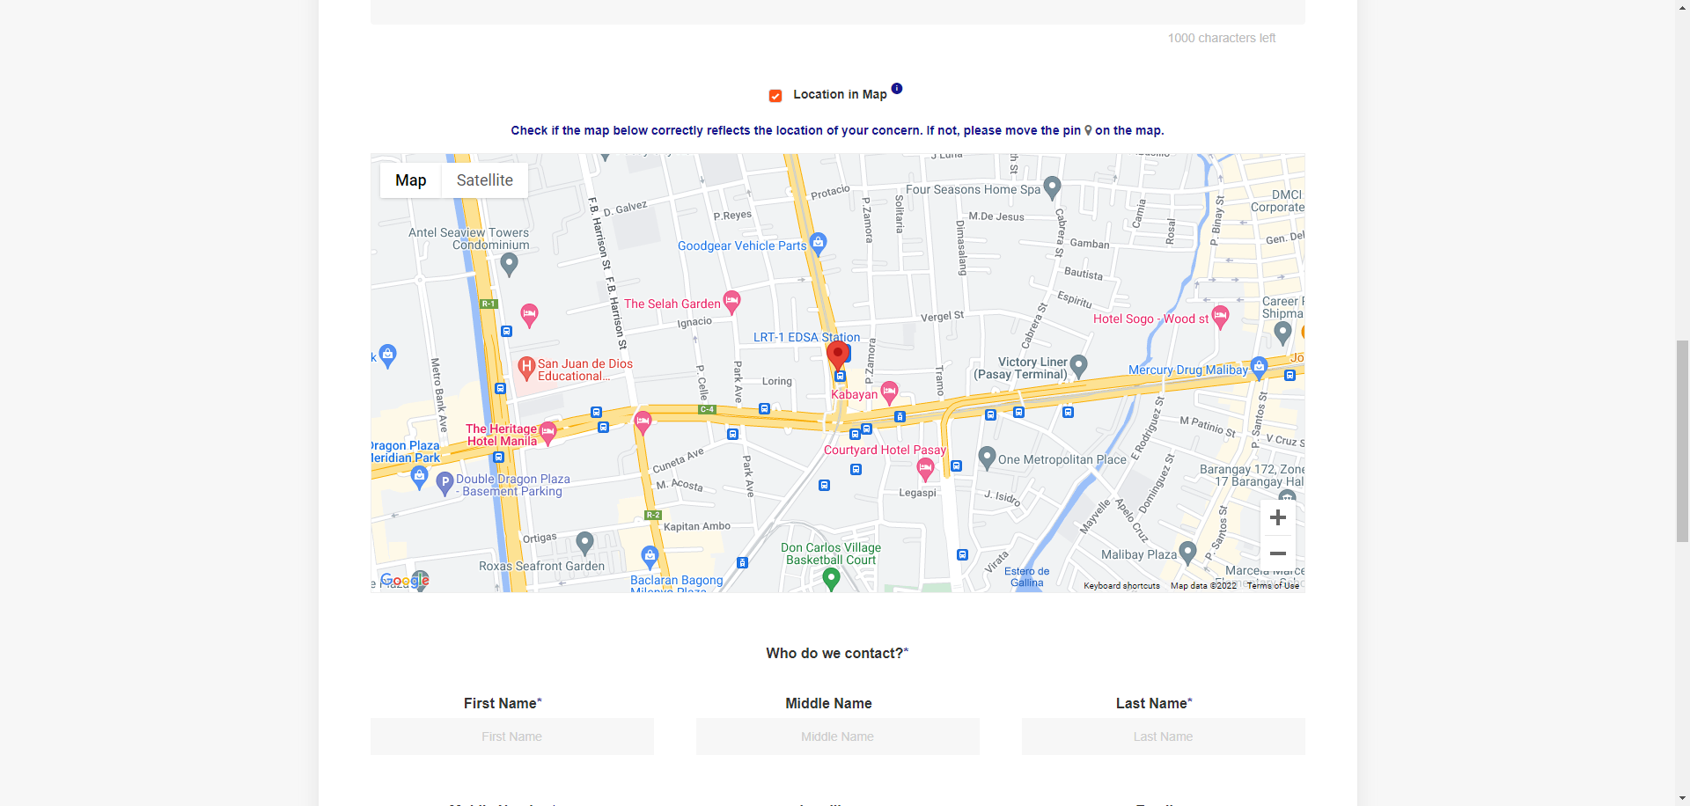

|  |
| --- |
| TC130_External Viewing as Authenticated User - Mini-map in Outage Reporting form |

|  |
| --- |
| Step 1 - Login to Meralco Online |
| User should be logged in |

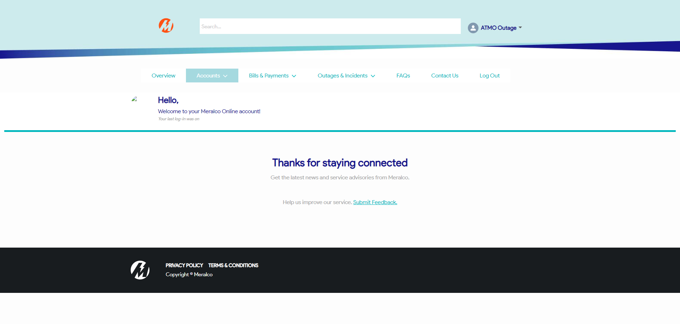

|  |
| --- |
| Step 2 - Go to Outages & Incidents > View/Report Outages |
| Map should be displayed |

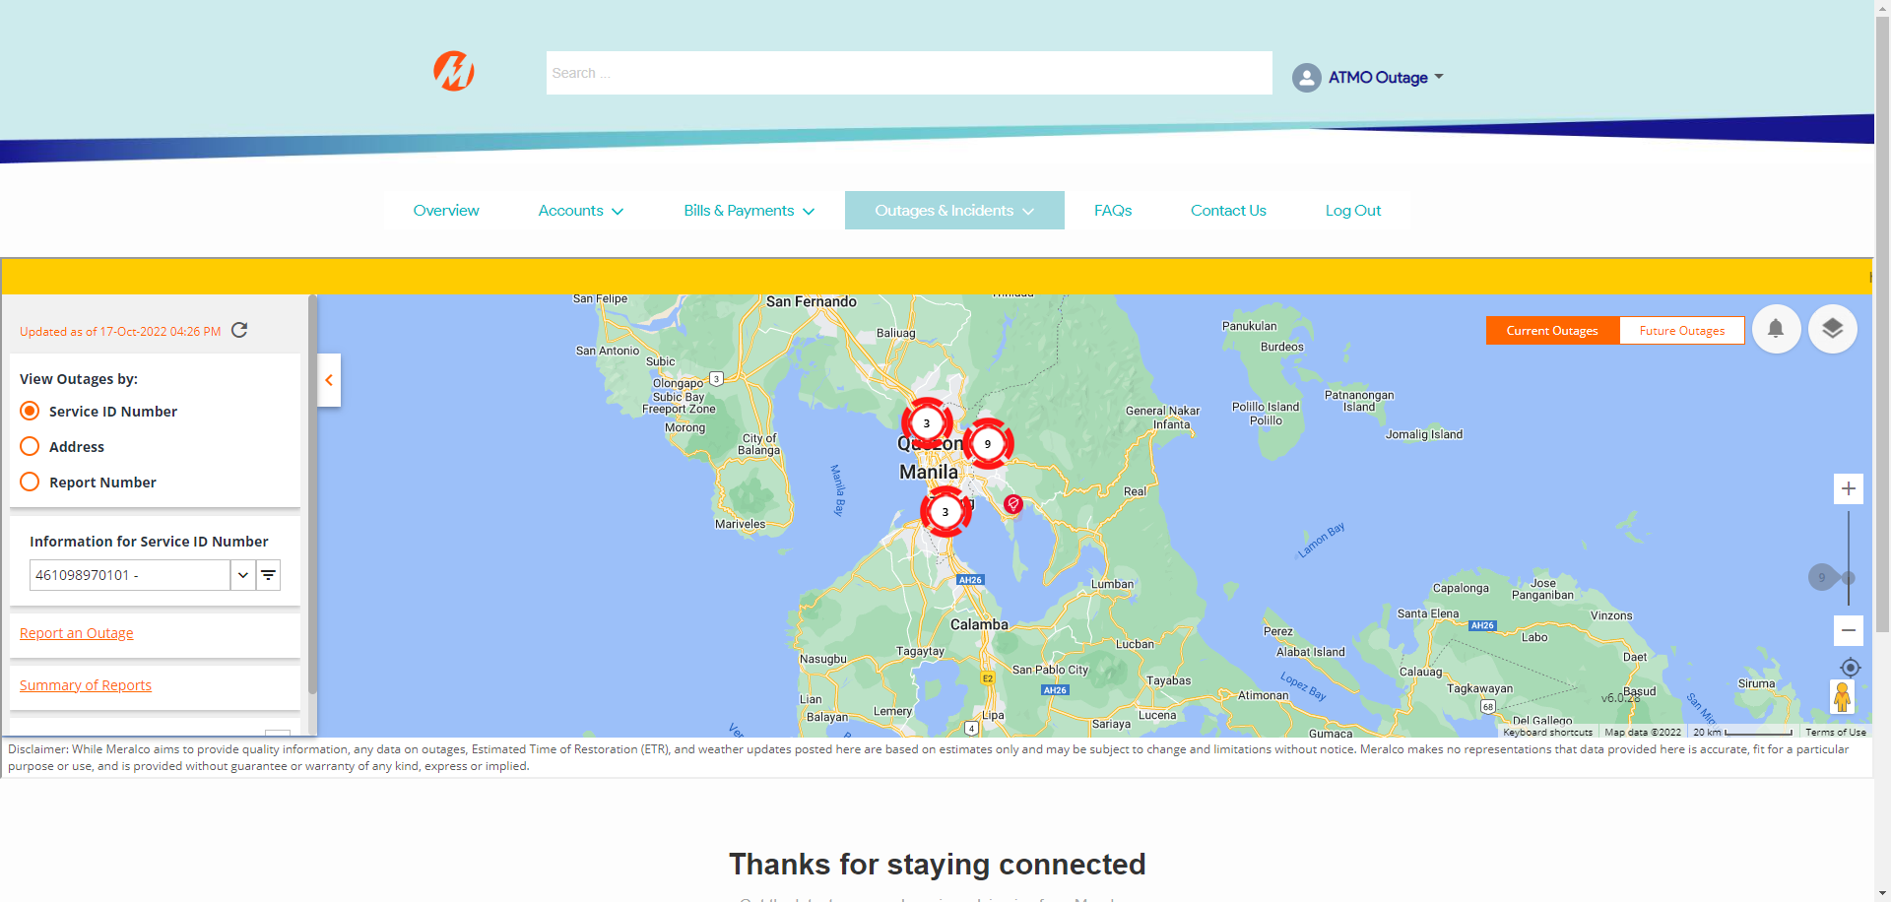

|  |
| --- |
| Step 3 - Click Report an Outage |
| User should be directed to Report an Outage or Incident page |

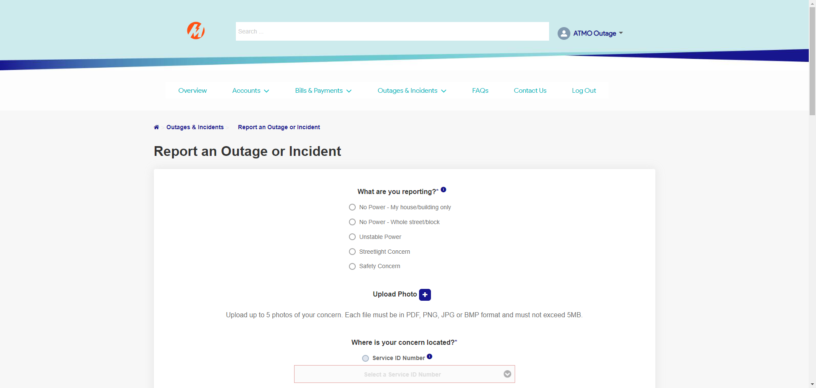

|  |
| --- |
| Step 4 - Populate required fields then tick Location in Map |
| Mini-map should be displayed under Location in Map |

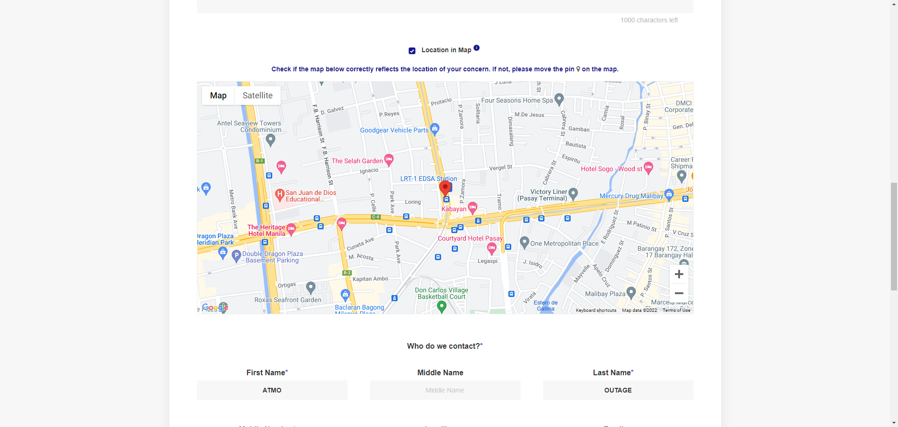

Passed