|  |
| --- |
| TS054 - Validation in External Map: Refresh Button |

|  |
| --- |
| TC133_External: Viewing as Guest User - Legends |

|  |
| --- |
| Step 1 - Go to https://fuat-meralco.cs73.force.com/customers/s/outagemap |
| Map should be displayed |

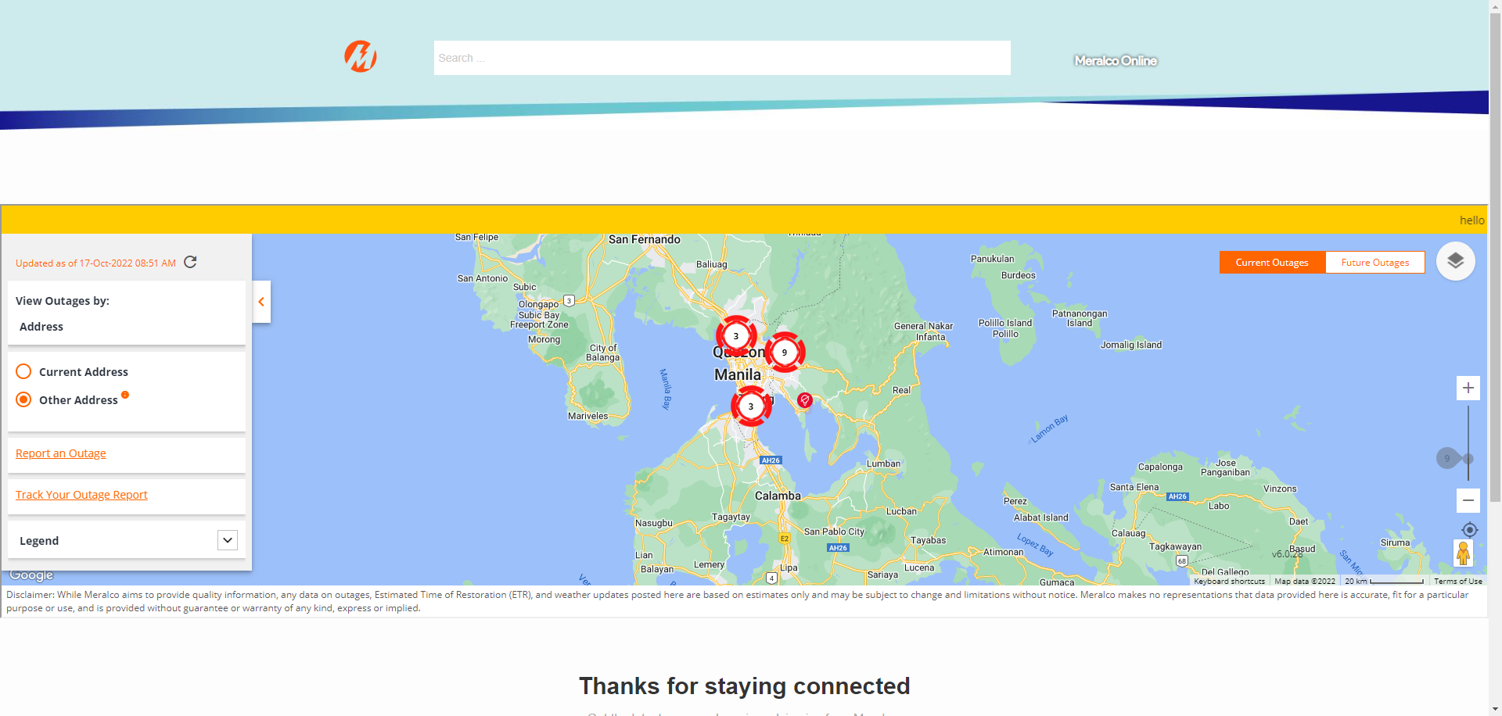

|  |
| --- |
| Step 2 - Click down button beside Legends |
| The following should be displayed: - Unplanned Outage - Planned Outage |

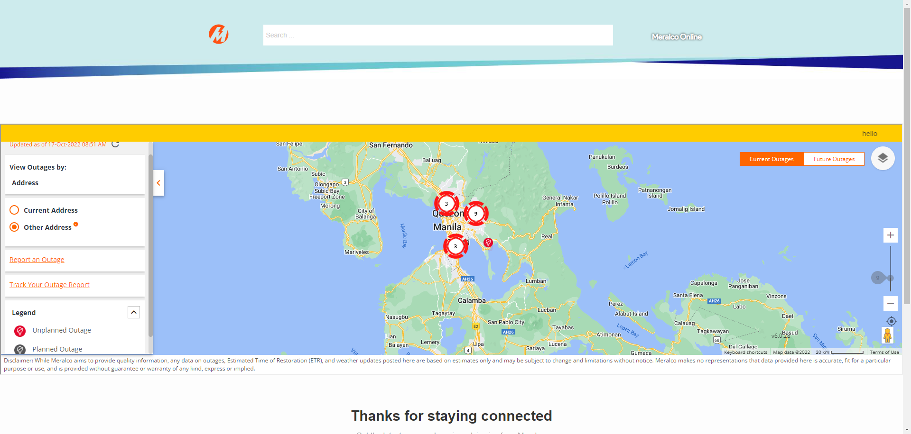

Passed