|  |
| --- |
| TS056 - Validation in External Map: Legends (Authenticated User) |

|  |
| --- |
| TC134_External: Viewing as Authenticated User - Legends |

|  |
| --- |
| Step 1 - Login to Meralco Online |
| User should be logged in |

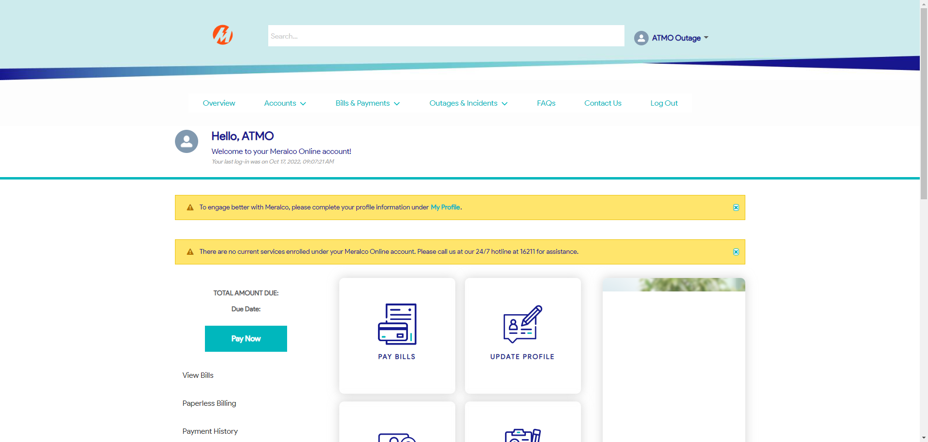

|  |
| --- |
| Step 2 - Go to Outages & Incidents > View/Report Outages |
| Map should be displayed |

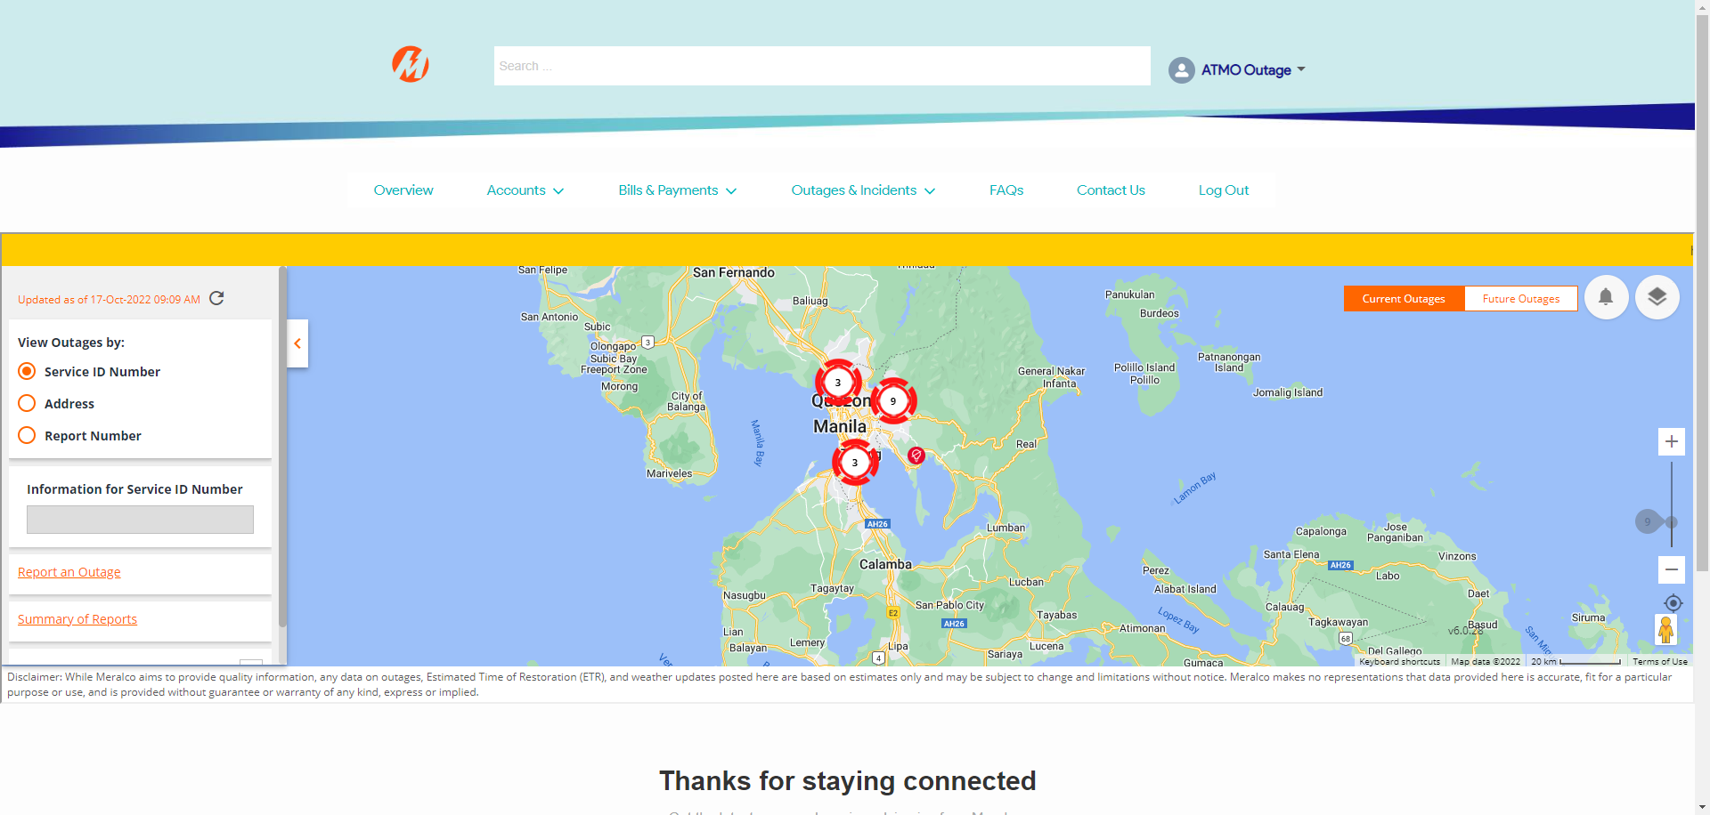

|  |
| --- |
| Step 3 - Click down button beside Legends |
| The following should be displayed: - Service with restored power - Service with unplanned outage - Service with planned outage - Service not affected by an outage - Unplanned Outage - Planned Outage |

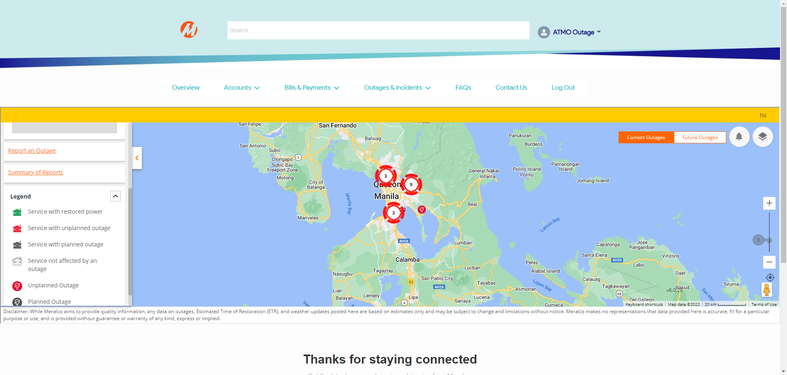

Passed