|  |
| --- |
| TS059 - Validation in External Map: Outages view (Guest) |

|  |
| --- |
| TC141_External: Viewing as Guest User - Outages view |

|  |
| --- |
| Step 1 - Go to https://fuat-meralco.cs73.force.com/customers/s/outagemap |
| Map should be displayed |

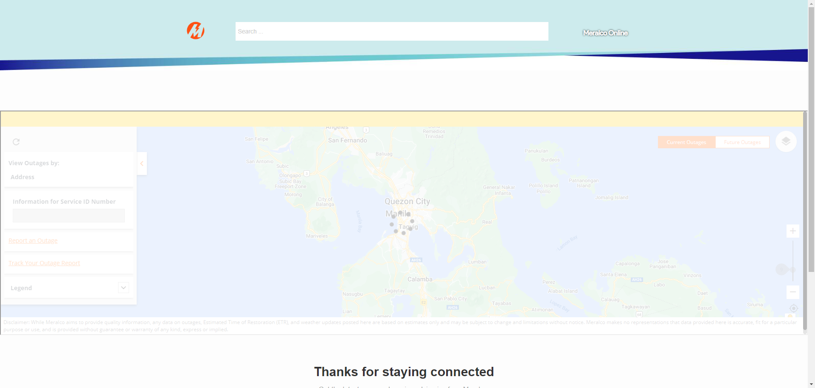

|  |
| --- |
| Step 2 - Validate View Outages by |
| View Outages by should be filtered by Address only; Current Address should be ticked by default and map should display your current location |

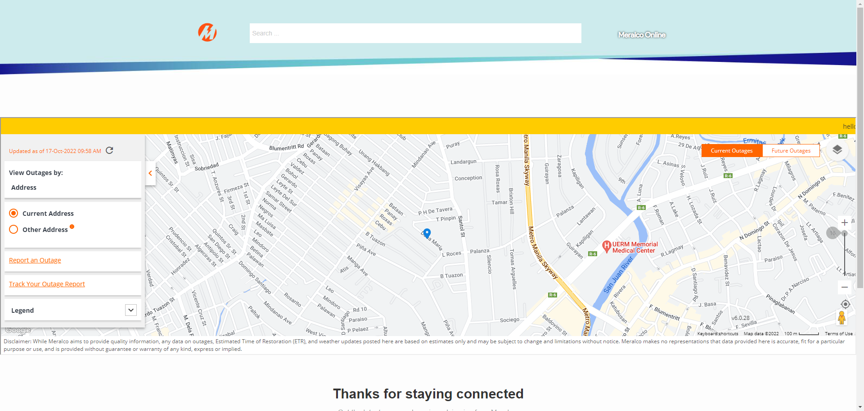

|  |
| --- |
| Step 3 - Tick Other Address |
| Current Location pin should not be displayed |

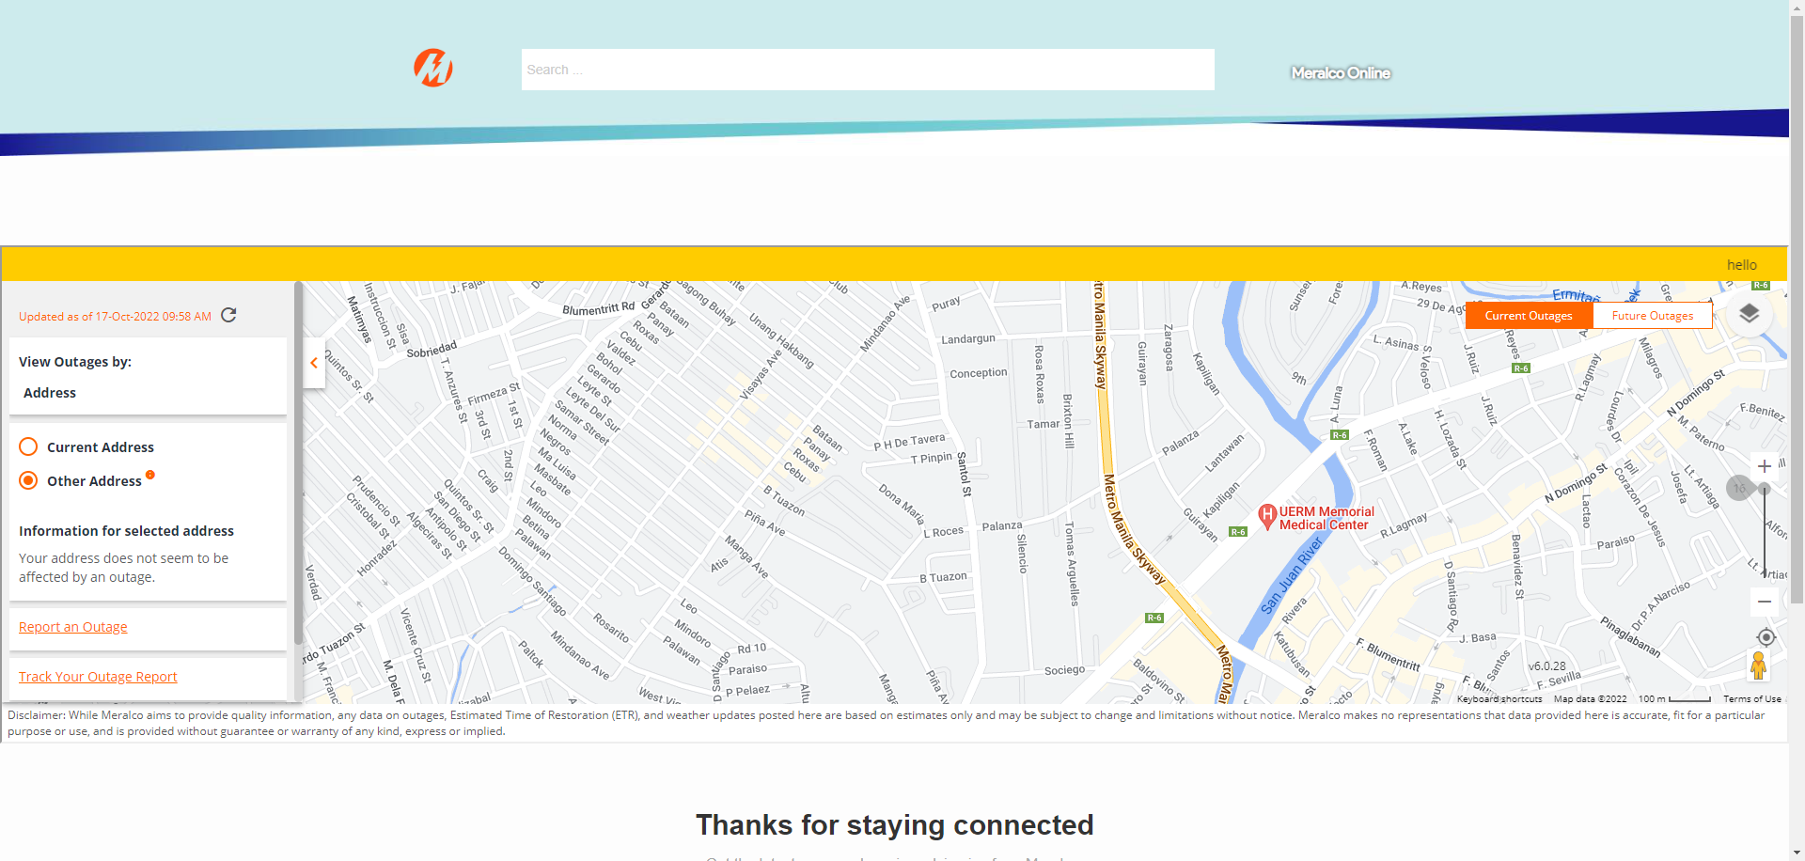

|  |
| --- |
| Step 4 - Tick Anywhere on the map |
| Information for the selected address should be displayed |

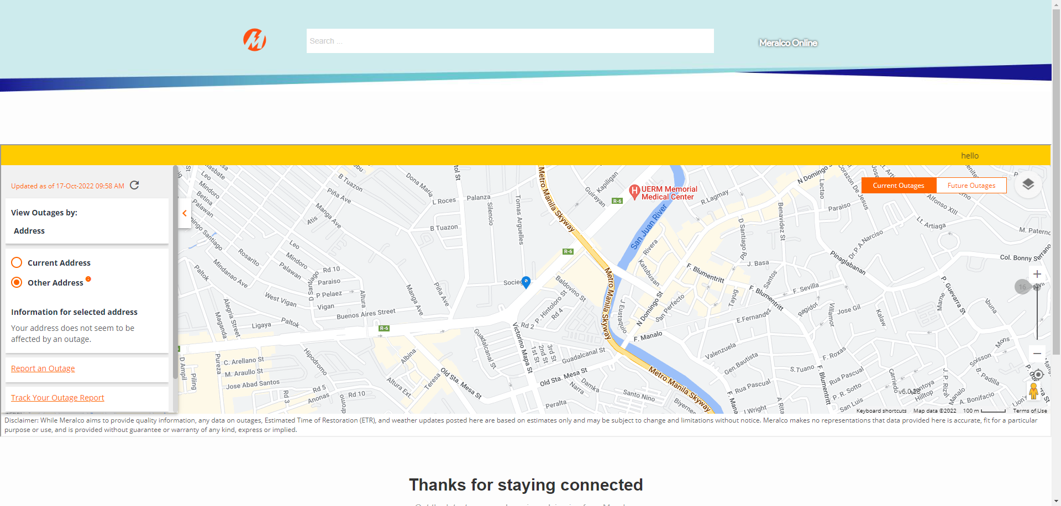

Passed