|  |
| --- |
| TS060 - Validation in External Map: Outages view (Authenticated User) |

|  |
| --- |
| TC142_External: Viewing as Authenticated User - Outages view |

|  |
| --- |
| Step 1 - Login to Meralco Online |
| User should be logged in |

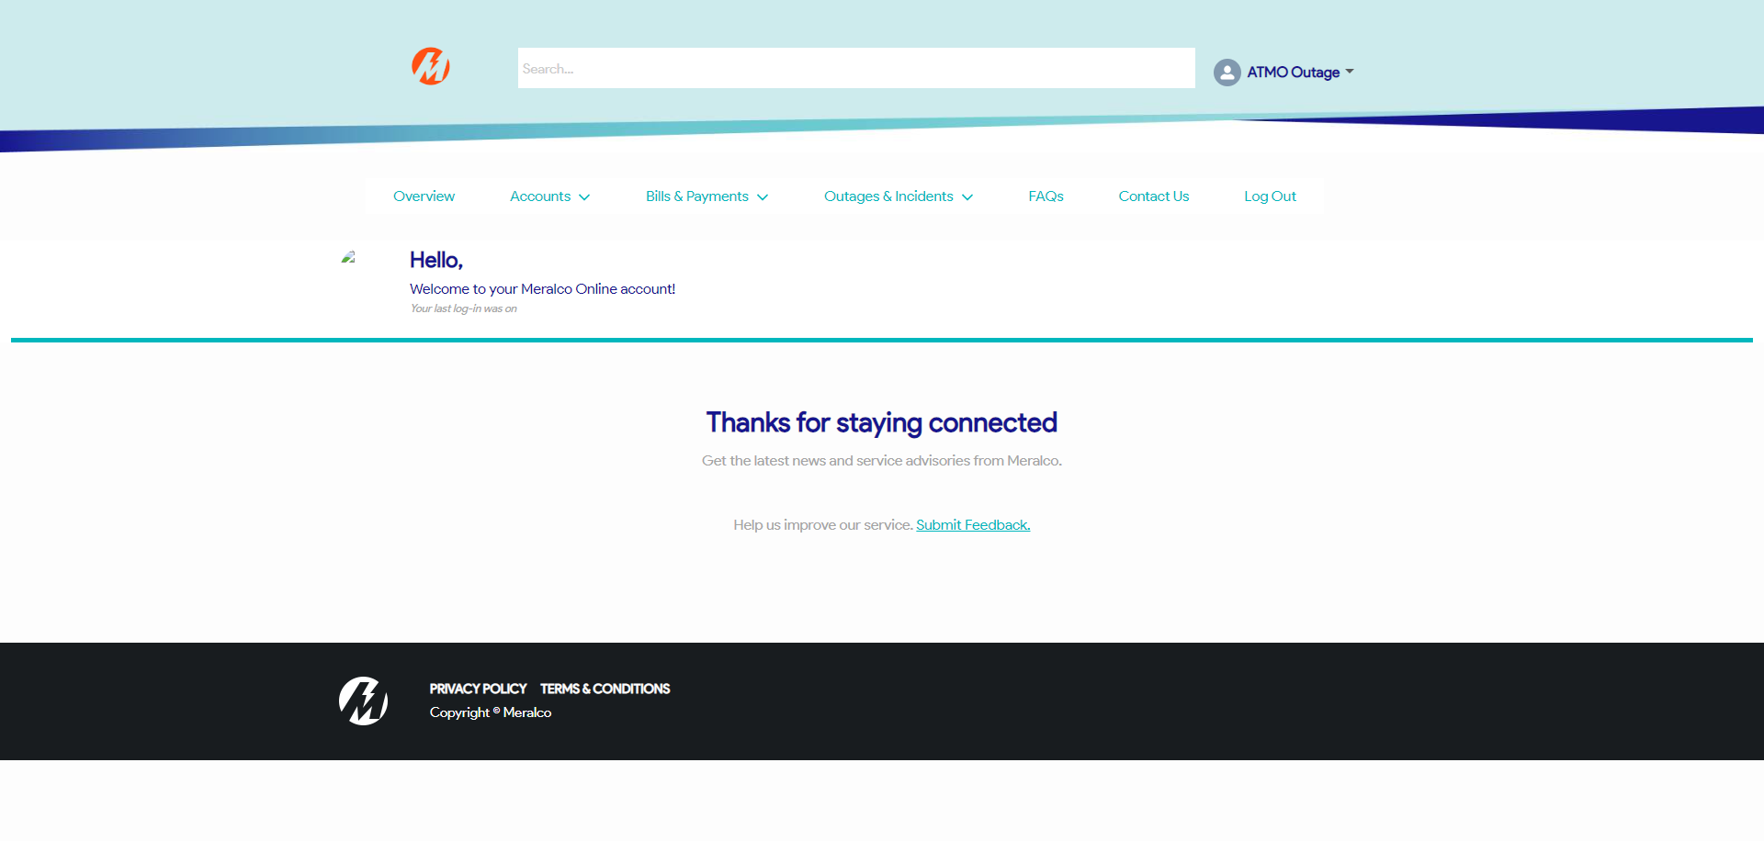

|  |
| --- |
| Step 2 - Go to Outages & Incidents > View/Report Outages |
| Map should be displayed |

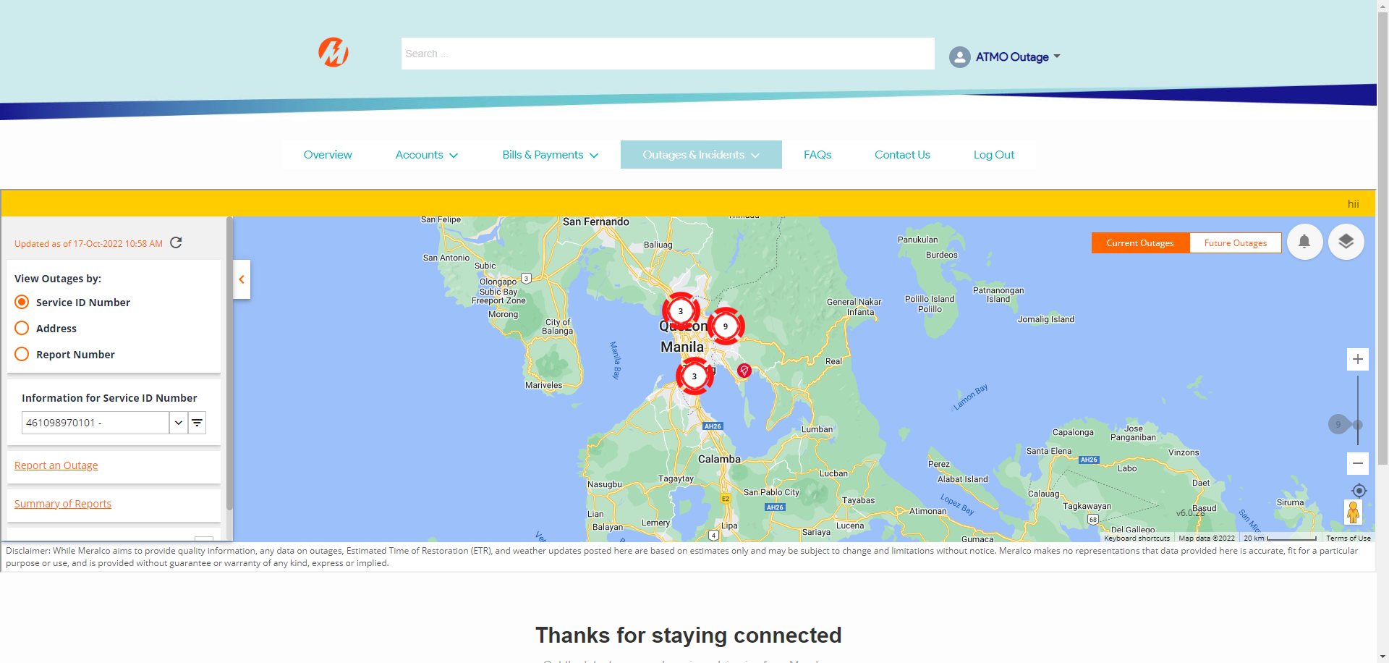

|  |
| --- |
| Step 3 - Validate View Outages by |
| - View Outages by should be filtered by the following: - Service ID Number (ticked by default) - Address - Report Number |

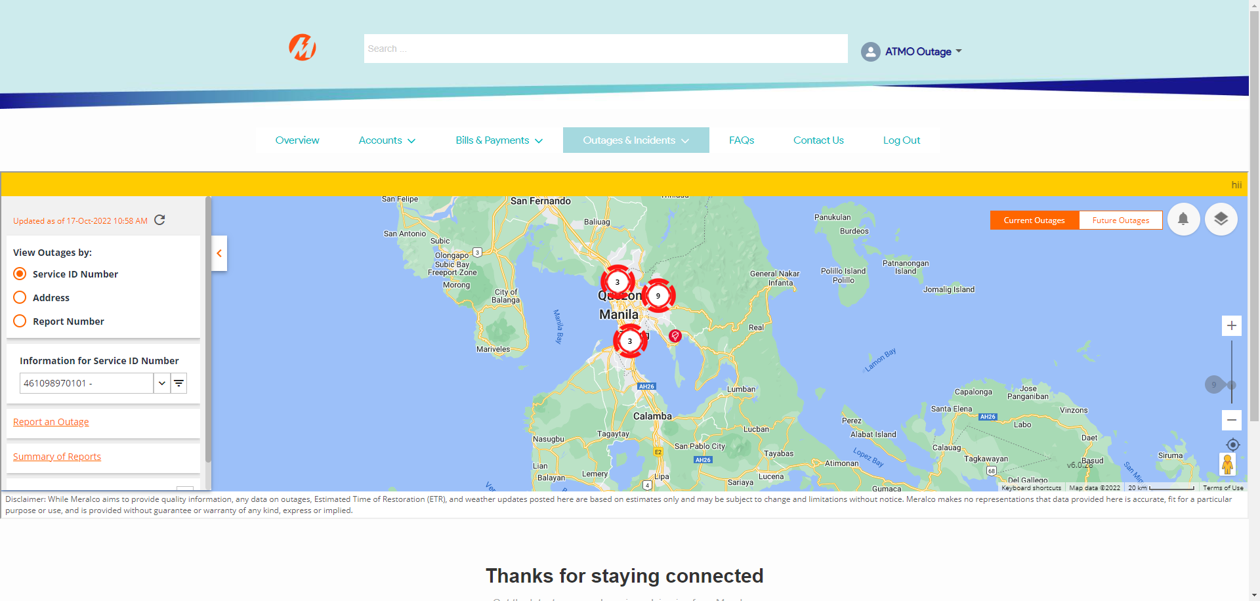

|  |
| --- |
| Step 4 - Select Service ID Number under Information panel |
| Selected SIN should be pinned in Map; Outage information should be displayed under Information panel  Note: If Account has a single service enrolled, Service ID number should be disabled and default value should be the enrolled SIN. |

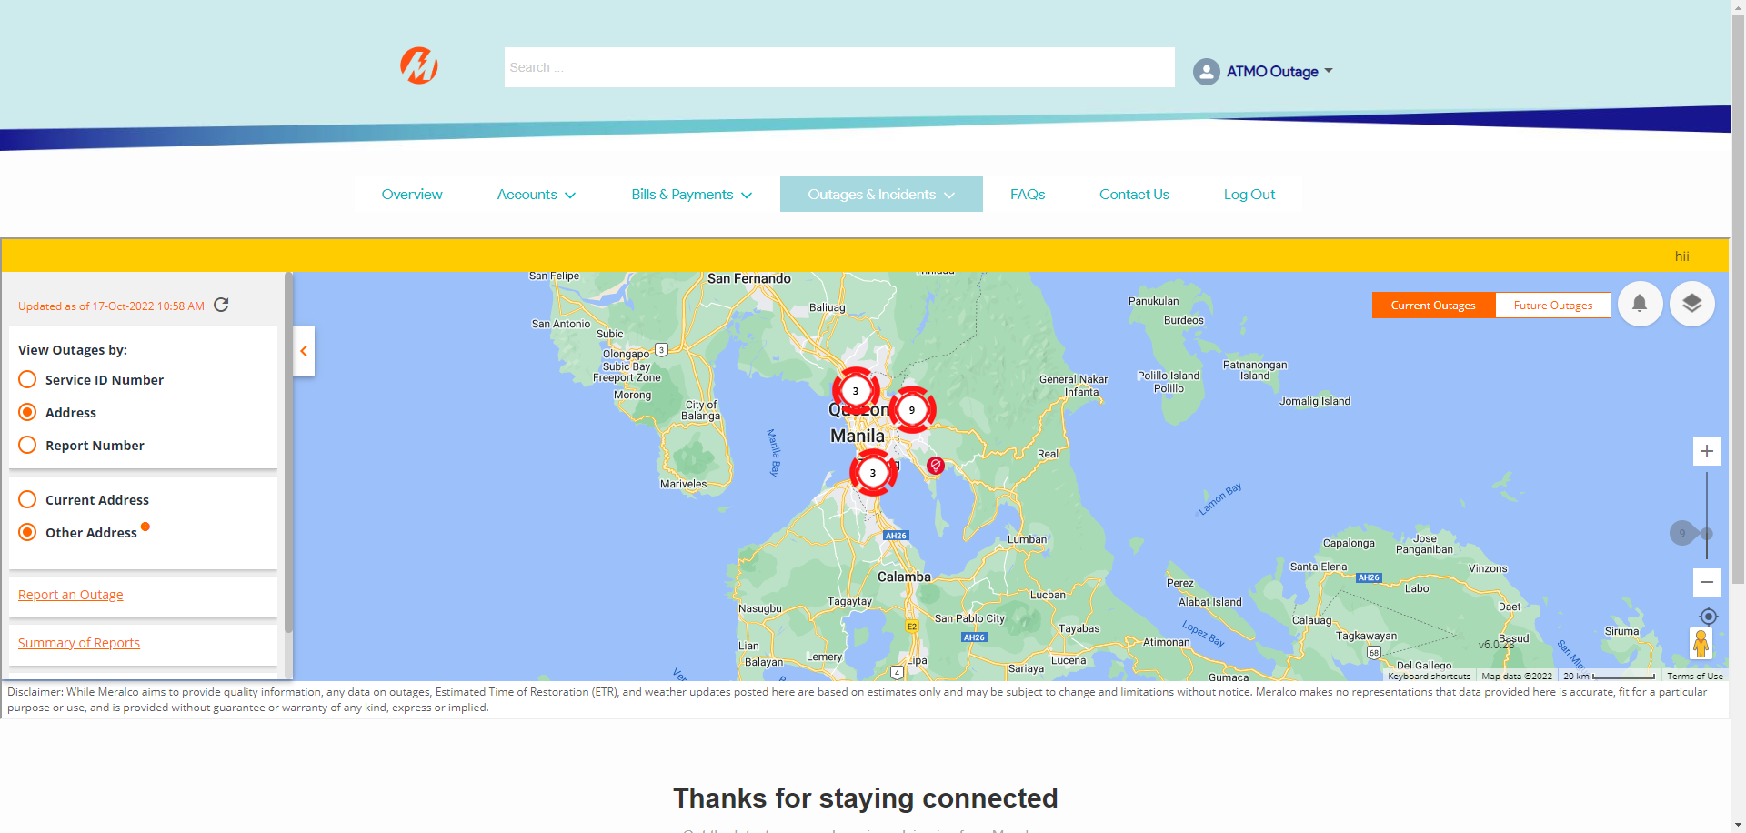

|  |
| --- |
| Step 5 - Tick Address under View Outages by |
| Other Address should be ticked by default under |

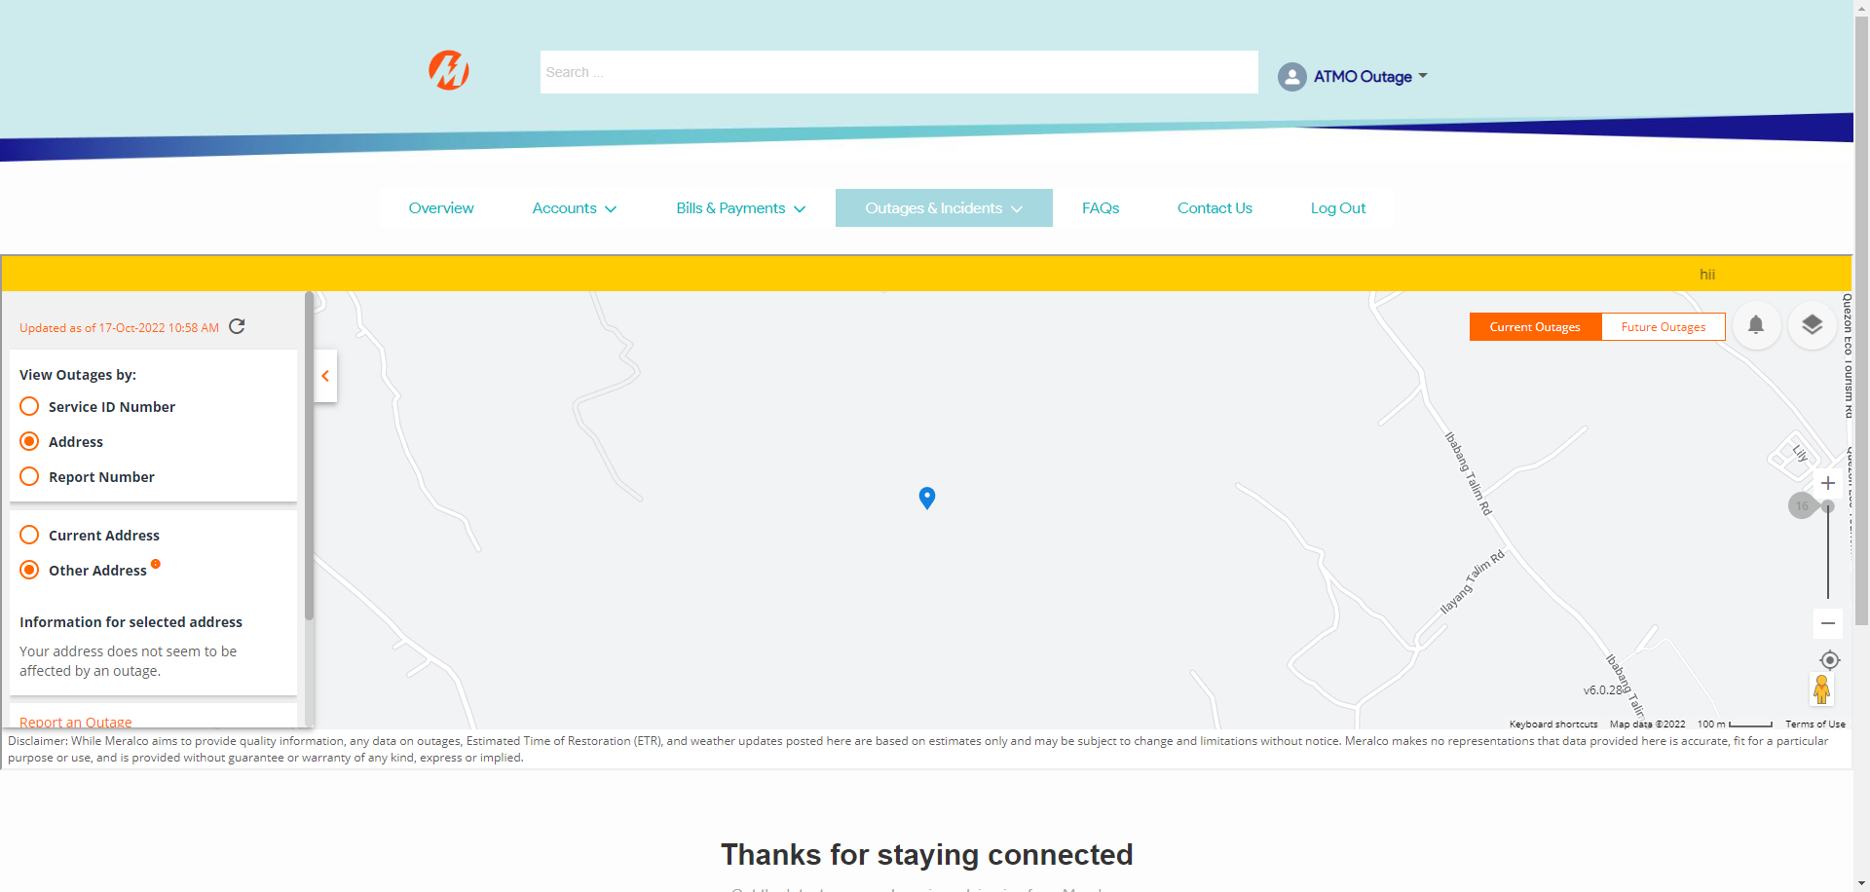

|  |
| --- |
| Step 6 - Tick Anywhere on the map |
| Information for the selected address should be displayed |

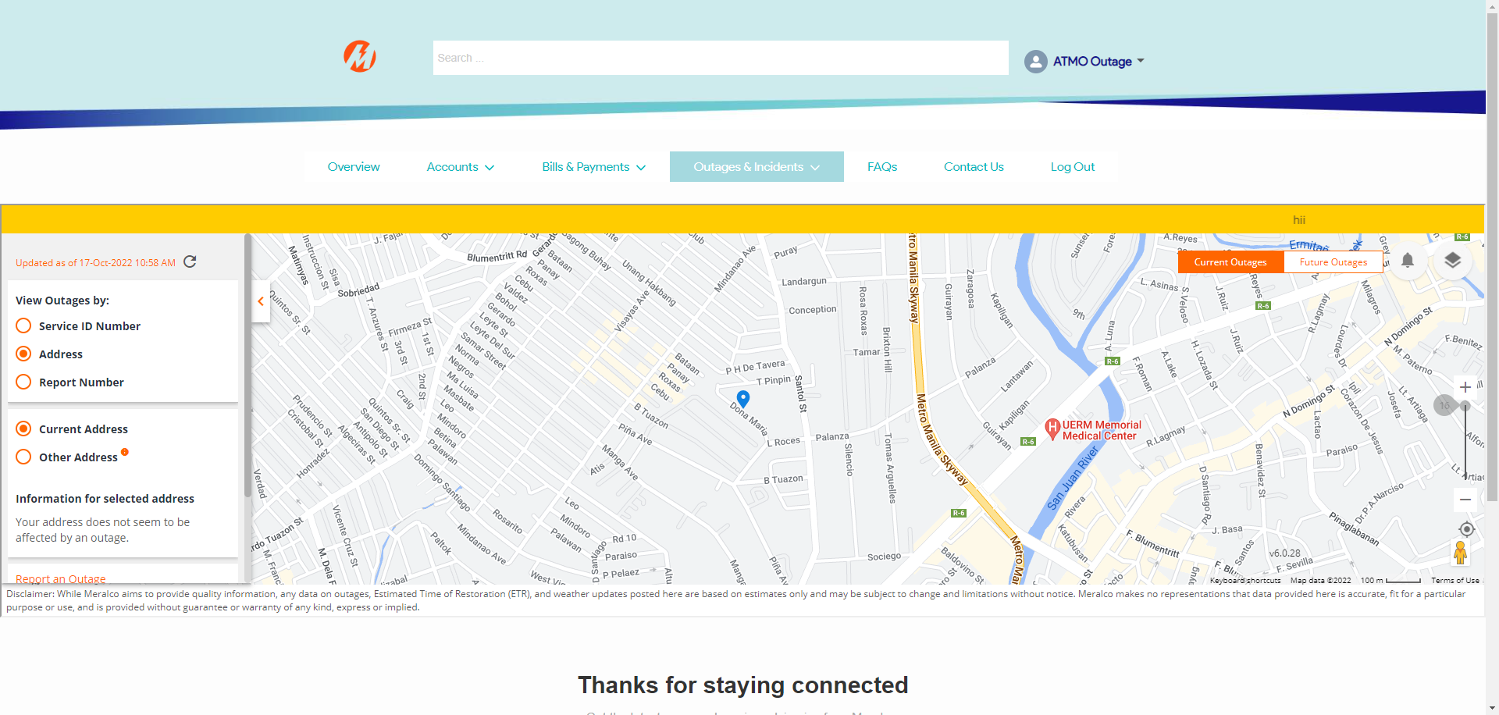

Passed