|  |
| --- |
| TS062 - Validation in External Map: Current Location |

|  |
| --- |
| TC145_External: Viewing as Guest User - Current Location |

|  |
| --- |
| Step 1 - Go to https://fuat-meralco.cs73.force.com/customers/s/outagemap |
| Map should be displayed |

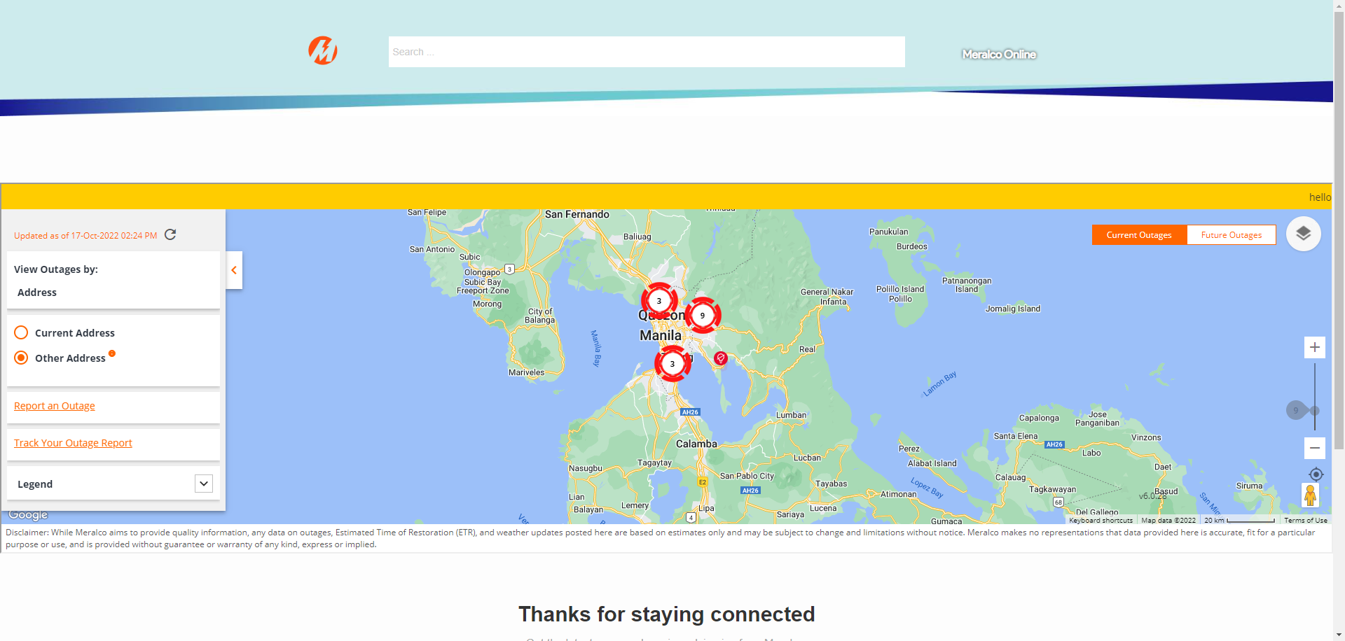

|  |
| --- |
| Step 2 - Click on Current Location icon under Zoom slider |
| Map should zoom in to current location |

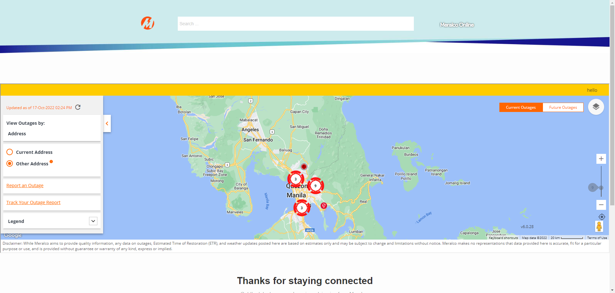

|  |
| --- |
| TC146_External: Viewing as Authenticated User - Current Location |

|  |
| --- |
| Step 1 - Login to Meralco Online |
| User should be logged in |

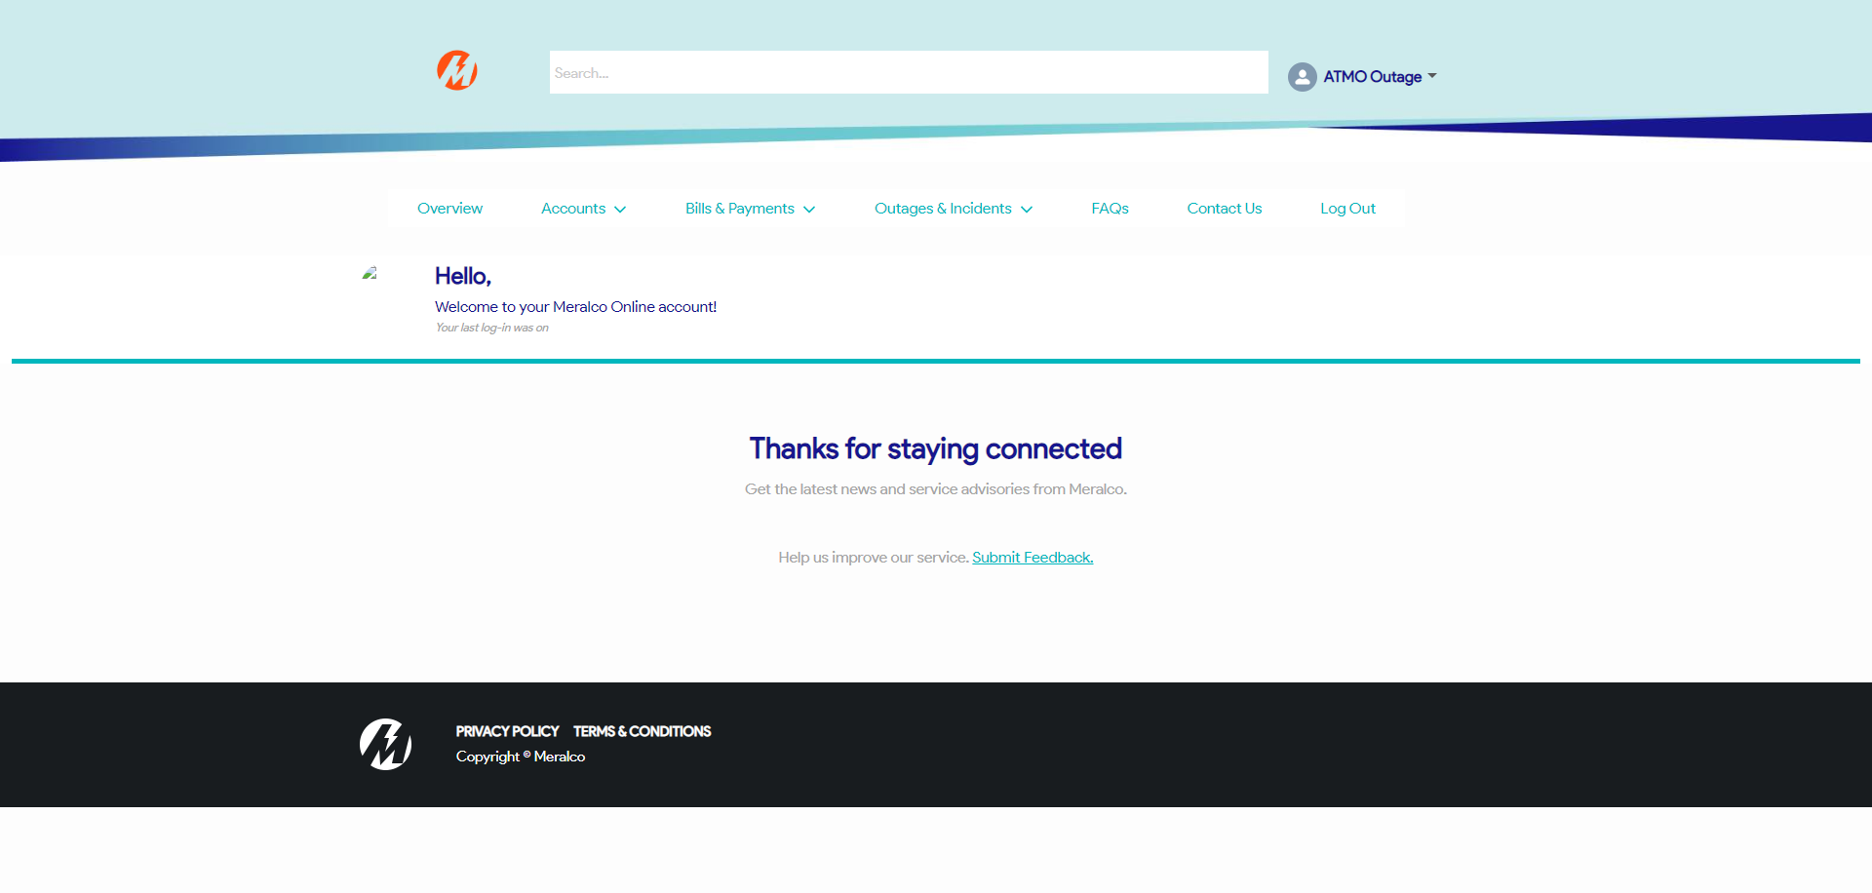

|  |
| --- |
| Step 2 - Go to Outages & Incidents > View/Report Outages |
| Map should be displayed |

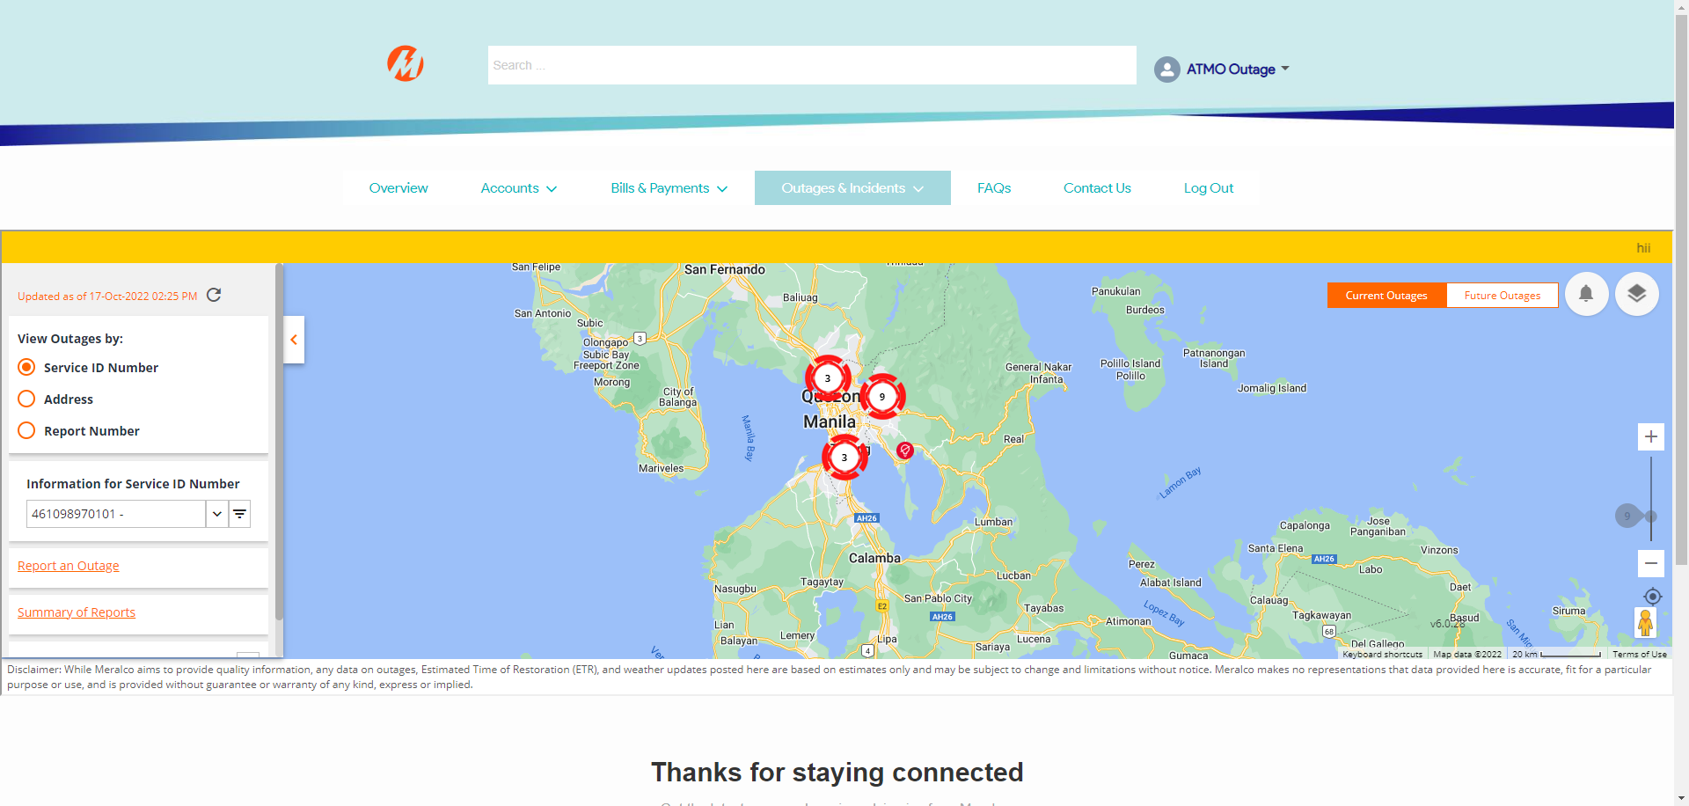

|  |
| --- |
| Step 3 - Click on Current Location icon under Zoom slider |
| Map should zoom in to current location |

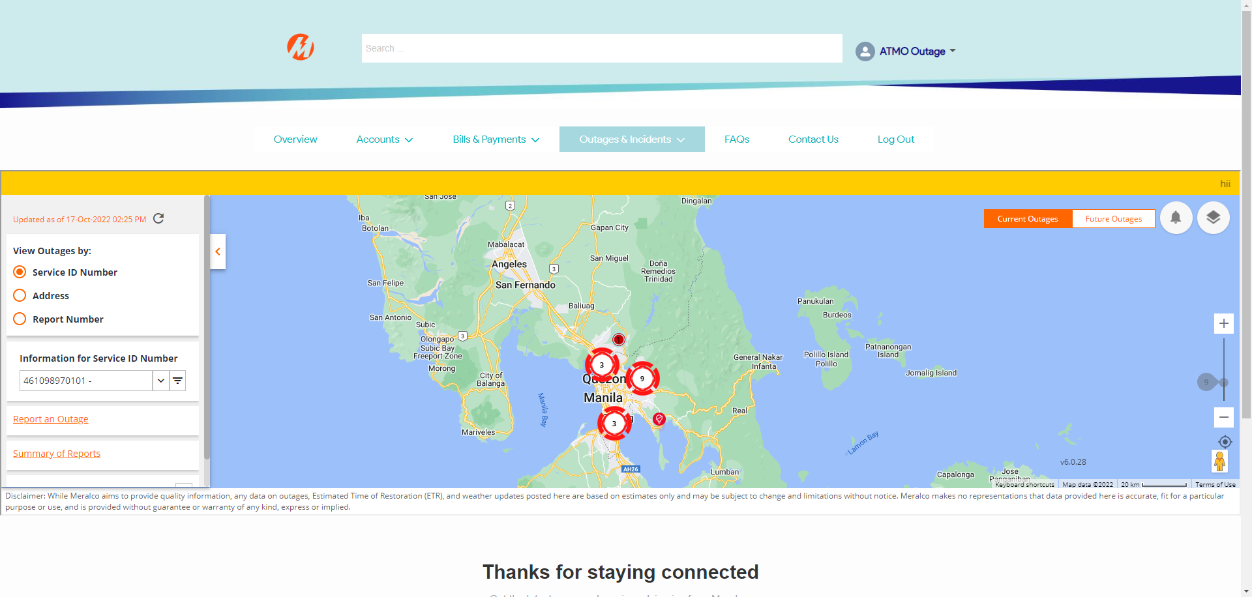

Passed