|  |
| --- |
| TS063 - Validation in External Map: Tooltip |

|  |
| --- |
| TC147_External: Viewing as Guest User - Tooltip |

|  |
| --- |
| Step 1 - Go to https://fuat-meralco.cs73.force.com/customers/s/outagemap |
| Map should be displayed |

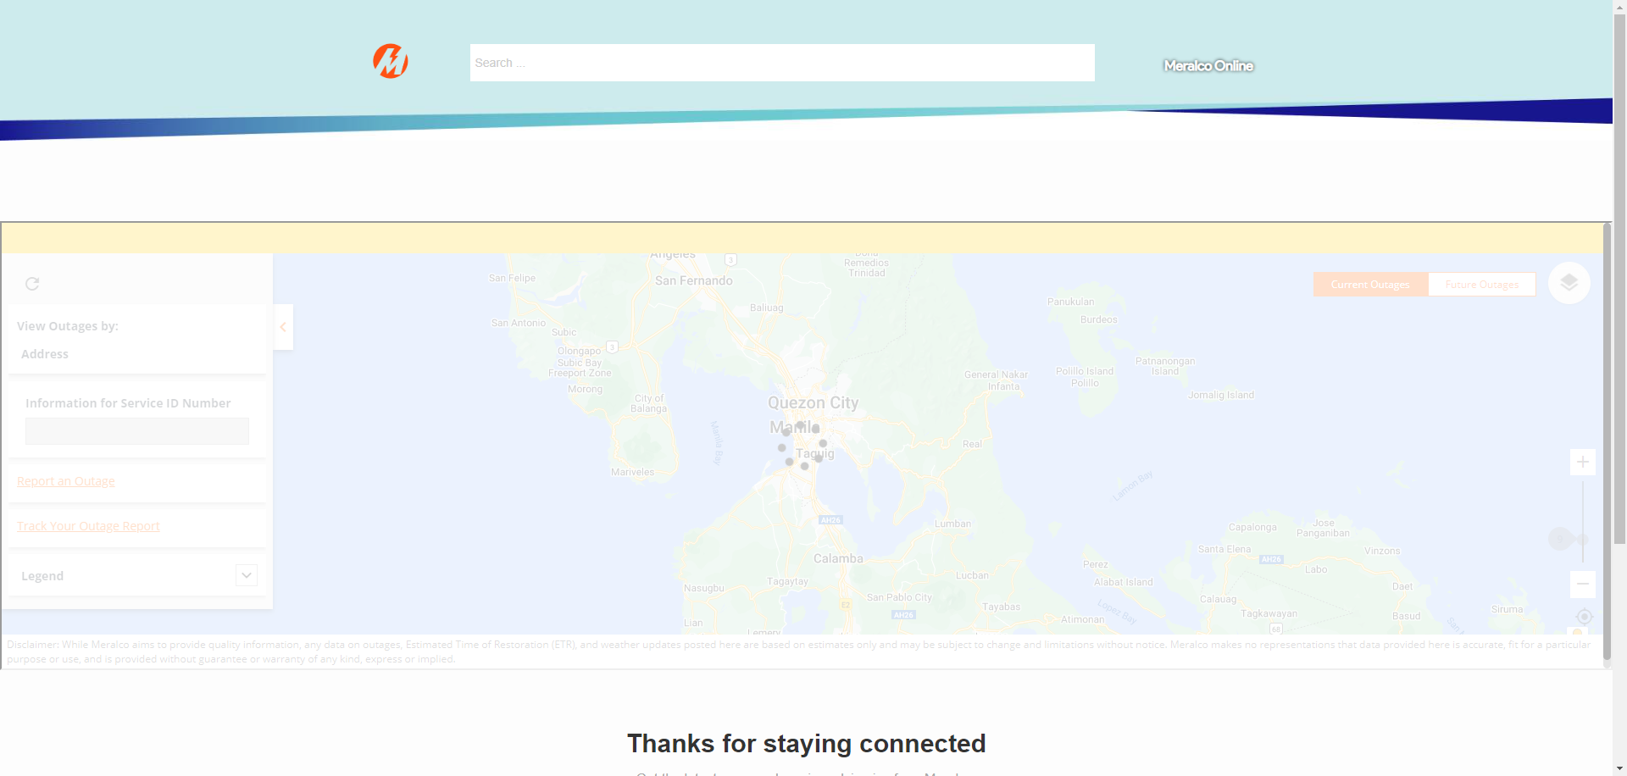

|  |
| --- |
| Step 2 - On the left side, hover on tooltip beside Other Address |
| Message should be displayed: Please pin your location on the map to help us identify if your area is affected by an outage. |

|  |
| --- |
| TC148_External: Viewing as Authenticated User - Tooltip |

|  |
| --- |
| Step 1 - Login to Meralco Online |
| User should be logged in |

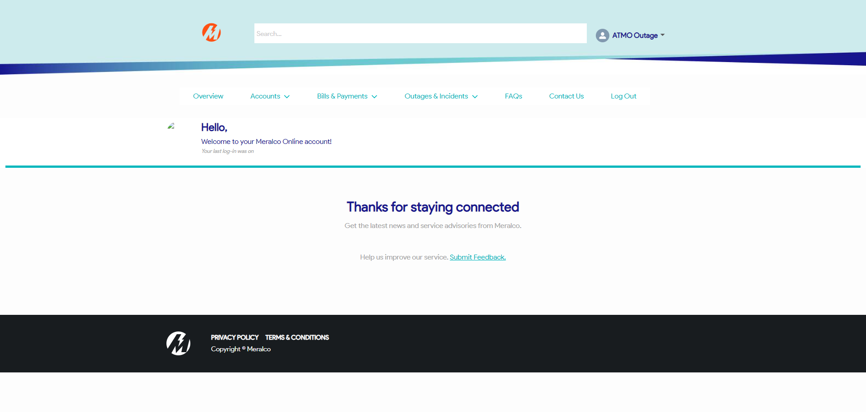

|  |
| --- |
| Step 2 - Go to Outages & Incidents > View/Report Outages |
| Map should be displayed |

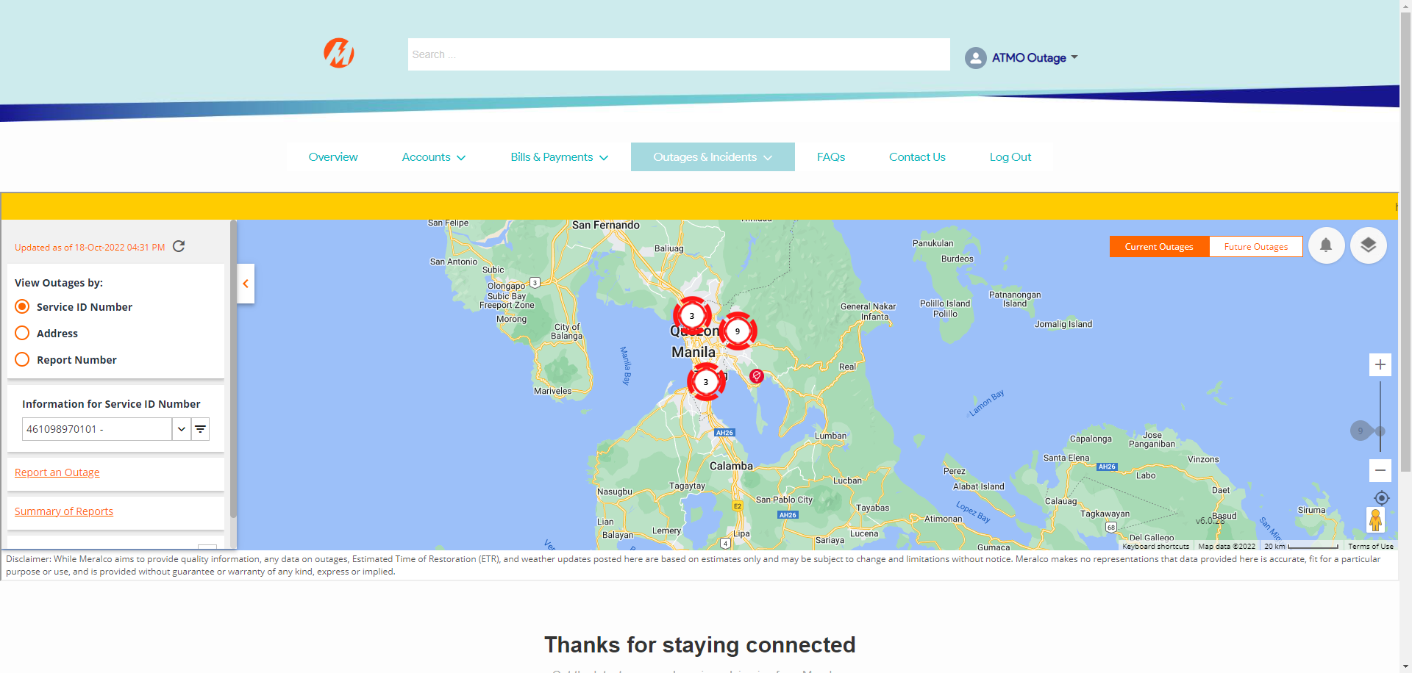

|  |
| --- |
| Step 3 - Tick Address on View Outages by |
| The following should be displayed under View Outages by section: - Current Address - Other Address |

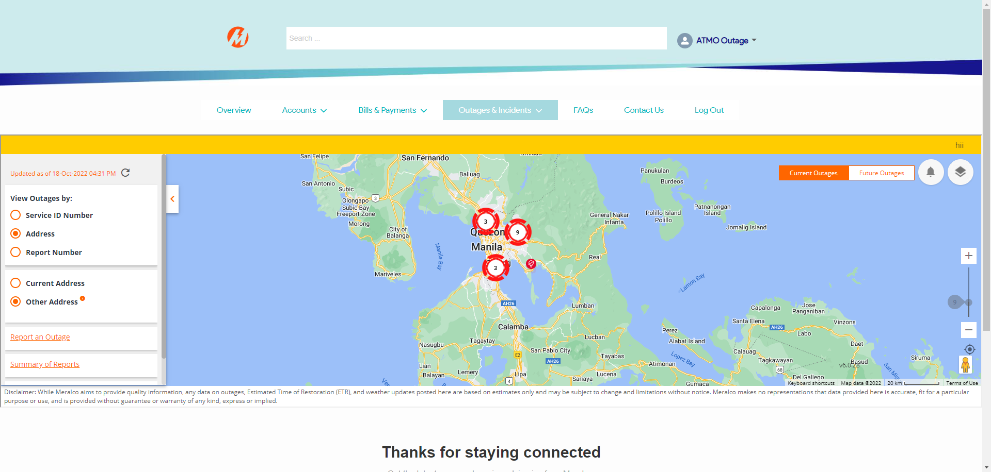

|  |
| --- |
| Step 4 - Hover on tooltip beside Other Address |
| Message should be displayed: Please pin your location on the map to help us identify if your area is affected by an outage. |

Passed