|  |
| --- |
| TS064 - Validation in External Map: Information Panel (Guest) |

|  |
| --- |
| TC147_External: Viewing as Guest User - Tooltip |

|  |
| --- |
| Step 1 - Go to https://fuat-meralco.cs73.force.com/customers/s/outagemap |
| Map should be displayed |

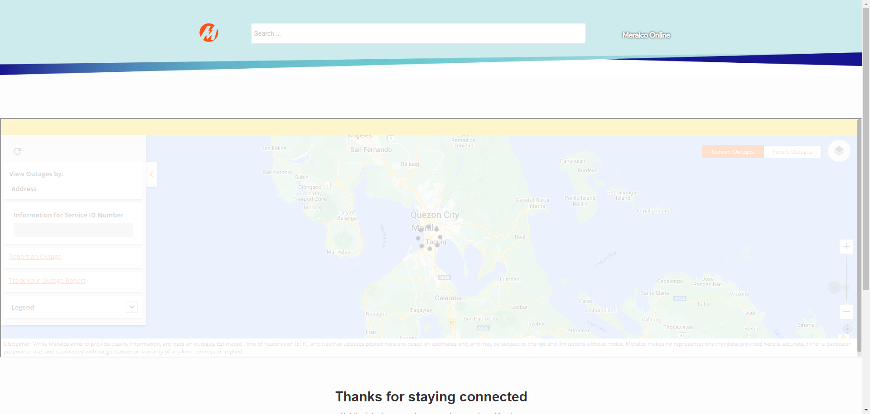

|  |
| --- |
| Step 2 - On the left side, hover on tooltip beside Other Address |
| Message should be displayed: Please pin your location on the map to help us identify if your area is affected by an outage. |