|  |
| --- |
| TS066 - Validation in External Map: Track Your Outage Report (Guest) |

|  |
| --- |
| TC151_External: Viewing as Guest User - Track Your Outage Report |

|  |
| --- |
| Step 1 - Go to https://fuat-meralco.cs73.force.com/customers/s/outagemap |
| Map should be displayed |

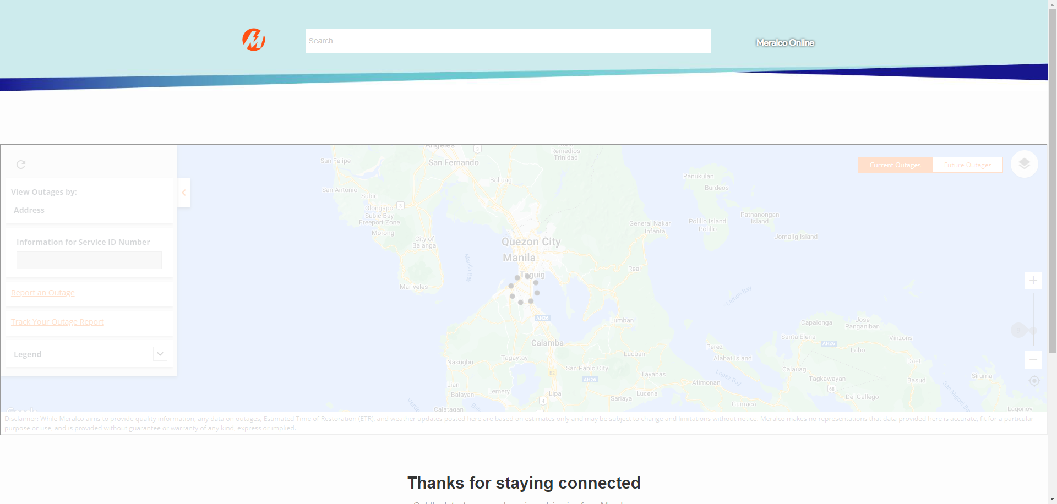

|  |
| --- |
| Step 2 - Click Track your Outage Report |
| Know the Status of your concern page should be displayed |

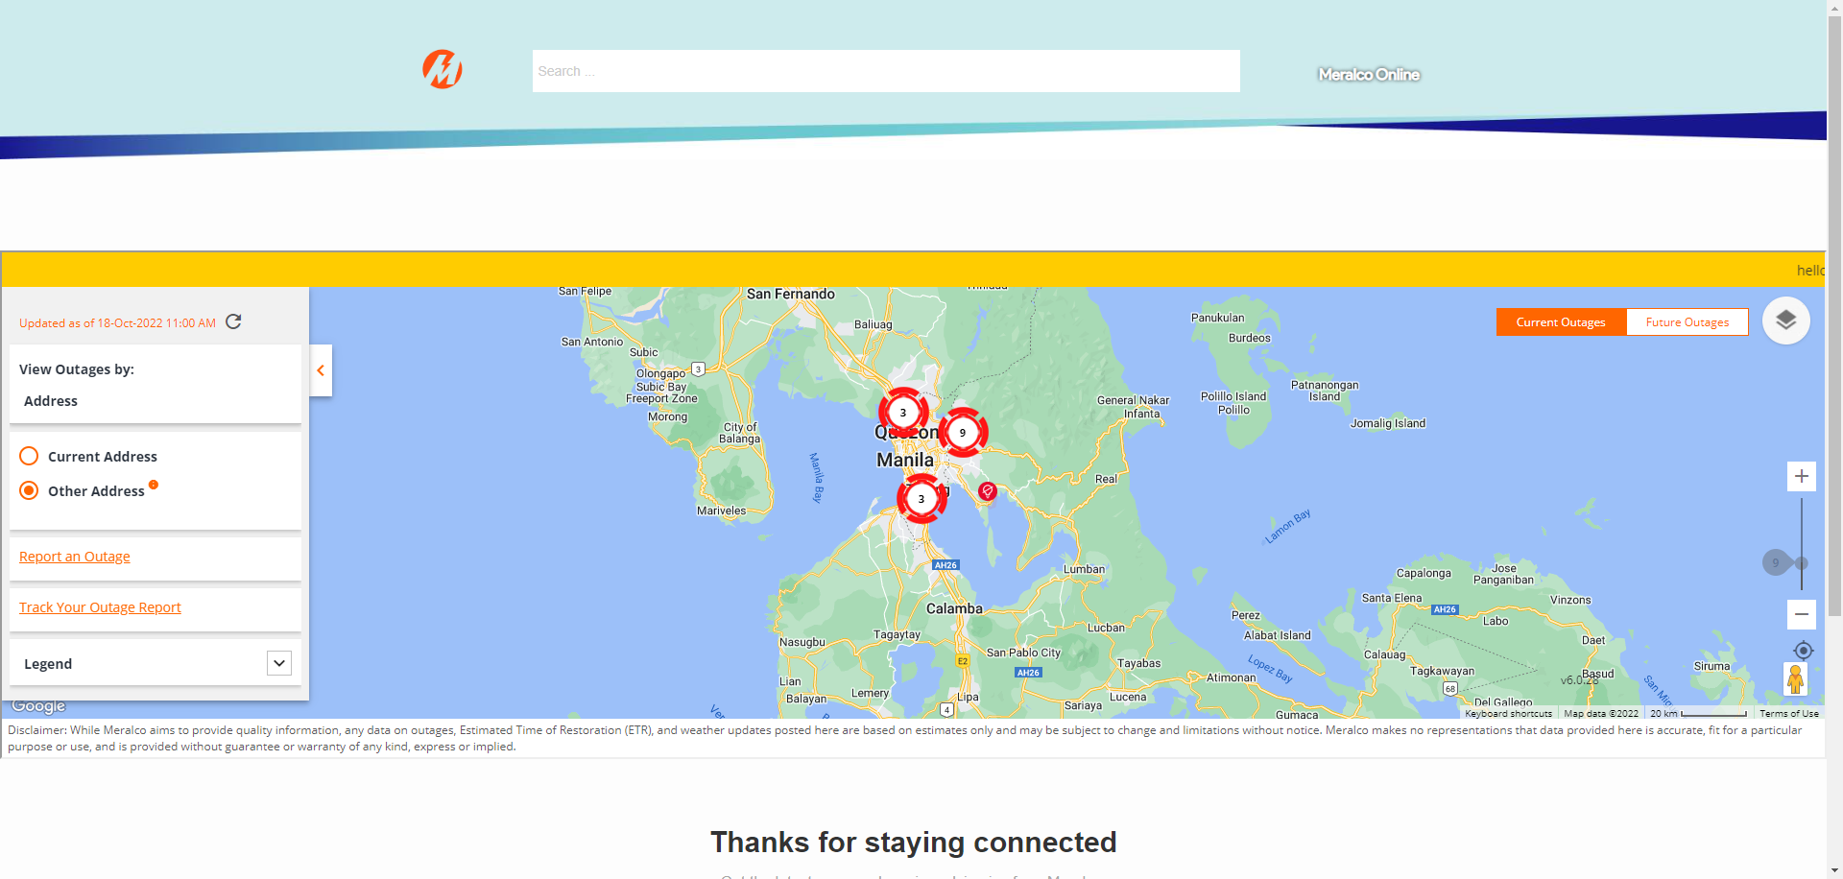

|  |
| --- |
| Step 3 - Populate Reference No. and Last Name > click Submit |
| Details of the report should be displayed in Progress Report page |

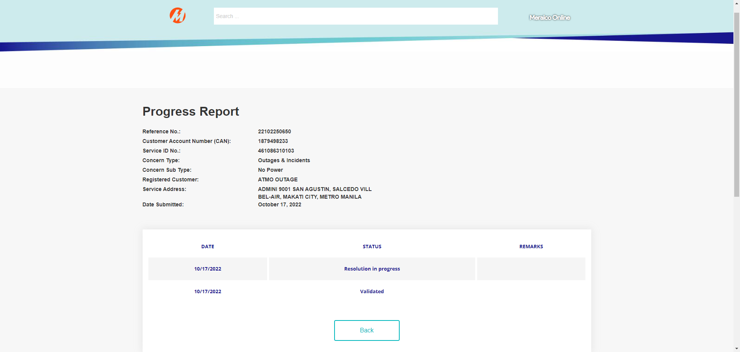

Passed