|  |
| --- |
| TS067 - Validation in External Map: Incident Filter for Authenticated Users |

|  |
| --- |
| TC152_External: Viewing as Authenticated User - Incident Filter |

|  |
| --- |
| Step 1 - Login to Meralco Online |
| User should be logged in |

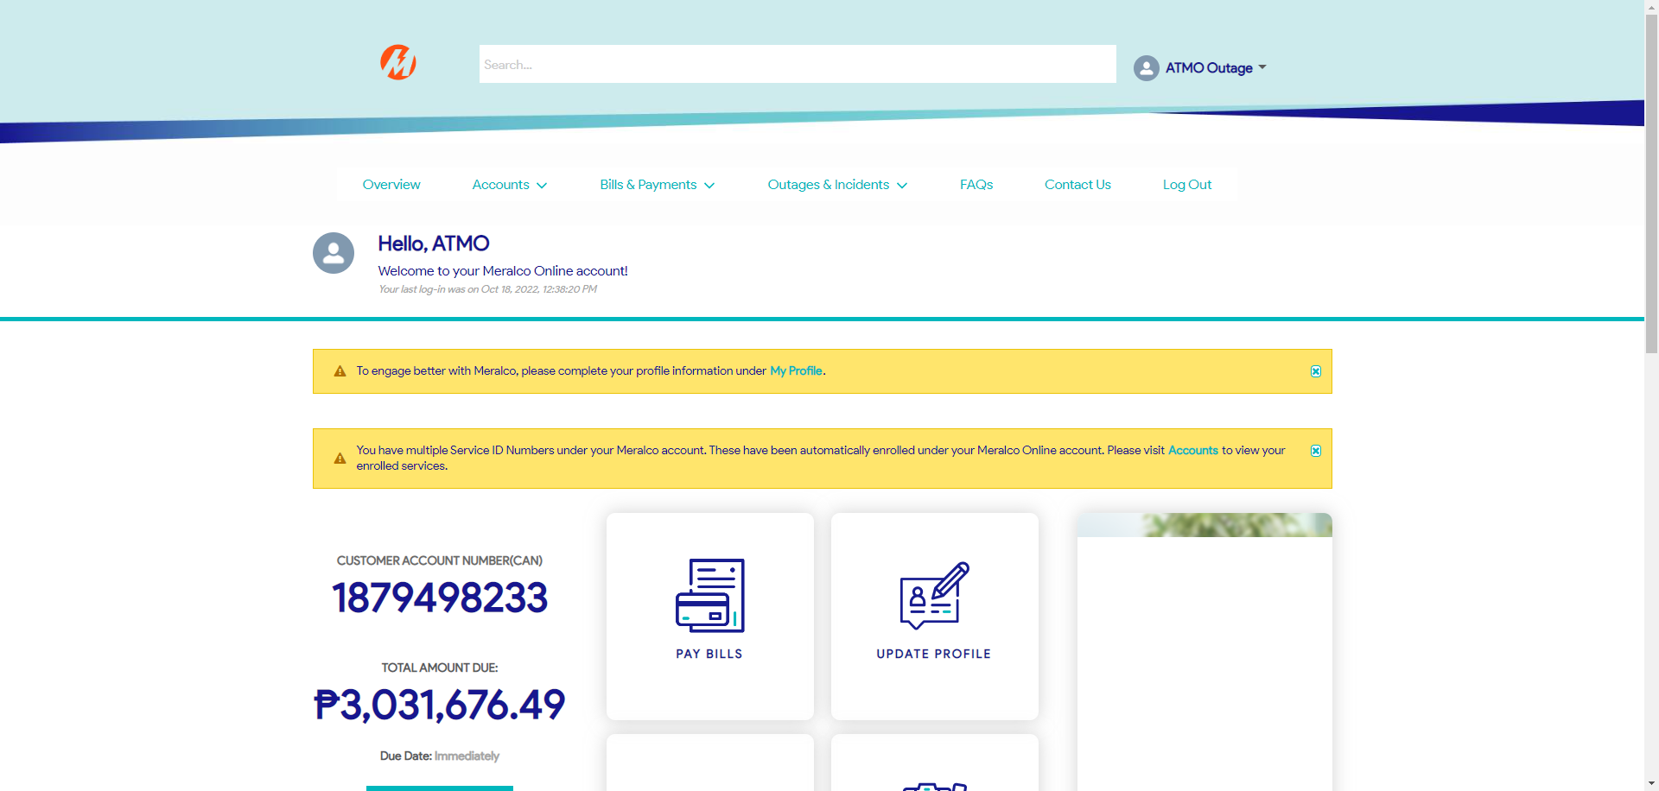

|  |
| --- |
| Step 2 - Go to Outages & Incidents > View/Report Outages |
| Map should be displayed |

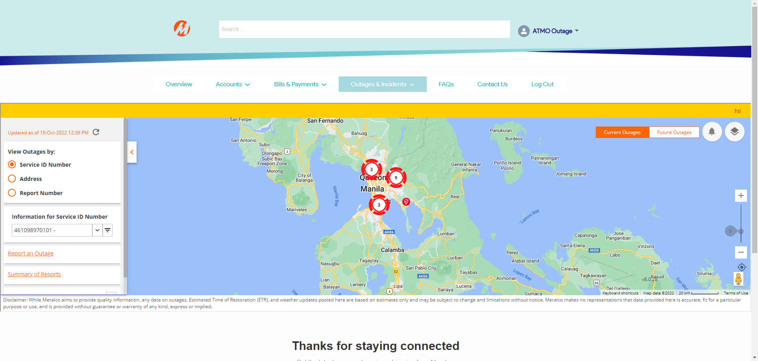

|  |
| --- |
| Step 3 - Click on Map Views button > Select All under Outage Type |
| All Outage Type should be displayed |

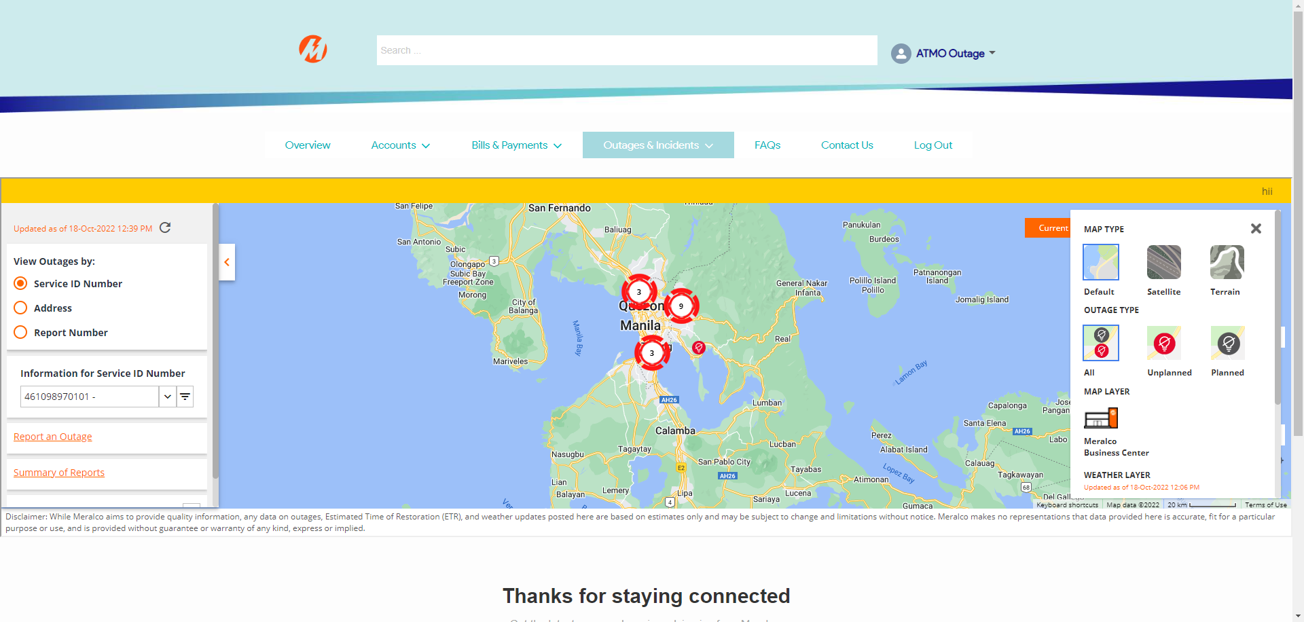

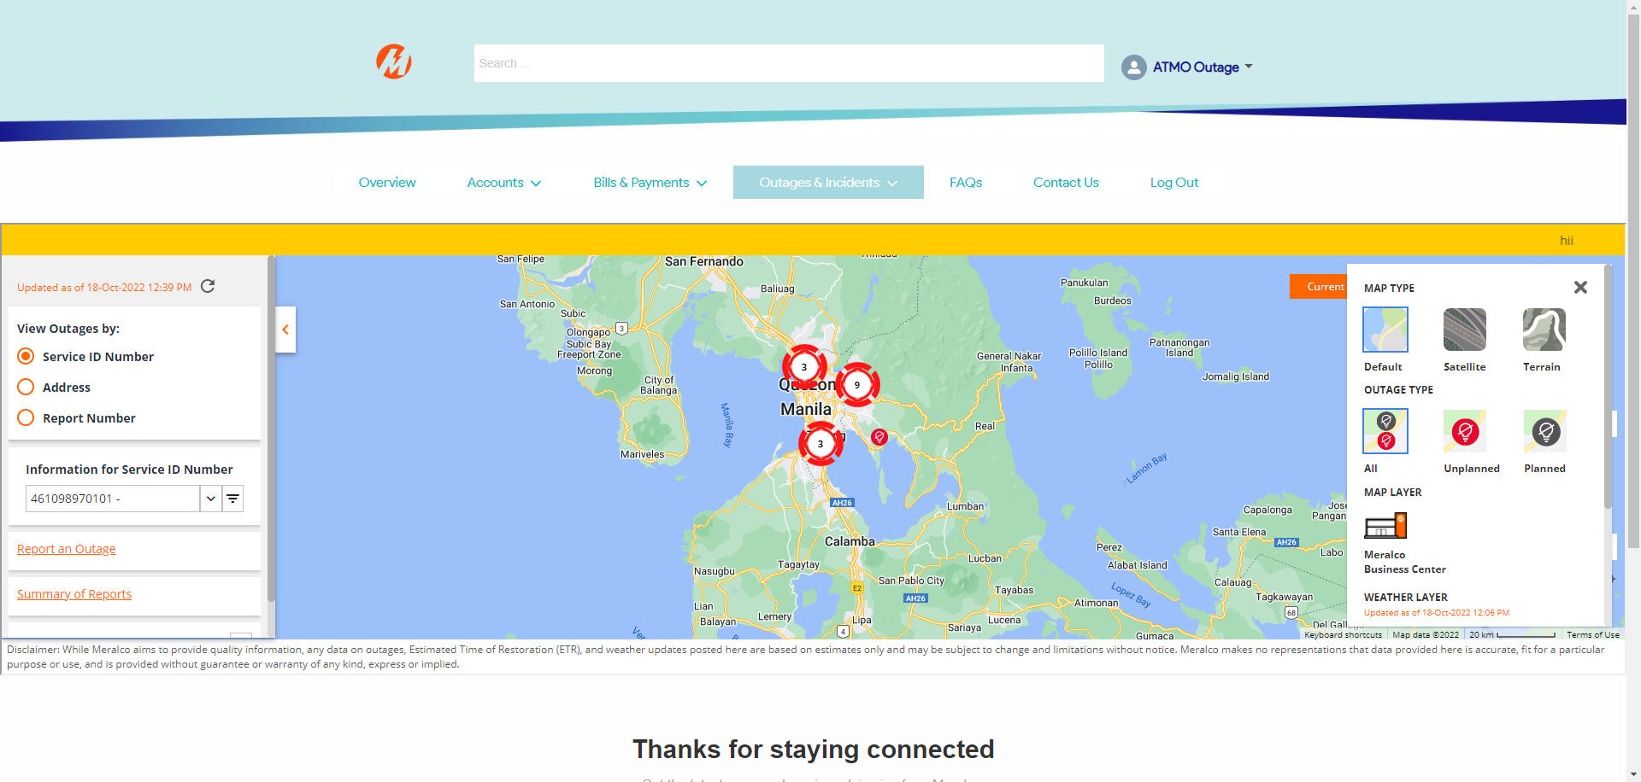

|  |
| --- |
| Step 4 - Click on any Outage Pin |
| Outage details should be displayed |

|  |
| --- |
| Step 5 - Click on Map Views button > Select Unplanned under Outage Type |
| All Outage Type should be displayed |

|  |
| --- |
| Step 6 - Click on any Outage Pin |
| Outage details should be displayed |

|  |
| --- |
| Step 7 - Click on Map Views button > Select Planned under Outage Type |
| All Outage Type should be displayed |

|  |
| --- |
| Step 8 - Click on any Outage Pin |
| Outage details should be displayed |

Passed