|  |
| --- |
| TS068 - Validation in External Map: Incident Filter for Guest Users |

|  |
| --- |
| TC153_External: Viewing as Guest User - Incident Filter |

|  |
| --- |
| Step 1 - Go to https://fuat-meralco.cs73.force.com/customers/s/outagemap |
| Map should be displayed |

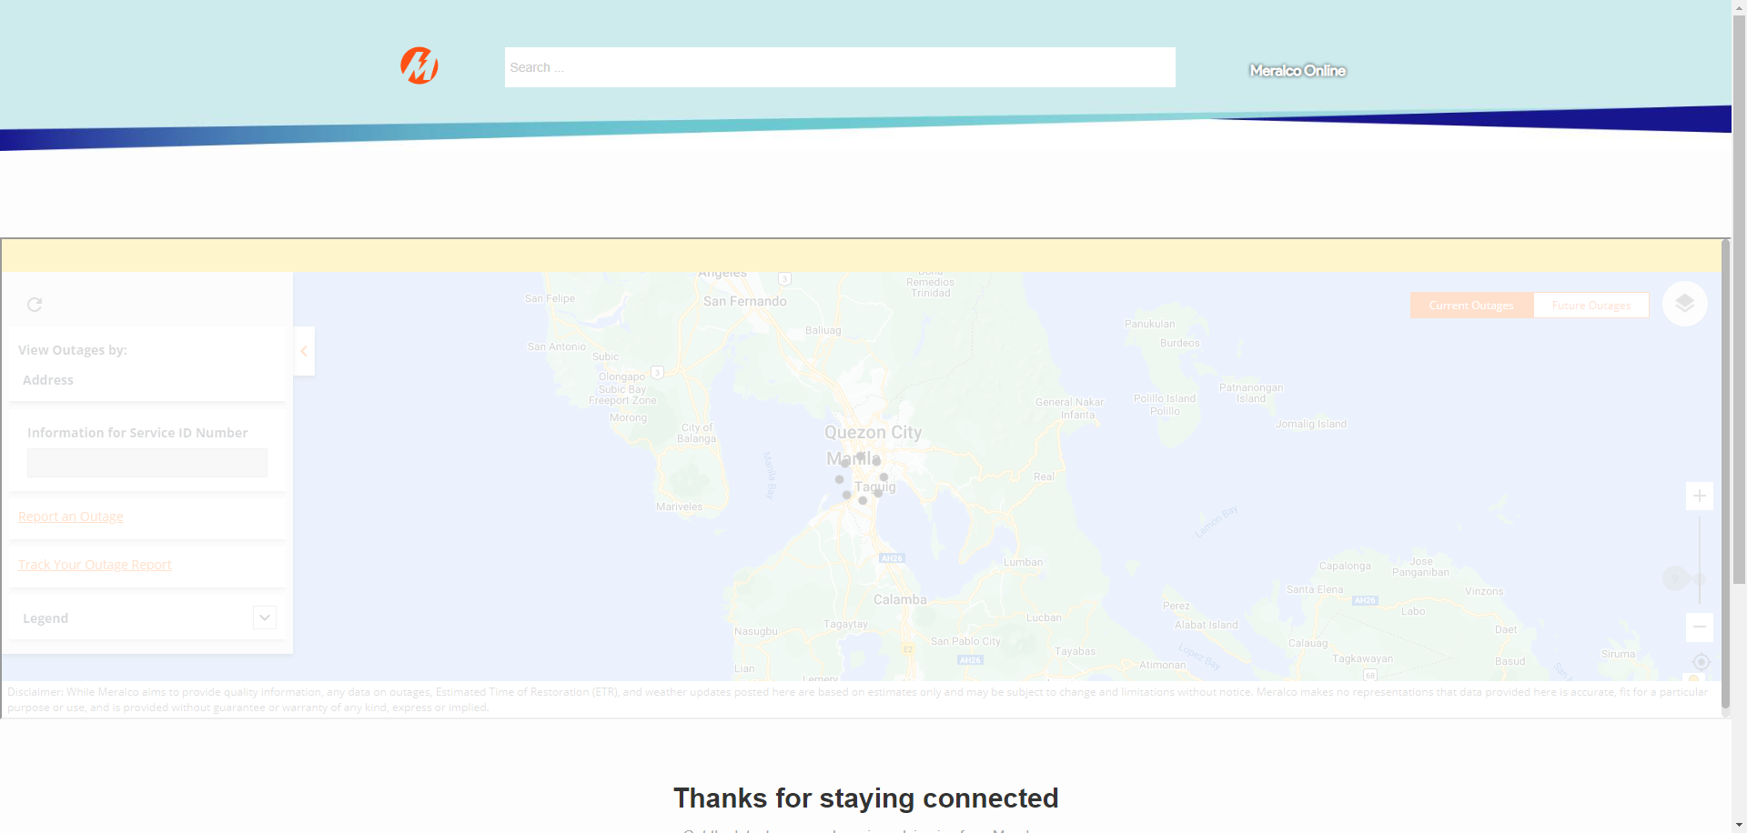

|  |
| --- |
| Step 2 - Click on Map Views button > Select All under Outage Type |
| All Outage Type should be displayed |

Passed