|  |
| --- |
| TS069 - Validation in External Map: Viewing of Meralco Business Centers |

|  |
| --- |
| TC154_External: Viewing as Authenticated User - Meralco Business Centers |

|  |
| --- |
| Step 1 - Login to Meralco Online |
| User should be logged in |

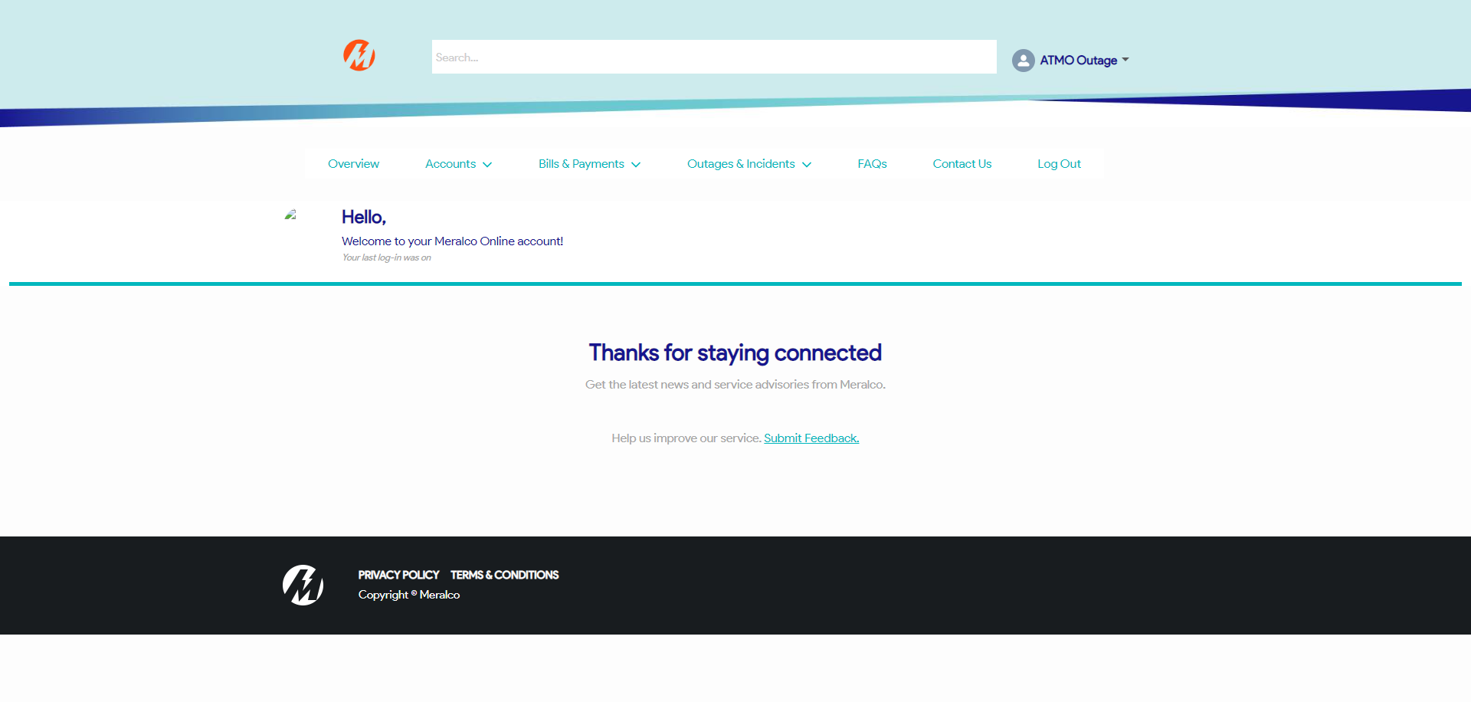

|  |
| --- |
| Step 2 - Go to Outages & Incidents > View/Report Outages |
| Map should be displayed |

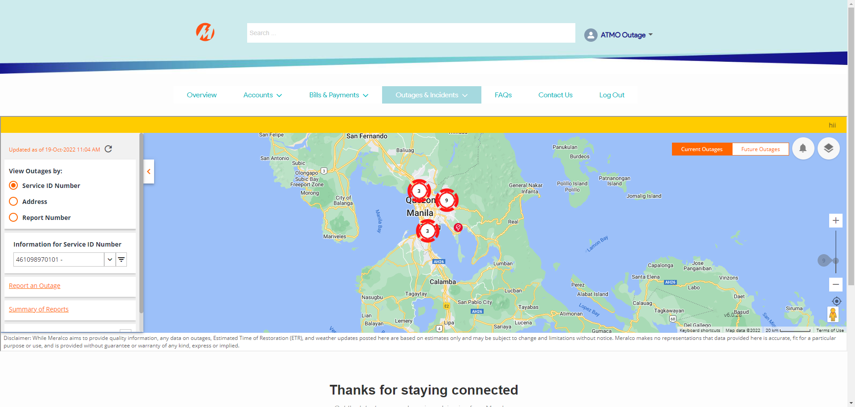

|  |
| --- |
| Step 3 - Click on Map Views button > Click Meralco Business Center under Map Layers |
| Message prompt should be displayed: The standard operating hours of our Business Centers are from Mon-Fri, 8am-5pm. For more info, visit our business center page in our website. |

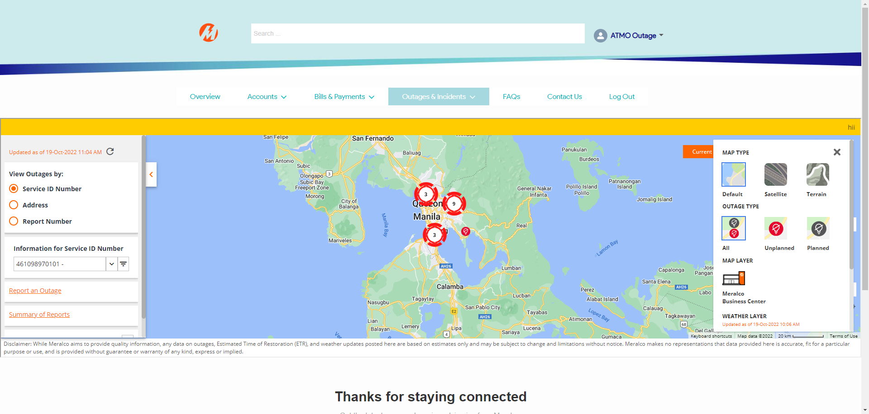

|  |
| --- |
| Step 4 - Click x |
| Meralco Business Center should be displayed in Map |

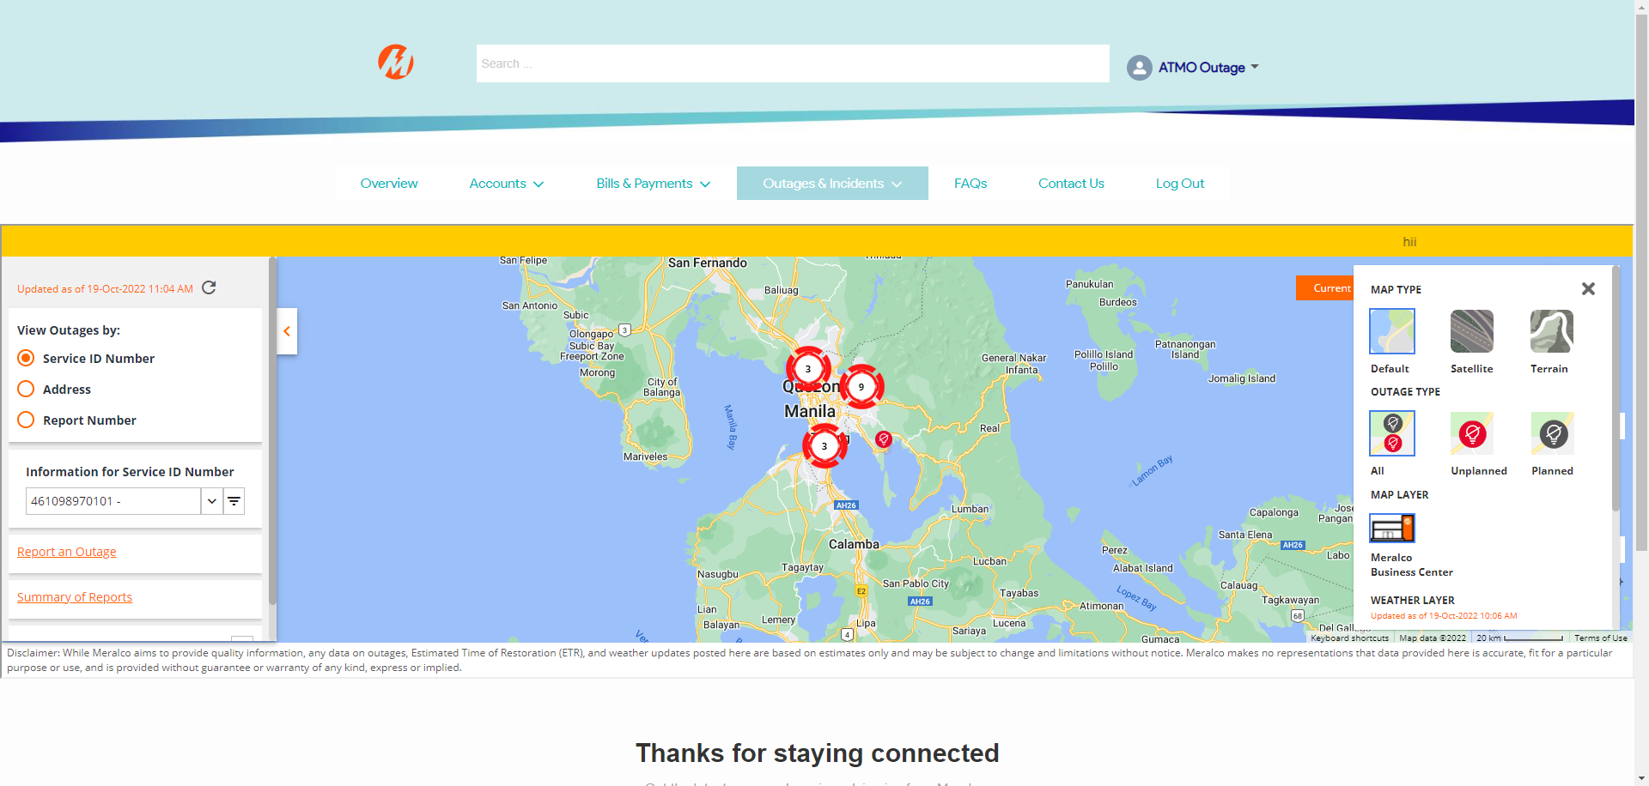

Passed