|  |
| --- |
| TS070 - Validation in External Map: Viewing of Meralco Business Centers for Guest Users |

|  |
| --- |
| TC155_External: Viewing as Guest User - Meralco Business Centers |

|  |
| --- |
| Step 1 - Go to https://fuat-meralco.cs73.force.com/customers/s/outagemap |
| Map should be displayed |

|  |
| --- |
| Step 2 - Click on Map Views button > Click Meralco Business Center under Map Layers |
| Message prompt should be displayed: The standard operating hours of our Business Centers are from Mon-Fri, 8am-5pm. For more info, visit our business center page in our website. |

|  |
| --- |
| Step 3 - Click x |
| Meralco Business Center should be displayed in Map |

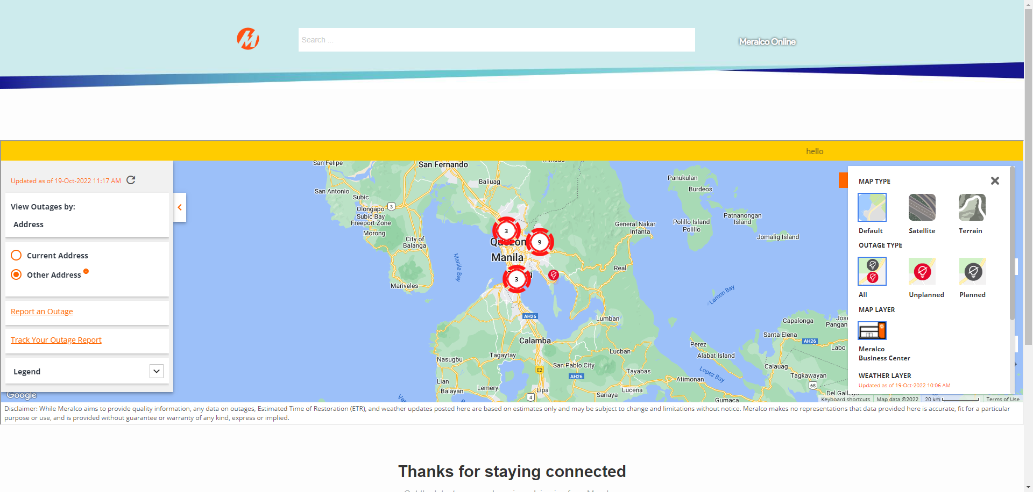

Passed