|  |
| --- |
| TS072 - Validation in External Map: View Weather Layer for External Users (Guest User) |

|  |
| --- |
| TC157_External: Viewing as Guest User - Weather Layer |

|  |
| --- |
| Step 1 - Go to https://fuat-meralco.cs73.force.com/customers/s/outagemap |
| Map should be displayed |

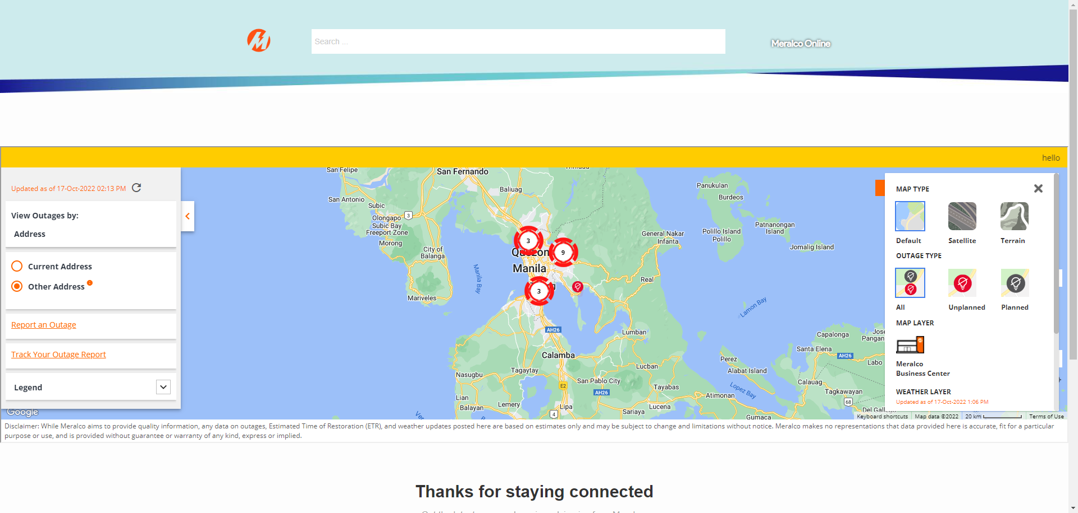

|  |
| --- |
| Step 3 - Click on Map Views > Select Temperature under Weather Layer |
| Message prompt should be displayed:  Weather data reflected here were authored by OpenWeatherMap.org. Meralco does not engage in weather measurement and forecasting, and relies solely on said external source for weather information. Weather data is normally updated every 3 hours depending on its availability. |

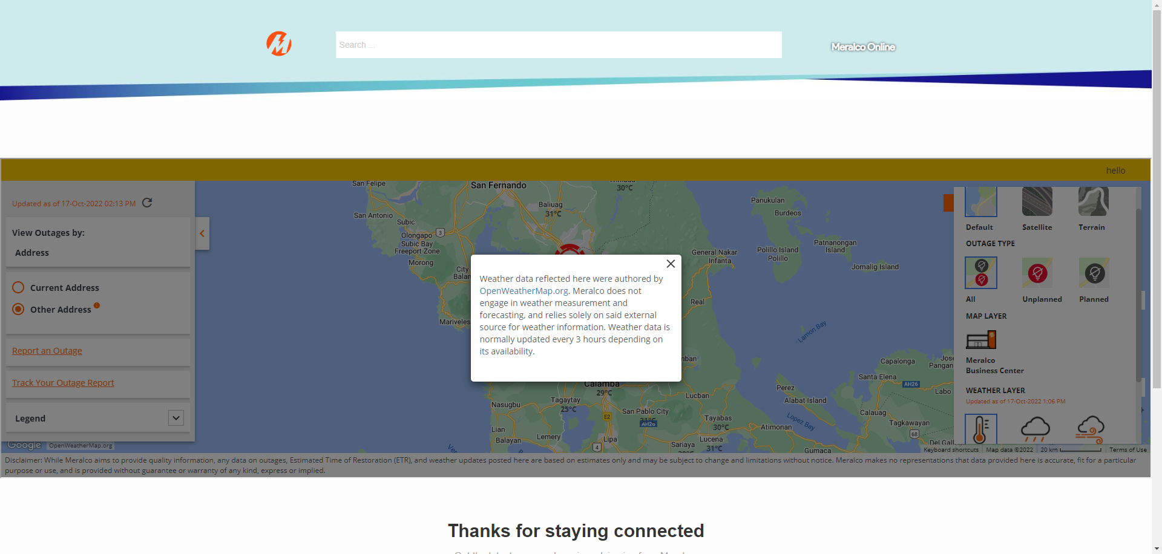

|  |
| --- |
| Step 4 - Click x |
| Temperature should be displayed in map. |

|  |
| --- |
| Step 5 - On Map views, select Wind Speed under Weather Layer |
| Wind Speed icon should be displayed in map |

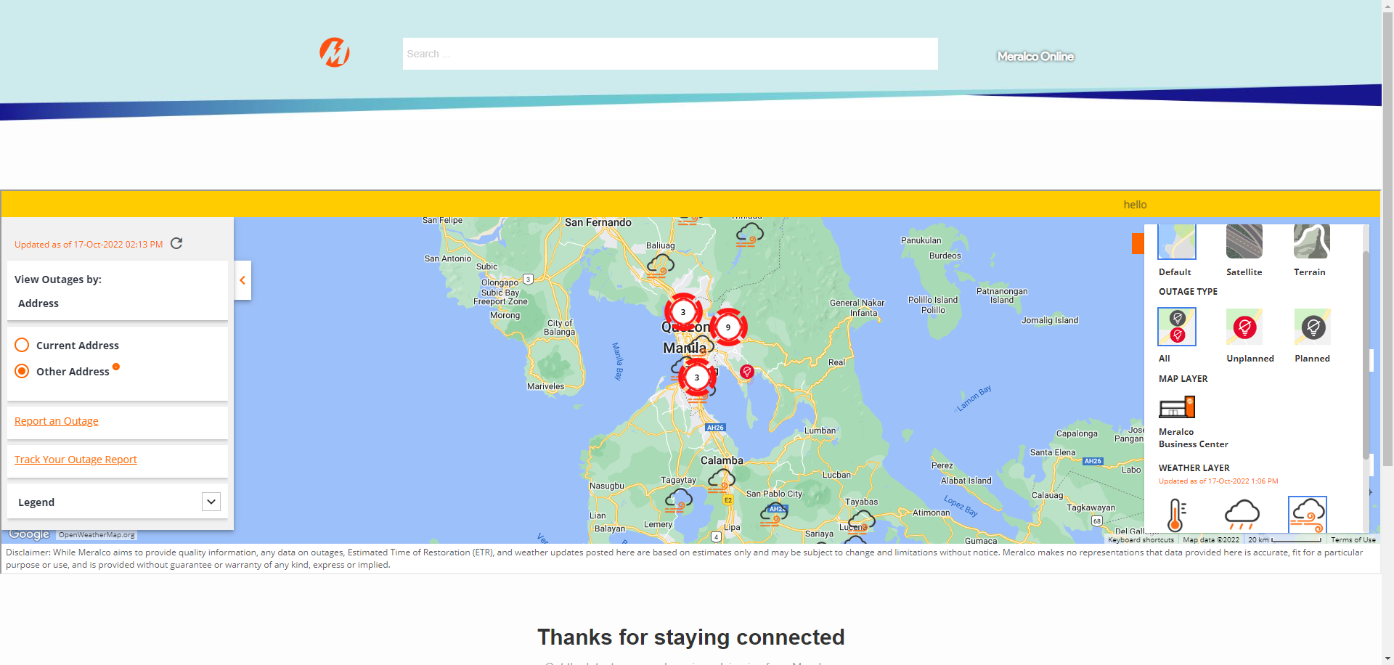

Passed