|  |
| --- |
| TS002 - TC004_Successful Registration; Payor |

|  |
| --- |
| TC004_Successful Registration; Payor |

|  |
| --- |
| Step 1 - Go to Registration page |
| Registration page should be displayed |

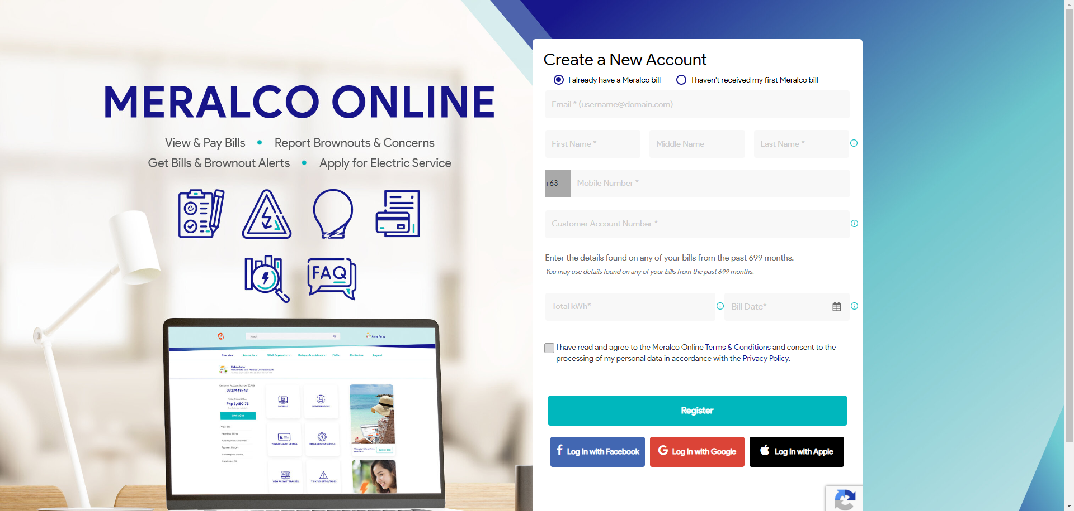

|  |
| --- |
| Step 2 - Populate the following field: - Email - First Name - Middle Name (optional) - Last Name - Mobile Number Customer Account Number - Total kWh - Bill Date  Note: Customer's name should match the Contract's Account Name |
| Field should be populated |

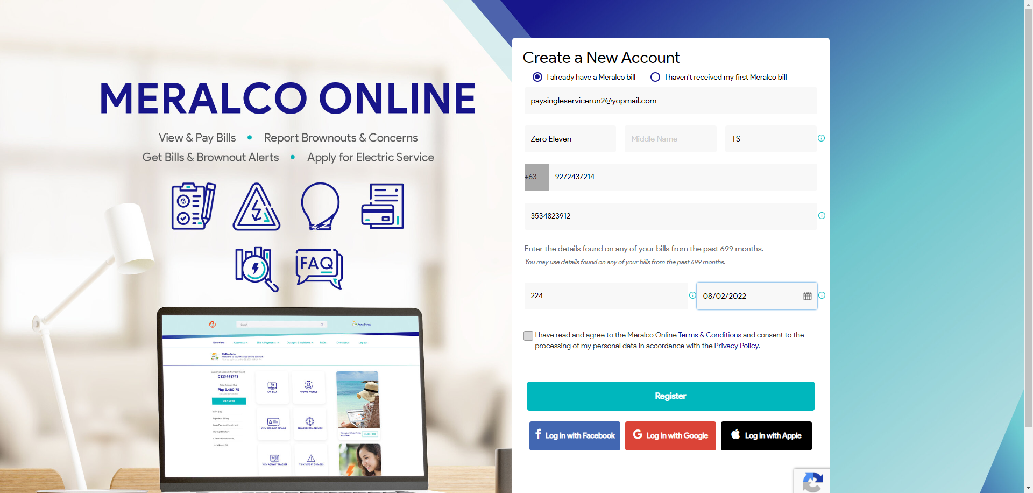

|  |
| --- |
| Step 3 - Tick on Meralco Online Terms & Conditions > Click Register |
| Registration should be successful |

