|  |
| --- |
| TS012 - TC011_Validation of CAN in Service Enrollment Email Notification |

|  |
| --- |
| TC012_Registration_Google |

|  |
| --- |
| Step 1 - Go to Registration page |
| User should be directed to Registration Page. |

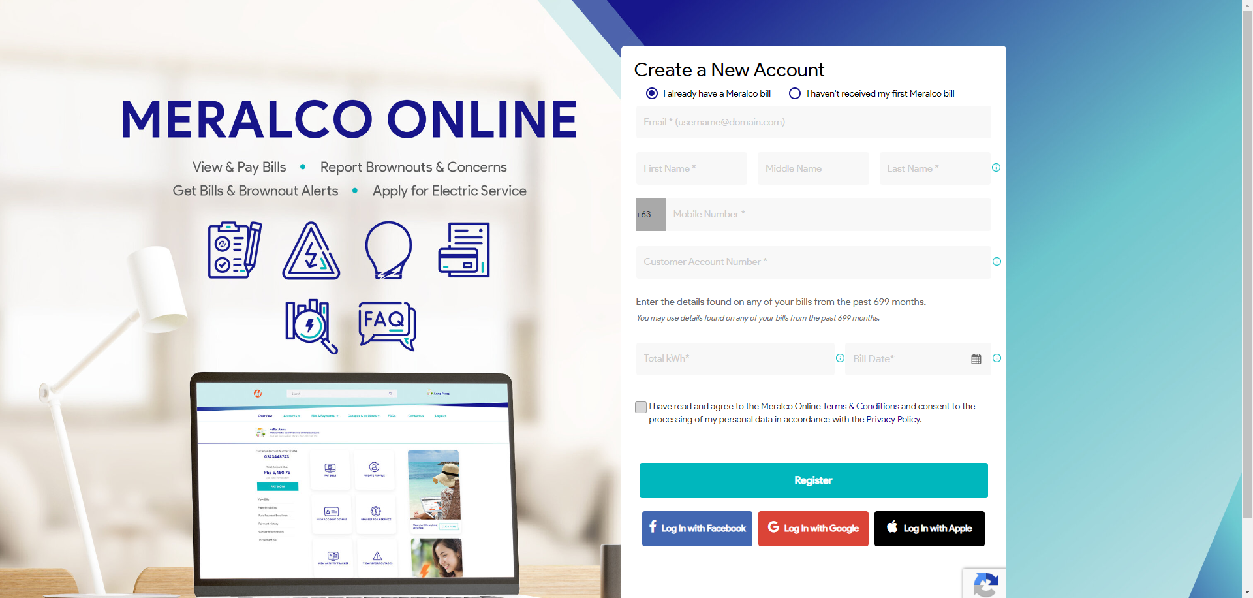

|  |
| --- |
| Step 2 - Click Sign In with Google |
| - Google login page should be displayed. |

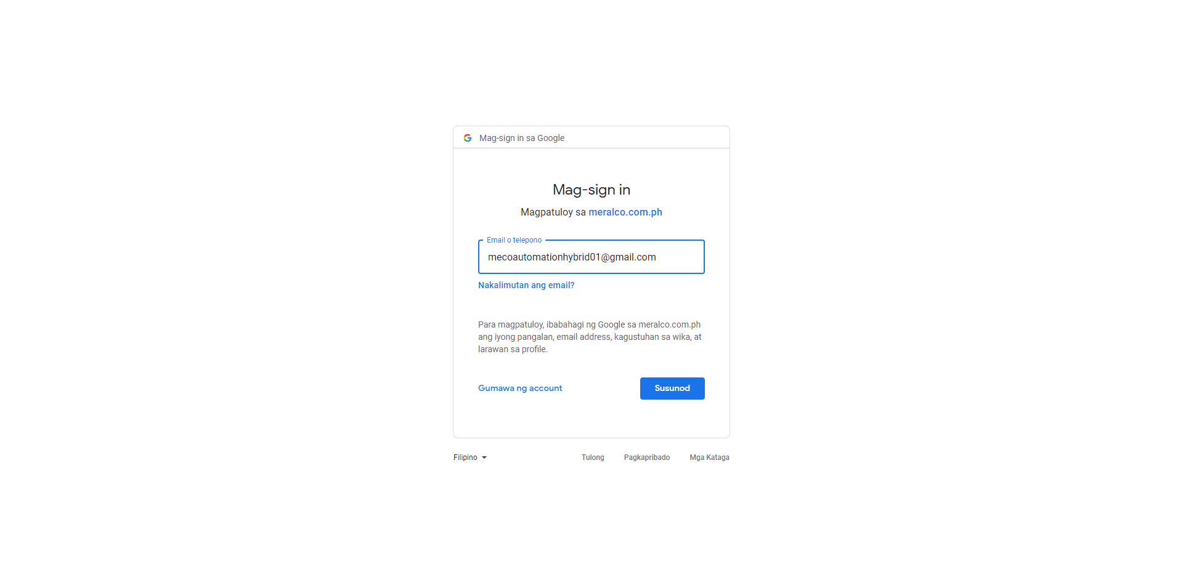

|  |
| --- |
| Step 3 - Populate required credentials > Login |
| - User should be logged in successfully |

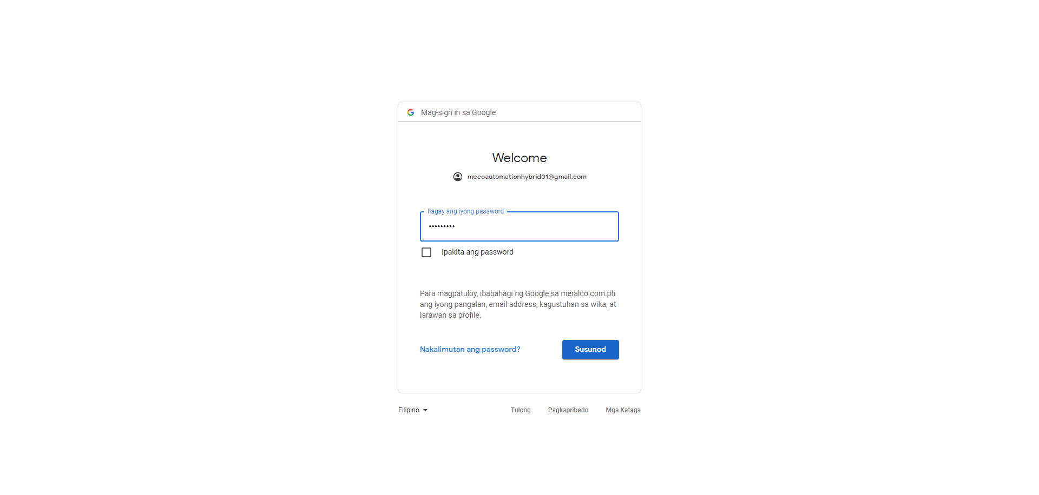

|  |
| --- |
| TC011_Validation of CAN in Service Enrollment Email Notification |

|  |
| --- |
| Step 1 - Validate Email Notification |
| CAN should be included in the Service Enrollment Notification  Note: Kindly see Reference tab for Service Enrollment Notification |

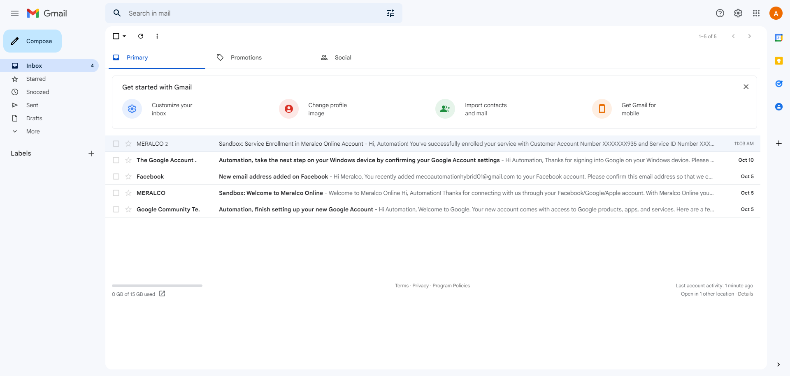

Passed