|  |
| --- |
| TS015 - TC024_Registration using CAN with Single Service; without first bill |

|  |
| --- |
| CAN used must have single service only; Customer's name should match the Contract's Account Name   'I haven't received my first Meralco bill' should be ticked in Meralco Bill Indicator |

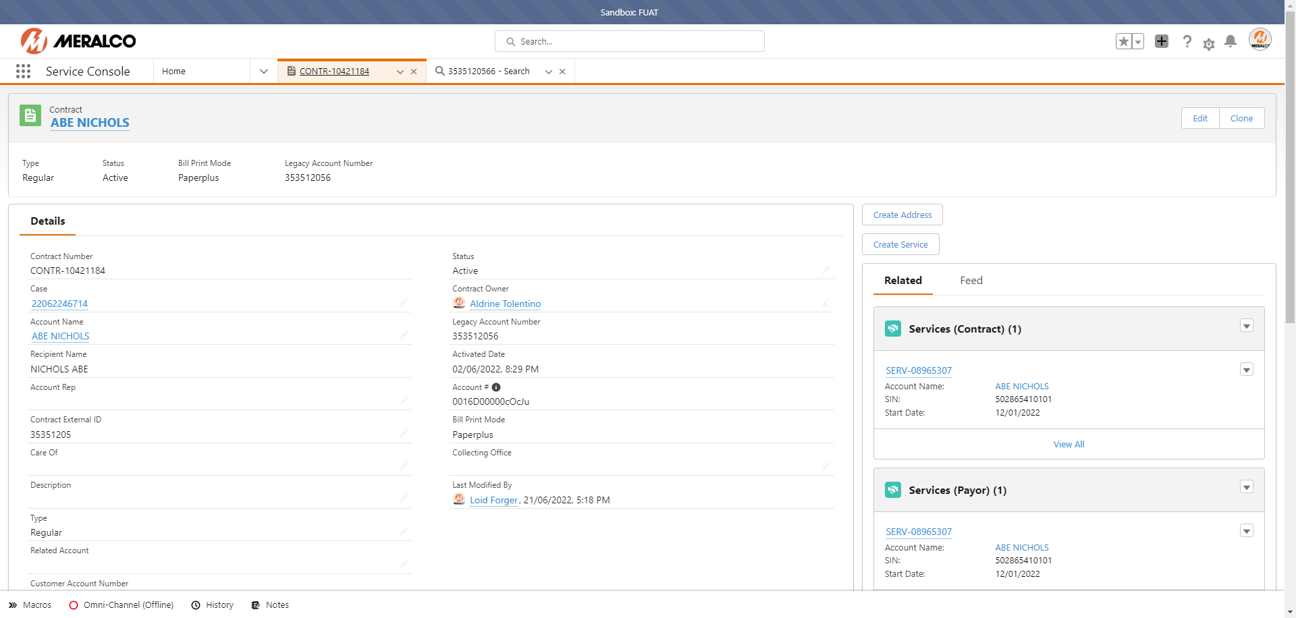

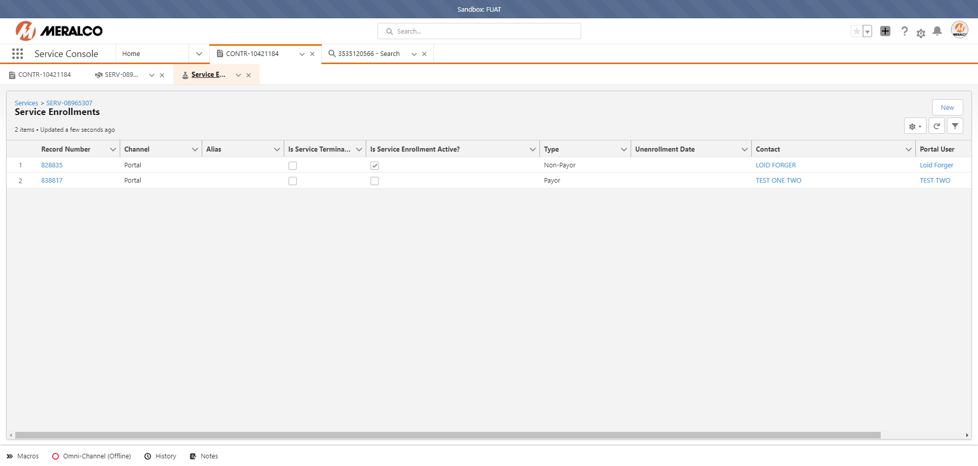

|  |
| --- |
| TC024_Registration using CAN with Single Service; without first bill |

|  |
| --- |
| Step 1 - In Registration page, Populate the following field: - Email - First Name - Middle Name (optional) - Last Name - Mobile Number - Customer Account Number - Bill Deposit - Payment Date |
| Field should be populated |

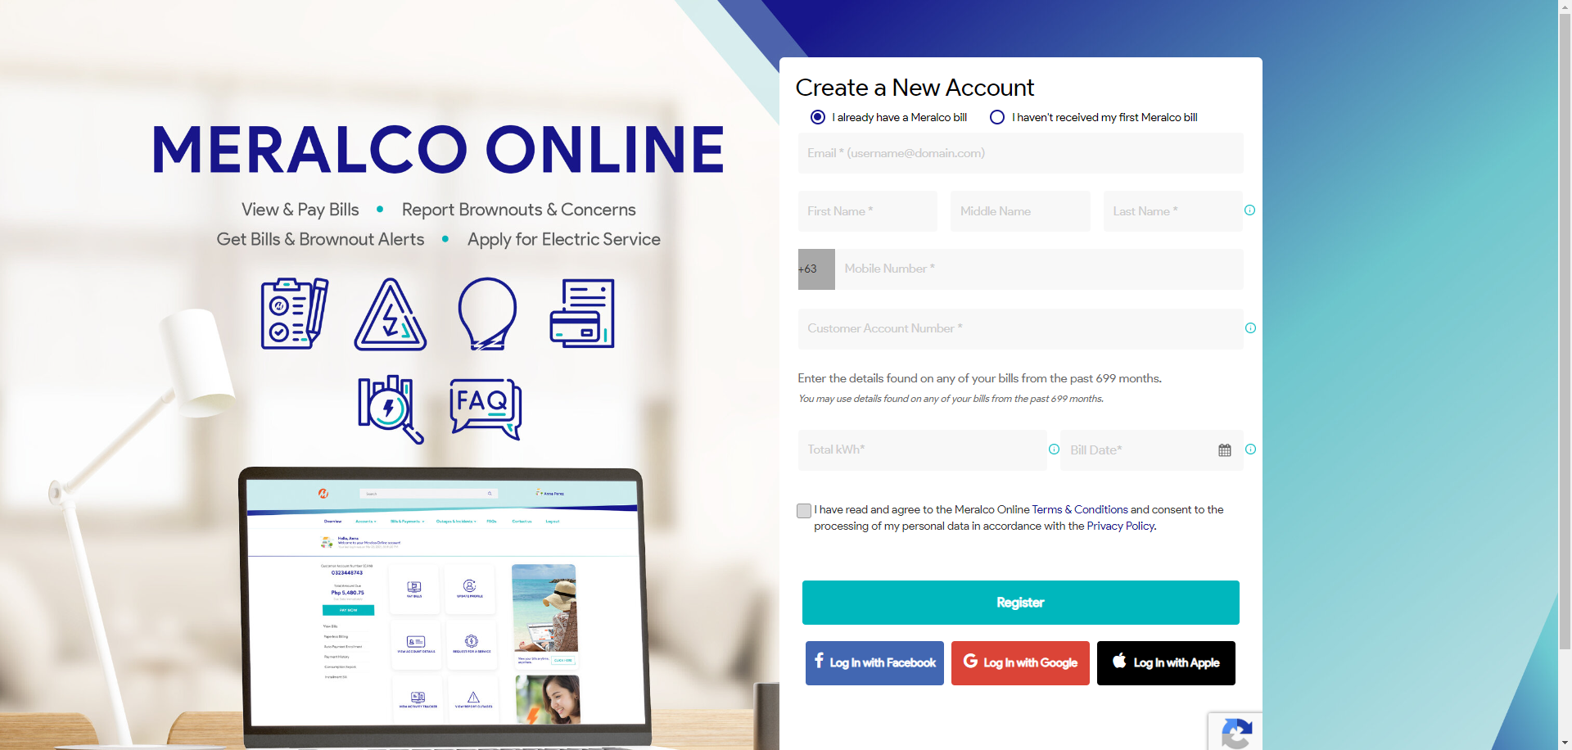

|  |
| --- |
| Step 2 - Tick on Meralco Online Terms & Conditions > Click Register |
| Registration should be successful |

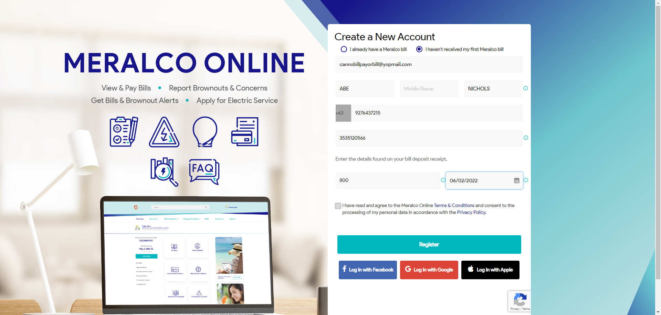

|  |
| --- |
| Step 3 - Verify email confirmation |
| Email confirmation should be received. |

