|  |
| --- |
| TS024 - TC011_Validation of CAN in Service Enrollment Email Notification |

|  |
| --- |
| TC026_Successful Enrollment of CAN and Service_CAN with Single Service only; Meralco Online |

|  |
| --- |
| Step 1 - In Enroll A Service page, tick "I haven't received my first Meralco bill" > populate Customer Account Number field |
| Customer Account Number should be populated. Bill Deposit and Payment Date fields should be displayed. |

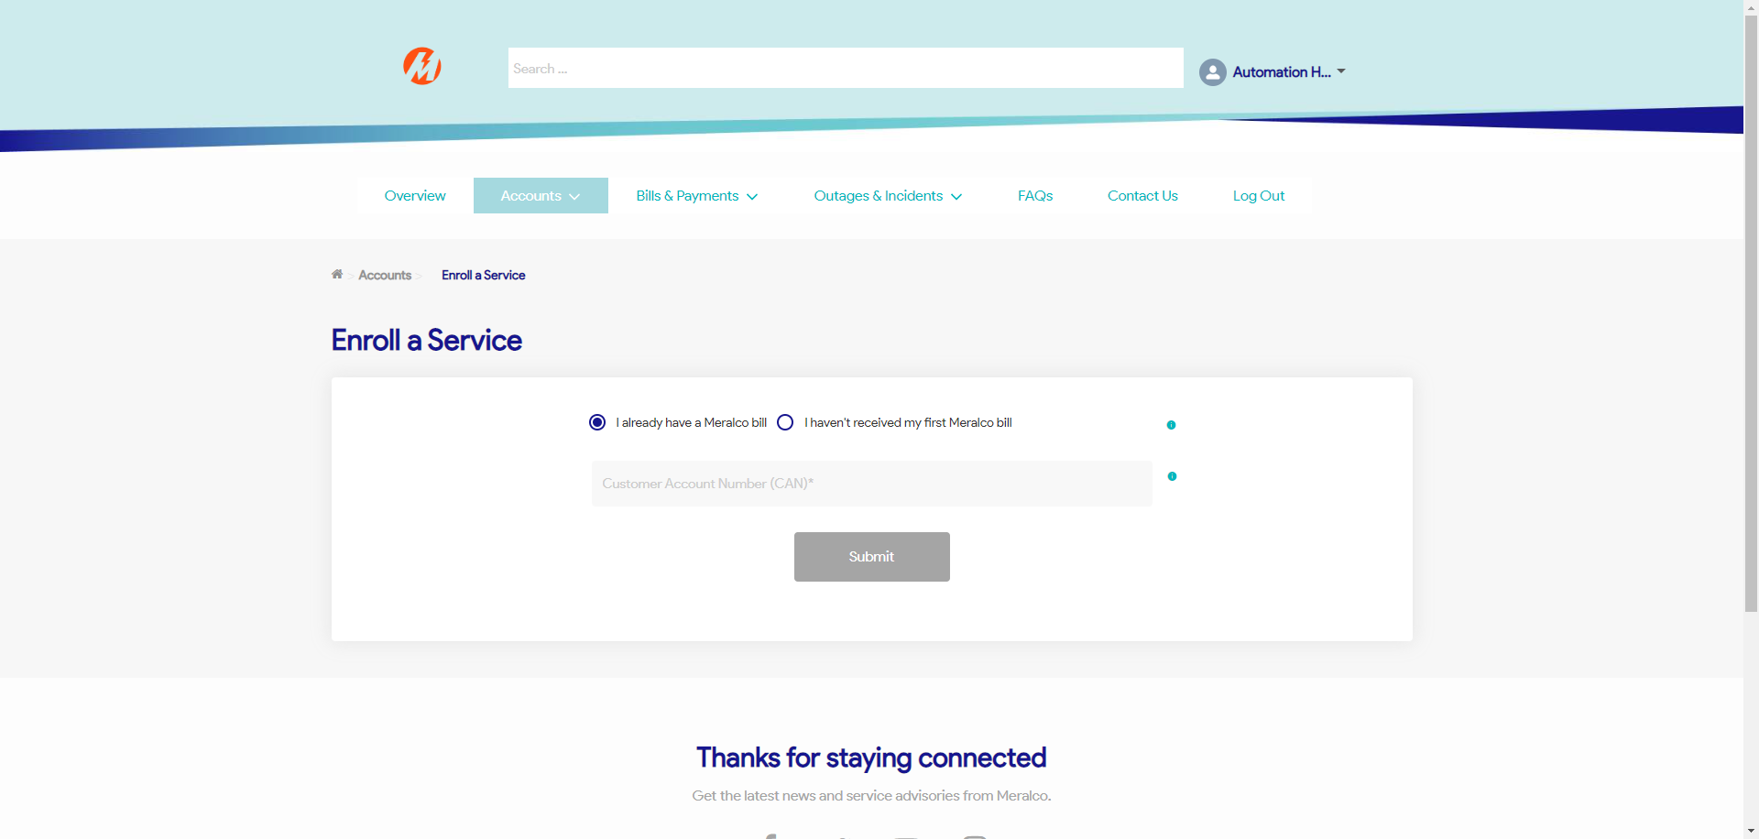

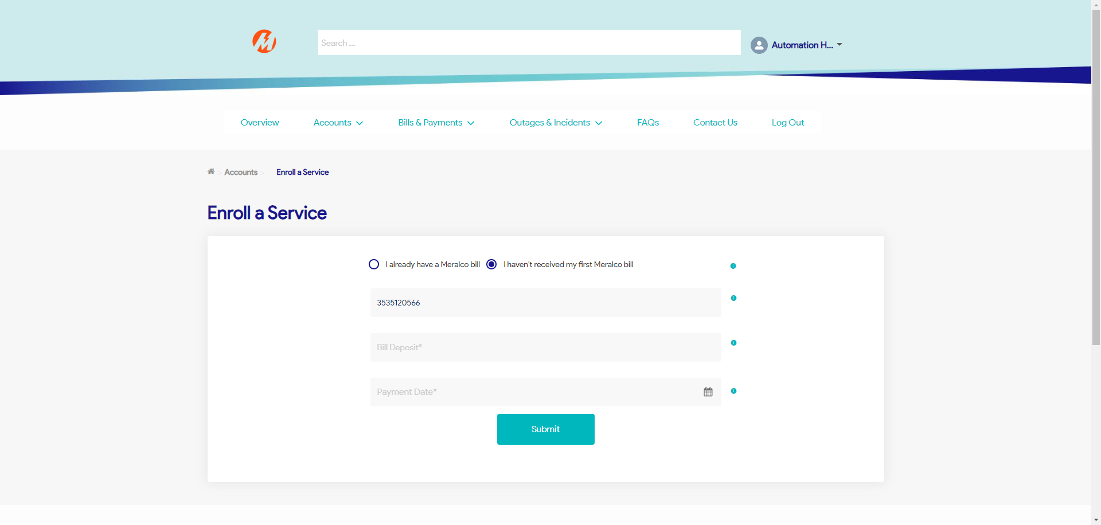

|  |
| --- |
| Step 2 - Populate Bill Deposit and Payment Date fields > Click Submit |
| CAN and Service should be added on the user account successfully |

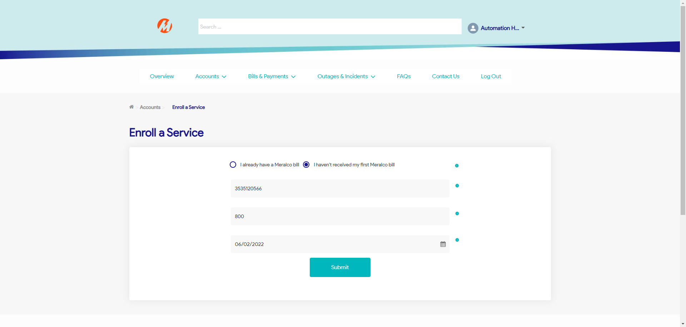

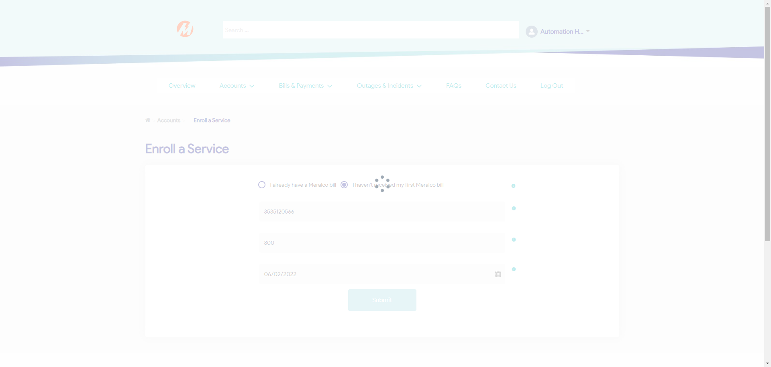

|  |
| --- |
| Step 3 - Go to Accounts > Manage Accounts > Click Submit button > Validate Enrolled CAN and Service |
| Customer Account Number, Service ID Number, Nickname (if any), Address, and Service Status of the enrolled CAN should be added on the Accounts table. |

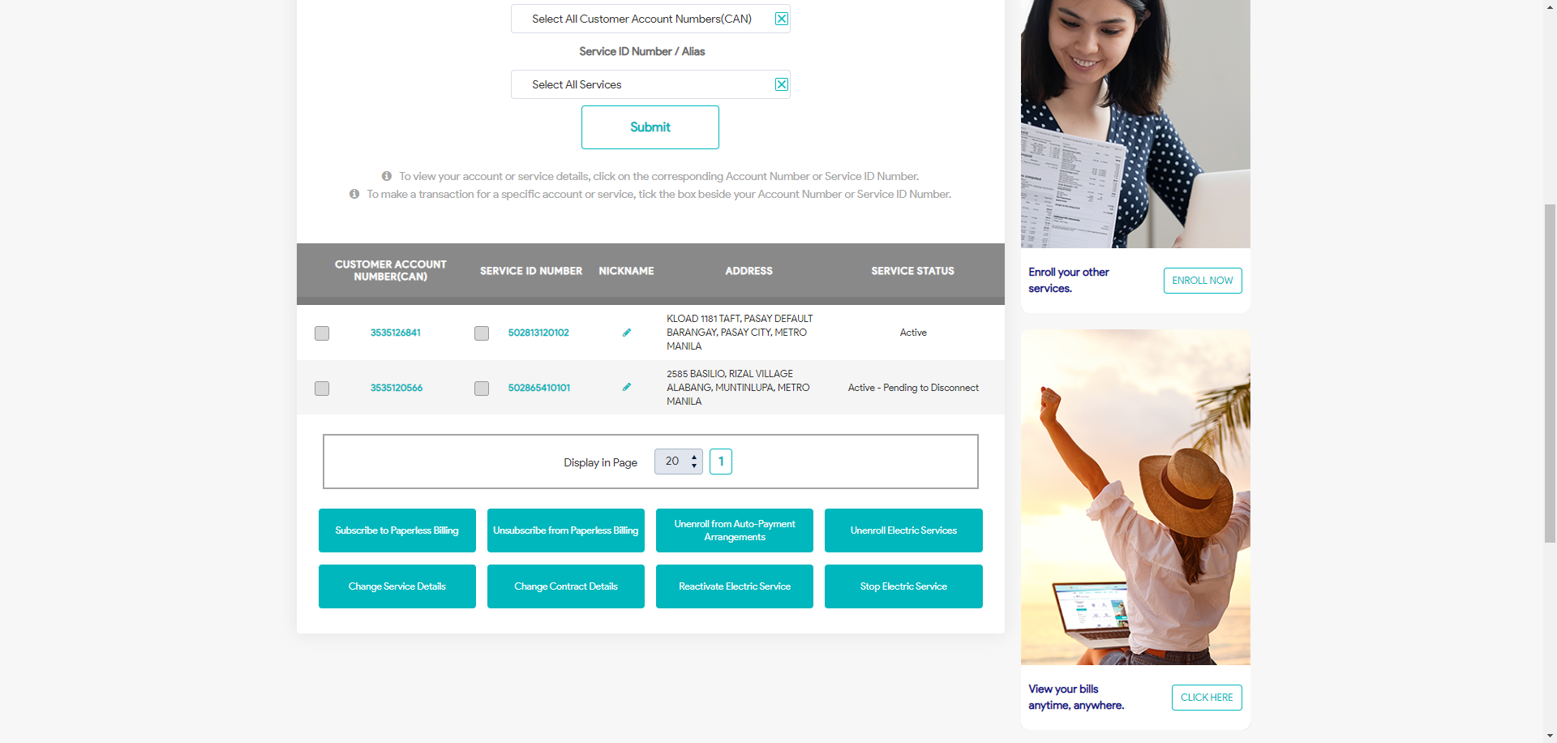

|  |
| --- |
| TC011_Validation of CAN in Service Enrollment Email Notification |

|  |
| --- |
| Step 1 - Validate Email Notification |
| CAN should be included in the Service Enrollment Notification  Note: Kindly see Reference tab for Service Enrollment Notification |

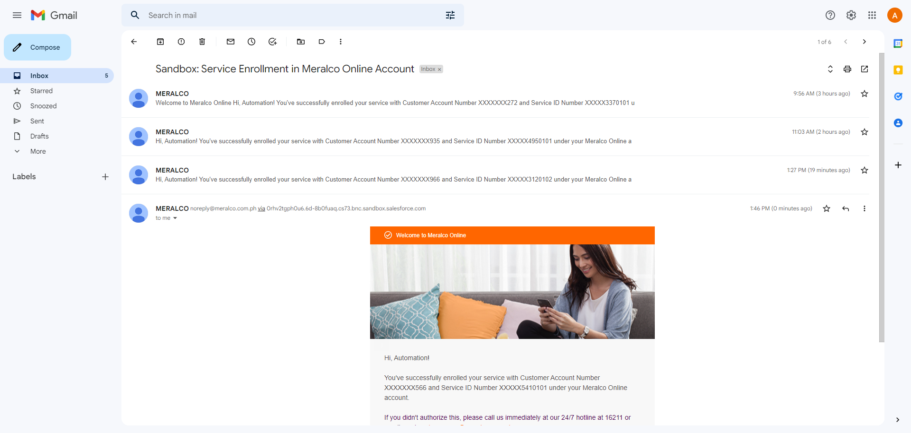

Passed