|  |
| --- |
| TS007 - TC111_Validation of Concern Email Notification |

|  |
| --- |
| TC007_Navigation to Contact Us Page_Guest User |

|  |
| --- |
| Step 1 - Go to https://fuat-meralco.cs73.force.com/customers/s/contact |
| Contact Us page for guest user should be displayed |

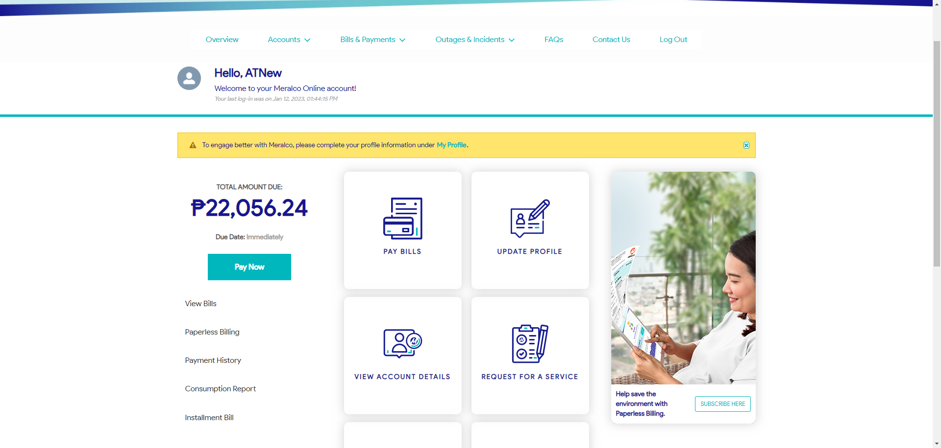

|  |
| --- |
| Step 2 - Click on page indicated in scenario |
| User should be directed to page indicated in scenario |

