|  |
| --- |
| TS032 - TC014_Validation of Service Application Email Notification_Welcome Message |

|  |
| --- |
| TC012_Application for New Service |

|  |
| --- |
| Step 1 - Login to Meralco Online |
| User should be logged in to Meralco Online |

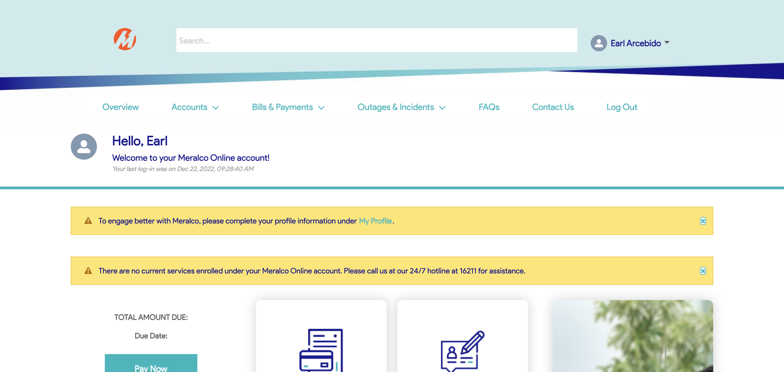

|  |
| --- |
| Step 2 - Click on Request for a Service tile |
| Start a Service page should be displayed |

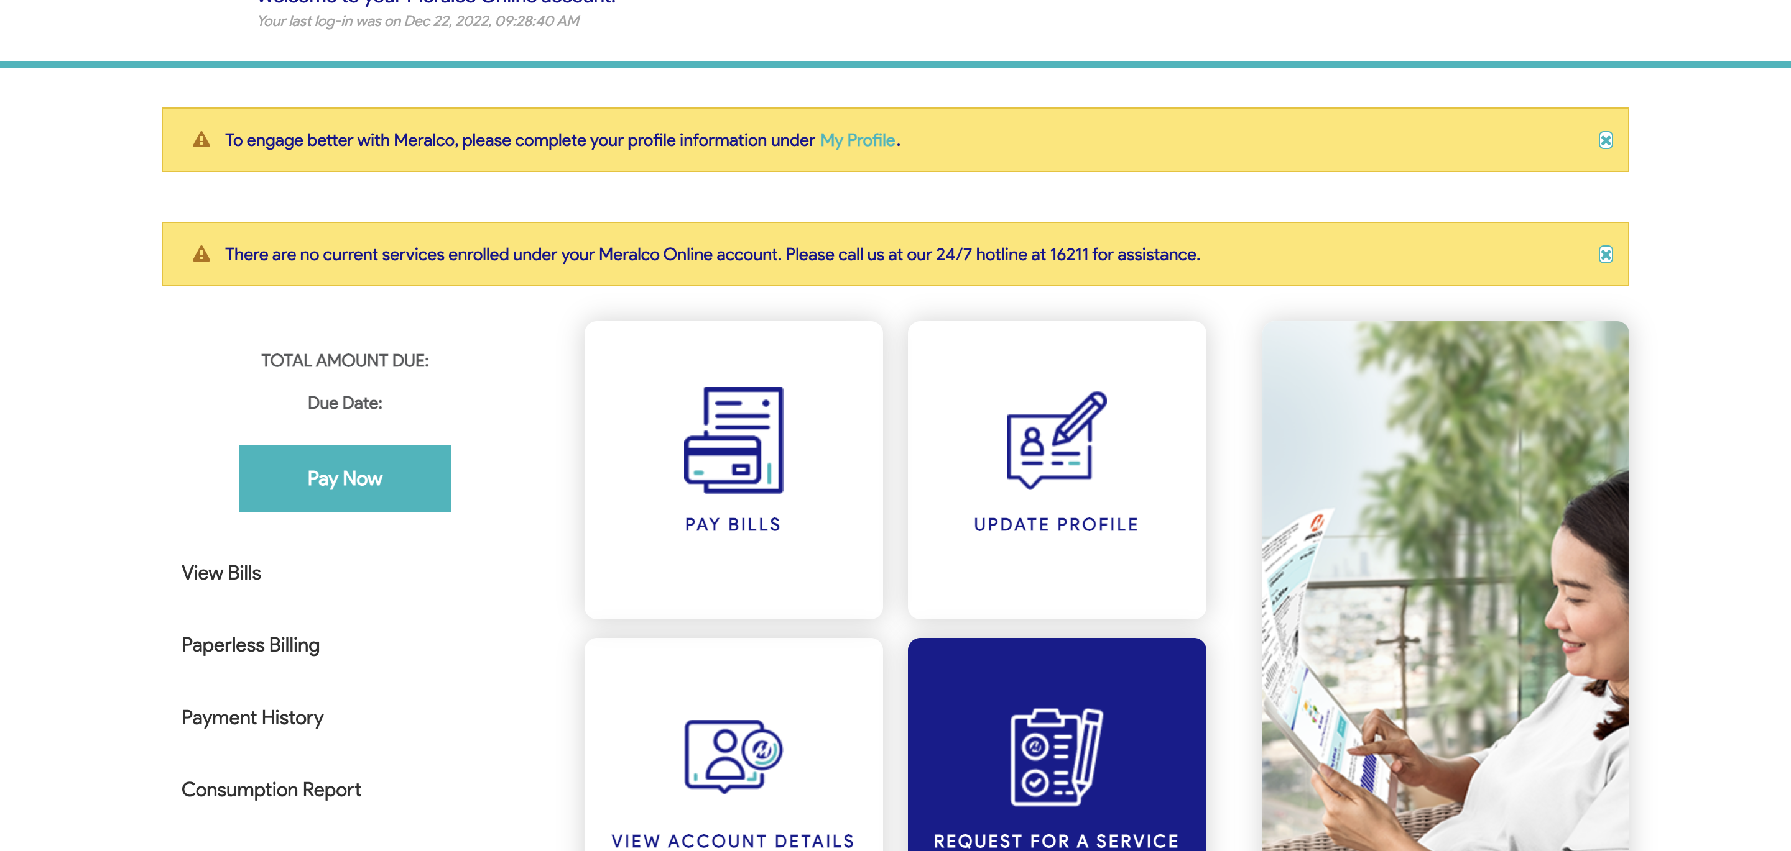

|  |
| --- |
| Step 3 - Populate all required fields in Contact Information tab > Click Next |
| Fields should be populated; New Address tab should be displayed |

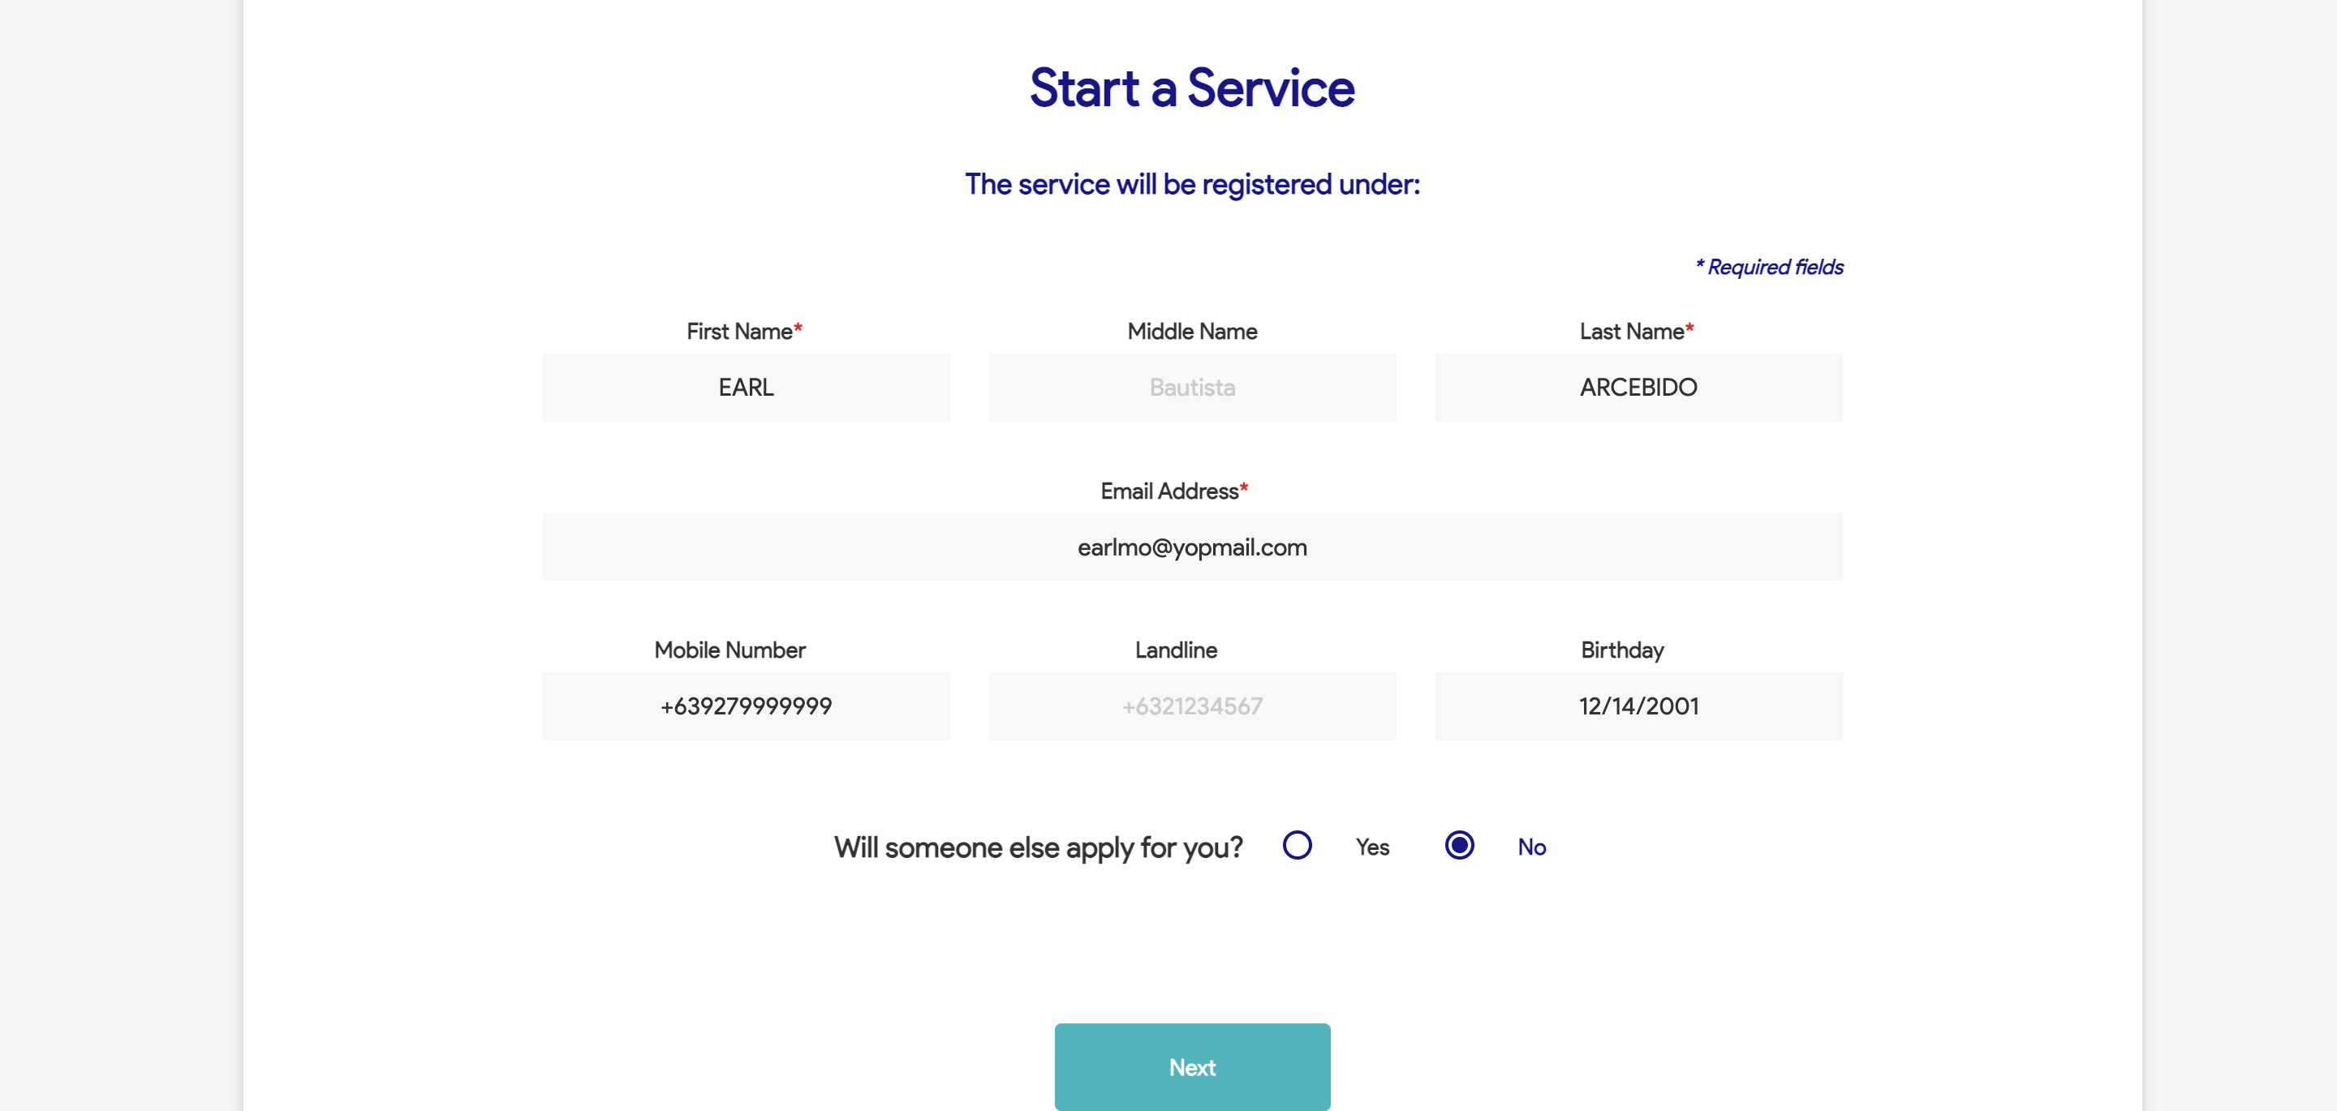

|  |
| --- |
| Step 4 - Populate the following: Service Address Province City / Municipality Home Ownership Billing Address Indicator |
| Fields should be populated; Value Added Service tab should be displayed |

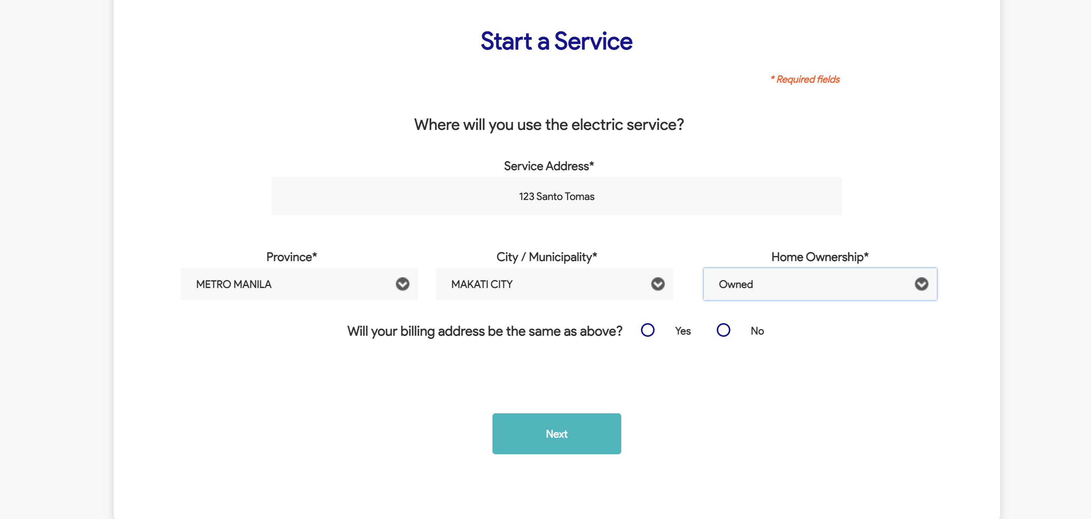

|  |
| --- |
| Step 5 - Populate the following: Notification indicator AMC indicator Paperless Billing indicator APA indicator > Attach documents > Click Next |
| Fields should be populated; Terms and Conditions tab should be displayed |

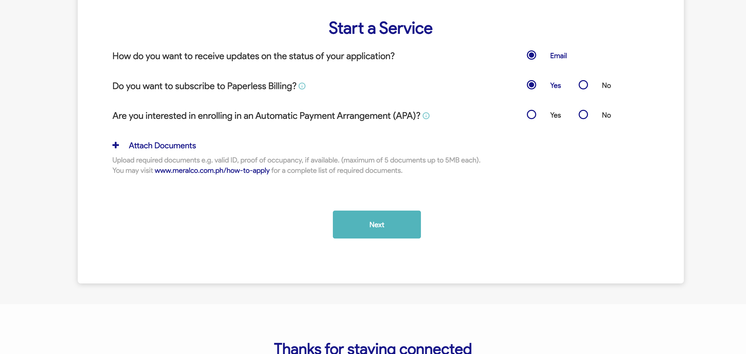

|  |
| --- |
| Step 6 - Tick on I have read and agree to the Meralco Online Terms & Conditions and consent to the processing of my personal data in accordance with the Privacy Policy |
| Submit button should be enabled |

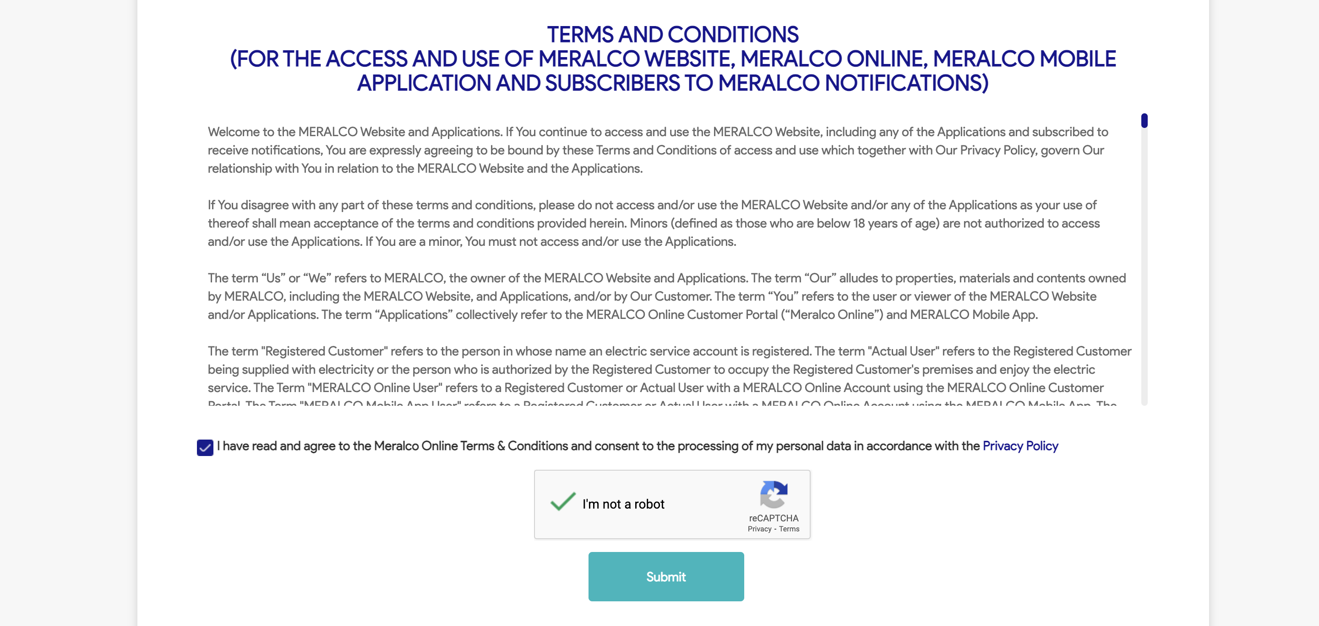

|  |
| --- |
| Step 7 - Click Submit |
| Confirmation tab should be displayed. Case # should be generated. |

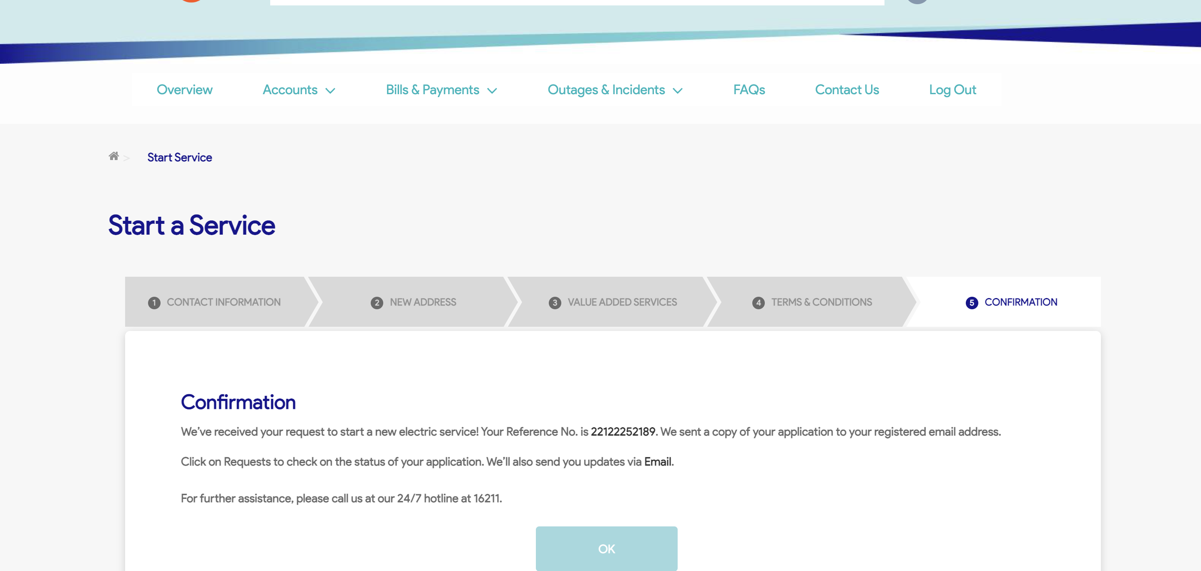

|  |
| --- |
| TC087_Validation of Activity Tracker_New Service Application |

|  |
| --- |
| Step 1 - Go to Activity Tracker page |
| Activity Tracker page should be displayed; Activity Tracker columns should be as follows: Reference No. Customer Account Number Service ID Number Date Received Concern Type Specific Concern Status Remarks |

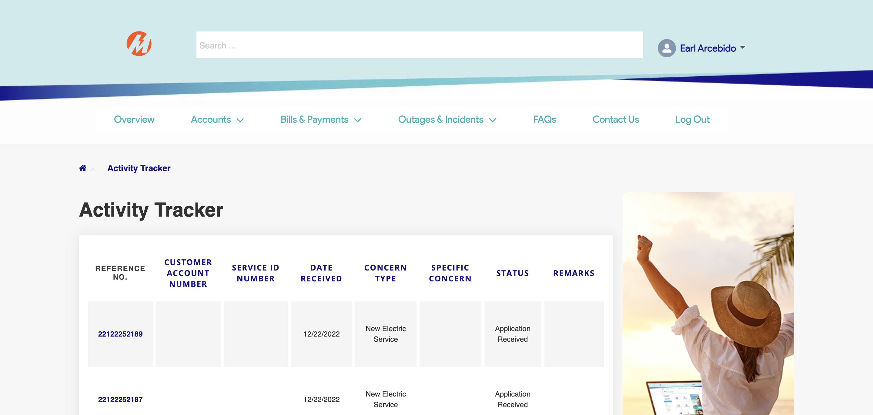

|  |
| --- |
| Step 2 - Check if created case is included in activity tracker page |
| Created concern should be in Activity Tracker page; No CAN and SIN should be displayed |



|  |
| --- |
| TC014_Validation of Service Application Email Notification_Welcome Message |

|  |
| --- |
| Step 1 - Validate email notification |
| Welcome Message for Service Application should be received |

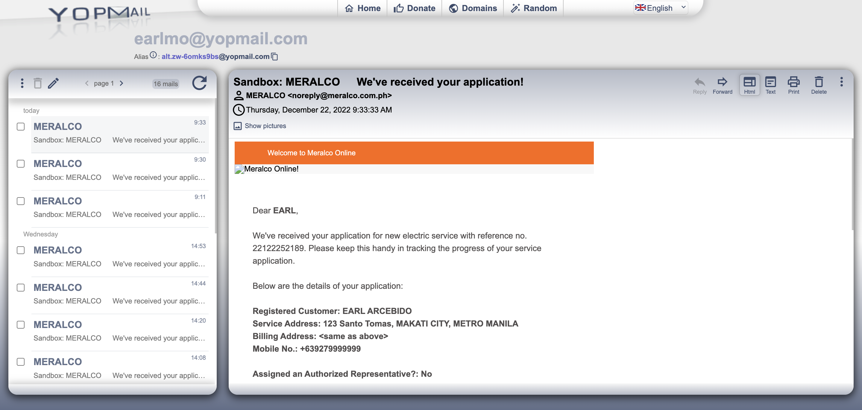

Passed