|  |
| --- |
| TS038 - TC014_Validation of Service Application Email Notification_Welcome Message |

|  |
| --- |
| TC023_Termination of Service Application |

|  |
| --- |
| Step 1 - Login to Meralco Online |
| User should be logged in to Meralco Online |

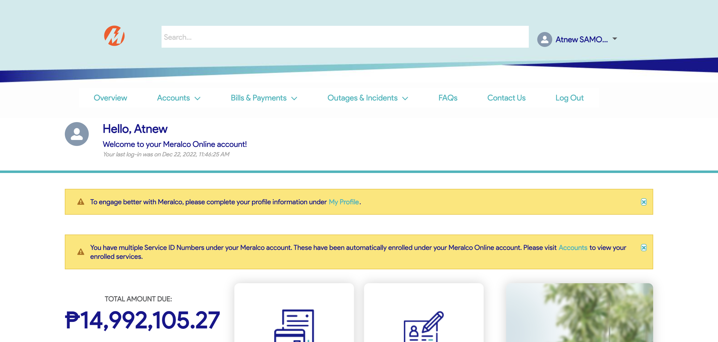

|  |
| --- |
| Step 2 - Go to Accounts> Manage Accounts |
| Accounts page should be displayed |

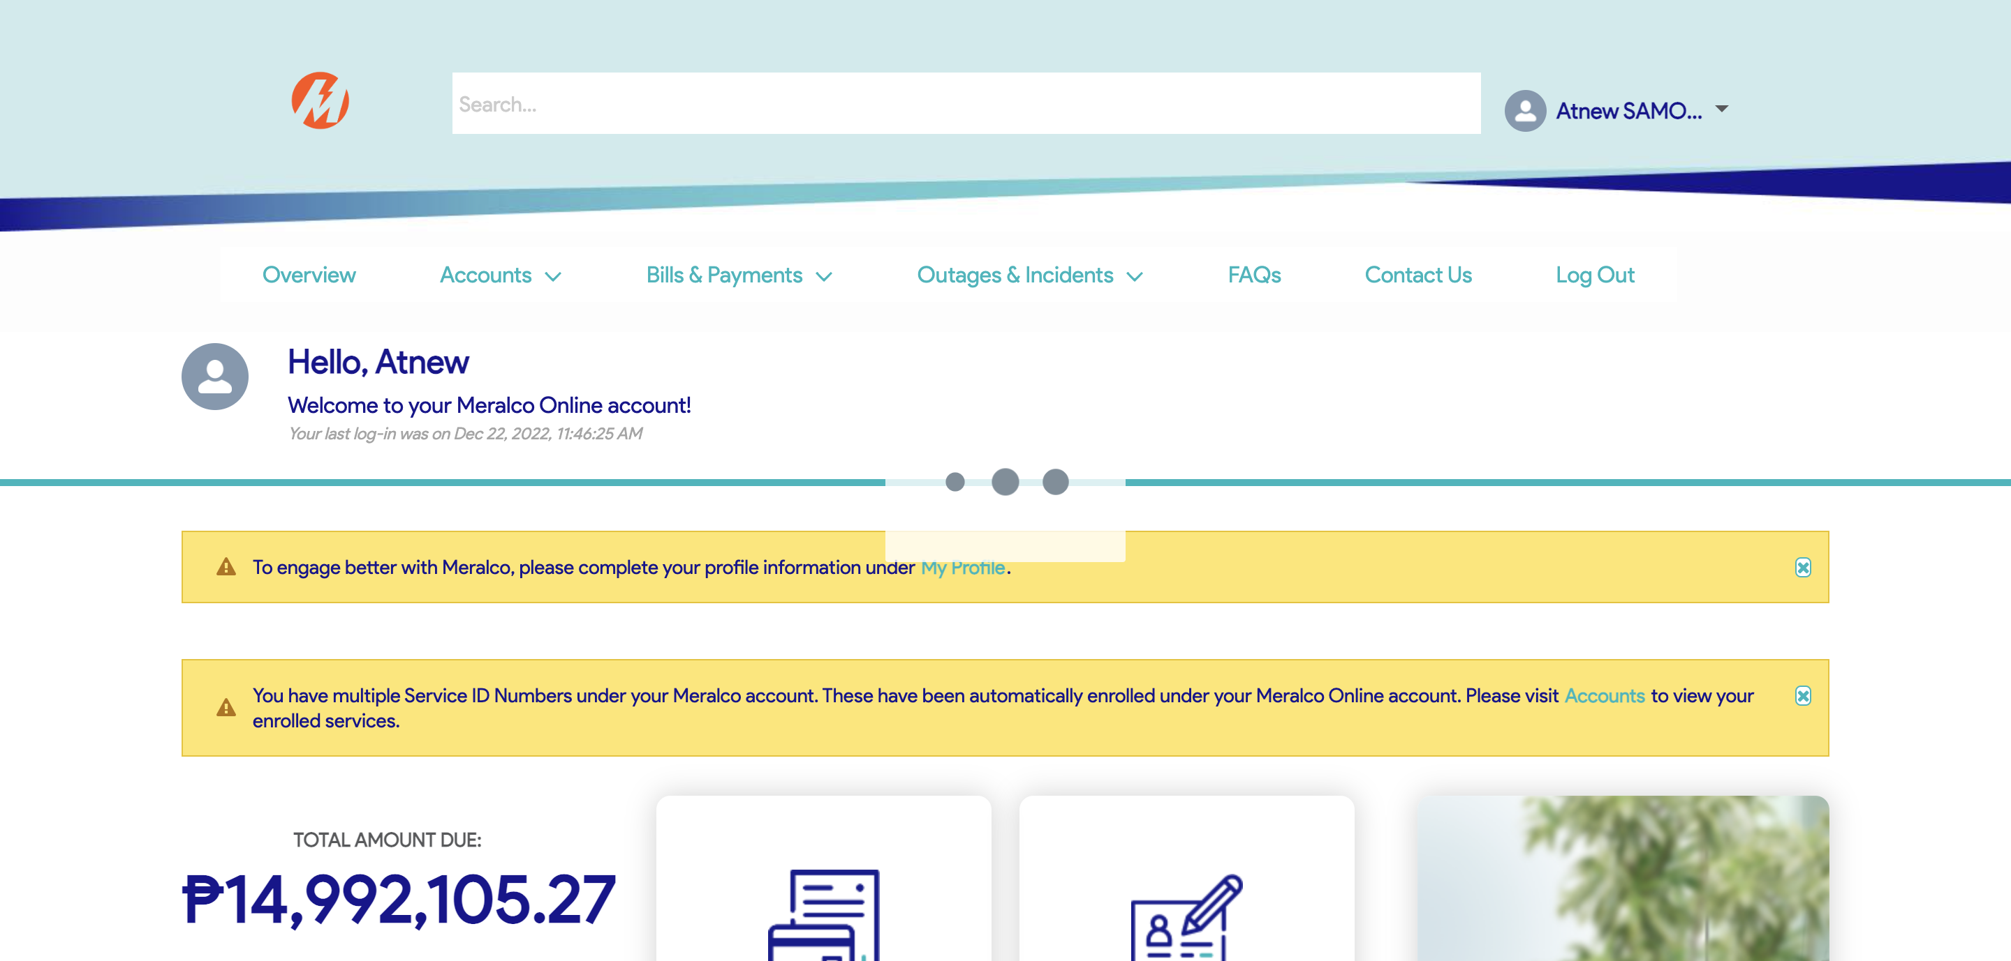

|  |
| --- |
| Step 3 - Search then Select Account > Click Stop Electric Service button |
| Request page for Stop Electric Service should be displayed |

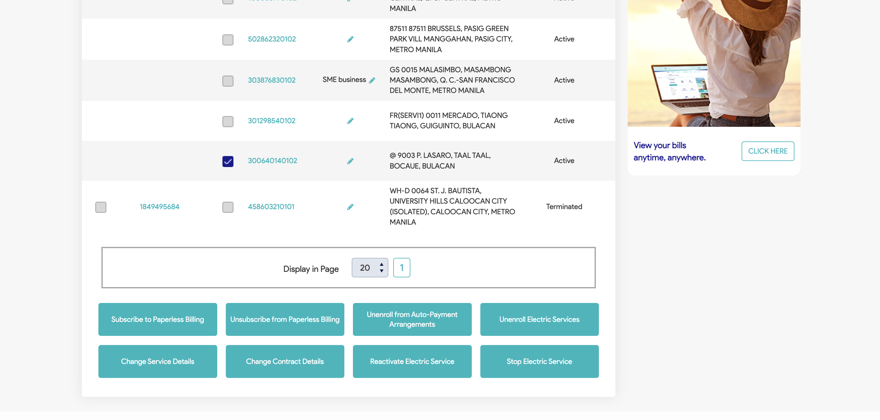

|  |
| --- |
| TC013_Validation of created case in Activity Tracker page |

|  |
| --- |
| Step 1 - Go to Activity Tracker page |
| Activity Tracker page should be displayed; Activity Tracker columns should be as follows: Reference No. Customer Account Number Service ID Number Date Received Concern Type Specific Concern Status Remarks |

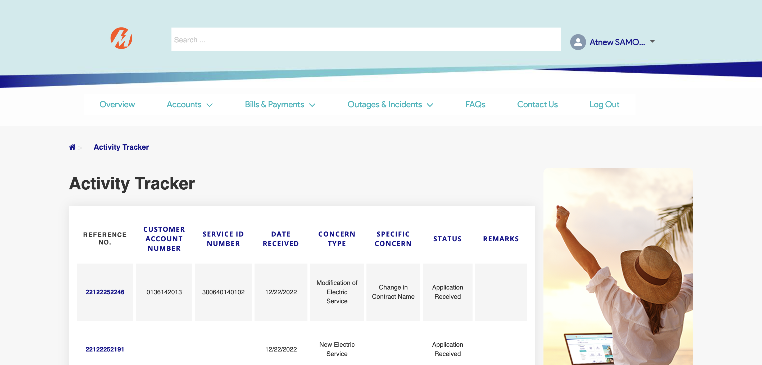

|  |
| --- |
| Step 2 - Check if created case is included in activity tracker page |
| Created concern should be in Activity Tracker page; CAN should added to the Activity Tracker details and SIN should be displayed if CAN has multiple associated SIN |



|  |
| --- |
| TC014_Validation of Service Application Email Notification_Welcome Message |

|  |
| --- |
| Step 1 - Validate email notification |
| Welcome Message for Service Application should be received |

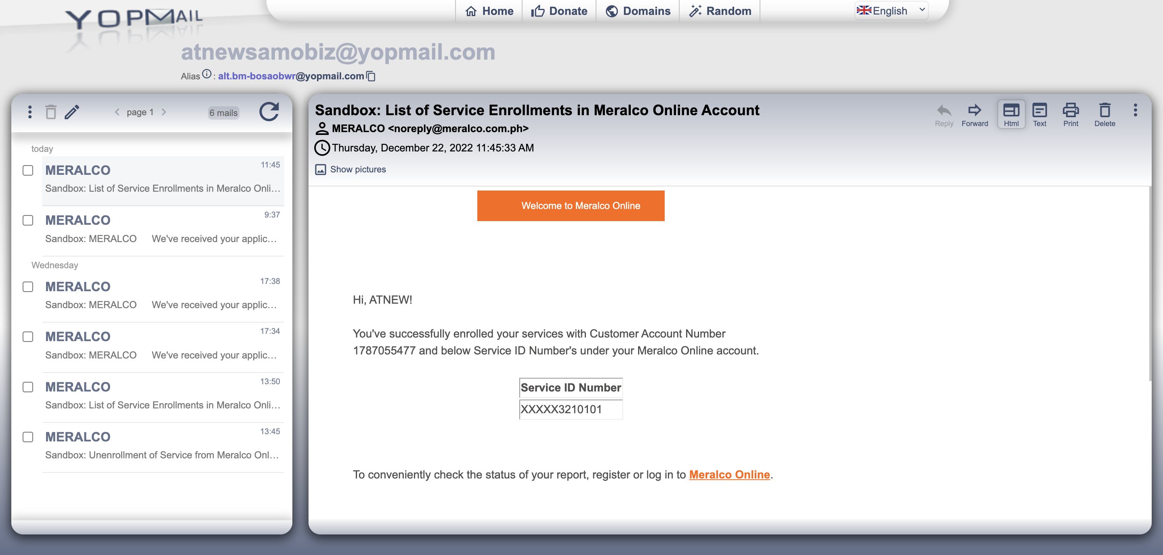

Passed