|  |
| --- |
| TS040 - TC014_Validation of Service Application Email Notification_Welcome Message |

|  |
| --- |
| TC024_Recontract of Service Application |

|  |
| --- |
| Step 1 - Login to Meralco Online |
| User should be logged in to Meralco Online |

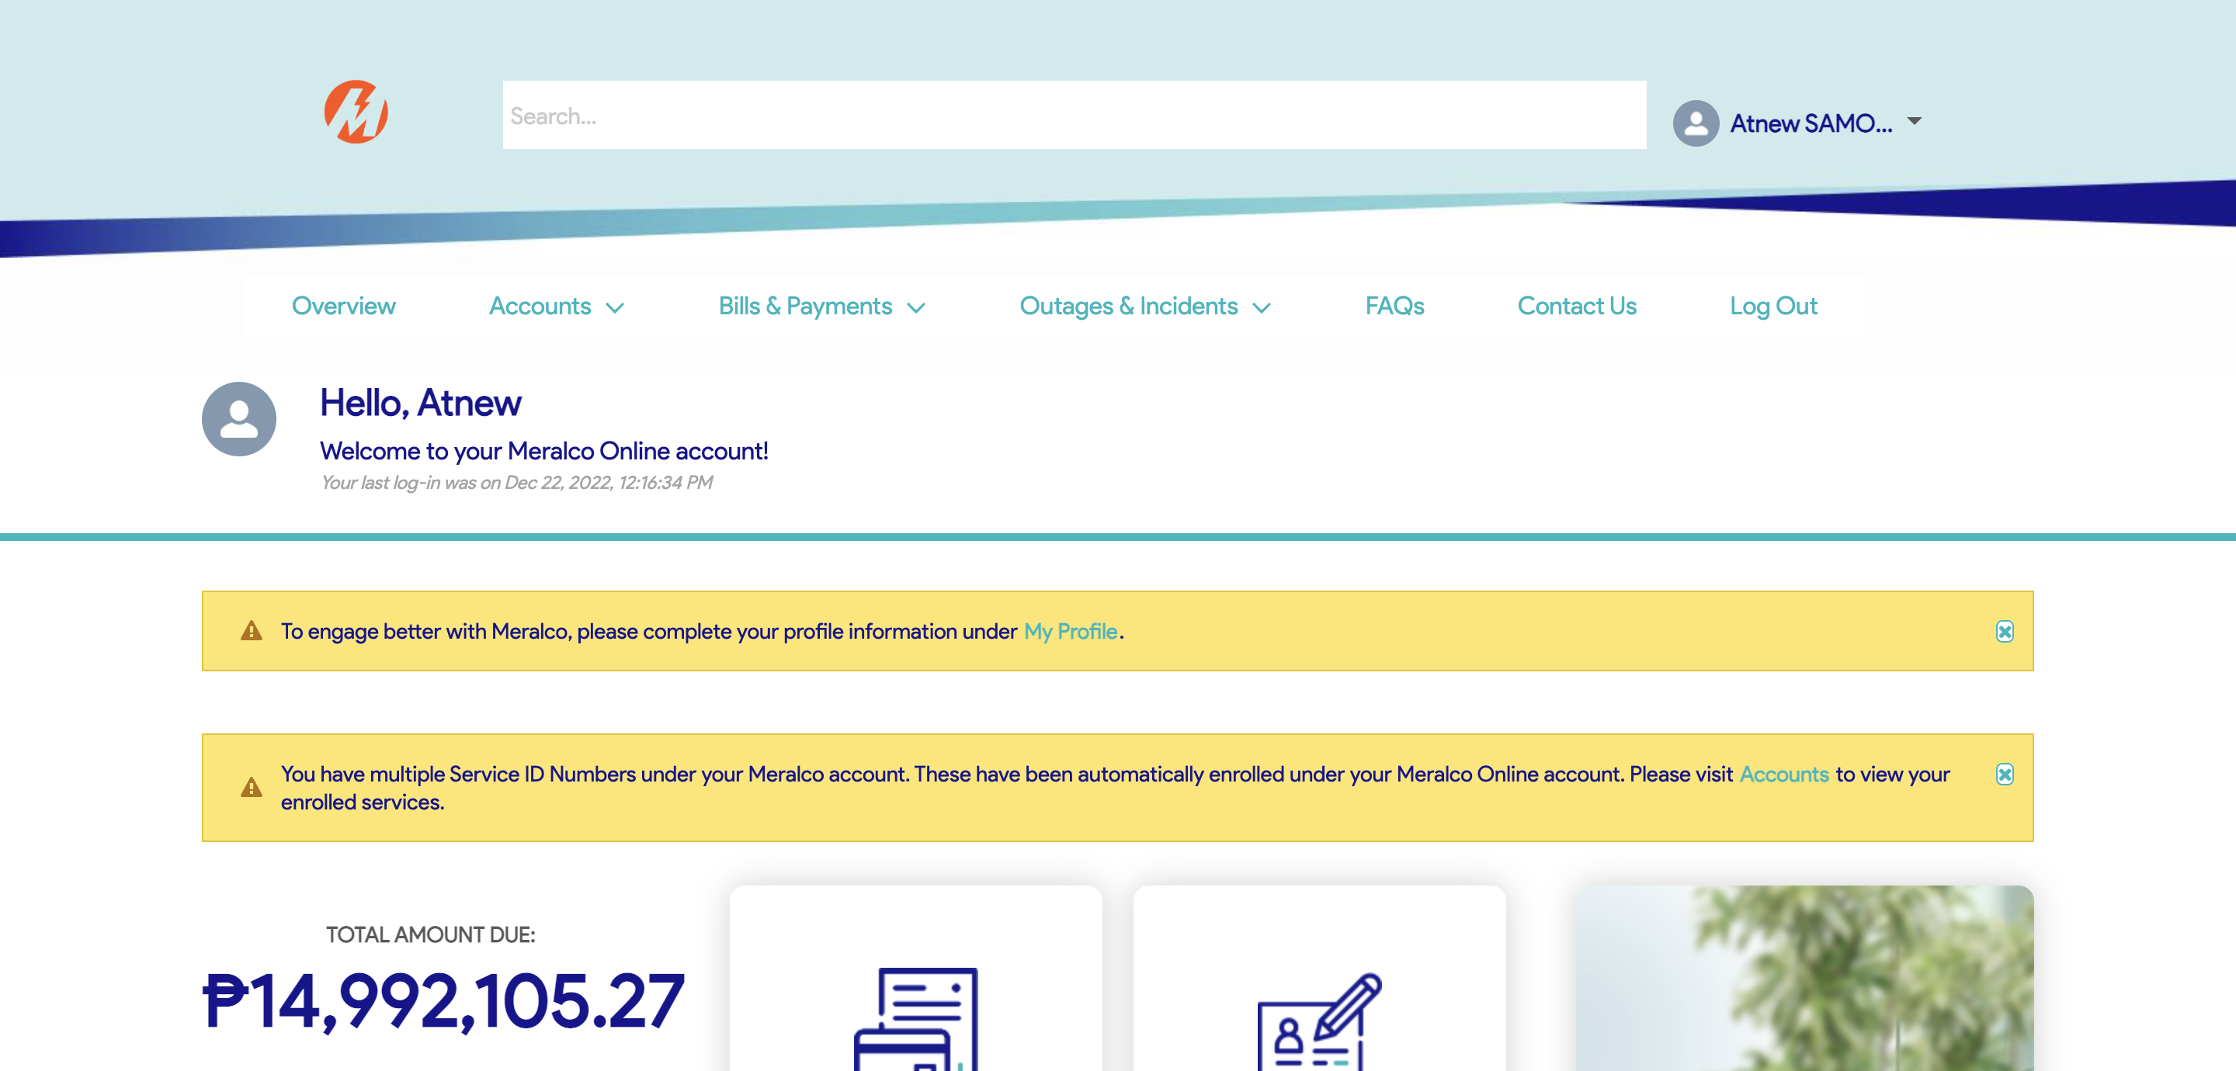

|  |
| --- |
| Step 2 - Go to Accounts> Manage Accounts |
| Accounts page should be displayed |

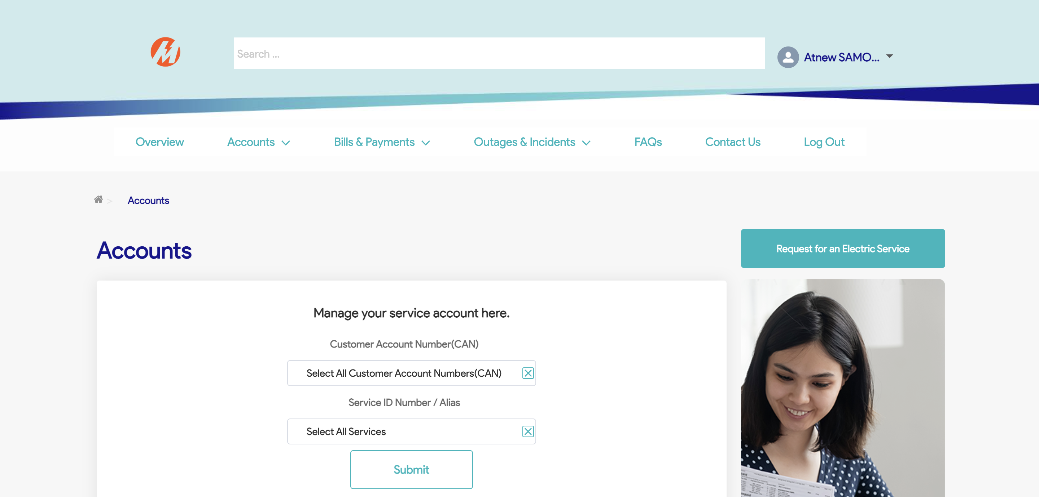

|  |
| --- |
| Step 3 - Search then Select Account > Click Reactivate Electric Service button |
| Request page for Reactivate Electric Service should be displayed |

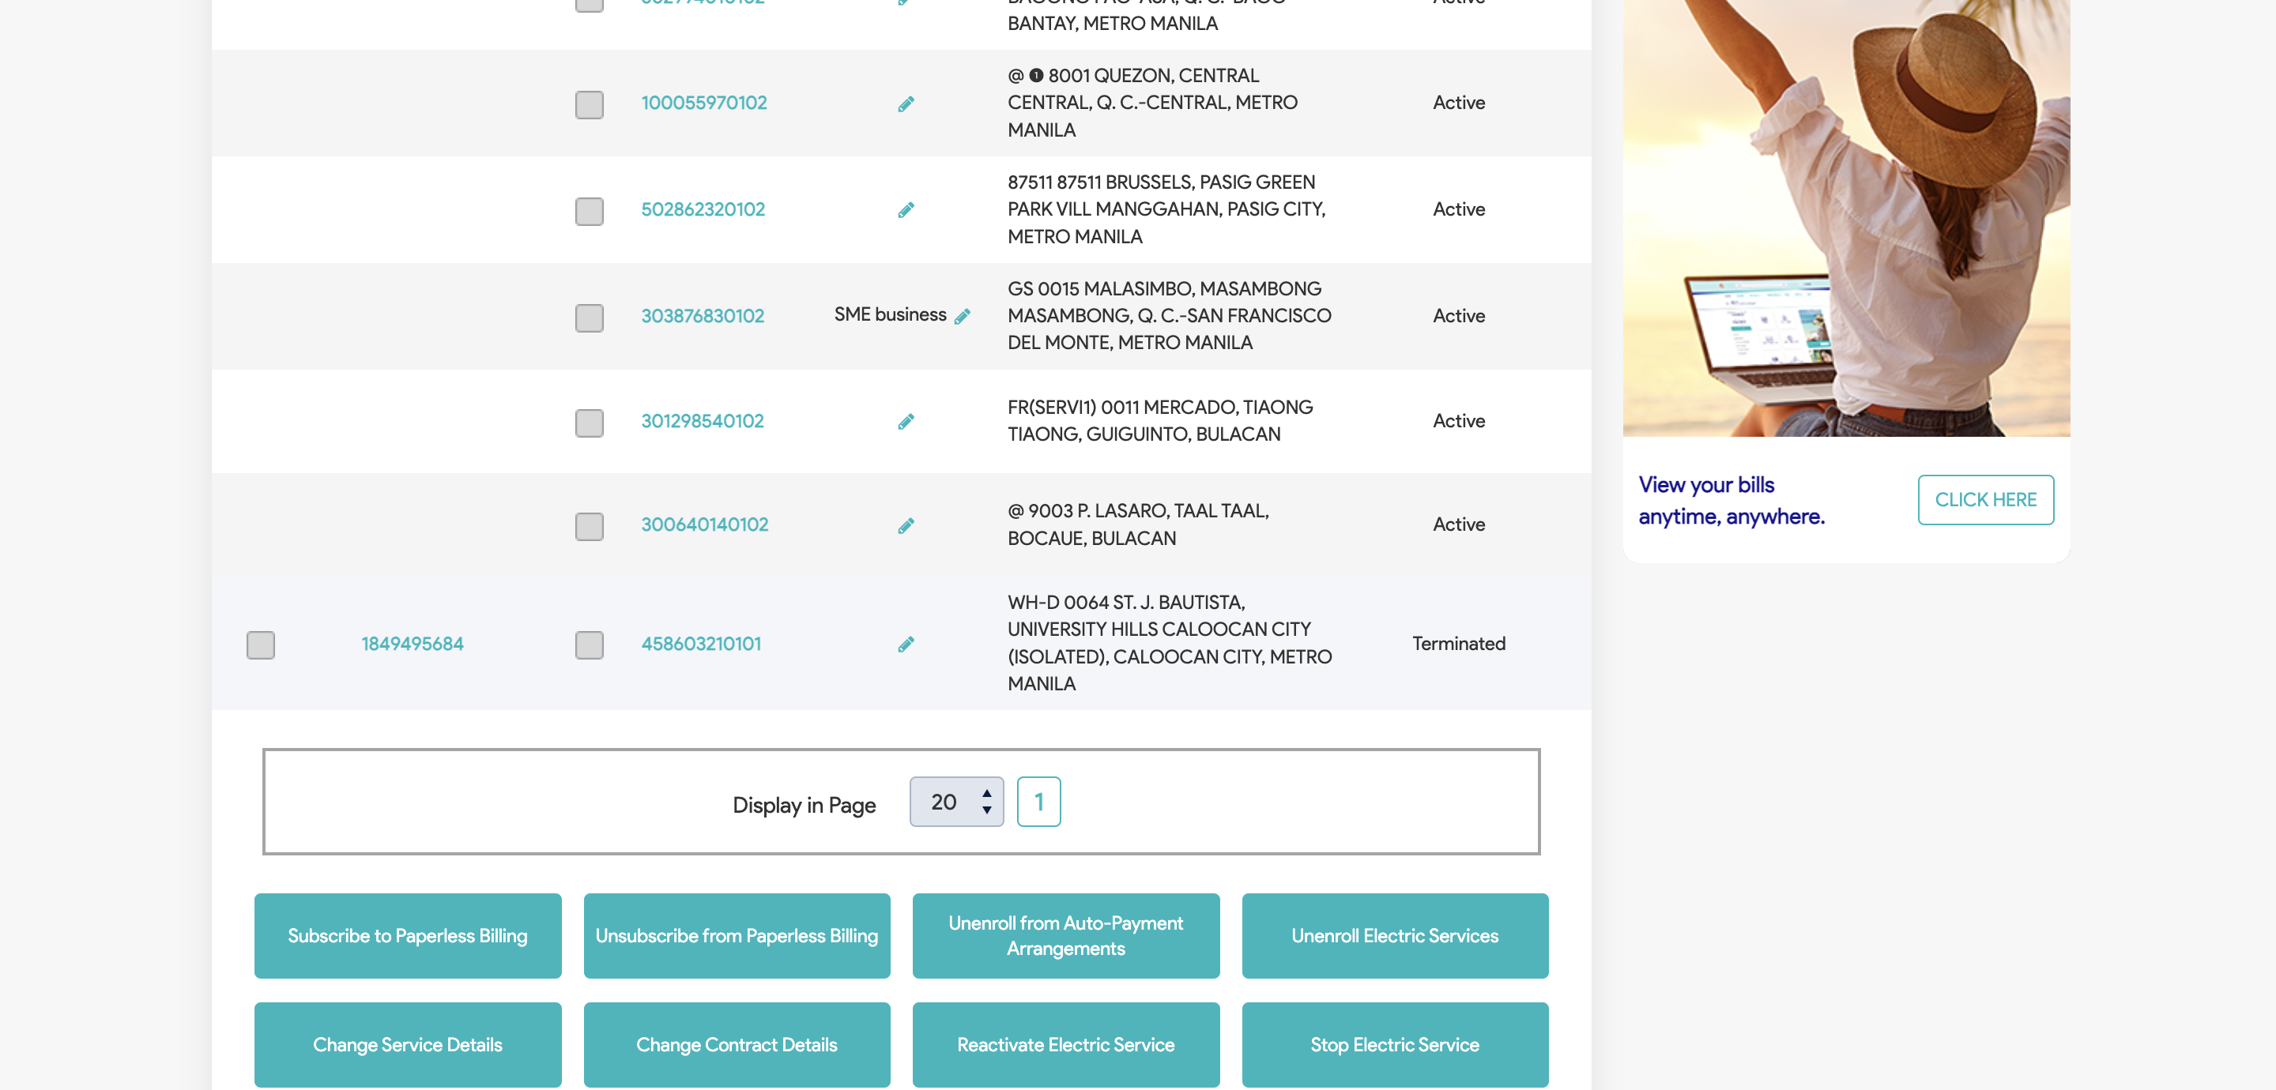

|  |
| --- |
| Step 4 - Populate the following: SIN First Name Middle Name (Optional) Last Name Email Address Mobile Number (optional) Landline (optional) Birthday (optional) Representative indicator Click Next |
| Fields should be populated; New Address tab should be displayed |

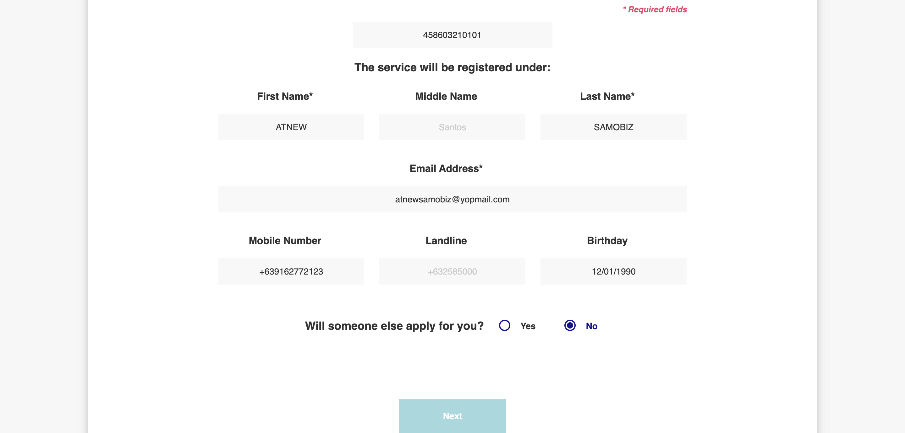

|  |
| --- |
| Step 5 - Populate the following: Service Address Province City / Municipality Home Ownership Billing Address Indicator |
| Fields should be populated; Value Added Service tab should be displayed |

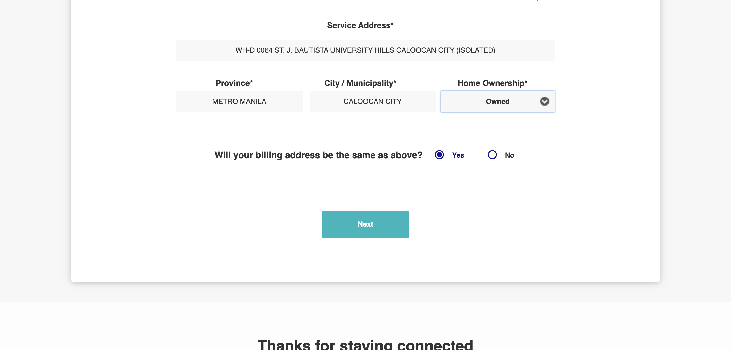

|  |
| --- |
| Step 6 - Populate the following: Notification indicator AMC indicator Paperless Billing indicator APA indicator > Attach documents > Click Next |
| Fields should be populated; Terms and Conditions tab should be displayed |

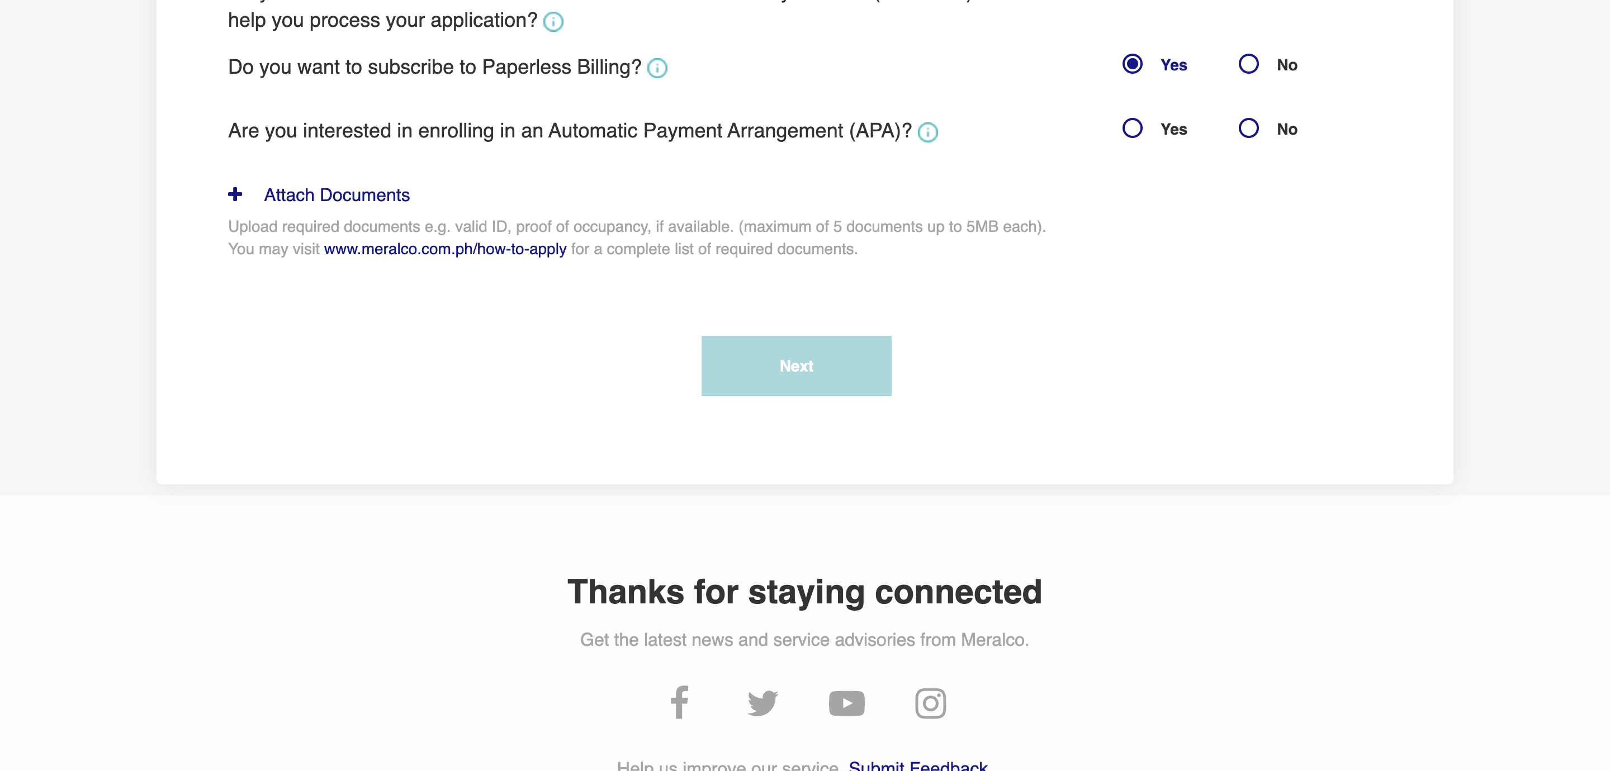

|  |
| --- |
| Step 7 - Tick on I have read and agree to the Meralco Online Terms & Conditions and consent to the processing of my personal data in accordance with the Privacy Policy |
| Submit button should be enabled |

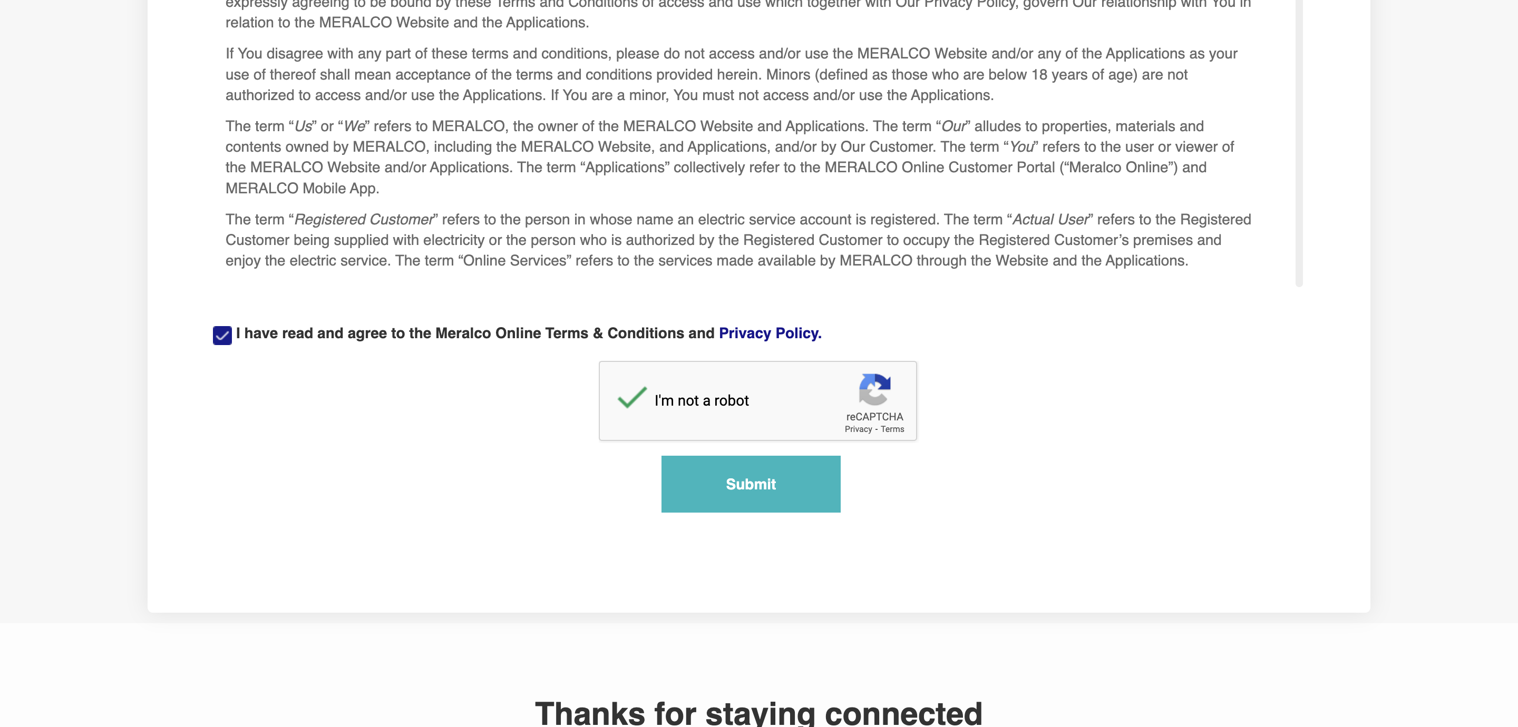

|  |
| --- |
| Step 8 - Click Submit |
| Confirmation tab should be displayed. Case # should be generated. |

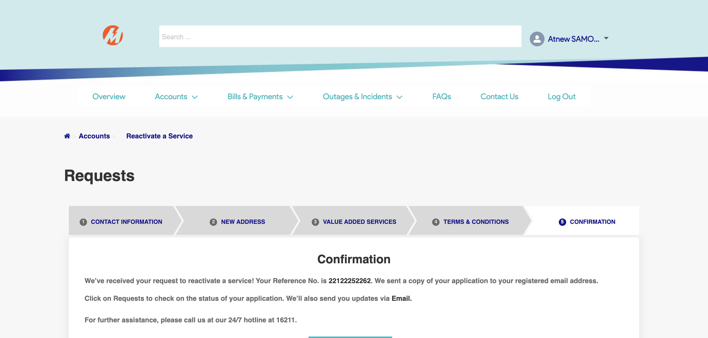

|  |
| --- |
| TC013_Validation of created case in Activity Tracker page |

|  |
| --- |
| Step 1 - Go to Activity Tracker page |
| Activity Tracker page should be displayed; Activity Tracker columns should be as follows: Reference No. Customer Account Number Service ID Number Date Received Concern Type Specific Concern Status Remarks |

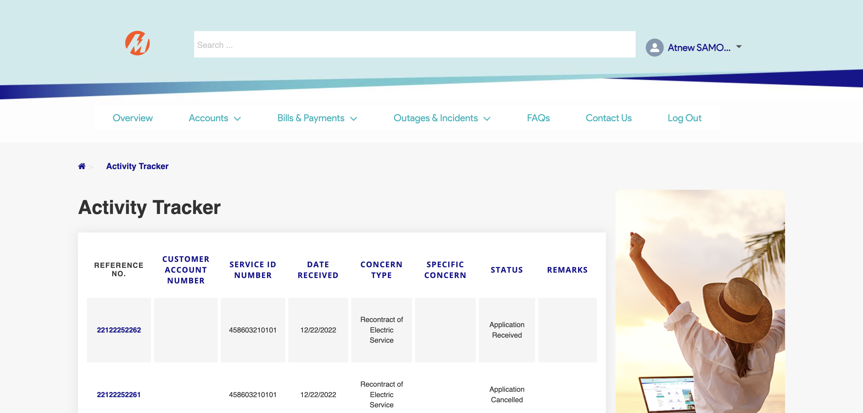

|  |
| --- |
| Step 2 - Check if created case is included in activity tracker page |
| Created concern should be in Activity Tracker page; CAN should added to the Activity Tracker details and SIN should be displayed if CAN has multiple associated SIN |



|  |
| --- |
| TC014_Validation of Service Application Email Notification_Welcome Message |

|  |
| --- |
| Step 1 - Validate email notification |
| Welcome Message for Service Application should be received |

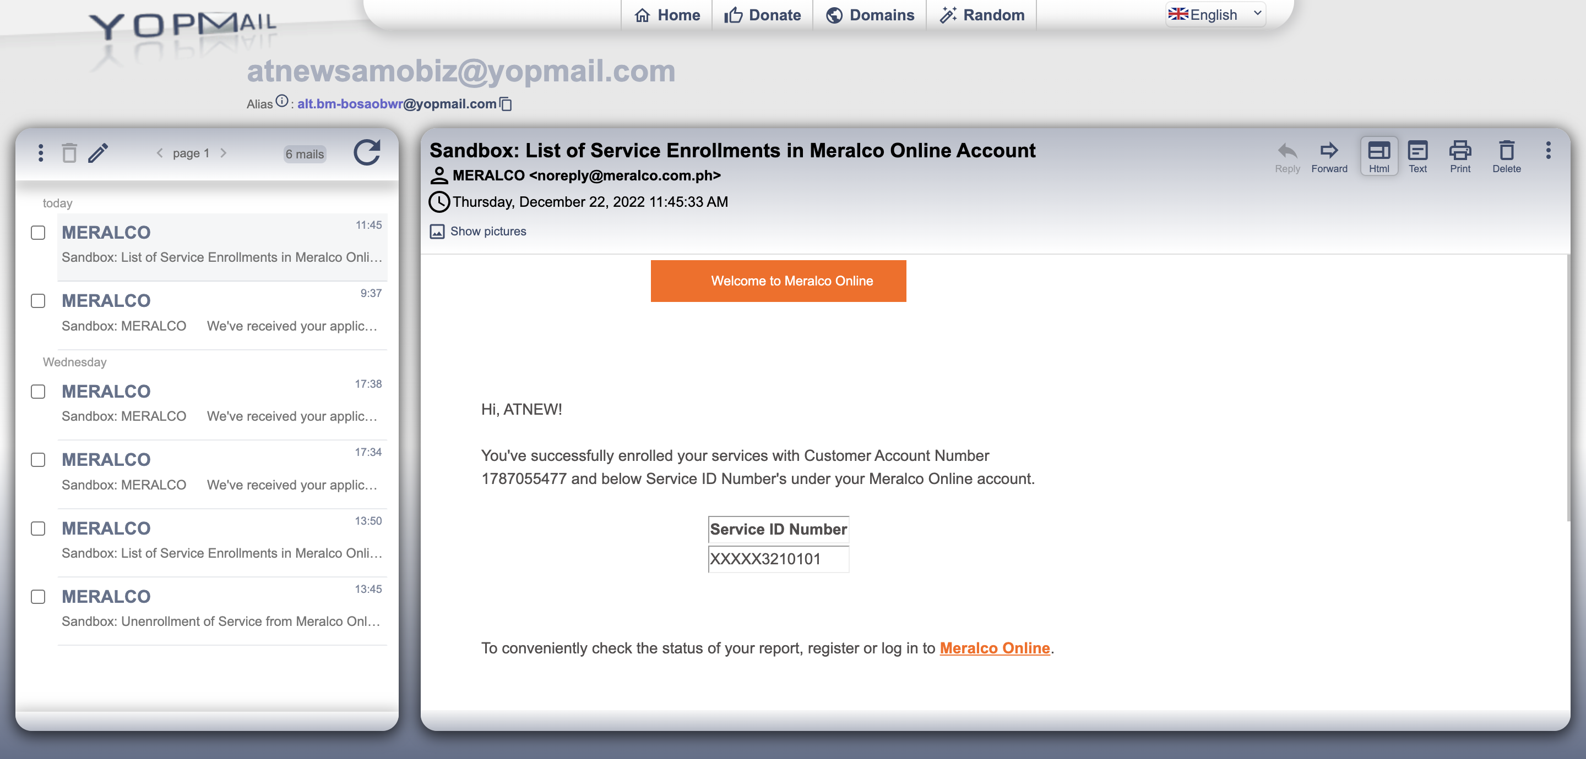

Passed