|  |
| --- |
| TS004 - SSO login with Service Enrollment with Mobile Number; Meralco Online |

|  |
| --- |
| TC012_Validate SSO login with Service Enrollment with Mobile Number; Meralco Online_Apple ID |

|  |
| --- |
| Step 1 - Go to Meralco Online |
| User should be directed to login Page. |

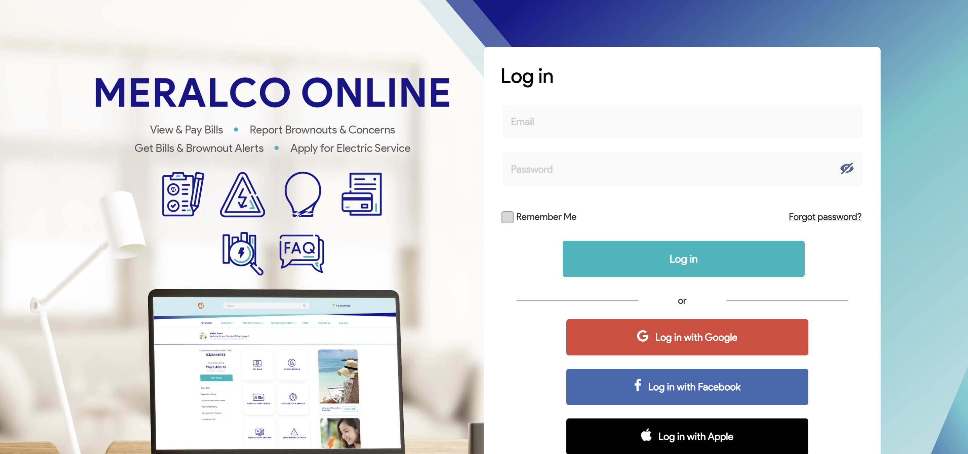

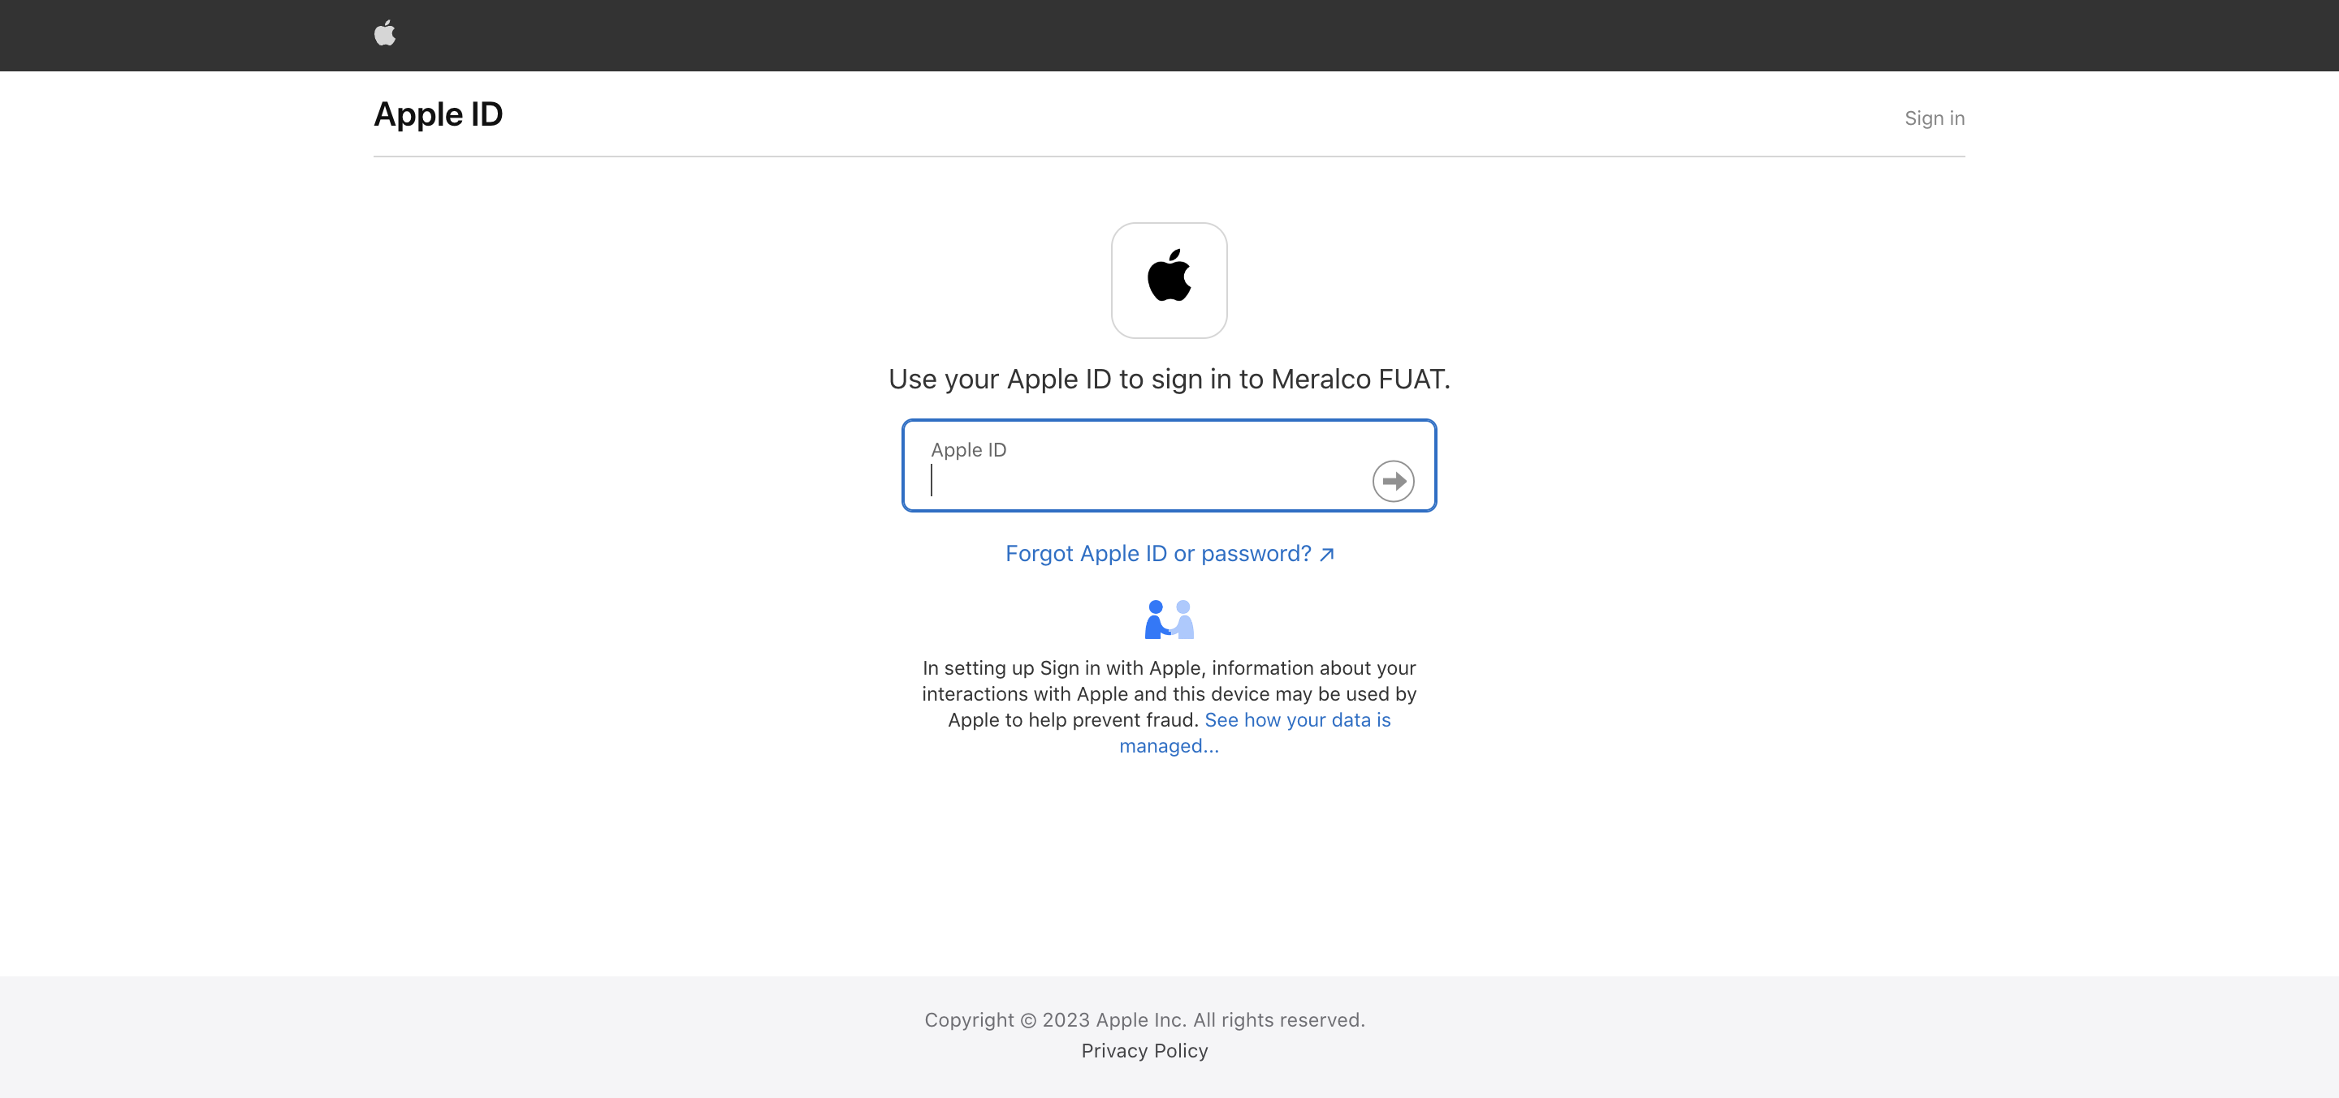

|  |
| --- |
| Step 2 - Sign In SSO Account via Apple ID |
| User should successfully login. |

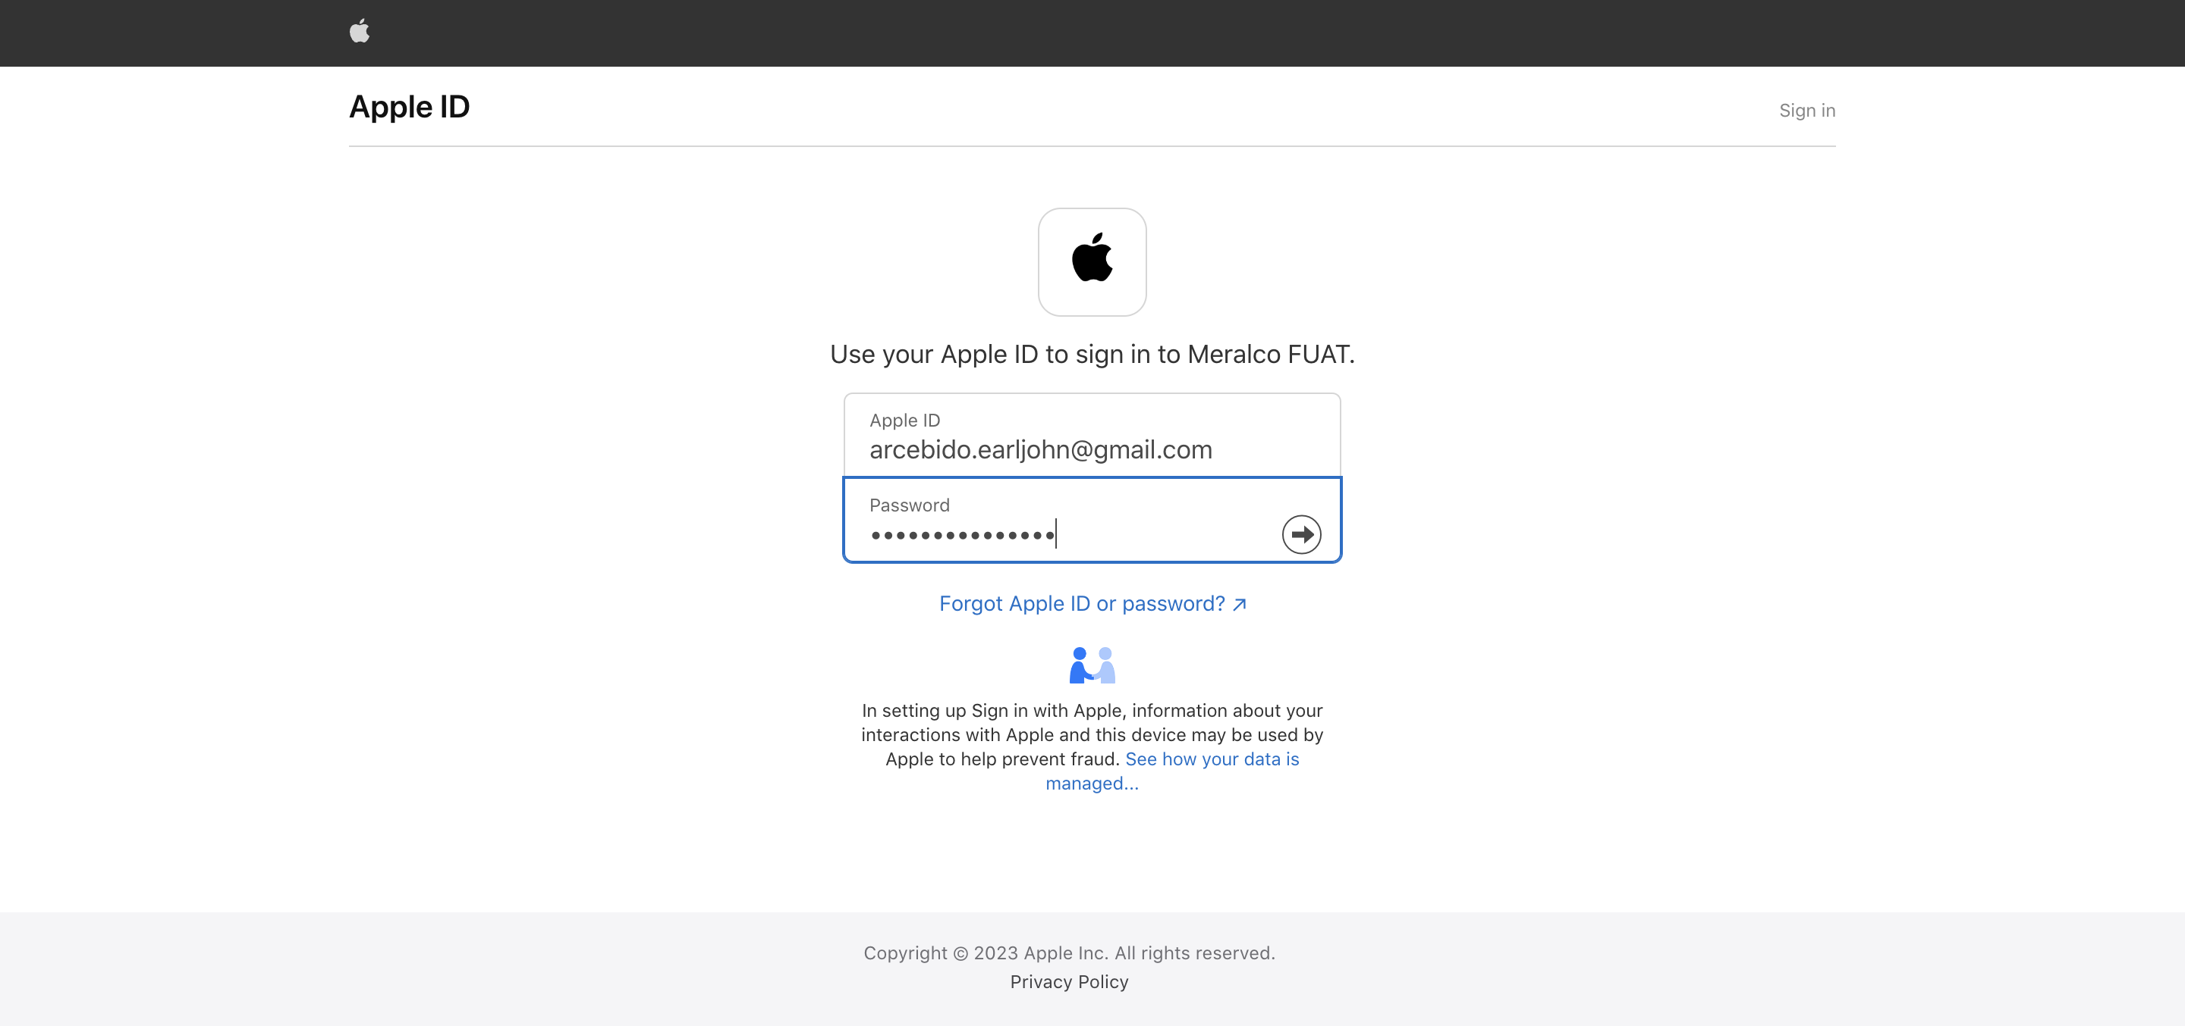

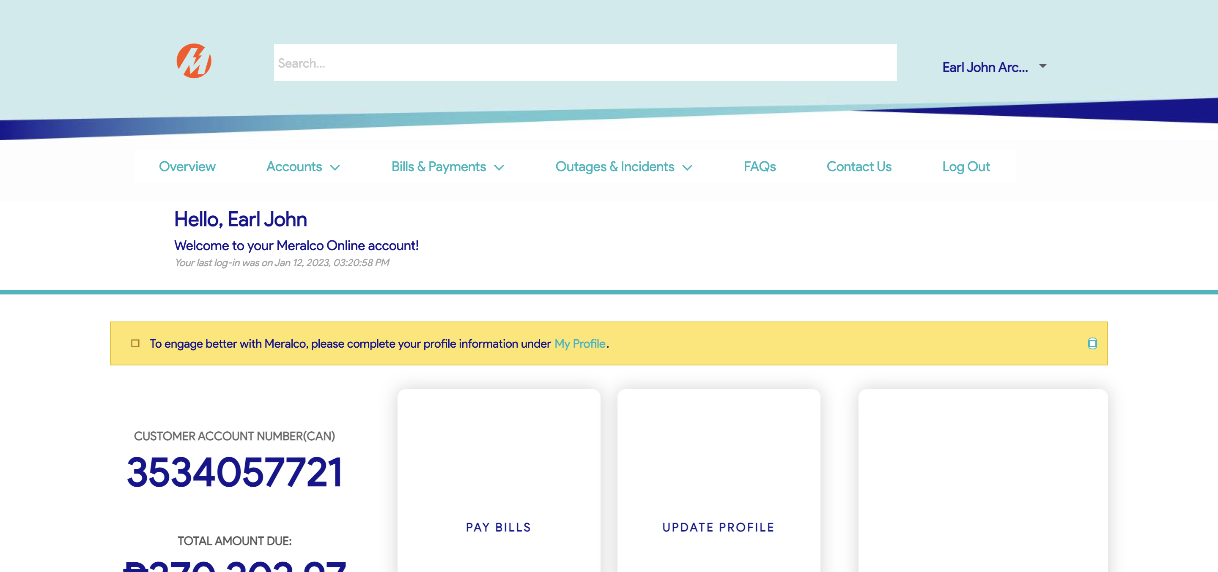

Passed