|  |
| --- |
| TS001 - SSO login with Service Enrollment w/o Mobile Number; Meralco Online |

|  |
| --- |
| TC003_Validate SSO login with Service Enrollment w/o Mobile Number; Meralco Online_Apple ID |

|  |
| --- |
| Step 1 - Go to Meralco Online |
| User should be directed to login Page. |



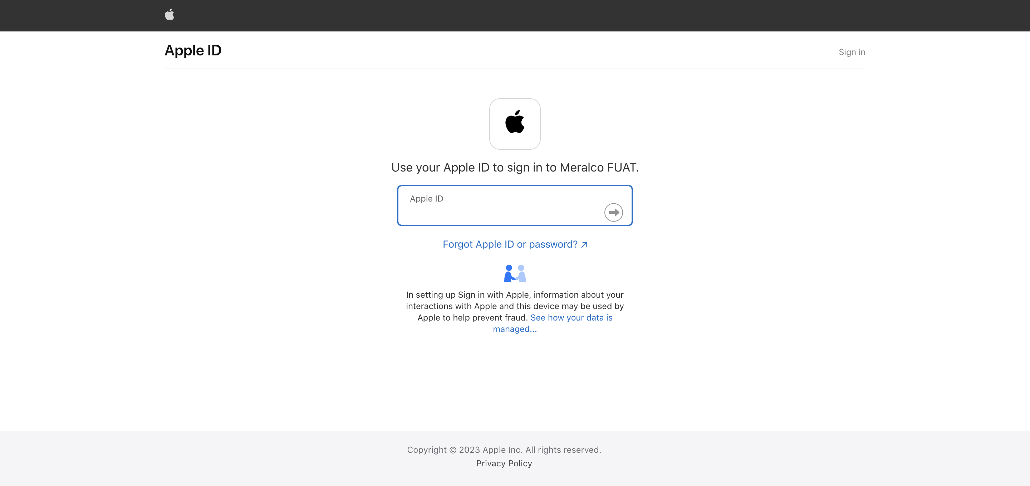

|  |
| --- |
| Step 2- Sign In SSO Account via Apple ID |
| Prompt should be displayed. |

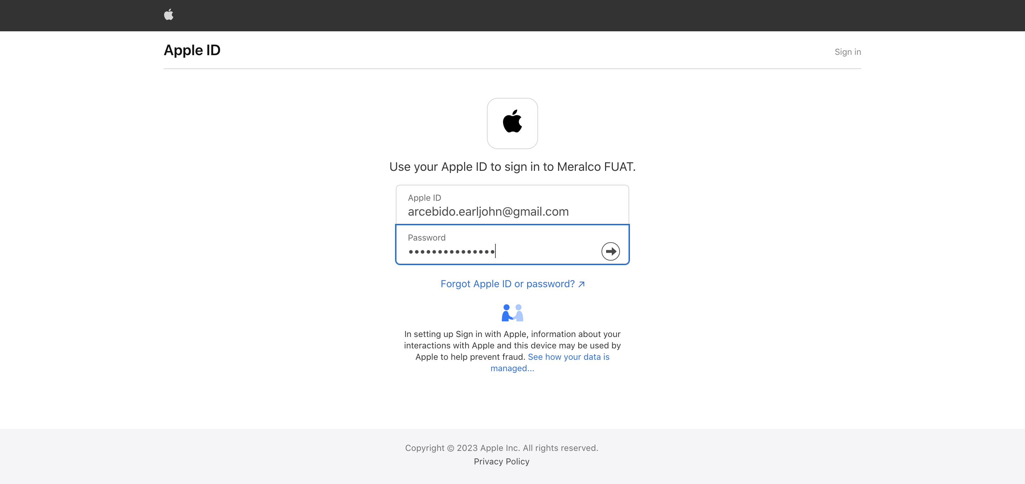

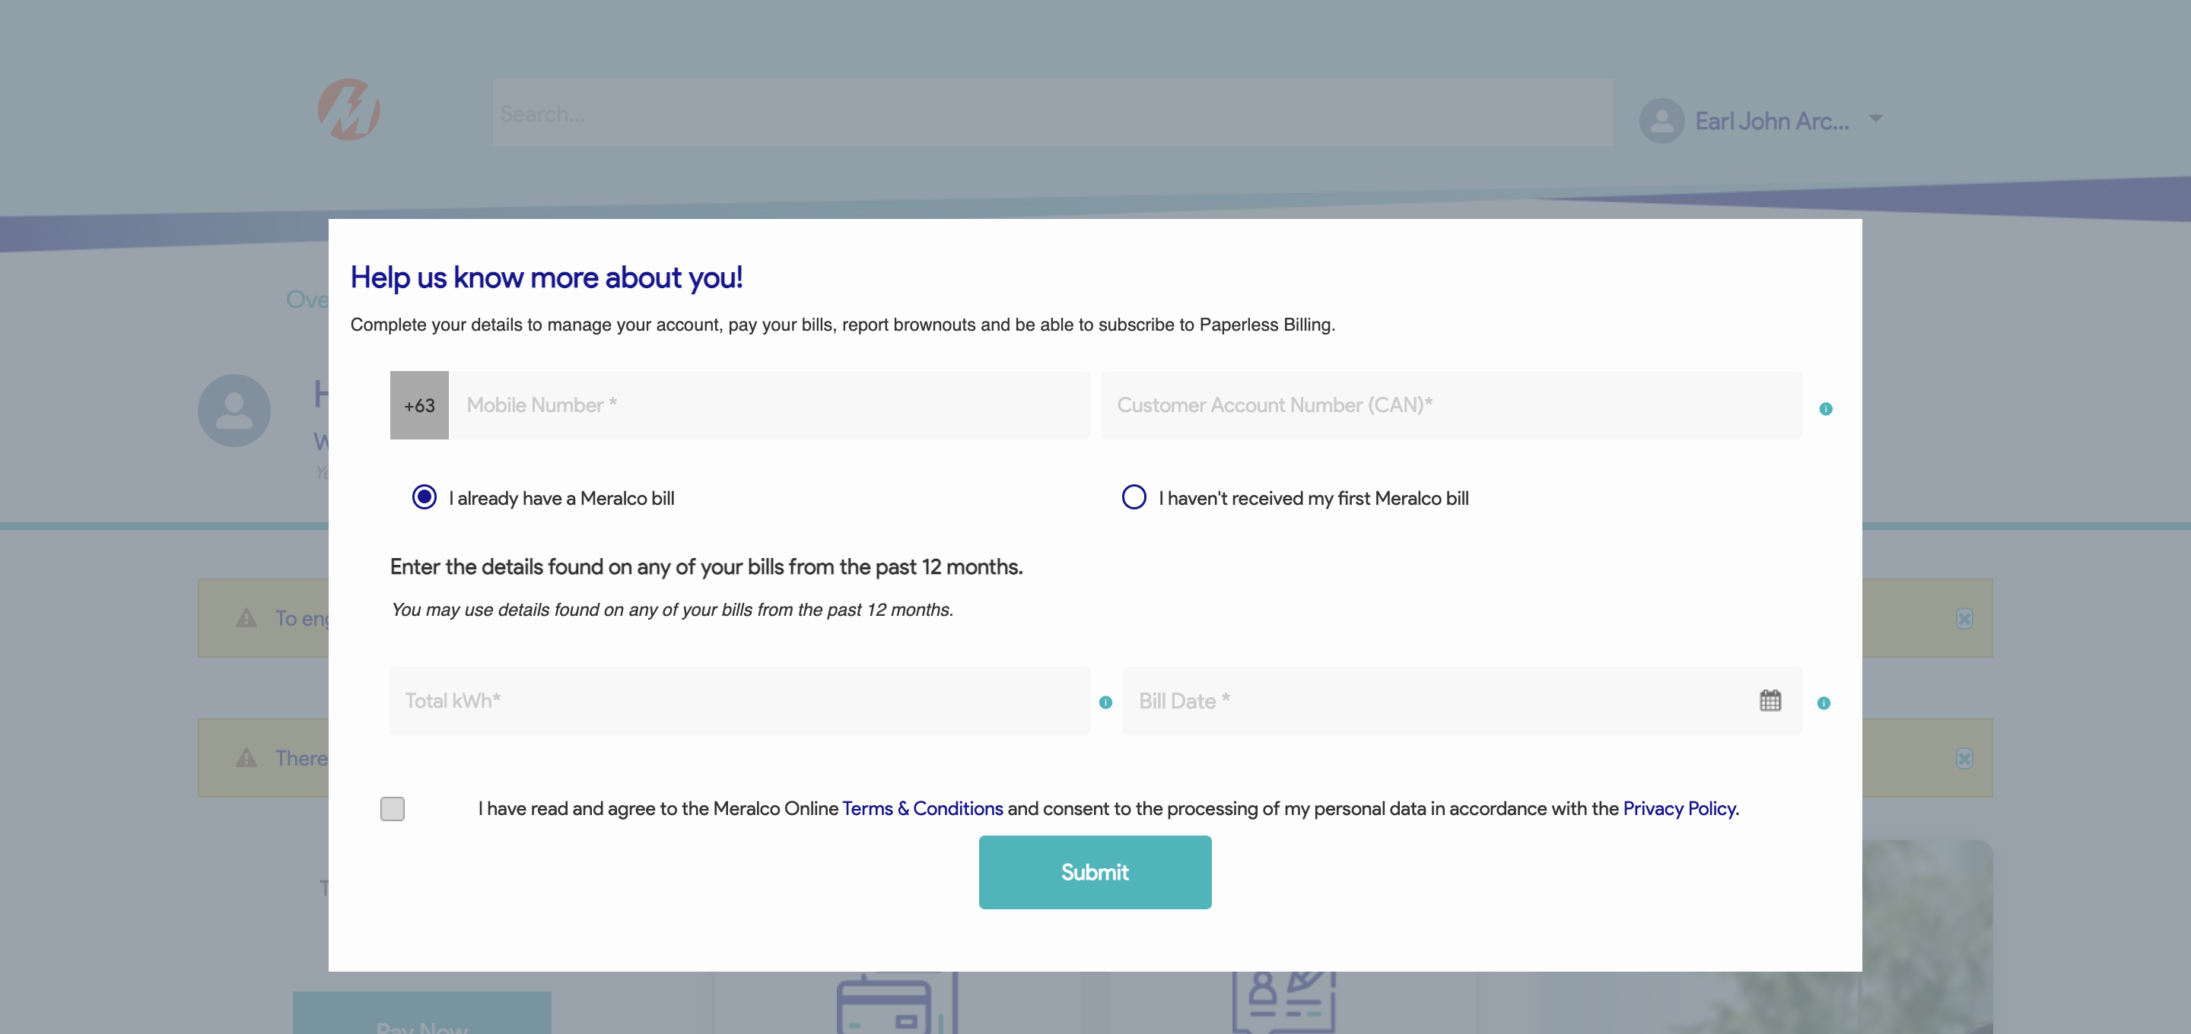

|  |
| --- |
| Step 3 - Populate field for Mobile Number > Submit |
| User should successfully login. |

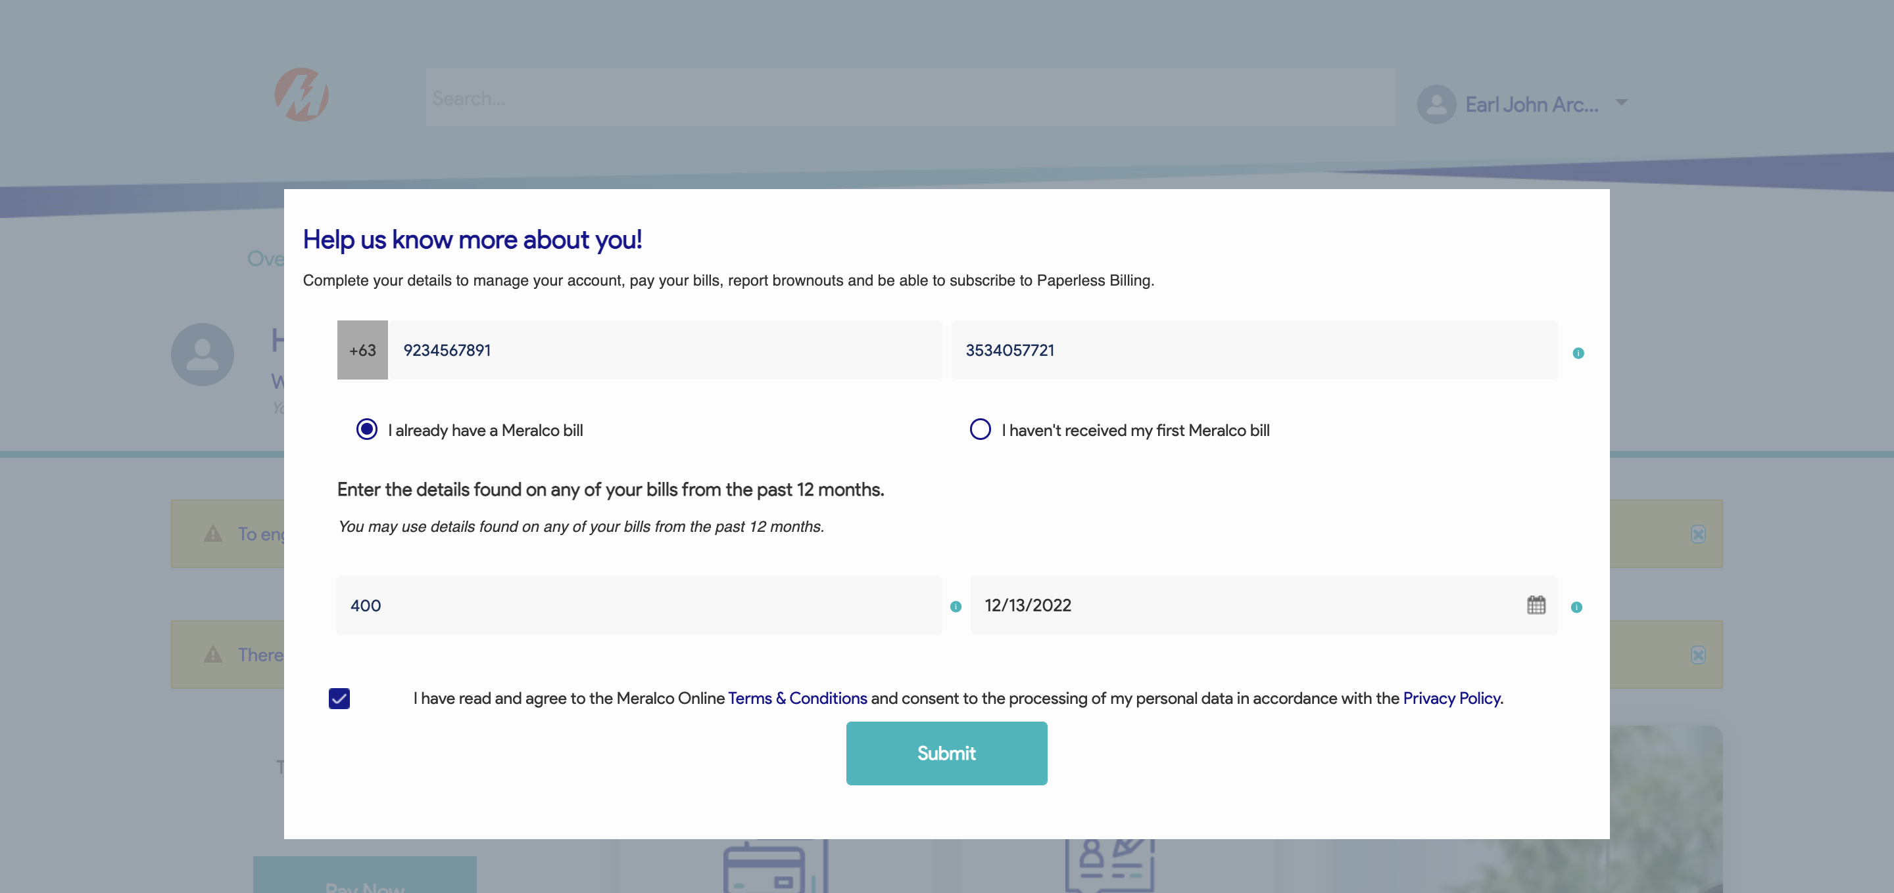

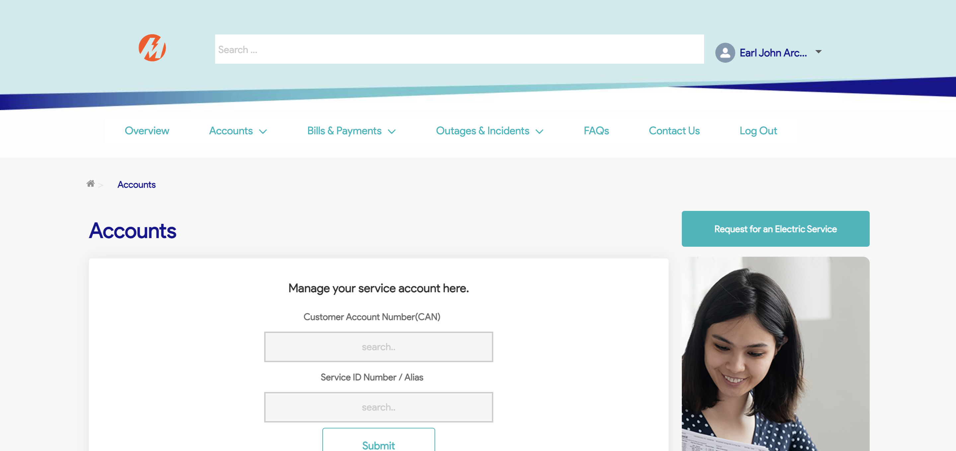

Passed