|  |
| --- |
| TS030 - TC048_Create an Outage Report |

|  |
| --- |
| TC048_Create an Outage Report |

|  |
| --- |
| Step 1 - Go to Outages & Incidents > Report Streetlight And Safety Concerns |
| User should be redirected to Report an Outage or Incident Form. |

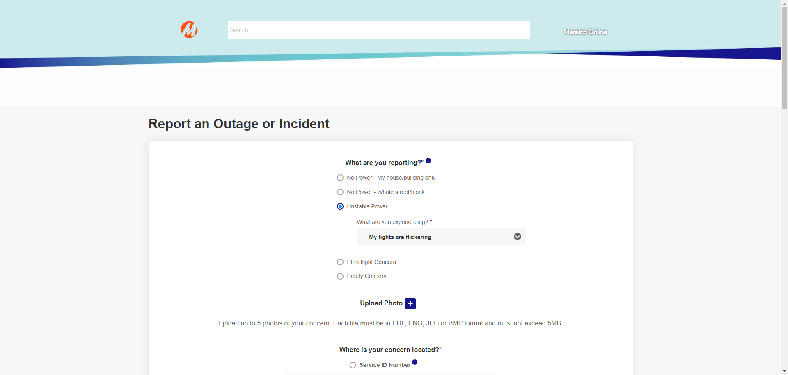

|  |
| --- |
| Step 2 - Populate required fields > click Submit |
| Outage report should be created. Reference number should be generated |

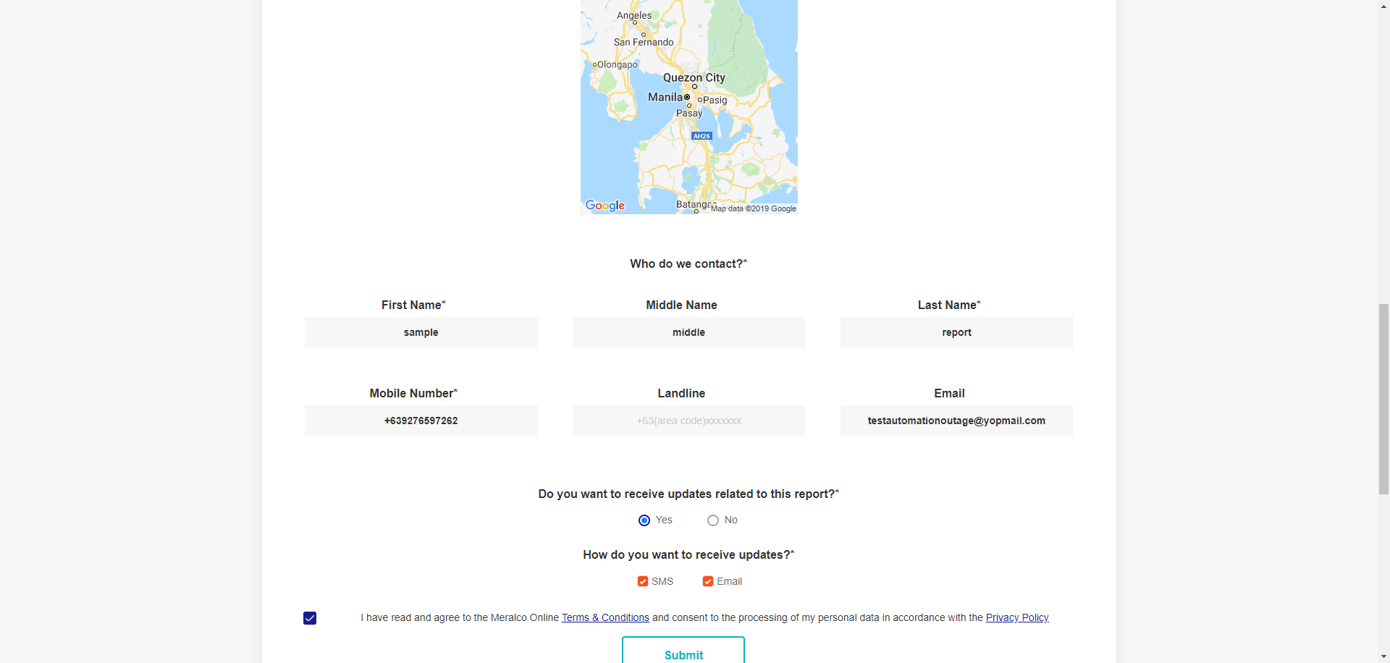

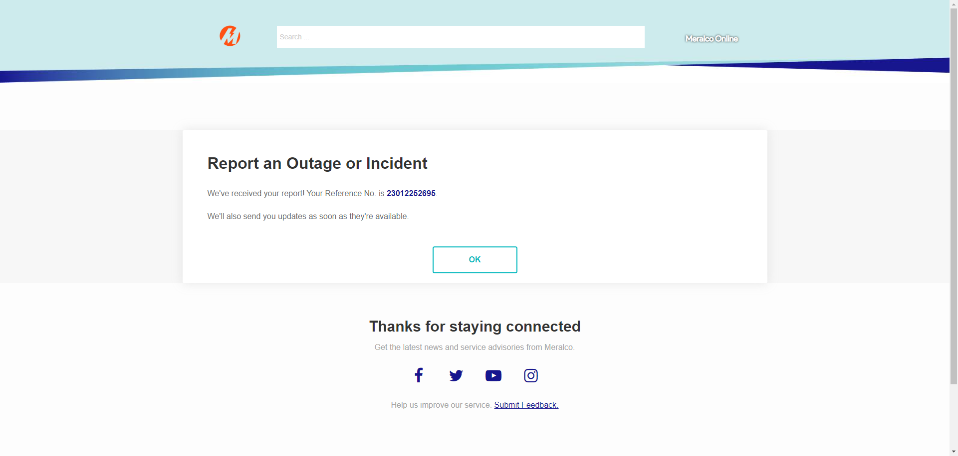

Passed