|  |
| --- |
| TS035 - TC061_Validate Case Number in CXE |

|  |
| --- |
| TC051_Create New Service Application_Business |

|  |
| --- |
| Step 1 - Go to https://fuat-meralco.cs73.force.com/customers/s/cxe-apply |
| Service Application page should be displayed |

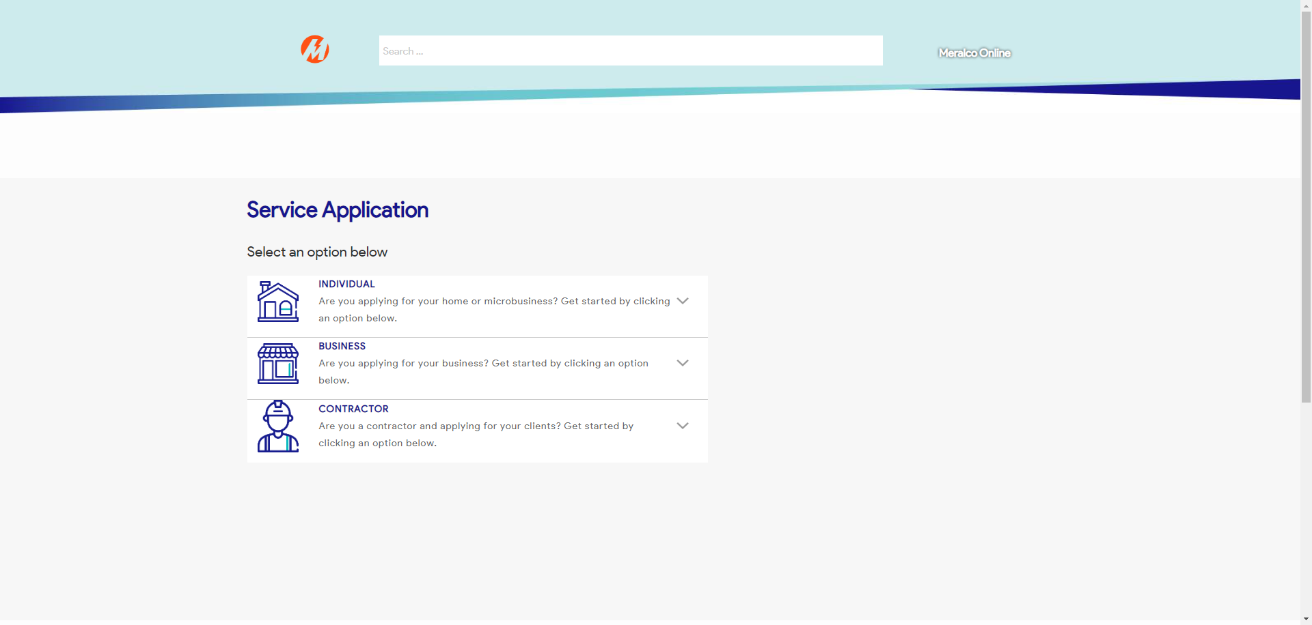

|  |
| --- |
| Step 2 - Click on Business |
| The following should be displayed under Business - Start Service - Modify Service - Reactivate Service - Stop Service |

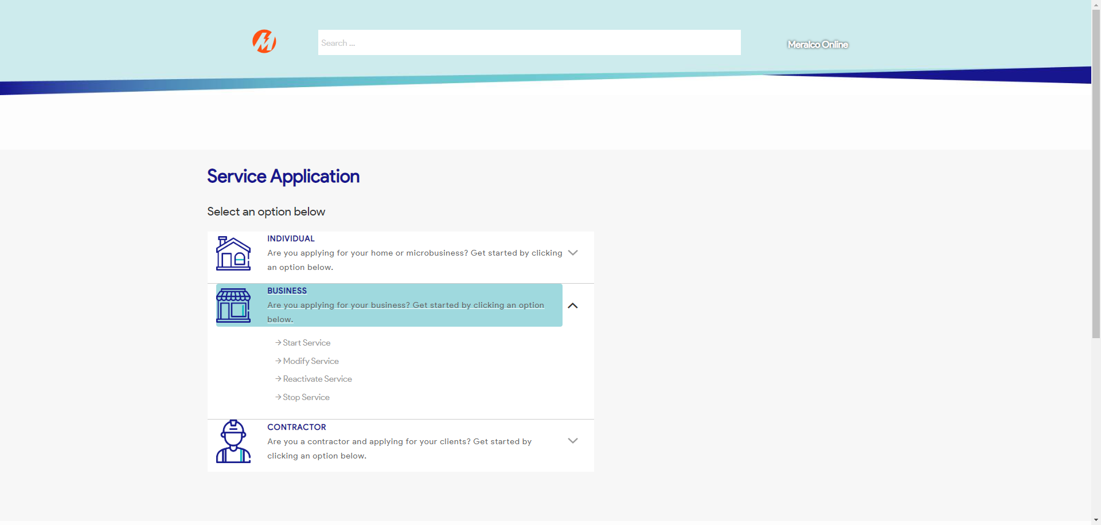

|  |
| --- |
| Step 3 - Click on Start a Service |
| A popup window should be displayed |

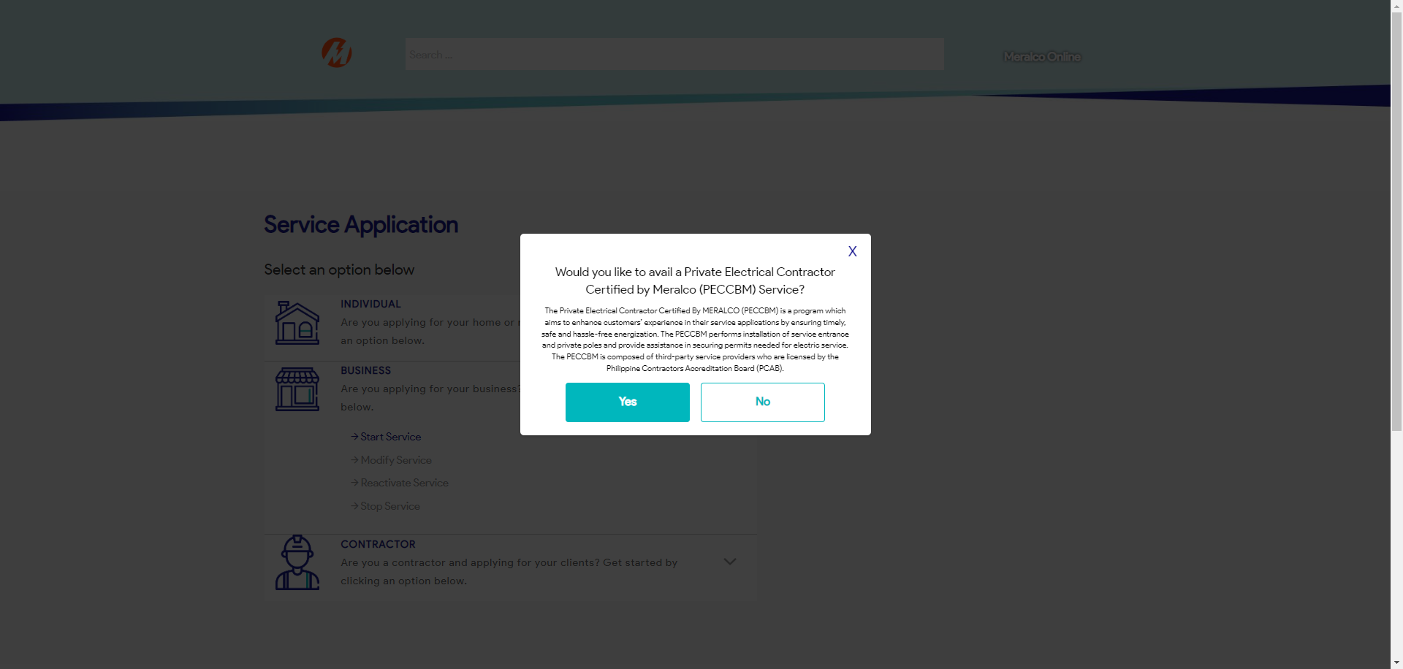

|  |
| --- |
| Step 4 - Click No |
| User should be directed to Start a Service Page. |

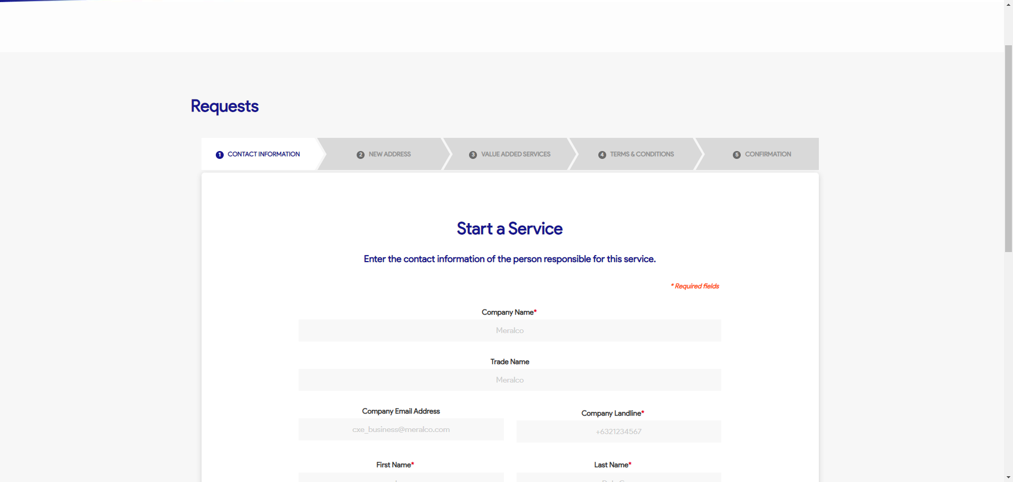

|  |
| --- |
| Step 5 - Populate the following fields: - Company Name - Trade Name (Optional) - Company Email Address (Optional) - Company Landline - First Name - Last Name - Email Address - Mobile Number - Designation  > Click Next |
| Fields should be populated; New Address tab should be displayed |

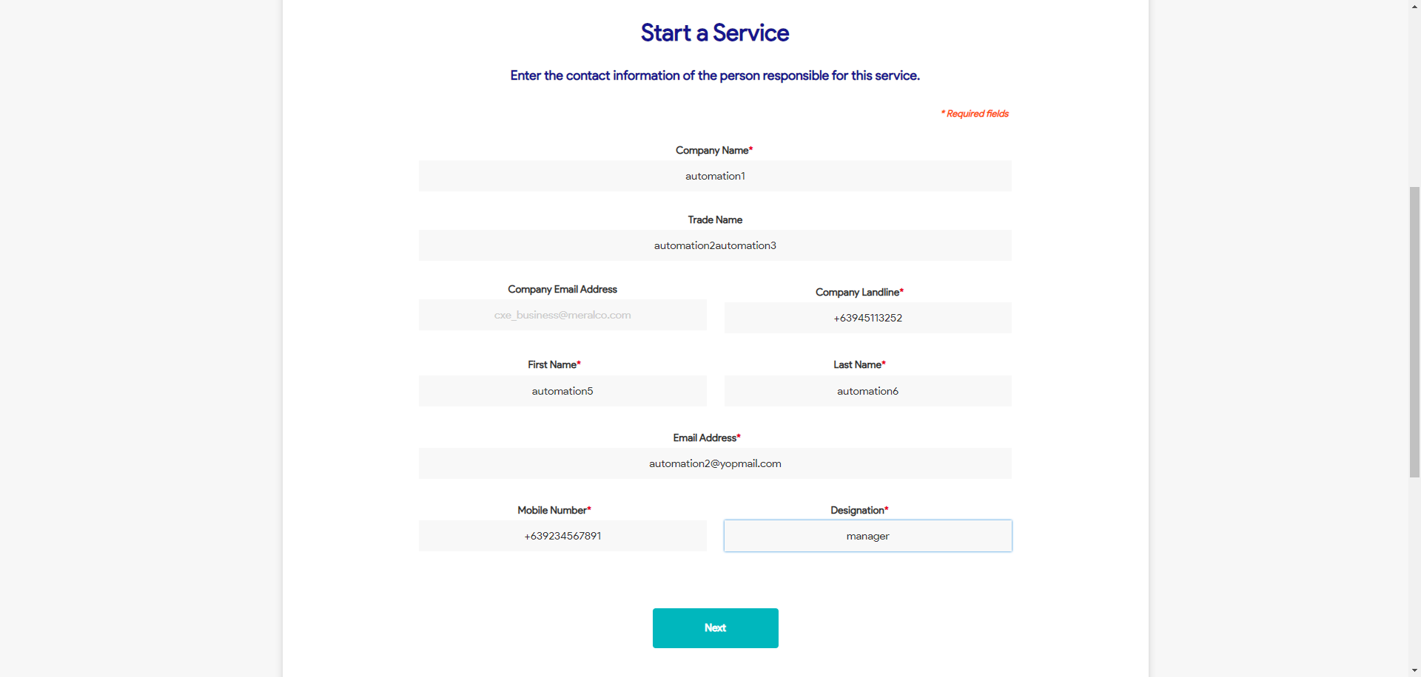

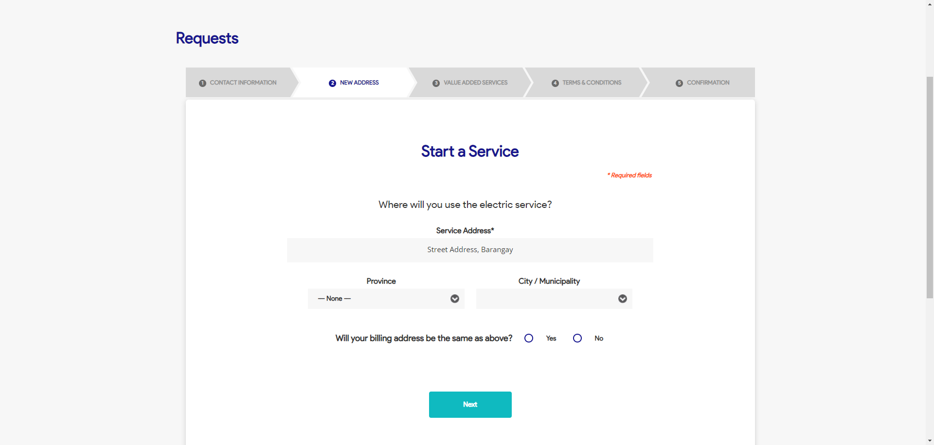

|  |
| --- |
| Step 6 - Populate the following: Service Address Province City / Municipality Home Ownership Billing Address Indicator  > Click Next |
| Fields should be populated; Value Added Service tab should be displayed |

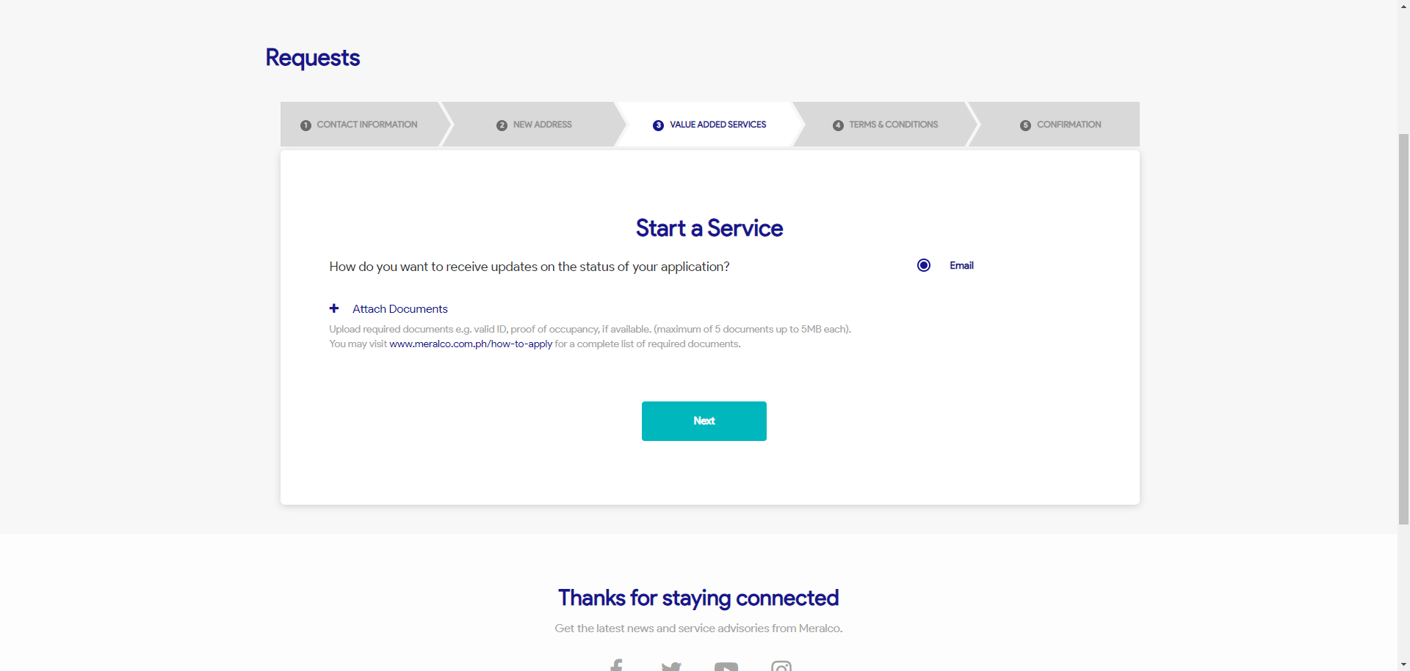



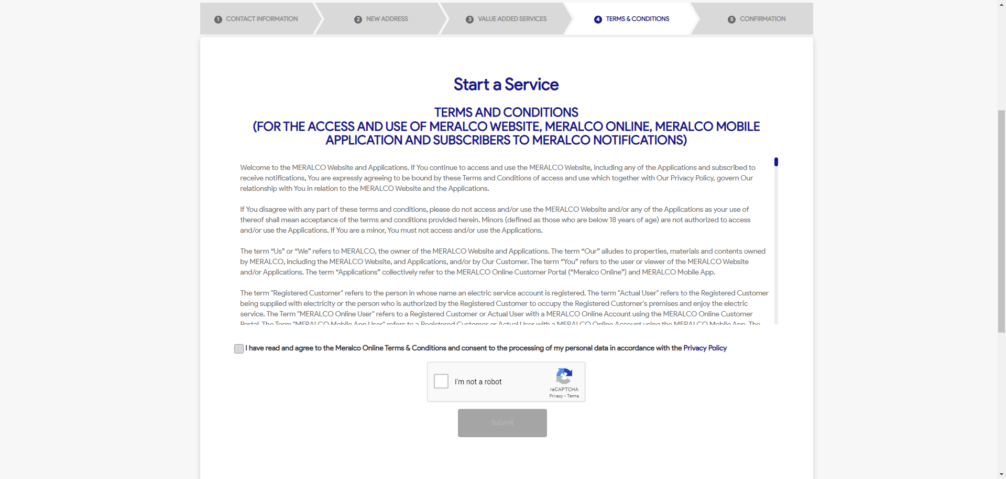

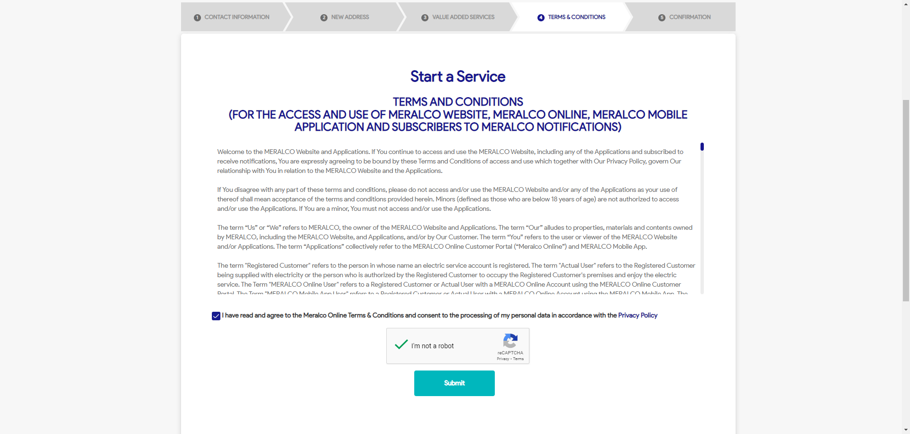



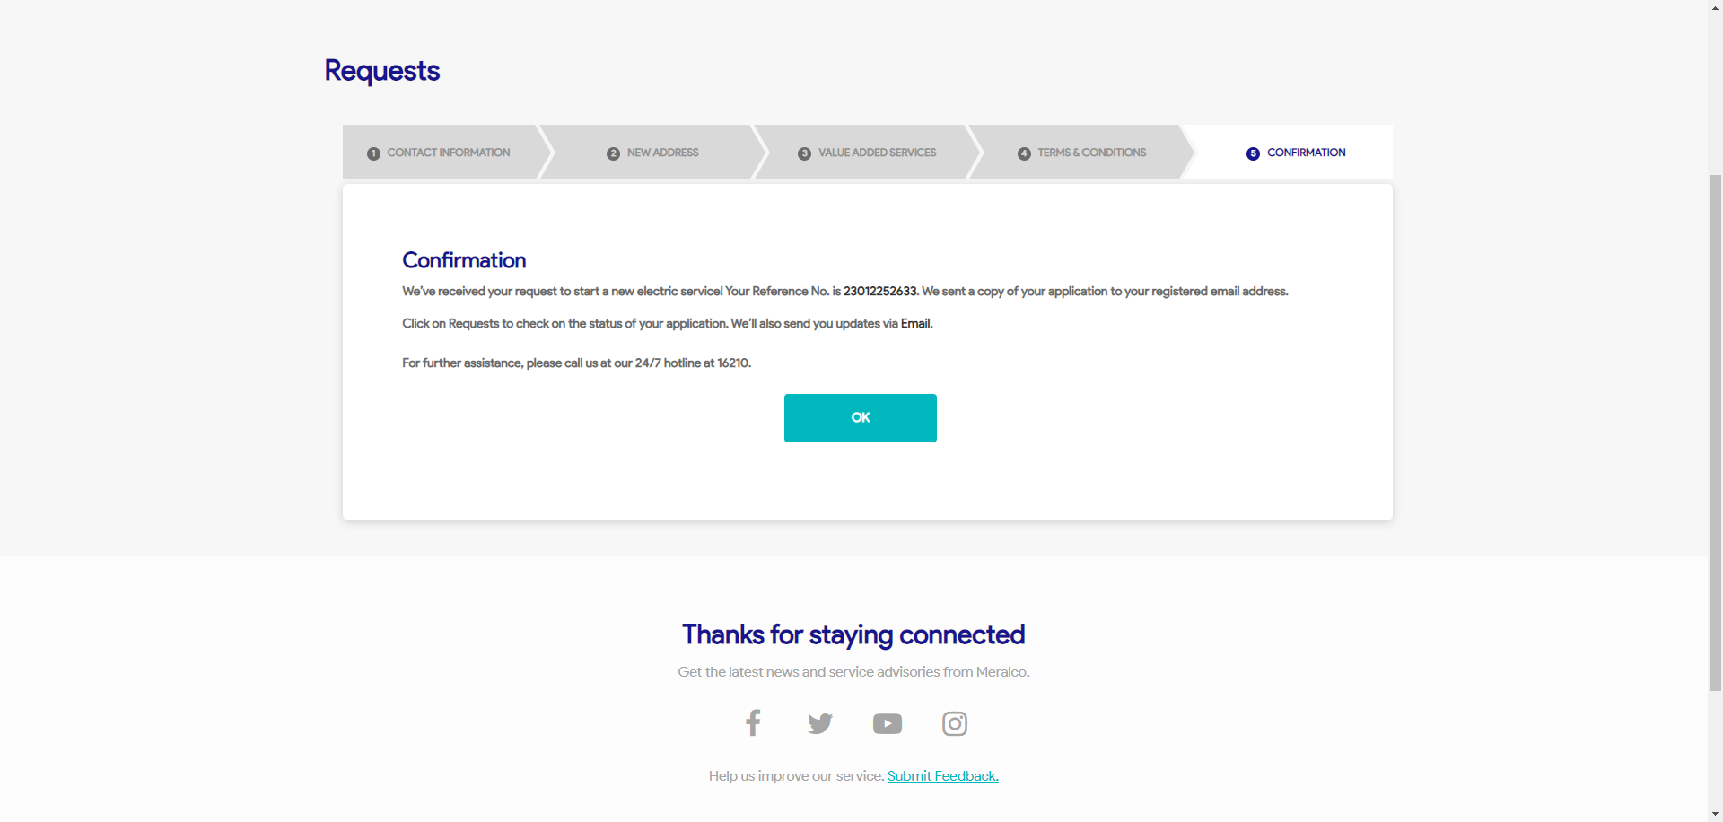

Passed