|  |
| --- |
| TS045 - TC063_Validate Popup Window for PECCBM in Start Service via CXE-Apply; No_Individual |

|  |
| --- |
| TC062_Validate Popup Window for PECCBM in Start A Service via CXE-Apply; Yes_Individual |

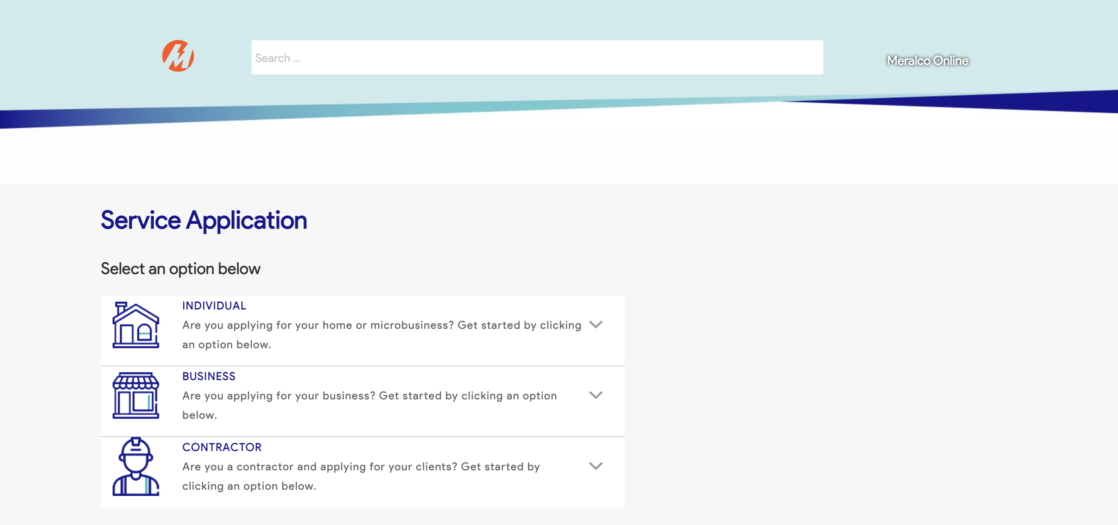

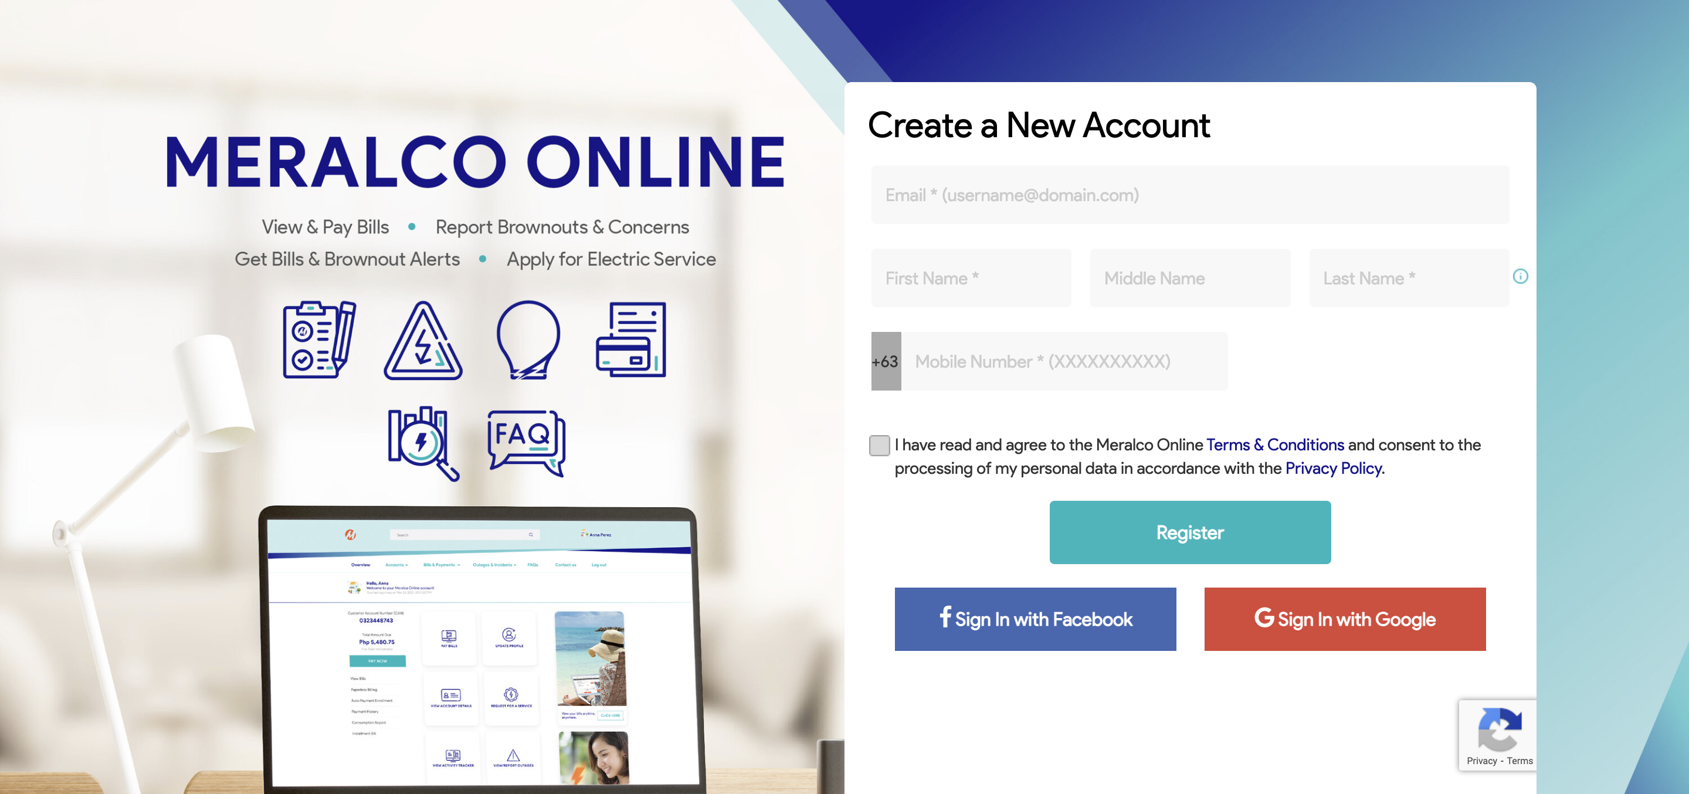

Passed