|  |
| --- |
| TS046 - TC065_Validate Popup Window for PECCBM in Start Service via CXE-Apply; No_Business |

|  |
| --- |
| TC064_Validate Popup Window for PECCBM in Start A Service via CXE-Apply; Yes_Business |

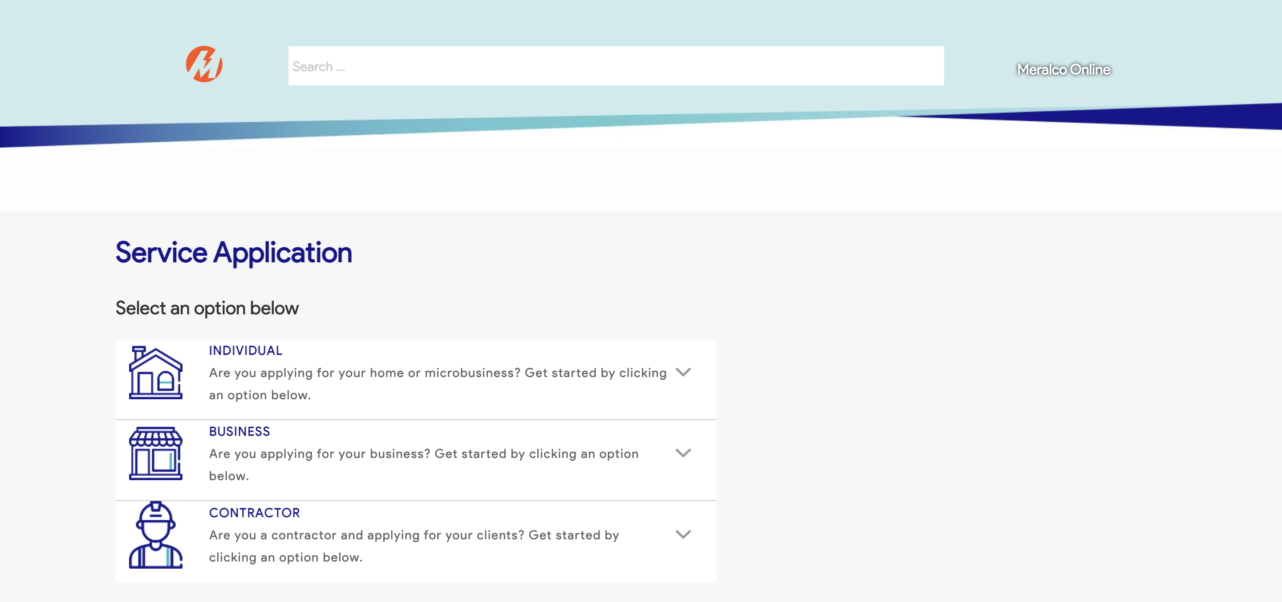

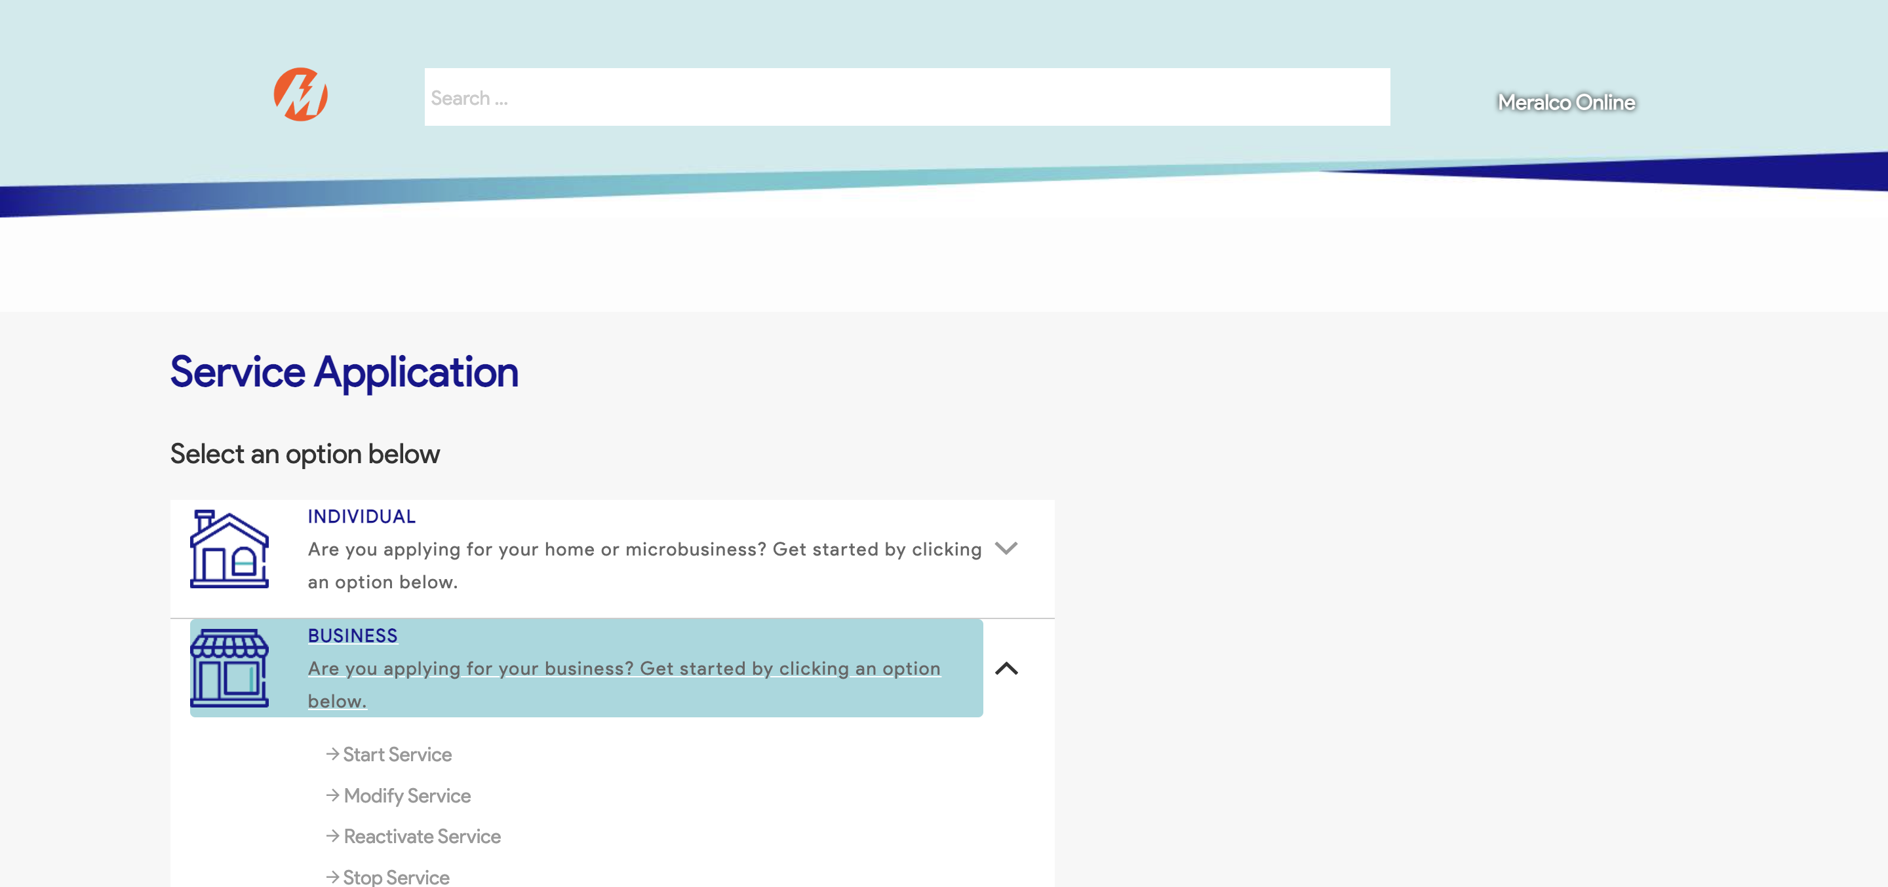

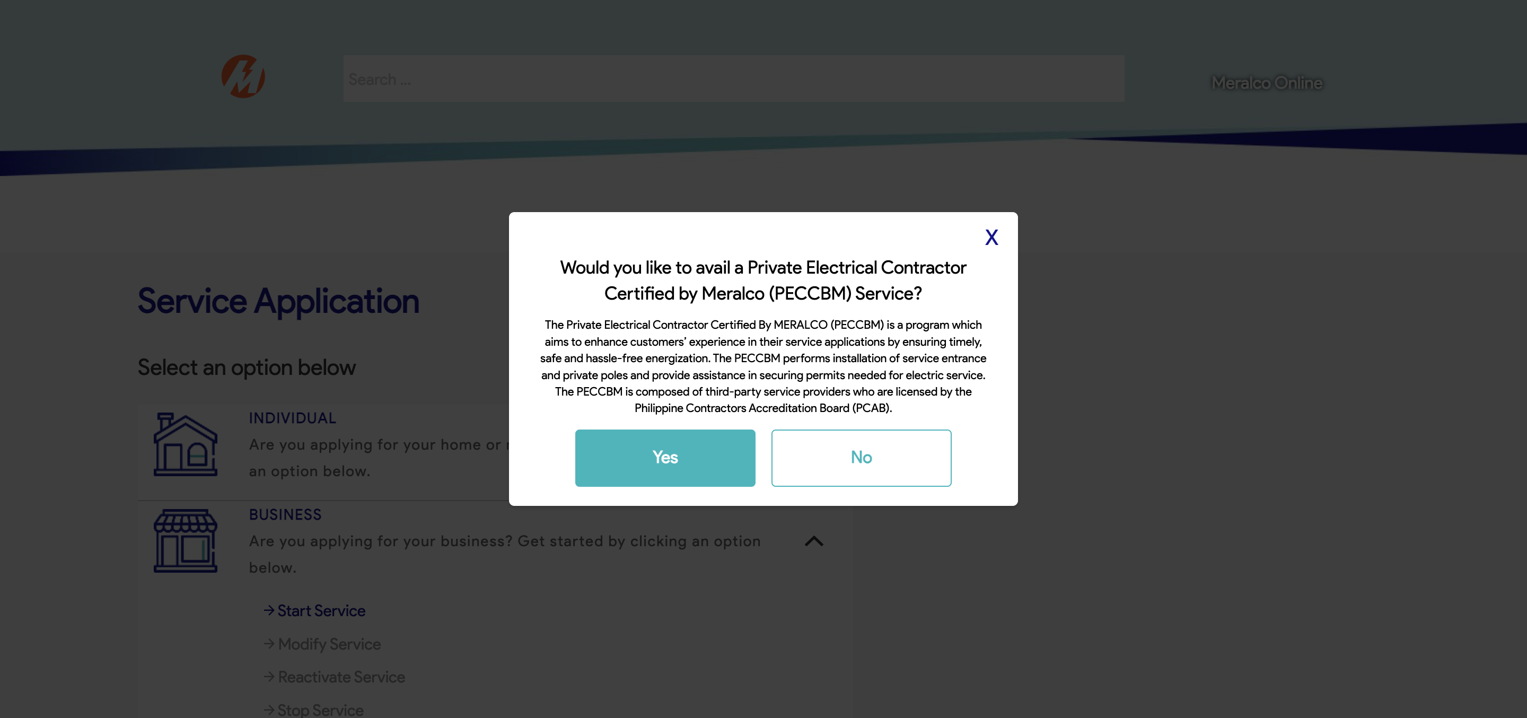



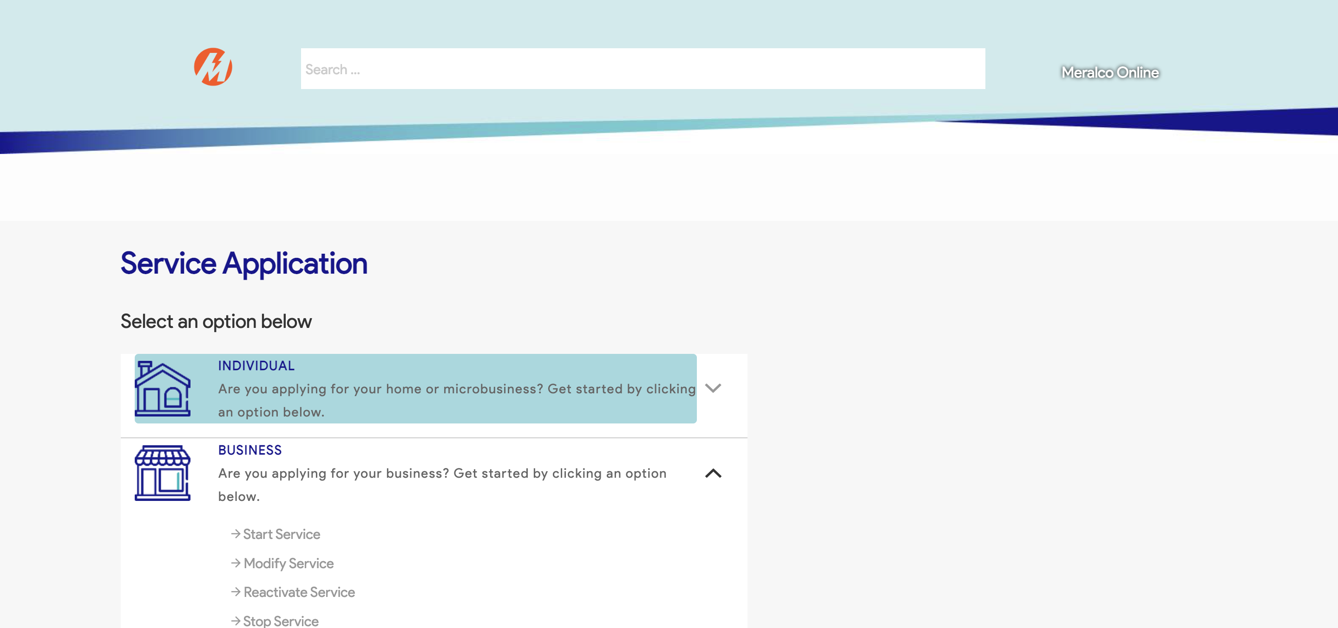

Passed