|  |
| --- |
| TS054 - Validate FAQs Page Update of CBM to PECCBM; Meralco Online |

|  |
| --- |
| TC074_Validate FAQs Page |

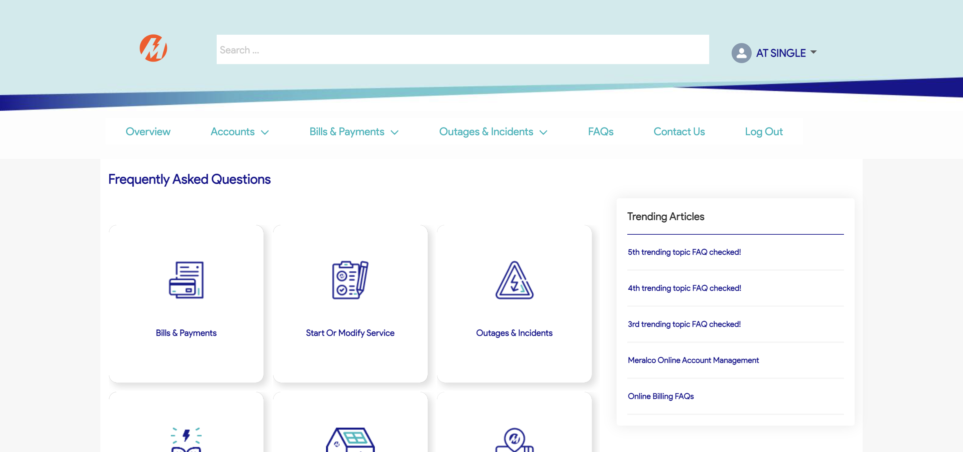

Passed