|  |
| --- |
| TS006 - Modification of Electric Service_Individual - Portal |

|  |
| --- |
| TC006_Modification of Service_Change Service Details |

|  |
| --- |
| Step 1 - Login to Meralco Online |
| User should be logged in to Meralco Online |

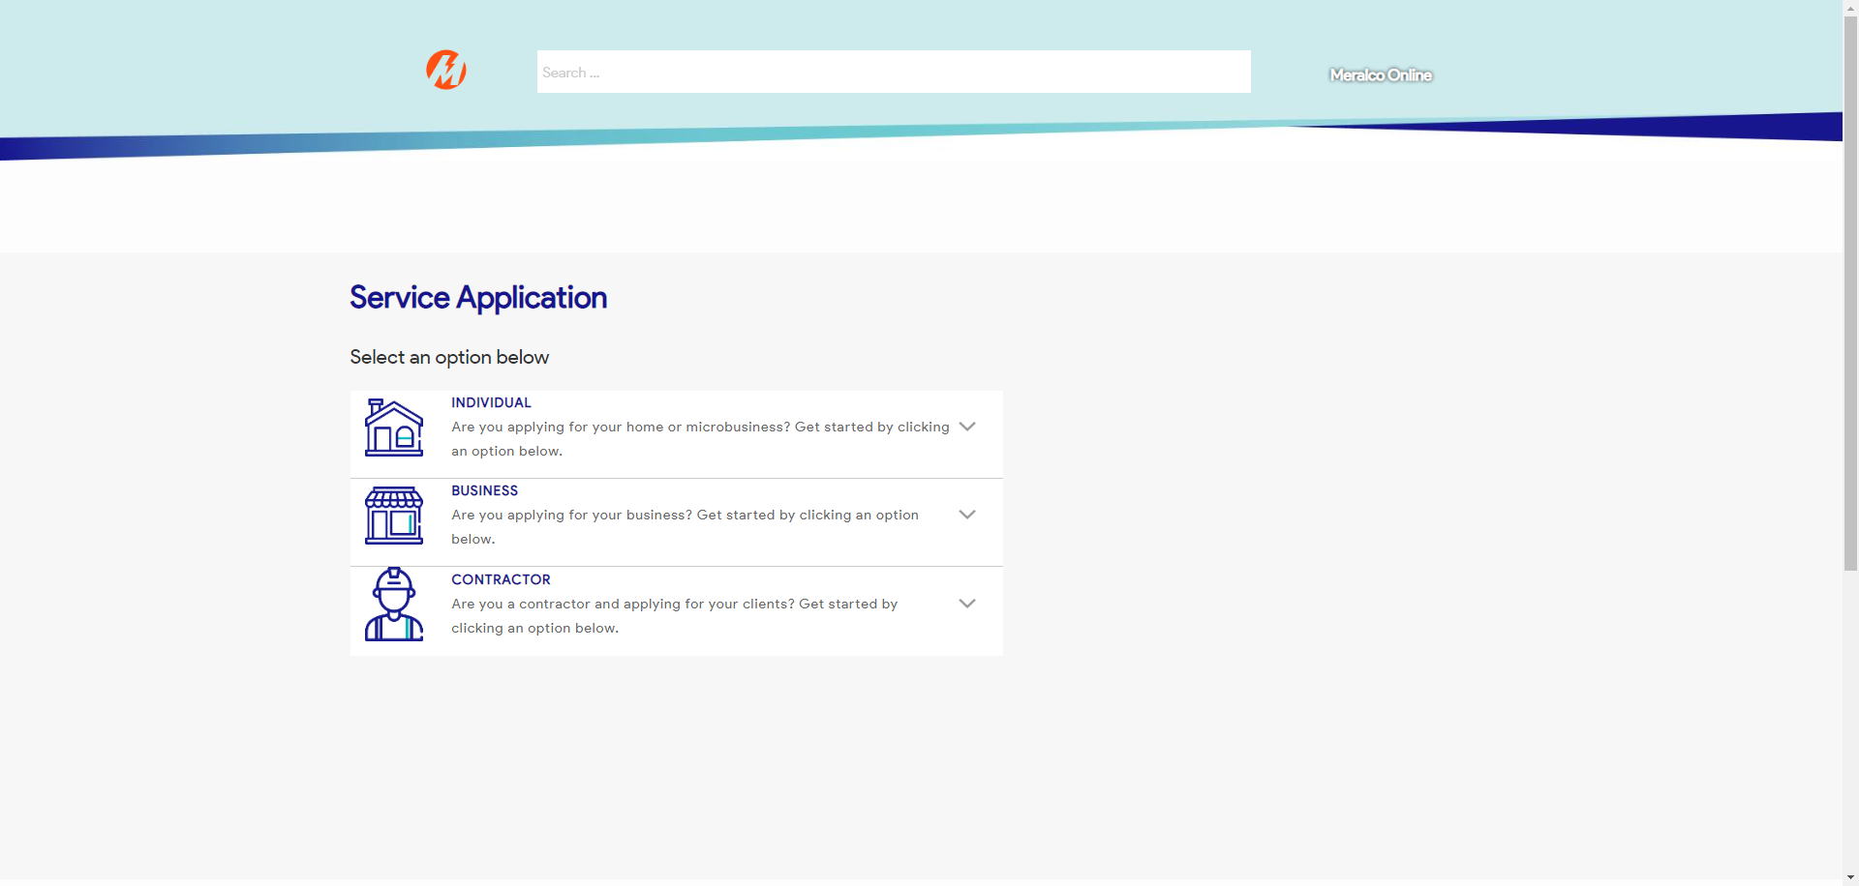

|  |
| --- |
| Step 2 - Go to Accounts> Manage Accounts |
| Accounts page should be displayed |

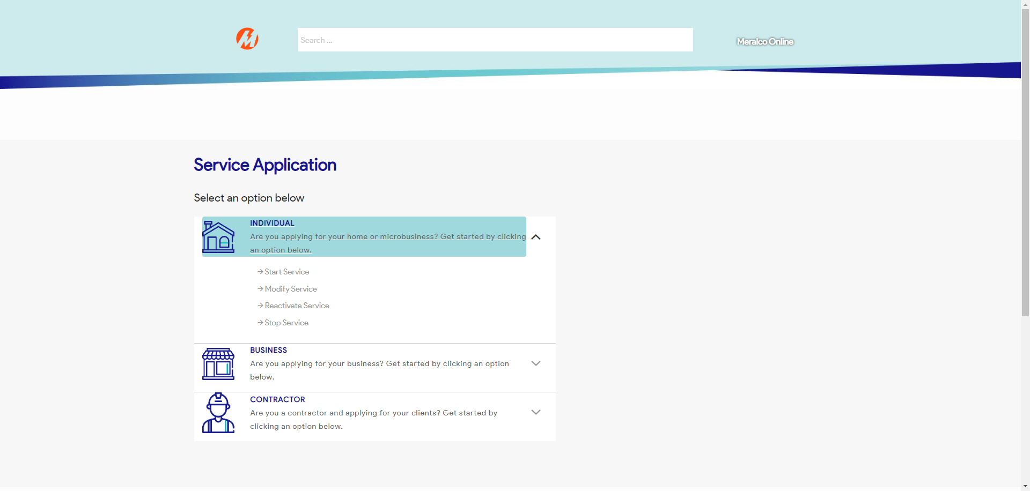

|  |
| --- |
| Step 3 - Search then Select Account > Click Change Service Details button |
| Request page for Change Service Details should be displayed |

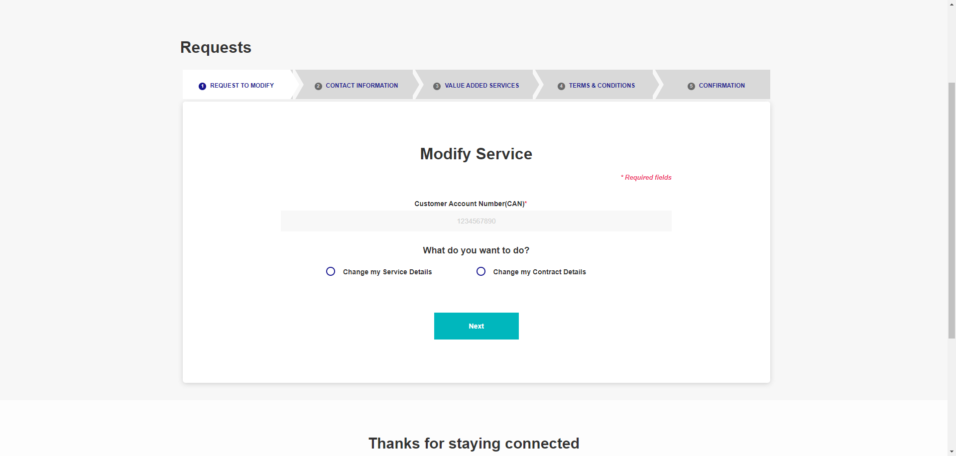

|  |
| --- |
| Step 4 - Select Change Service Details request options then click Next |
| Value Added Services tab should be displayed |



|  |
| --- |
| Step 5 - Populate the following: Notification indicator AMC indicator > Attach documents > Click Next |
| Fields should be populated; Terms and Conditions tab should be displayed |

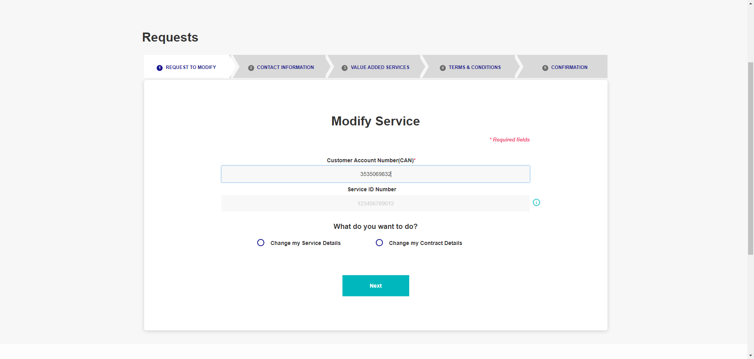

|  |
| --- |
| Step 6 - Tick on I have read and agree to the Meralco Online Terms & Conditions and consent to the processing of my personal data in accordance with the Privacy Policy |
| Submit button should be enabled |

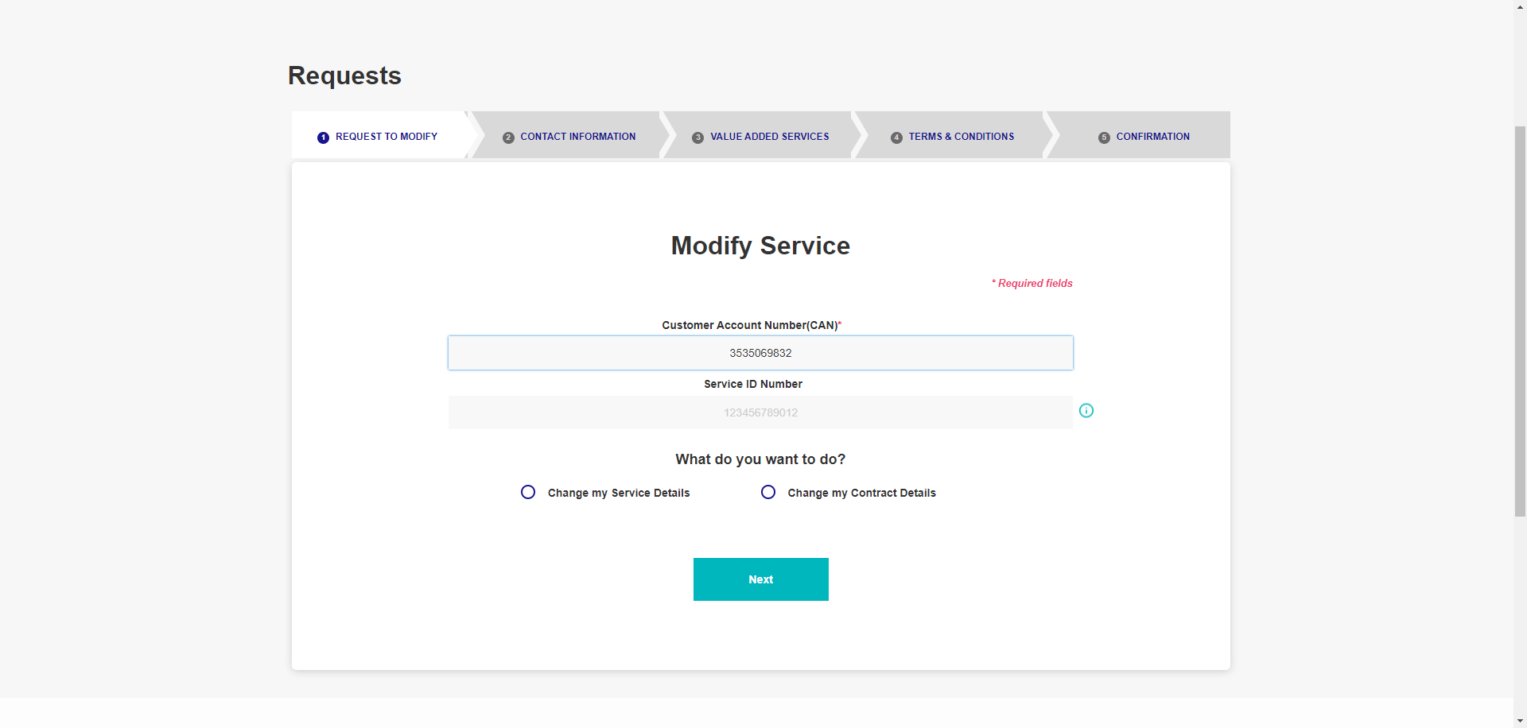

|  |
| --- |
| Step 7 - Click Submit |
| Confirmation tab should be displayed. Case # should be generated. |

