|  |
| --- |
| TS007 - Modification of Electric Service_Business - Portal |

|  |
| --- |
| TC007_Modification of Service_Change in Contract Name |

|  |
| --- |
| Step 1 - Login to Meralco Online |
| User should be logged in to Meralco Online |

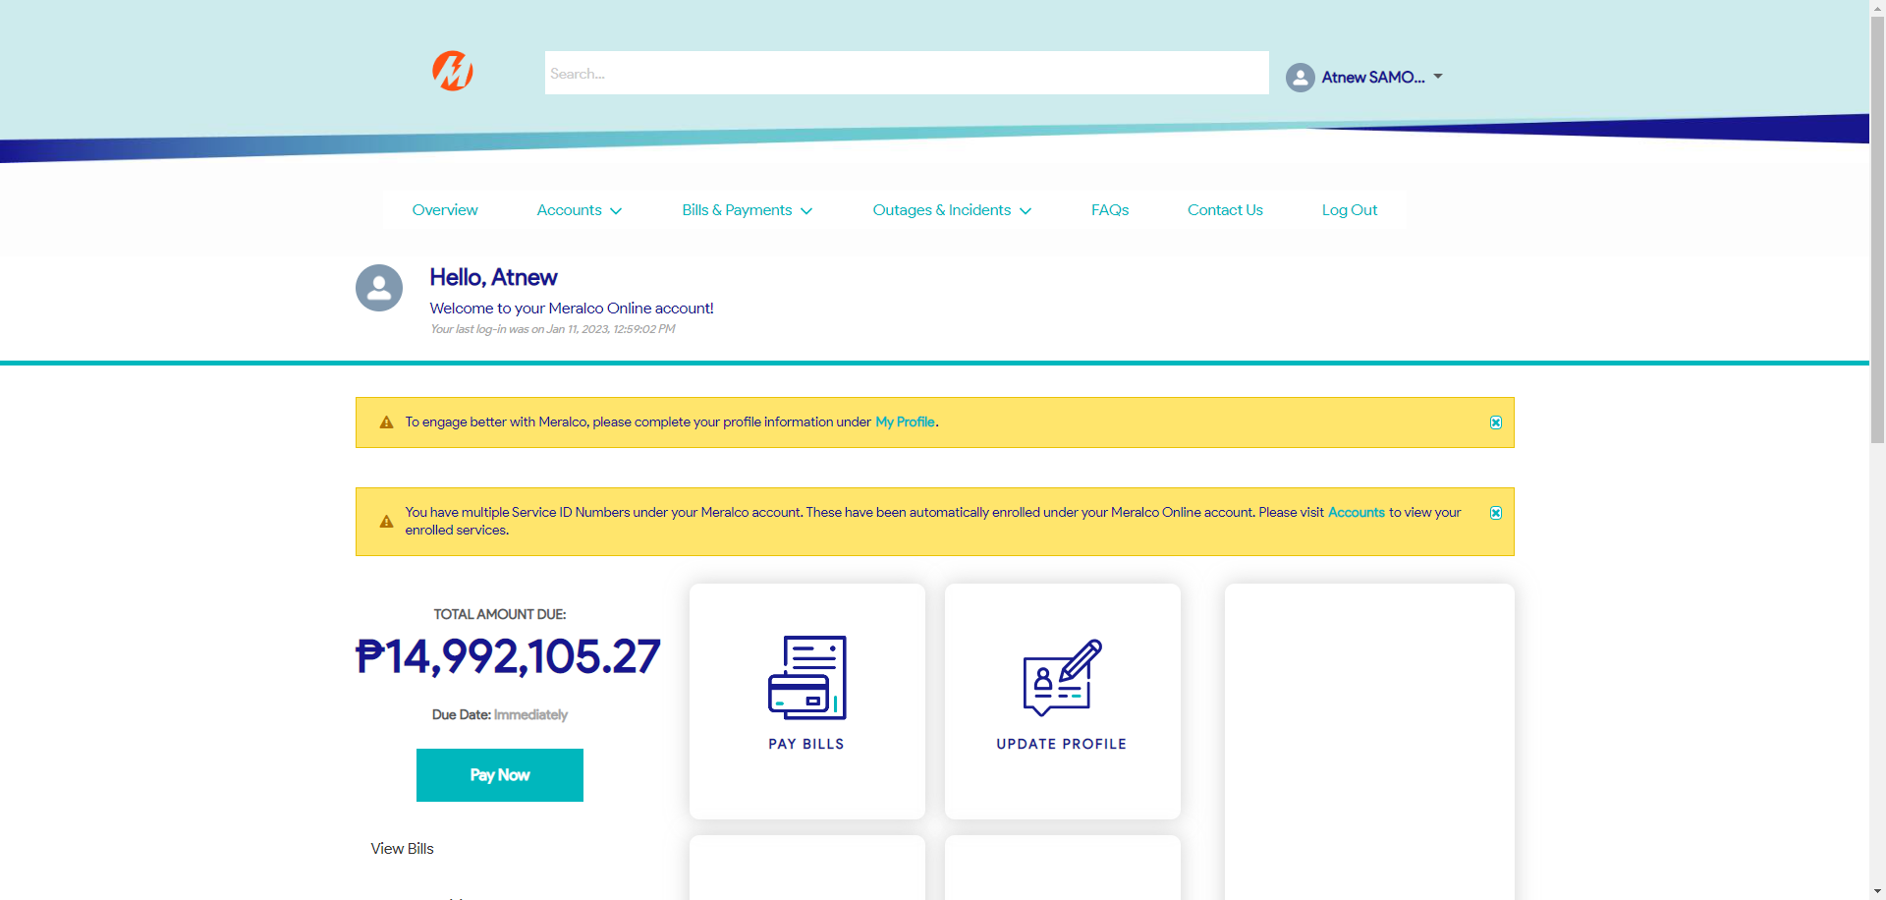

|  |
| --- |
| Step 2 - Go to Accounts> Manage Accounts |
| Accounts page should be displayed |

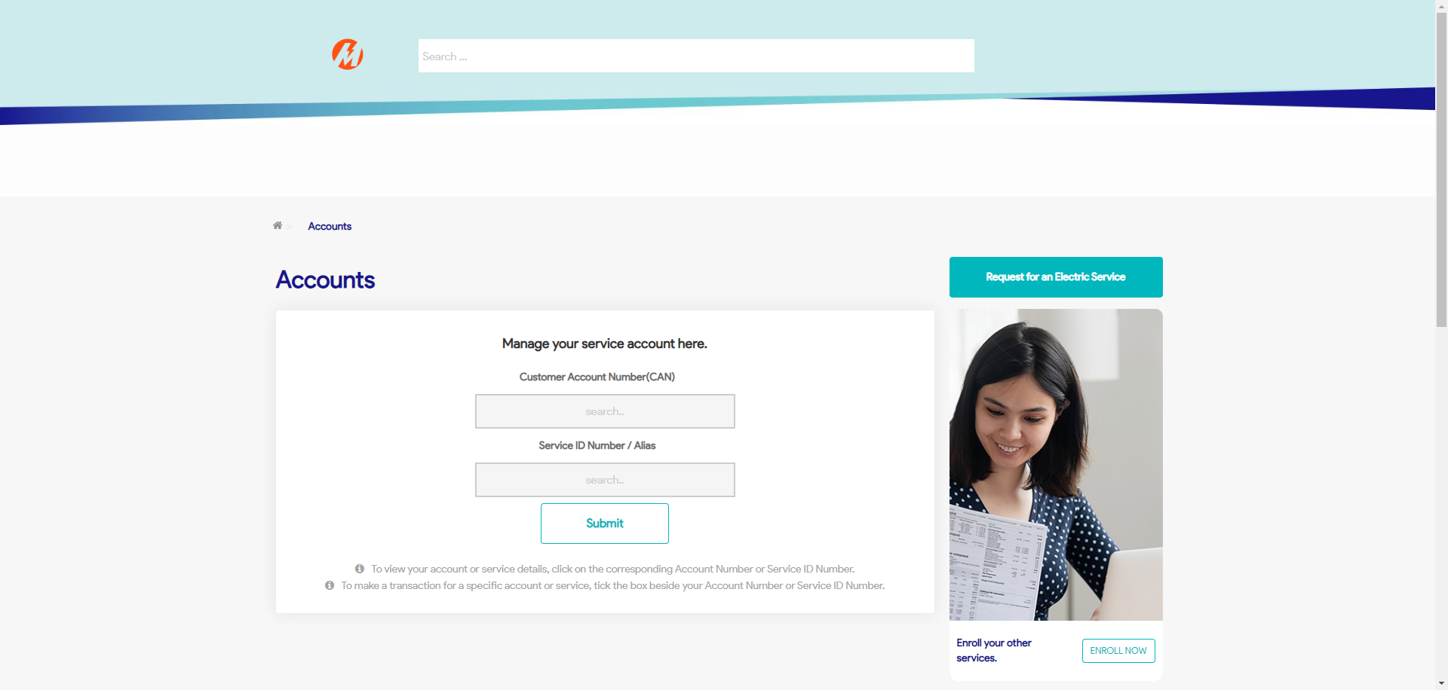

|  |
| --- |
| Step 3 - Search then Select Account > Click Change Contract Details button |
| Request page for Change Contract Details should be displayed |