|  |
| --- |
| TS011 - Modification of Electric Service_Contractor - CXEApply |

|  |
| --- |
| TC013_Modification of Service via CXE Apply_Contractor |

|  |
| --- |
| Step 1 - Go to https://fuat-meralco.cs73.force.com/customers/s/cxe-apply |
| Service Application page should be displayed |

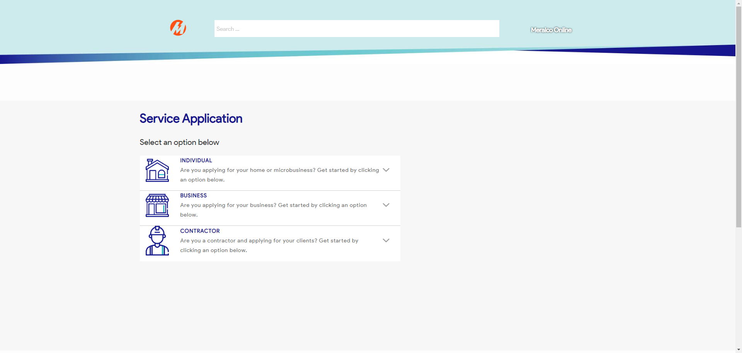

|  |
| --- |
| Step 2 - Click on Contractor |
| The following should be displayed under Contractor |

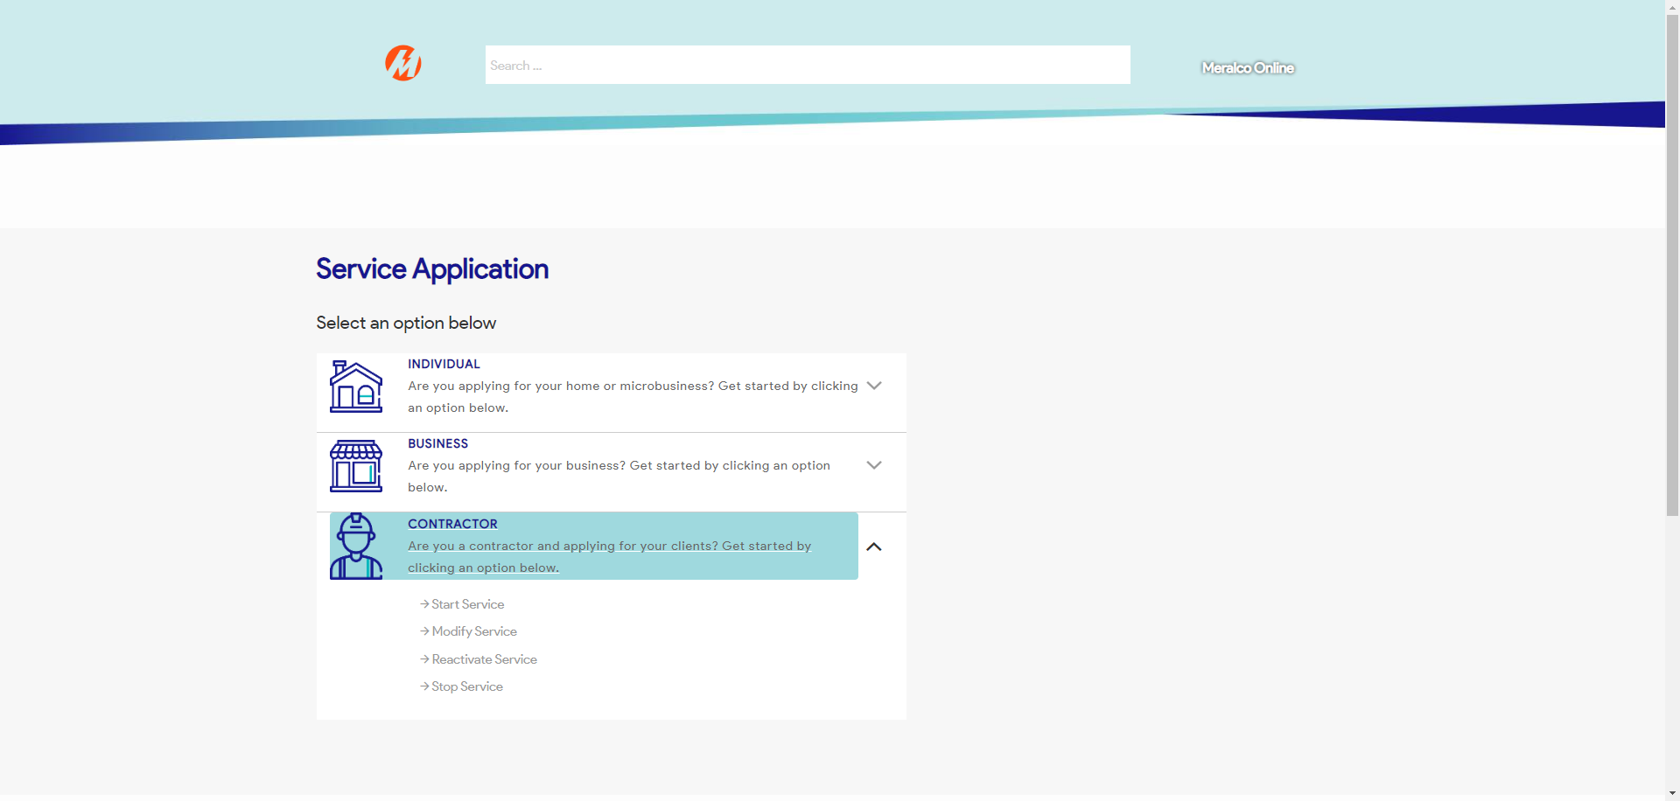

|  |
| --- |
| Step 3 - Click on Modify Service |
| Request page for Modify Service should be displayed |

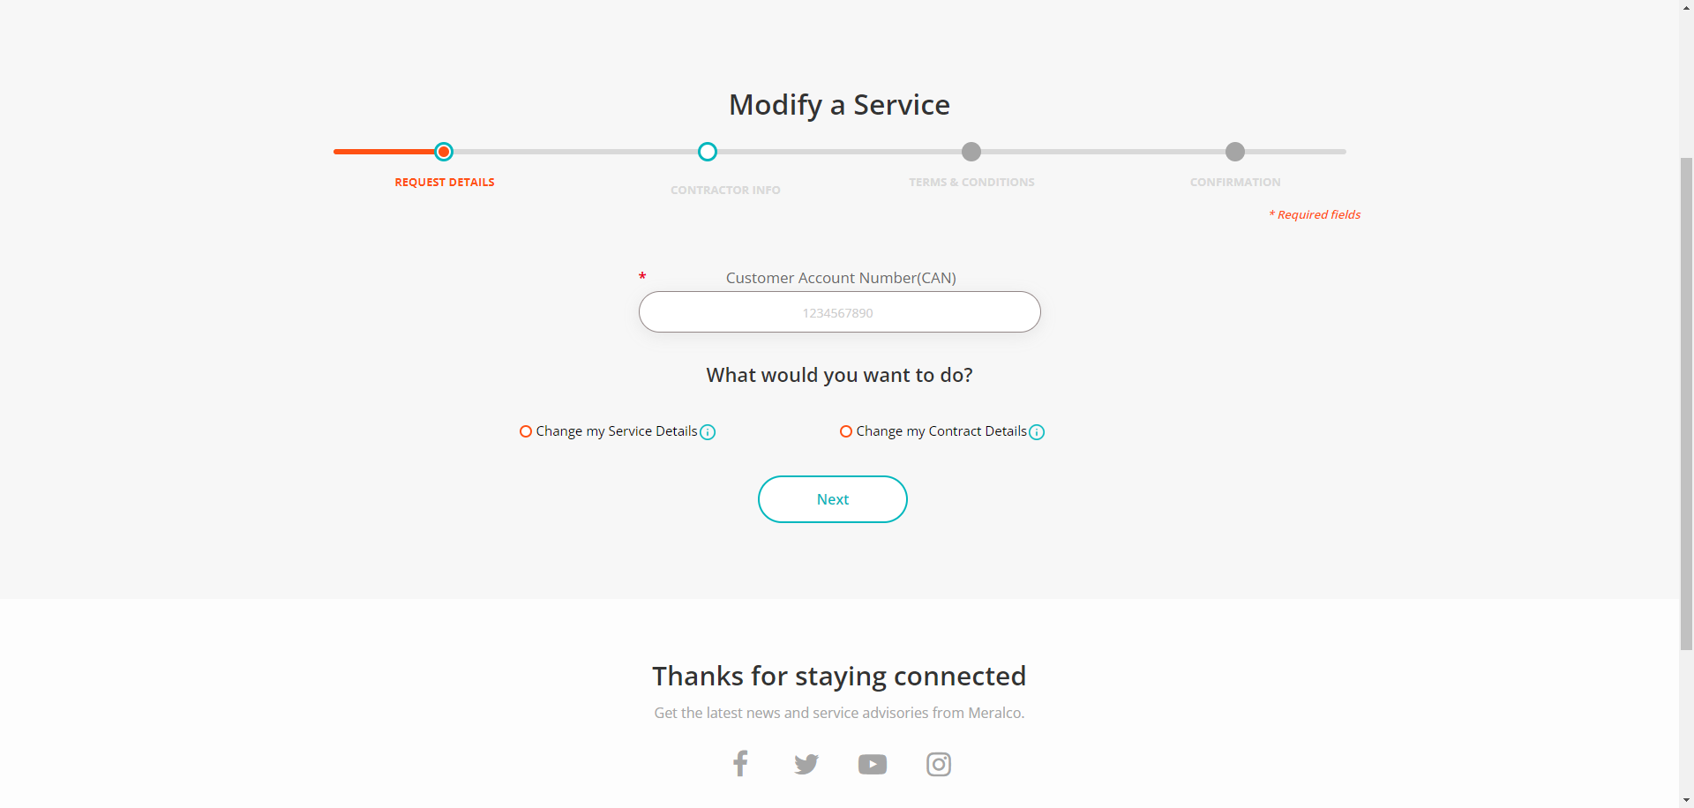

|  |
| --- |
| Step 4 - Validate if CAN field is visible and enabled |
| CAN field should be visible and enabled |



|  |
| --- |
| Step 5 - Populate CAN field |
| CAN field should be populated |

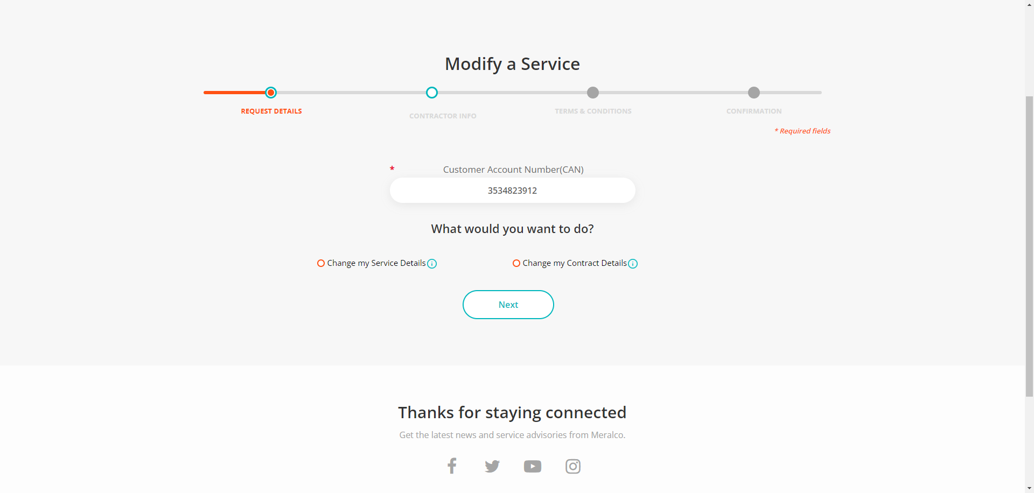

|  |
| --- |
| Step 6 - Tick Change my Service Details > tick Request to downgrade electrical load > click Next |
| Transfer of Service should be selected |

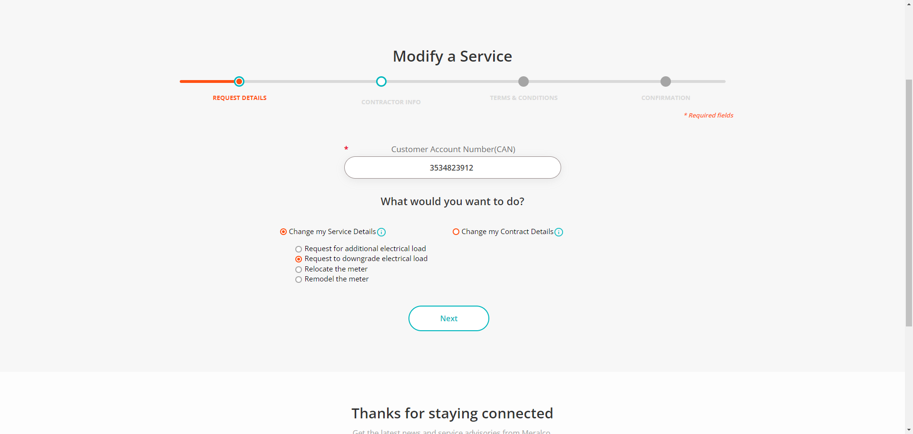

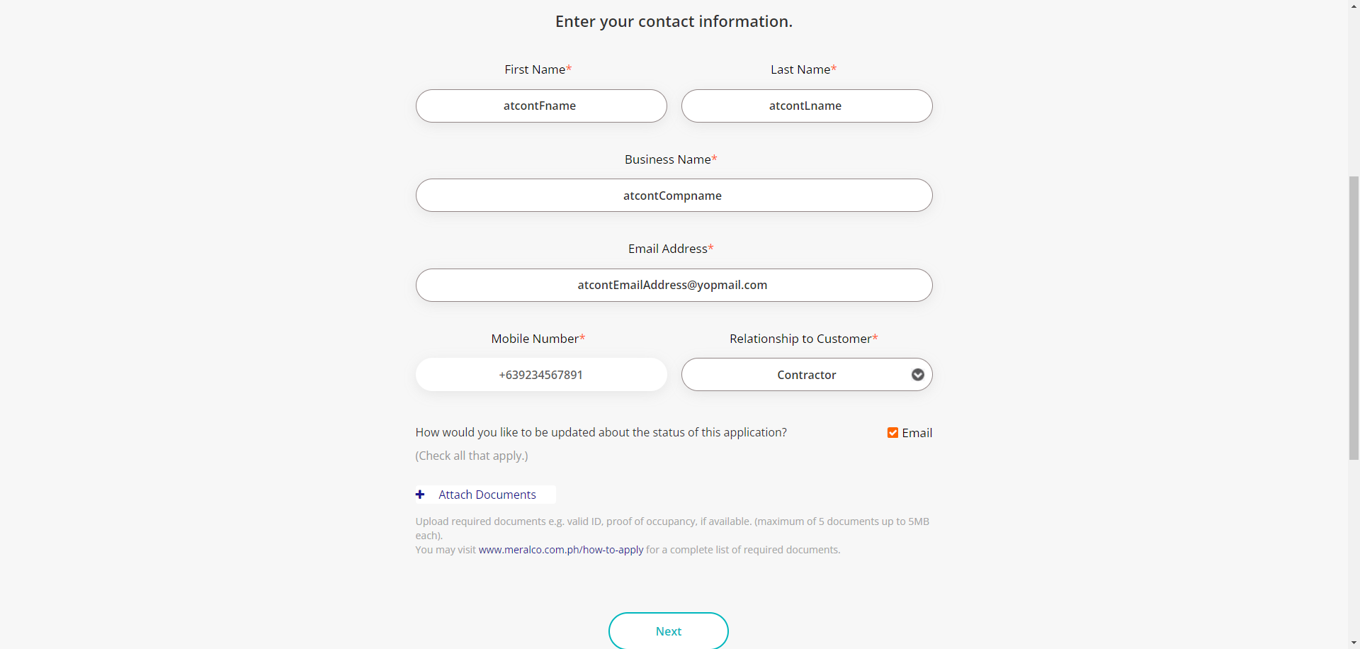

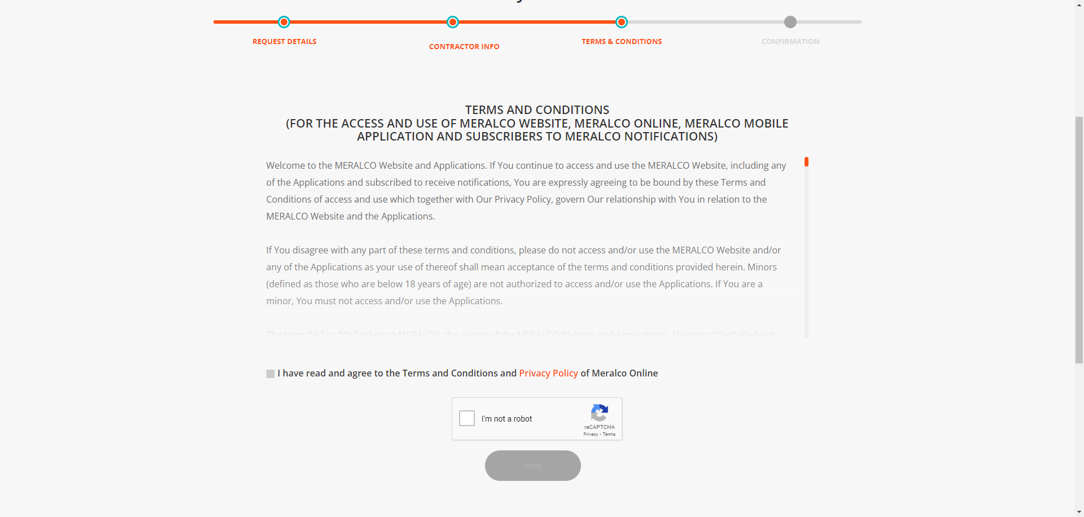

|  |
| --- |
| Step 8 - Populate the following field: |
| Fields should be populated; Terms and Conditions tab should be displayed |

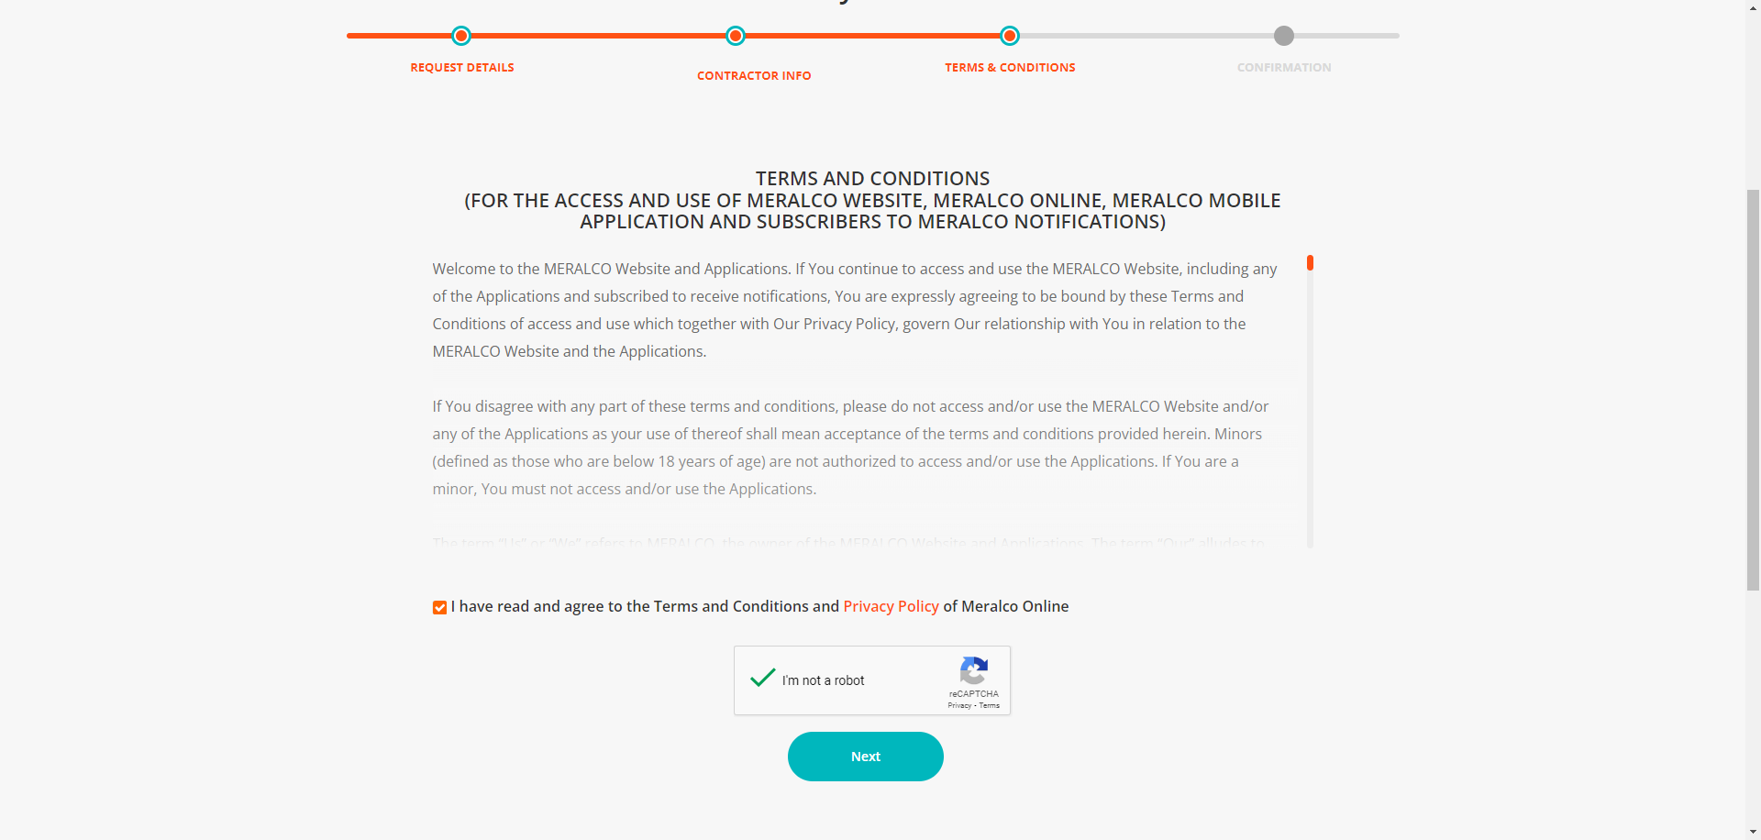

|  |
| --- |
| Step 9 - Tick on I have read and agree to the Meralco Online Terms & Conditions and consent to the processing of my personal data in accordance with the Privacy Policy |
| Submit button should be enabled |

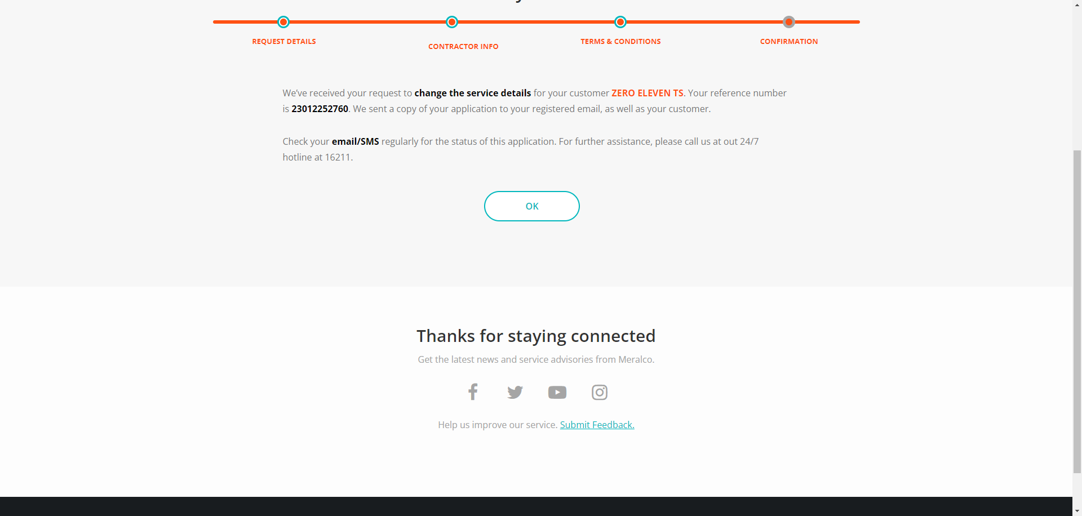

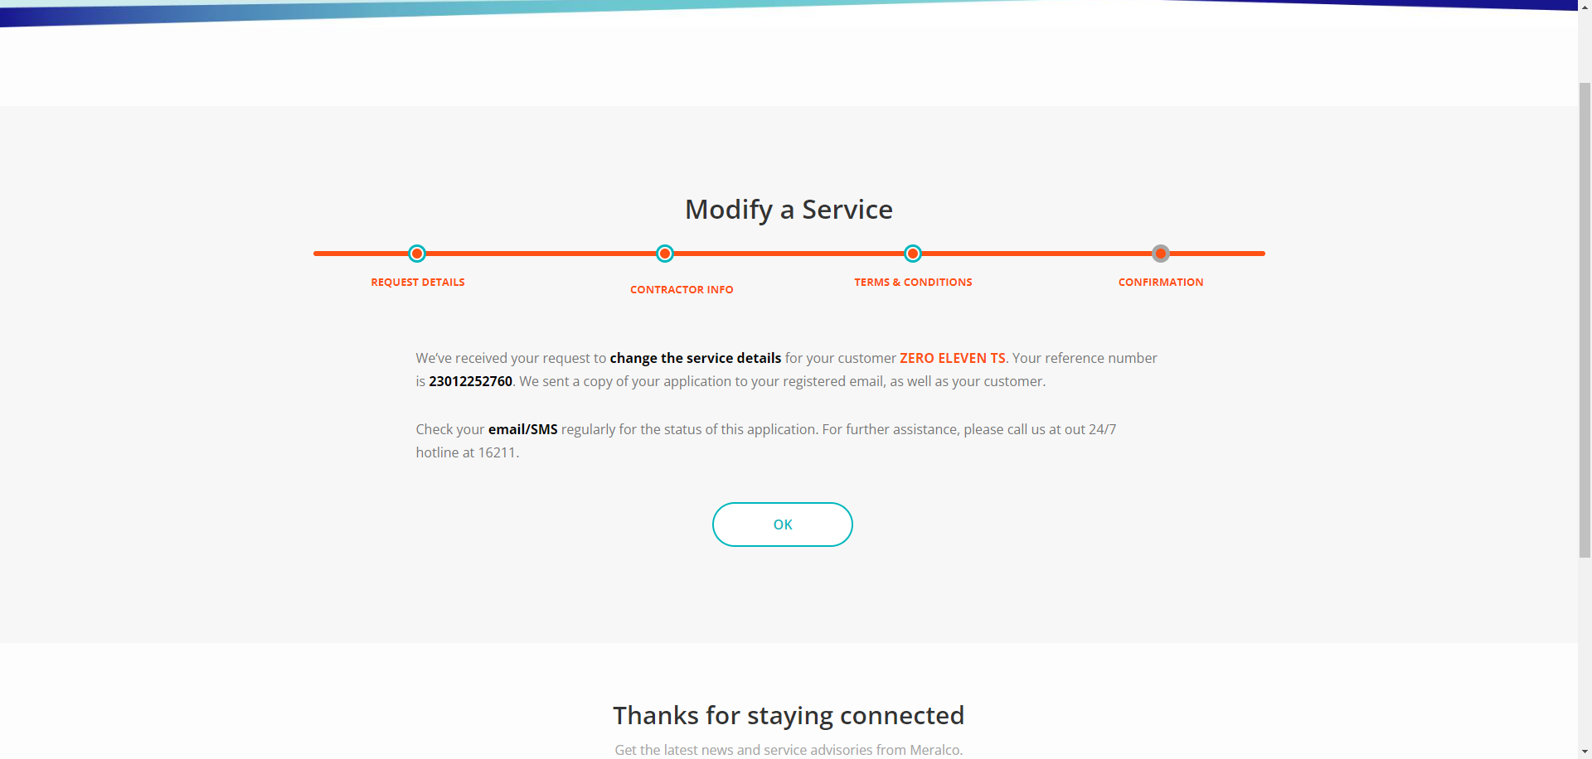

Passed